High-Level Design
Emergency Power Station
12/6/12

James Benner
Chen Chen
Andrew Dolan
Ryan Loos
Everistus Obiakor

Table of Contents
Table of Contents 2
1 Introduction 3
2 Problem Statement and Proposed Solution 3
3 System Requirements 3
4 System Block Diagram 4
4.1 Overall System 4
4.2 Subsystem and Interface Requirements 5
4.3 Future Enhancement Requirements 6
4.3.1 GPS Emergency Beacon 6
5 High Level Design Decisions 7
5.1 Audio System 7
5.2 Clock 8
5.3 GPS System 8
5.4 LED Flashlight 9
5.5 Power System 9
5.5.1 Battery 9
5.5.2 Battery Management System 9
5.5.3 Hand Crank 10
5.5.4 Solar Cell 10
5.5.5 USB Charger Output 10
5.6 Screen 11
5.7 User Interface 11
6 Open Questions 11
6.1 Audio System 11
6.2 Power System 11
6.3 User Interface 11
7 Major Component Costs 12
8 Conclusions 13
8.1 References 13

Introduction
Virtually everyone today carries a mobile phone. Recent developments have allowed for the use of cell phones for almost anything, from displaying maps to playing games. Although cell phone technology is more advanced than ever, modern cell phones still have limitations. Cell phone batteries only last for a few days at most under constant use. Signal can be severely reduced in areas far from service towers. These limitations aren’t much of an issue in most residential areas, but your cell phone can be rendered useless when you are lost in a forest without any charge. We hope to remedy these issues with a device specifically geared to emergency situations. Our device should provide power and information necessary to aid someone dealing with a nature emergency. Our system, the “Solar Charger”, is a small, portable power station, equipped with several features particularly useful in emergency situations.

Problem Statement and Proposed Solution
We seek to solve the problems of relatively limited battery life of today's smartphones, limited availability of AC electricity from a typical wall charger, weak signal strength, and other problems that arise in emergency situations. Cell phones are especially important in situations such as emergencies, road trips, hiking, blackouts, etc., and access to a renewable and sustainable charging source in these situations would prove to be very valuable. In addition to the problem of limited battery life, we plan on addressing other problems that could arise in emergency situations such as knowing the date, time, your location via GPS, and access to an AM/FM radio.
The emergency unit we plan to design and build will be a compact, affordable and durable solution to the aforementioned problems. We plan to use solar panels and a mechanical crank as our two power sources. The unit would have rechargeable batteries for storage, and a USB port as charging interface. The unit would have a small screen to display the time and the location as well as an AM/FM radio with the possibility of access to weather alerts.

System Requirements

Overall Requirements
General Purpose | Must be able to operate both indoors and outdoors  Must be lightweight and portable  Must be durable and able to withstand the elements
Power | Must be able to run off both battery and wall power  Must be able to charge USB devices
Safety | Must be safe to use both indoors and outdoors  Must not carry risk of electrical fires
Expected Life of  Product | Batteries must be able to last for 1000 cycles
Cost | Prototype must cost less than $500 to design and build
FCC Compliance | Must not cause interference with other signals or other operating appliances
Aesthetic Design | Must be portable and easy to carry by the consumers (no more than 15 pounds in weight, no larger than 12’’10’’6’’)
User Interface | Must be able to control the subsystems  Must be easy, efficient, and enjoyable to use

System Block Diagram

Overall System
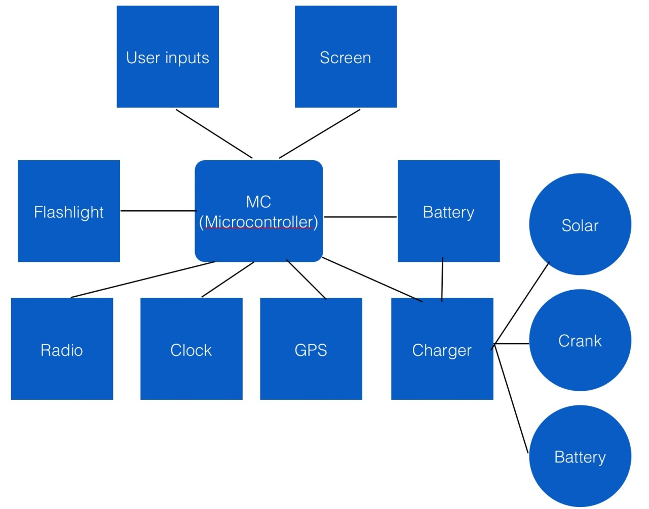

Subsystem and Interface Requirements

Subsystem/Interface | Requirements
Audio System | Must receive AM and FM signals at user selected frequencies  Must be able to take an input signal from 3.5mm jack  Must be able to switch between AM, FM, and auxiliary input  Must be able to switch between speakers and auxiliary output  Must be able to drive output signal through a speaker  Must be able to output to a 3.5mm jack
Clock | Must be able to display the time in a 12-hour format at any given time (in hours and minutes)  Must also be used as a stopwatch in order to accurately measure the time for an event or as a timer.
GPS System | Must be able to interface with the GPS receiver to accurately give the geographic coordinates of the user (in degrees and minutes)
LED Flashlight | Must be able to provide enough light to see at least 5 feet in front of the user when on
Microcontroller  Software | Must use a reasonable amount of program memory  Must control the battery charging system and monitor battery status  Must be able to receive GPS coordinates  Must be able to process audio input and output  Must be able to control the switching of different operating modes
Power System | Must be able to receive power input from wall, solar panel, and hand crank  Must be able to recharge two 3.7V lithium ion batteries  Must be able to power the system by either wall power (when plugged into the wall) or by battery power (when not plugged into the wall)  Must be able to manage power inputs and monitor battery charge level so the system knows when to charge and when not to  Must be able to charge USB devices (phones, Ipods, etc.)
Screen | Must be able to display clock, radio frequencies, and GPS coordinates on a 7-segment or LCD screen
User Interface | Must be able to turn on and off LED flashlight via a switch  Must be able to turn on and off the radio via a switch  Must be able to tune the AM or FM radio via a knob  Must be able to turn on and off the speaker via a switch  Must be able to tune the volume of the speaker via a knob  Must be able to recalculate the current location via a reset button  Must be able to turn on and off the clock and GPS displays via switches  Must be able to monitor the battery level from a display  Must be able to use a hand crank to charge up the battery  Must be able to charge up the battery from wall outlets via a plug  Must be able to plug in and charge up USB devices through a USB port

Future Enhancement Requirements

Future Enhancement Requirements
Aesthetic Additions | Must be able to be a portable party device.  Must have multi-colored LED lights with strobing effect synced to audio output  Must be thinner and lighter
Interfacing | Must be able to add IPhone/Android App to be able to be able to act as remote control for device
GPS Additions | Must be able to determine location and able to set start point and end points for route calculation  Must be able to send out emergency beacon to emergency responders so they can pin point your location
Smart Charger | Must be able to show battery cycles remaining to help user determine how much lifetime their batteries have
Traffic/Weather Radio | Must be able to tune to traffic broadcasts so user is aware of congestion on the roads  Must be able to tune to weather broadcasts so user is aware of any server weather in the listening area

GPS Emergency Beacon

In addition to the already existing GPS system on our product that tells the user his longitude and latitude, we will like to add an emergency beacon in the future to this system. The way this will work is as follows: in the event of an emergency or situation whereby the user of our product needs help, the user will be able to send ‘distress signals’ to the non-geostationary satellites and these signals can be located by the combination of GPS trilateration and doppler triangulation. In order to effectively implement this kind of technology in the future, we will need to add tracking transmitters (or emergency beacons) on our GPS system which will aid in detection and location of the user in the case of an emergency. These usually work at a frequency of about 406 MHz (depending on the kind of mode at which we decide to operate).

High Level Design Decisions

Audio System

Each radio system requires an oscillator, mixer, signal amplifiers, detector, and AFC. The oscillator creates a local signal with constant frequency. The mixer mixes the local frequency created by the oscillator with the signal received by the antenna to create an intermediate frequency signal which can be recognized and amplified by the IF amplifiers. The amplifier increases the amplitude of the signal. The detector converts the intermediate frequency into a signal which can be played through the speaker. The AFC is a feedback loop which keeps the system zoned in on one receiving frequency signal. All of these subsystems are contained within an AM/FM IC. An example of such an IC is the Phillips TEA5711 AM/FM stereo radio circuit with Digi-Key part number TEA5711N-ND ($1.36). The following figure is the block diagram of a typical AM/FM radio.

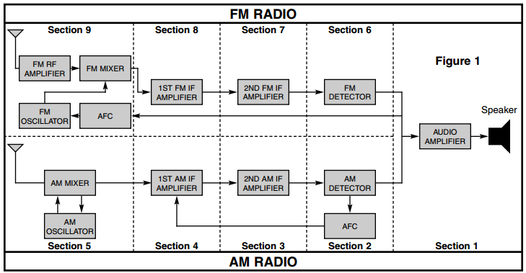
Figure 1: AM/FM Radio diagram
(Elenco, 3)
As can be seen above, the output of both radio systems must be put through an audio amplifier in order to have amplitude high enough to create a loud sound when driven through the speaker. Linear audio amplifiers can be found for less than $1. We have not decided on a speaker yet, but there are many that can be purchased from Digi-Key for less than $5. We will also need basic components in order to complete the radio circuit (resistors, capacitors). In addition to using radio outputs as inputs to the speaker, we also plan to include a 3.5mm input jack in order to play music from devices such as mp3 players through the speaker. An example of such an input is Digi-Key part number CP-2206-ND ($2.58). We will also include a 3.5mm output jack, which can be used instead of the speaker. An example of this is Digi-Key part number CP-3523MJCT-ND ($1.34). The input switch to the audio amplifier will be controlled by the user through the microcontroller. The output switch will default to the speaker, but will switch to the 3.5mm phone jack output when a device is plugged into the jack. This automatic switching will be handled by the microcontroller.

Clock

We also intend to incorporate a clocking/timing system in our design in order for the user to be able to accurately know what time of the day it is. This will be in a 12-hour format whereby the clock tells the hour and the minute of the day and then a letter after it representing 'before noon' or 'after noon', for example, a display of '08:43 P' will represent a time of 8:43pm or 20:43.

In order to implement this clocking system, we will make use of the internal oscillator of the microcontroller. In addition, we will also be using the external clocks and timer/counter of the PIC32 microcontroller. In order for the user to be able to access the clock, the clock will be properly interfaced to the input and output. The input will serve to change it 'clock mode' and make it visible on the screen. On the screen, the time will be projected. Depending on how we finally choose to display it, we will be using a seven-segment LED or an LCD display preferably.

One advantage of using the internal clock of the microcontroller is that it saves costs as it is already an in-built device. Hence, they will be no need to purchase an additional clocking device.

GPS System

We also intend to incorporate a Global Positioning System (GPS) system into our design. The aim of the GPS will be to tell the geographic coordinates (longitudes and latitudes in degrees and minutes) of the user. In order to implement this system in our design, we will order a GPS receiver and connect the UART of the microcontroller to the serial port of the GPS receiver. We will program the microcontroller to interface with the GPS through the input (user controls) and the output (the screen).

Of key importance will be the type of GPS receiver we purchase. Some of the examples we have been looking at include: GPS USB Receiver for PC/Laptops sold on www.ankaka.com for $21.55; Navin miniHomer Waterproof GPS Position Finder/Data Logger sold on www.buy.com for $59.99; Garmin 18x PC GPS Navigation Unit sold on Amazon.com for $67.99.

The type of receiver to use is of importance as each of the above receivers has different advantages. For the Garmin 18x receiver, it has a very high sensitivity GPS sensor and is more accurate; however, it is the most expensive of all the GPS receiver. Another advantage of it is that it can be easily programmable and interfaced to work with the microcontroller. This receiver is about 4x2x4 inches and weighs roughly 6.6 ounces. It has a DB 9 pin serial connector and can be powered through the battery or the USB port.

LED Flashlight

This subsystem requires one or multiple Light Emitting Diodes, and cheap, easily accessible passive components such as resistors. The flashlight will run off of one or several of the power sources available to this system including the battery/batteries, solar panel, and crank generator. It will also need to have an on/off switch. The cost of the LED’s should total more than $10.

Power System

The power subsystem is made up of the following main components: battery, battery management system, hand crank, solar cell, and the USB charger output. This section will break down each of these components and how they are implemented in our system.

Battery

Rechargeable batteries will be used the form of portable power storage for our product. After comparing the main kinds of rechargeable batteries, we have decided that lithium ion batteries would be the best fit for our project. We have decided to use 3.7 V 800mAh rechargeable Li-ion batteries. In order to get the voltage high enough to power the microcontroller, we will require 2 of these batteries in series which will put out 7.4 V. We can get the batteries from all-Battery.com product number 30001-0 and they will cost $3.49 a piece ($6.98).

Battery Management System
The battery management system is the essential part of our power system. It will take in power from three different inputs: wall, solar cell, and hand crank. The main goal of the battery management system will be able to charge the 2 Li-ion batteries when plugged into the wall and then have these batteries able to provide power to the system when the wall input is removed. To do this there are many different battery management IC’s available. After researching different ones it would appear one that may suit our project well is one from Linear Technology called the LTC1980 - Combination Battery Charger and DC/DC Converter. Looking at the diagram below, you can see how the battery management system will operate.
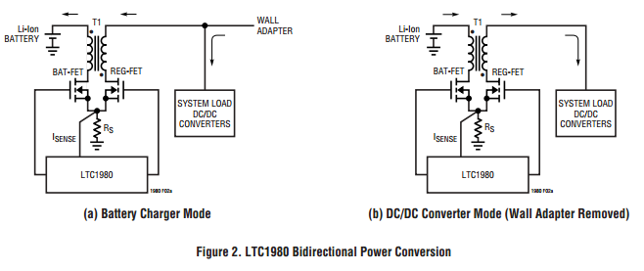
The battery management system will take an input voltage from 3-10V and use it to power the system at the desired voltage via a DC/DC converter/regulator in addition to charging the batteries. When the wall power is removed, the system load will still be able to receive power. This part can be found on the Linear Technologies website for $5.36.

Hand Crank

The hand crank will act as the second of our power inputs that will charge the battery when the system is not connected to the wall. The hand crank charger will consist of a DC motor and hand crank with possible gear assembly that will allow the kinetic power from turning the crank to be converted into electrical power. For our design, we have plan on using a 7.4V DC Motor similar to Digi-Key part P14356-ND which costs $3.53 and some combination of plastic gears and a foldable plastic handle. The anticipated total cost of the hand crank subsystem is ~$10.

Solar Cell

The solar cell will act as one of our power inputs that will charge the battery when the system is not connected to the wall. The solar cell will do this by taking light in from the surroundings and converting it to DC power. We have tentatively chosen is a 7.56 V, 200mA solar cell from Digi-Key product number SLMD481H12-ND and it costs $30.91. In order to interface this solar cell with the charging circuit we will need some combination of diodes, resistors, and capacitors that can be hopefully found in house or ordered if need be.

USB Charger Output

The USB charger is used to charge any portable USB device such as cell phones, MP3 players, e-readers, etc. The USB charger will consist of a female USB port like Digi-Key part 151-1080-ND that cost $1.20. There will also be UART that will be a serial adapter for the USB that will allow us to send and receive data so we can monitor the device. The UART we can use a part like Digi-Key part 768-1008-1-ND which costs $4.50.

Screen

The screen will consists of a single or several lines of 7-segment LEDs placed adjacently to each other or 16x2 LCD display. The microcontroller will be used to control the screen. The screen will display the time, current location, radio frequency, or outputs of other functions implemented through the microcontroller. Whether we decide to use the 7-segment or LCD display the cost of the screen should be no more than $20.00.

User Interface

A control panel can be built to include all the buttons, switches, knobs, displays and a hand crank. The user interface should allow the user to turn on/off the subsystems and to tune the speaker volume and radio frequencies. The exact words “On” and “Off” should be visible to the user near the switches. A frequency range should be visible around the radio tuning knob to show the user which way to go. The direction to apply the hand crank (clockwise or counterclockwise) should be indicated near the hand crank if the direction matters.

Open Questions

Audio System
It is not yet apparent how frequency and volume will be controlled in the radio. Ideally these will be controlled by the user through the microcontroller.

Power System
Although we have identified a battery management system that is able to handle charging and running the system from a wall input of 3V to 10V we are unsure if this will also allow for the input of a solar cell or hand crank at ~7.5V to also work seeing that the input would not always be constant seeing that the solar cell and hand crank will not always be providing power and are variable.

User Interface

It remains an open question whether all the switches, buttons, knobs and displays can be placed together on a single platform to ease usage. If not, then either the user is held responsible to recognize different switches/buttons/knobs for their corresponding functions, or the exact words such as “Radio” or “Flashlight” should be marked at proper spots to guide the user.

Major Component Costs
The table below depicts our anticipated costs. Numbers below represent maximum projected costs. Actual costs may be lower.

Radio | Cost:
IC AM/FM Radio | $1.36
3.5mm output jack | $1.34
3.5mm input jack | $2.58
Speaker | $5.00
Power
Batteries | $6.98
Solar Cell | $30.91
Hand crank | $10.00
USB Female Port | $1.20
UART | $4.50
Battery Management System | $5.36
GPS
GPS Navigation unit/device | $67.99
LED flashlight subsystem
LED’s | $10.00
Screen
LCD | $20.00
Additional Costs
Board | $50.00
Housing and Miscellaneous Parts | $50.00
Total Costs | $267.22
Total Budget | $500
Funds Remaining | $232.78

Conclusions
This project requires interplay of a number of complex systems in order to function properly. The range of topics touched upon in our design include semiconductor physics, power systems, electronic displays, signal processing, and programming. Our design attempts to reduce such complex systems to a maximally simple interface for our users. The philosophy behind our design is that in an emergency, a person shouldn’t have to struggle with an interface, they should simply feel safe.
Our device isn’t only for emergencies. A functional radio and speaker system, as well as an LED flashlight make it a handy device for use around the house. Charging a cell phone with our solar charger will also save the user money on electricity. Our user should never feel like it’s the wrong situation to use our device, it should be useful at all times.
Our Heroes

References
Figure 1: AM/FM Radio diagram
AM/FM Radio Kit Assembly and Instruction Manual. Elenco Electronics, Inc. 150 Carpenter Avenue Wheeling, IL 2010
Figure 2: LTC1980 Bidirectional Power Conversion
Linear Technology - LTC1980 - Combination Battery Charger and DC/DC Convertor Spec Sheet, Page 9.

