Final Report: Camera Controls Group
Electrical Engineering Senior Design
May 6, 2008

G. Hippleheuser
B. Marek
B. McMeel
C. Motsinger
T. Ngo

1 Introduction 3
2 High-Level Project Description 4
2.1 Problem Statement 4
2.2 System Requirements 4
2.3 Solution 6
2.4 Deviations from Original Design 7
2.5 Success of the Project 8
3 System Level Project Description 8
3.1 System Block Diagrams 8
3.2 System Theory of Operation 9
4 Detailed Subsystem Design and Operation 11
4.1 Wiring Board Microcontroller 11
4.2 Laser Circuit 18
4.3 Motorized Lens Control 21
4.4 Pan/Tilt Unit Control 25
4.5 Power Circuit 28
4.6 Host PC Software GUI 29
4.7 UBOX USB/Network Interface 30
5 System Integration Testing 30
6 Users Manual 30
6.1 Users Manual/Installation Manual (General system) 30
6.2 Users Manual/Installation manual (GUI) 31
7 Conclusions 34
8 Appendixes 35
8.1 References/Datasheets (Organized by Subsystem) 35
8.2 Semester’s Project File 37
8.3 Complete Board Schematic 43
8.4 Board Layout 45
8.5 Controller Board Bill of Materials 46
8.6 MATLAB GUI Code Listing 47
8.7 Wiring Board Microcontroller Software Listing 76

Introduction
The field of robotics has a very diverse nature, which gives rise to a variety of specific applications which yield unique constraints on the functionality of the system. Uses range from mobile vehicles to fixed arms, which are commonly used in industry for a multitude of manufacturing and assembly tasks. Traditionally, a robotic arm has been controlled by a method of teach-repeat, which is achieved by predefining the exact positions of the tool or end-effecter as it moves around a fixed work piece. This is often seen in automotive factories where the precise location and orientation of a car frame at a given time is known and used for spot welding. While this method is effective for mundane tasks, a certain degree of flexibility is lost.
To make a robotic arm more versatile, a current research trend is to use vision-based control systems. This allows for the robotic manipulator to interact with the environment without knowing the orientation or location of a work piece beforehand. One method involves processing images from a camera array in order to locate the position of the end-effecter with respect to a work piece. This information is then used to visually guide the servo motors to a desired pose. In order to realize the full capabilities of a robotic arm, a minimum of two cameras are necessary to allow the 3-dimensional world to be mapped into a 2-dimensional camera space. Additional cues for these Camera Space Manipulation (CSM) techniques are provided by either a single laser spot or a multiple laser spot field. One of the main benefits of CSM is that it is accomplished with uncalibrated cameras, greatly reducing the cost and sensitivity of implementing such a system.

Current research at The University of Notre Dame, under the direction of Dr. Steven B. Skaar, implements CSM to control a robotic manipulator for various tasks. The present setup has been successful in a number of applications, but is still limited in number of ways. Research has been restricted to the lab where the cameras are mounted to the ceiling and controlled by a dedicated computer, making testing of CSM techniques for mobile applications difficult. The CSM setup in the lab also has a reliance on outdated technology.

For the purpose of this project we propose to provide a new interface to the camera array for carrying out Dr. Skaar's CSM research, which will be both open source and platform independent. We believe that the current setup can be simplified, while increasing functionality and adaptability. While the primary intent of this project is to enable a more robust and cost effective solution for CSM in an integrated package, we believe that other areas would benefit from such a system as well.

High-Level Project Description

Problem Statement
One of the main drawbacks of the camera setup as its stands is its reliance on outdated technology. The CSM lab uses analog cameras which are connected to a frame grabber card on a dedicated computer. The frame grabber converts the analog signals from the cameras into a digital file to be processed further in software. The end result is a black and white digital photo. While the still achieved via these cameras are sufficient for current applications, the trend in cameras is decidedly away from analog units. As this style of camera becomes less easily available, the labs reliance on them will become increasing problematic because of availability and cost. It also excludes Dr. Skaar’s research group from taking advantage of new advances in digital cameras.

In addition to using outdated cameras, the lens currently being used in the lab are better suited for personal photography than for vision based controls. The issue is not with the amount of zoom and the ability to focus; both are well suited for the room. Instead, both functions have to be operated manually by twisting the physical lens apparatus. This is not practical for cameras mounted in the ceiling, especially since the entire system is intended to be manipulated by a user sitting at the lab PC. As a result, the advantages of a zoom lens are being underutilized.

Another issue is the amount of dedicated hardware required in the current system. Each camera is mounted onto a pan/tilt unit (PTU) for positioning, which interfaces with the computer through a serial port connection. A laser device is also mounted on a PTU, which are interfaced to the computer to control orientation. Currently, the lab is set up for 3 PTUs and two laser pointers. This setup each component being individually hooked up to the computer is clearly no the most efficient. Not only are serial connections becoming increasingly unavailable on new computers, but few would have multiple ports for control of more than one PTU. It is also redundant to have the hardware set up this way, since the control signals are the same for all the units.

Lastly, another consequence of the dedicated connections to the lab PC is that the system has limited accessibility. A user must be on that specific computer, and the equipment is only available to one person at a time. The set-up as it stands has no real avenue to become mobile. Since a portion of Dr. Skaar’s research is developing a vision control digging rover for remote recovery, it is clear that this is a technological option that is important to the future of his work.

System Requirements
Both the final design and the development process were driven by a limited budget, with a hard cap of $500 being provided by the course, and an understanding that the additional funding for equipment provided by Dr. Skaar should be reasonable considering the value added to his lab. Therefore the first step in developing system requirements was to make a general determination of what components of the current system should be kept, and what needed to be replaced.

The cameras existing in the lab are analog black and white cameras, with the pictures being converted to digital for the computer’s use via a frame grabber. Since there is such a strong trend towards digital cameras in what is being developed and brought to market, it was decided to focus our system around using more modern digital cameras. However, given the huge expense it would require to replace all cameras, as much as possible we would make our developed software backwards compatible with the old cameras so the new technology could be phased in slowly without losing the functionality of the lab.

In contrast, we decided to keep the Pan-Tilt units. The main reason for this was that there was no problem in the preformed functionality of the PTUs; they moved just as they needed to. Instead, the issue was the serial ports required by the PC to control them. It would have been extremely expensive to replace the unit merely for the sake up updating the interface. Instead, it was decided to utilize the one of the many options in serial conversion chips to update the signal variety presented to the computer while retaining the actual equipment. In addition, looking at other PTUs available showed that the serial interface is still very common, so designing our system around it would not create equipment limitations in the near future.

Additional equipment available in the lab was the laser pointers and the lab PC. Both functioned well in there respective applications, so we did not see any reason to replace either.

Once these basic equipment determinations are made, the system requirements are directly tailored to solving the problem outlined above. First and foremost, we wanted to update and simplify the interface of the hardware and the computer. To accomplish the first of these goals, we decided to convert as many of the connections as possible to USB, which is by far the protocol most used in computer peripheral development. Because of its plug-and-play design, using USB makes new equipment easy to install and use. To simplify, we wanted to route as much of the equipment as possible to a single connection to the computer. The nature of how the system is used lends itself well to this, since it is controlled by a single person who only manipulates one piece of equipment at a time.

Once the system is updated, the next step was to look at how to improve overall functionality. One way this was done was to include on our board the ability for the user to manipulate a motorized zoom/focus lens that could be utilized easier than the lenses currently in the lab. A second way was to allow the system to be used remotely; thereby increasing the possible directions that Dr. Skaar’s research could go. To accomplish this, control of our board needed to be available on to a computer to which it is not directly connected. In addition, it is desirable to keep as much of the software and hardware the same, no matter if it is being directly or remotely used. This will reduce the cost of the system, as well as making it easier to use. So the design needed a way to break all hardwired connections into the computer and substitute a form of remote communication.

Overarching all of the specific requirements was an understanding that this system was being designed for a mechanical engineering research group whose needs and requirements will change over time. With that in mind, the system should be as transparent as possible, especially from the hardware side. The board is designed so the needed components can be plugged in and the developed software used with little or no hardware modification needed at run time. In addition, both hardware and software needs to be as non-peripheral specific as possible, i.e. a variety of lasers, cameras and PTUs should be useable with minimal changes to the system itself. Also, changes that are needed should rely most heavily on software changes, which are cheaper and easier to accomplish. The software itself will be open-source, and utilize library style function commands, making it flexible for a variety of applications.

Solution
As outlined above, a major part of our project is creating way for multiple peripherals to connect to the computer and be controlled by a single USB port. To accomplish this, we created a printed circuit board to act as a common port for the laser pointers, PTUs, and lens motors. The heart of this board is the microcontroller. It acts as the point of connection for control of all the attached equipment, taking in signals via a USB port, converting them to serial, and interpreting the commands into proper manipulation of Digital Input/Output (DIO) pins and pulse-width modulation (PWM) pins.

The remainder of the hardware is on a board that plugs into the microcontroller, thus getting access to all of its pins. The board provides on/off power to the laser pointers, with connections for up to four lasers. To control the PTUs, the microcontroller takes in commands that indicate the unit to move, and what value. The needed serial signals are then multiplexed to the proscribed PTU’s serial port after first going through a line driver which converts the logic level signals to RS-232 serial. For the motorized lens, control is provided for three motors, allowing it to manipulate a lens with motorized zoom, focus, and iris.

For the imaging, two different types of USB digital cameras were tested: commercially available webcams and a high resolution camera development board available from a CMOS sensor manufacturer. Both can easily be used by just connecting them to the host PC via the USB ports to be recognized and pull up their own drivers. Utilizing the plug-and-play nature of USB yields a lot of flexibility in the choice of camera, allowing one to be chosen based on cost and the need of the application at hand.

The other major design component was the software resident on the host PC. It provides a graphical user interface (GUI) that allows the user to manipulate the various system components. The GUI was created in MATLAB because of the ease that language provides in manipulating images and imaging devices. Clicking buttons and slider bars creates commands which are either sent directly to the cameras or to the microcontroller. The software to control the microcontroller is designed around an open-source library of alpha-numeric commands which specify the hardware component and parameters such as speed or position. The cameras are controlled using the image-acquisition toolbox available in MATLAB.

To make the system mobile, it must be possible to access the controller board and the cameras without needing them to be directly connected to the computer’s USB ports. To achieve this, a piece of hardware called the UBOX was purchased. It is specifically designed to broadcast USB peripherals over a network, allowing any connected computer access. To make the system truly mobile, it is possible to attach a wireless router to the UBOX, allowing use of the system in places where a wired network connection is not readily available. The limiting feature of this system is that the UBOX can only handle full speed isochronous transfers, which are the type most commonly used by imaging devices. Thus users of the system are precluded from using high-speed USB cameras, which tend to have a higher resolution. However, for most mobile applications, lower resolution will likely be sufficient.

Deviations from Original Design
It is interesting to note here some significant changes made from the low-level design submitted last December. Control of a motorized lens was not included in the original design, but rather was added this semester after talking further with Dr. Skaar about his research needs. Also, the programming language of the host GUI was originally going to be C++ or Java. This was changed to MATLAB because of these ease it provided in manipulating the images and the cameras themselves through the image acquisition library. This toolbox greatly simplified the task of create software that could interface any attached imaging device. It is relatively easy to translate between MATLAB and C++/Java, so the GUI could be converted if the need arose, and it has been easy to translate programs already used by Dr. Skaar’s research group.

The major change in our design is how the cameras are accessed and the hardware for making the system mobile. The original plan was to include the cameras on our designed board, so that the image data and control signals could be bundled into as single interface with the microcontroller. The hardware used was a chip called Matchport, provided by Lantronix. This chip had two serial ports that it broadcasted over an ethernet jack and a wireless 802.11 radio, providing both a wireless and hardwired option for controlling the system. To control the cameras and pass on image data to one of the serial ports, we intended to use a chip called the Vinculum, which acted as the host driver for the USB protocol, and could convert the USB to serial signals.

This plan eventually had to be abandoned for two reasons. First, the Vinculum was not well designed to handle isochronous transfers, which how most digital cameras transmit image data. So while the control endpoint could be accessed as expected, we were not able to get images off of the camera via this chip. Also, the Matchport was designed to appear to Windows as two virtual com ports. While the scheme was successful for passing data back and forth, it precluded Windows from recognizing the camera as imaging devices and pulling up the proper drivers to allow our software access to them. Attempts to modify the driver to recognize a COM port proved unsuccessful. Since it was our desire to create a system that was easily modified by Dr. Skaar’s research group, we elected to instead purchase hardware that was specifically design to achieve what we wanted – the UBOX for broadcasting USB devices over the network. The downside of this method is that the cameras need to be connected to the UBOX directly and thus cannot be included on our board. Also, the UBOX currently limits the speed of the camera’s transfers. Still, this was deemed the best solution we could achieve to meet our design requirements.

Success of the Project
We came into this project with four main design requirements: update the hardware, simplify the interface, yield an option for greater mobility, and make the system easy to use and modify. Our system meets all of those requirements. We have begun to phase in the use of digital USB cameras to replace the older, analog units. Also, control of serial-pan/tilt units, lens motors, and the laser pointers can be achieved over a single USB connection to our board. The UBOX allows both the main controller board and certain USB cameras to be accessed remotely over the network. The software GUI can interface a variety of cameras, both the MATLAB code and the code resident on the microcontroller can be easily modified to adapt to hardware changes should the PTUs be changed in the future. Also, the design of our command library, which dictates how commands are sent from the host PC to the microcontroller, is straightforward and easily adapted to use with other GUIs and to accommodate hardware changes. We have already had success in integrating some of the programs currently used by Dr. Skaar’s research group into our GUI.

There are two main shortcomings of our system from what we hoped to achieve. First, we were not able to simplify down to a single interface for the entire system. Instead, the cameras still need to be attached separately to either the host PC or the UBOX, and cannot reside on our controller board. Second, the nature of UBOX limits remote cameras to slower, lower resolution versions. However, discussions with Dr. Skaar on the needs of his group indicate that these limitation wills will not prevent our system from being a useful addition to his lab.

System Level Project Description

System Block Diagrams
Figure 1: Functional Block Diagram
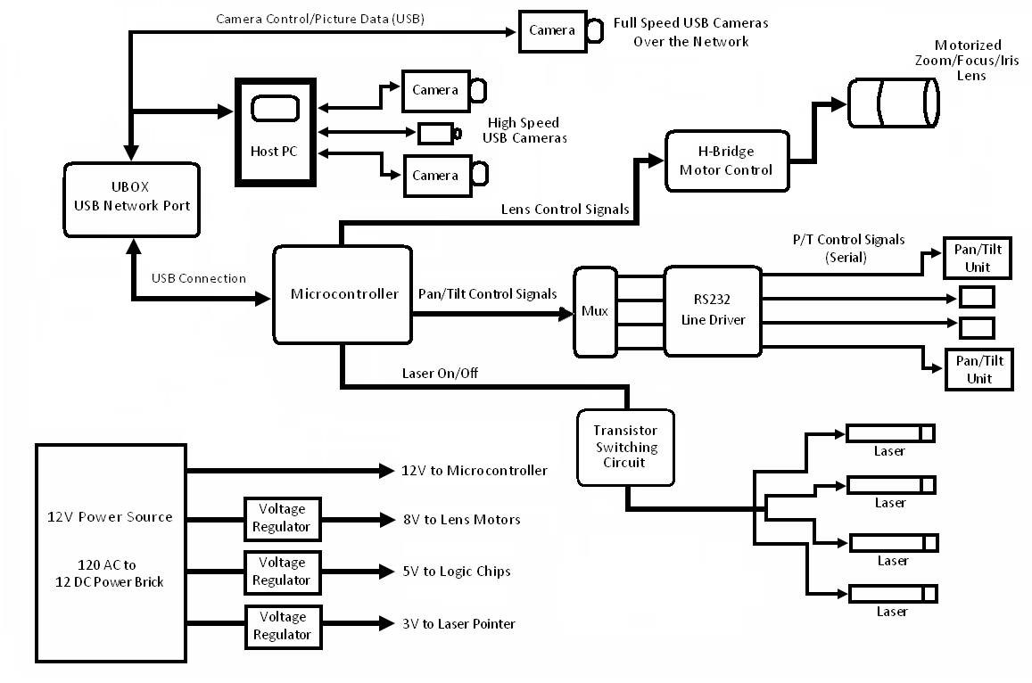

System Theory of Operation
The heart of our project is a controller board that allows multiple peripherals to connect to the host PC and be controlled by a single USB port. A printed circuit board, which rest atop of our microcontroller, acts as a common port for the laser pointers, PTUs, and lens motors.

The microcontroller board controls command routing between the host and attached devices. It takes in these commands via a USB connection on its development board. This connection is hardwired to the microcontroller development board and also provides a dedicated means for programming and troubleshooting. The signals are then converted to serial and sent to one of two dedicated serial ports on the microcontroller itself. Commands are alphanumeric and contain both a hardware identifier and relevant parameters such as the desired speed for controlling the motors, or a location if manipulating one of the PTUs. Once received, the microcontroller interprets these commands into the necessary pin settings.

The remainder of the control hardware is resident on the second board that plugs into the microcontroller. Female connectors allow the two to be easily connected and disconnected. Control of the laser pointers is achieved by utilizing the DIO pins on the microcontroller to switch NMOS transistors on and off, providing the lasers a connection to ground. One digital pin is necessary for each laser. Currently, Dr. Skaar’s lab is using one single and one multiple spot laser, both mounted to a common PTU.

The board also provides DB-9 serial connections for up to 4 PTUs. The microcontroller receives commands in the format described above, and rebroadcast them over a second hardware serial line in the format needed by our specific PTU. The TX line is run through a multiplexer (mux), and the RX line though a demultiplexer (demux), which allows one serial line to control all four PTU lines. Two additional DIO pins act as selector bits to determine which physical serial port the signals will be routed to. After the mux/demux, the commands are run through line-driver circuitry to convert them from logic to RS-232 levels.

To improve the quality of the photos taken, the board allows for control of a motorized lens. The lens we selected has motorized zoom, focus, and iris. Operation is very straightforward electronically. An applied voltage of +/-8V to any of the motors will turn them counter-clockwise/clockwise. They are driven using a chip that acts as a full H-bridge to convert logic signals to the DC voltages required. The microcontroller manipulates two bits per motor to select one of four modes: stationary, forward, reverse, or braking. In addition, the dedicated PWM pins on the microcontroller are tied to enable pins on the chip, and varying the duty cycle controls the speed of motor operation.

For actually taking the pictures, a variety of USB digital cameras can be used with the system: commercially available webcams and a high resolution camera development board available from a CMOS sensor manufacturer were both tested. They are connected to the PC via the USB ports, which allows them to be recognized and pull up their own drivers. Utilizing the plug-and-play nature of USB yields a lot of flexibility in the choice of camera, allowing one to be chosen based on cost and the needed of the application at hand.

The other major design component was the software resident on the host PC. It provides a graphical user interface (GUI) that allows the user to manipulate the various system components. The GUI was created in MATLAB because of the ease that language provides in manipulating images and imaging devices. Clicking buttons and slider bars creates commands which are either sent directly to the cameras or to the microcontroller. The software to control the microcontroller is designed around and open-source library of alpha-numeric commands which specify the hardware component and parameters such as speed or position. The cameras are controlled using the image-acquisition toolbox available in MATLAB.

To make the system mobile, it must be possible to access the controller board and the cameras without needing them directly connected to the computer’s USB ports. To achieve this, a piece of hardware called the UBOX was purchased. It is specifically designed to broadcast USB peripherals over the network, allowing any connected computer access. To make the system truly mobile, it is possible to attach a wireless router to the UBOX, allowing use of the system in places were a network connection is not readily available. The limiting feature of this system is that the UBOX can only handle full-speed isochronous transfers, where are the type most commonly used by imaging devices. Thus users of the system are precluded from using high-speed USB cameras, which tend to have a higher resolution. However, for most mobile applications lower resolution will likely be sufficient.

Lastly, the power circuit will provides all the necessary DC voltages to the board. The controller platform will be powered externally by a 12V DC supply. The 12V is directly used to power the microcontroller. Voltage regulators will then cut this down into 8V to power the lens motors, 5V for the logic chips, and 3.3V to power the laser pointers.

Detailed Subsystem Design and Operation

Wiring Board Microcontroller
4.1.1 Microcontroller Functionality
The microcontroller acts as the main driver of the controller board. It is responsible for controlling the laser pointers, pan/tilt units, and motorized lens. It takes in serial commands from the host GUI and translates them to properly control attached hardware. The serial commands are generated by the user when they use the software resident on the host PC. These are transmitted to the microcontroller via a USB connection. The instructions sent are alphanumeric, and contain a hardware identifier to denote what component is being manipulated. They also contain information as to what action is required, such as on or off for the laser pointers, the pan/tilt position values, speed of the lens motor, etc. The microcontroller carries them out by setting its pins to the proper logic values, or in the case of the PTU units, by broadcasting serial commands.

4.1.2 Microcontroller Hardware Design
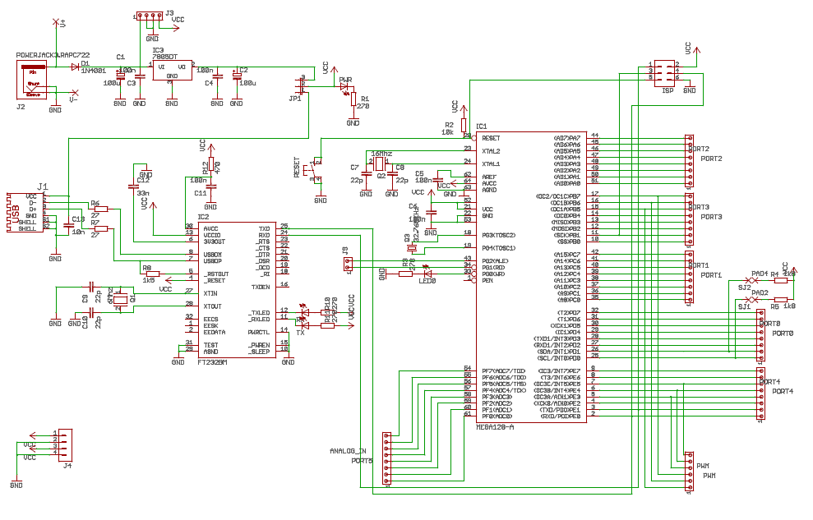
Figure 2: Microcontroller Schematic

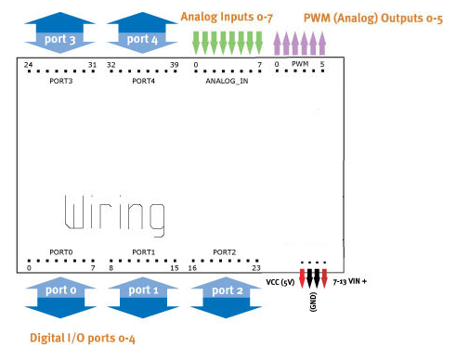
The microcontroller we will be using is the Wiring development board. It operates on the Atmel ATMega128 microcontroller and is powered over either a USB connection or an external 7-12V DC source. It can store 128k in memory for user created programs. It also has as a USB interface connected via a USB-to-serial converter to a hardware serial port on the chip that acts as an external programmer and debugger. The USB jack on the board is a USB B female connector.

The microcontroller has various types of available IO, which are arranged physically on the development board by functional. In total, there are 42 digital IO pins. Pins 0-39 are organized in groups of 8 on Ports 0-4. In addition, pins 49 and 50 are also DIO. There are also 8 Analog input pins and 6 PWM output pins available. Lastly, there are two hardware serial lines, one tied to the USB to serial converter, and the other free for other uses. This array of IO allows for control of multiple devices in various applications.

We chose this microcontroller because of the ease of using the development board. It came with pin out connections to all the IO pins, which was very useful during prototyping. Also, it is both programmed and controlled via USB, which is the interface we had chosen for all peripherals that would connect to the PC. There was an abundance of available I/O pins, giving us the flexibility to add features to our project, just as the lens control was added second semester. Two dedicated hardware serial ports allowed us to easily listen to the host PC with one port, and broadcast serial commands to the PTUs on the other. Lastly, the programming is done in a very straightforward C/C++ style library. There were simple sample program and functions available for all our application needs: control of motors, control of DIO, and reading/writing to the serial ports.

Since we continued to use the wiring development board in our final project, there was little additional hardware needed for the functionality of the microcontroller itself. To interface the board our group designed, which contained the remainder of the hardware for controlling attached components, we had the microcontroller sit atop of our board, connected via female headers that allowed the development boards pin outs to be plugged directly in. The remainder of the task was to determine the type and number of pins needed. Below is a description of pin usage.
Table 1: Pin Usage of the Wiring Development Board
Pin | Connected To | Functional Usage
DIO 2  (Serial1 RX) | 74LS151 (MUX)  Pin 5 | RX line connected to the muxed RX lines for all 4 possible PTUs.
DIO 3  (Serial1 TX) | 74LS38 (DEMUX)  Pin 4,5 | TX line connected to joint input pins to demuxed TX lines for all 4 possible PTU’s
DIO 5 | 74LS151 (MUX)  Pin 9 | Chip select C for multiplexer (MSB)
DIO 6 | 74LS151 (MUX)  Pin 10 | Chip select B for multiplexer
DIO 7 | 74LS1510 (MUX)  Pin 11 | Chip select A for multiplexer (LSB)
DIO 15 | SN754410(2)  Pin 15 | Direction select 4A for motorized iris son lens
DIO 16 | SN754410(2)  Pin 10 | Direction select 3A for motorized iris on lens
DIO 18 | SN754410(1)  Pin 15 | Direction 4A select for motorized zoom on lens
DIO 19 | SN754410(1)  Pin 10 | Direction 3A select for motorized zoom on lens
DIO 21 | SN754410(1)  Pin 7 | Direction select 2A for motorized focus on lens
DIO 22 | SN754410(1)  Pin 2 | Direction select 1A for motorized focus on lens
DIO 24 | Q1 Gate | On/Off control of laser 1
DIO 25 | Q2 Gate | On/Off control of laser 2
DIO 26 | Q3 Gate | On/Off control of laser 3
DIO 27 | Q4 Gate | On/Off control of laser 4
DIO 37 | 74LS151 (MUX)  Pin 3 | Chip select bit C for demultiplexer (MSB)
DIO 38 | 74LS151 (MUX)  Pin 2 | Chip select bit B for demultiplexer
DIO 39 | 74LS151 (MUX)  Pin 1 | Chip select bit A for demultiplexer (LSB)
PWM 3 | SN754410(2)  Pin 8 | Act as a speed control PWM signal for motorized focus on lens
PWM 4 | SN754410(1)  Pin 8 | Act as a speed control PWM signal for motorized zoom on lens
PWM 5 | SN754410(1)  Pin 1 | Act as a speed control PWM signal for motorized iris on lens

Summary of Microcontroller Pin Usage:
Total Pins: 21
Serial Pins: 2 (Rx/Tx)
General DIO: 16
Analog Output/PWM: 3

For more detail on the interconnection and use of the microcontroller with attached components, please see hardware section for the respective subsystems.

4.1.3 Microcontroller Software Design
The main purpose of the microcontroller software is to listen for command to come in over the USB port and interpret from those commands the proper pin setting to control the attached hardware. The commands from the host PC contain a hardware identifier to denote what component is being manipulated. They also contain information as to what action is required, such as on or off for the laser pointers, the pan/tilt position values, speed of the lens motor, etc. Every command ends with the character X. This was necessary because the microcontroller takes in data over the serial line one character at a time, thus a character line deliminator was needed. Below is listing of the command library to the microcontroller.

Table 2: Listing of Serial Microcontroller Commands
Hardware ID | Component | Serial Commands | Function
A  B  C  D | PTU 1  PTU 1  PTU 3  PTU 4 | PP*X | Pan PTU to the location specified by *; possible values are [3000,-3000]
A  B  C  D | PTU 1  PTU 1  PTU 3  PTU 4 | TP*X | Tilt PTU to the location specified by *; possible values are [100,-1000]
A  B  C  D | PTU 1  PTU 1  PTU 3  PTU 4 | PPX | Home PTU to the pan position of 0
A  B  C  D | PTU 1  PTU 1  PTU 3  PTU 4 | TPX | Home PTU to the tilt position of 0
E | Laser 1 | 0X | Turn Laser 1 off
E | Laser 1 | 1X | Turn Laser 1 on
F | Laser 2 | 0X | Turn Laser 2 off
F | Laser 2 | 1X | Turn Laser 2 on
G | Laser 3 | 0X | Turn Laser 3 off
G | Laser 3 | 1X | Turn Laser 3 on
H | Laser 4 | 0X | Turn Laser 4 off
H | Laser 4 | 1X | Turn Laser 4 on
L | Lens | ZI*X | Zoom in at speed *; possible values are [0, 1023]
L | Lens | ZO*X | Zoom out at speed *; possible values are [0, 1023]
L | Lens | ZKX | Kill the zoom motor
L | Lens | FI*X | Focus near at speed *; possible values are [0, 1023]
L | Lens | FO*X | Focus far at speed *; possible values are [0, 1023]
L | Lens | FKX | Kill the focus motor
L | Lens | II*X | Open iris at speed *; possible values are [0, 1023]
L | Lens | IO*X | Close iris at speed *; possible values are [0, 1023]
L | Lens | IKX | Kill the iris motor
T | Onboard LED | 0X | Turn onboard LED off
T | Onboard LED | 1X | Turn onboard LED on

Commands to the microcontroller are created by combining the hardware ID and the desired serial command. To pan PTU 3 to 500, the command CPP500X would be sent over the serial; to turn laser 1 on, the command E1X; to zoom out at a speed of 600, LZO600X.

The microcontroller programmed to listen to the Serial line (the hardware serial connected to the USB port) until there is data available. It then begins a function call tree that determines the needed pin settings to carry out the command. A high level look at the software flow and a listing of all functions are below.
Figure 3: Microcontroller Software Flowchart
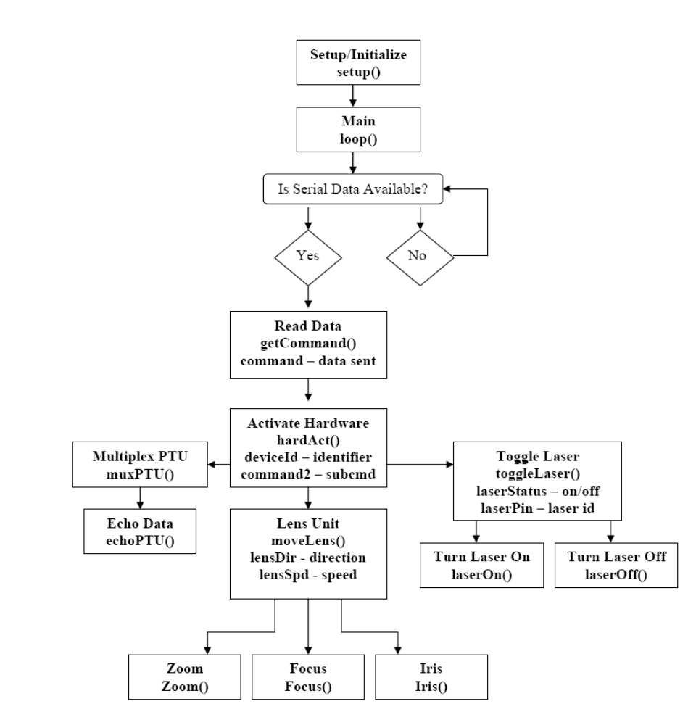
Table 3: Summary of Functions
Function Name | Task
setup() | Appropriately names and initializes all pins
loop() | Checks to see if data is on the serial port.
getCommand() | Reads the serial port appending each character to a command string. Executes hardAct() function on escape character ‘X’ otherwise returns to loop if no valid command sent.
hardAct() | Called after serial command is received. Sets first character into deviceID variable and everything else into command2 string. Then determines requested hardware and calls the appropriate functions.  PTU → muxPTU(), echoPTU()  Lens → moveLens()  Laser → toggleLaser()
muxPTU() | Called by hardAct() if a PTU was requested. Sets the chip select bits appropriately on the mux/demux chips to access the proper PTU
echoPTU() | Called by hardAct() if a PTU was requested;  Strips command data for PTU specific  command. Echoes command over the Serial1  line to the PTU.
moveLens() | Called by hardAct() if the Lens was requested; Sets lensDir and lensSpd values from command2. Determines motor, direction, and speed requested and calls either zoom(), focus() or iris().
Zoom() | Based on the value of lensDir, manipulates the direction select pins for the zoom motor control. Sends a PWM signal to the enable pin of the motor control chips whose duty cycle reflects the desired speed.
Focus() | Based on the value of lensDir, manipulates the direction select pins for the focus motor control. Sends a PWM signal to the enable pin of the motor control chips whose duty cycle reflects the desired speed.
Iris() | Based on the value of lensDir, manipulates the direction select pins for the focus motor control. Sends a PWM signal to the enable pin of the motor control chips whose duty cycle reflects the desired speed.
toggleLaser() | Checks laserStatus value, calls either laserOn() or laserOff()
laserOn() | Sets the proper DIO pin high to turn on the requested laser
laserOff() | Sets the proper DIO pin low to turn off the requested laser

A complete software listing for the Wiring board microcontroller can be found in Appendix 8.7. Further details on the control of individual devices can be found in the following subsystem sections.

4.1.4 Interface with Other Subsystems
As mentioned above, the main input-communication interface to the microcontroller is a USB connection to the host PC. The board follows standard USB protocol as far as enumeration and communication with the necessary endpoints. The device appears to windows as a USB serial port, and is handed as such on the software end. This is because the hardware actually accessed by the computer is a FTDI USB to serial conversion chip resident on the development board. This chip was responsible for converting the USB signals to logic level serial commands that it then forwarded to the Atmel ATMega microcontroller.

On the output side, the microcontroller communicates with attached hardware through its output pins. The digital IO and dedicated serial lines are all logic level (5V, 0V).

4.1.5 Microcontroller Functionality Testing
Given the ease of use and reliability of the microcontroller, often just integrated system testing was performed with each software revision. However, when problems arose, the verification of the microcontroller itself was preformed as follows

- Verified that microcontroller is properly powered off of either USB or the external power jack, and that the power jumper was placed correctly to indicate the source.
- Ensured that there were no stray wires misconnecting output pins
- Connected output serial lines (those that would normally interface the PTUs) to a DB-9 serial connector that comes with a logic level to RS-232 conversion chip.
- Connected this serial port to the computer using a USB serial chord.
- Opened a connection to the input USB serial port using HyperTerminal. This is the USB port on the Wiring board, that connects to the microcontroller via an FTDI chip
- Opened a connection to the output USB serial port using HyperTerminal. This is the port that would normally connect to the PTUs.
- Sent serial commands from the library to the microcontroller.
- For the DIO pins, ensured that the proper voltage level (5V, 0V) was achieved using a digital multimeter.
- For the echoed serial commands to the PTU, ensured that the proper characters were passed through
- Where applicable in the code, look for feedback on the input serial port. This was been written into to ensure the function tree was called correctly.

Laser Circuit
4.2.1 Laser Circuit Functionality
Laser pointers are used as visual cues in a number of Dr. Skaar’s vision based algorithms. In the current setup, they are mounted on a dedicated PTU, and can be used to mark points in space around the robotics, providing mobile visual cues.

Our board provides a way to control up to four lasers. By reading the specifications on the main lasers used in the lab, we discovered they ran off of 3.3V. However, we wanted to leave a future option of to use higher powered pointer such as multiple spot lasers. To allow for flexibility, we provided a variety of voltage hookups. Two of the laser jacks are hooked up to the 3.3V power source, one is 5V, and the other is 8V.
Table 4: Voltages Provided by the Laser Ports
Laser | Voltage Provided
1 | 8V
2 | 5V
3 | 3.3V
4 | 3.3V

For all jacks, the negative terminal is attached to a transistor that is turned on and off by the Wiring board, thus opening and closing a connection to ground. This allows the lasers to be remotely controlled through the board.

4.2.2 Laser Circuit Hardware Design
Figure 4: Laser Circuit Schematic
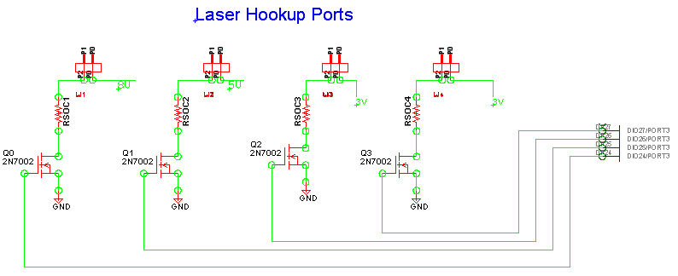

Each laser port is actually a two pin female header to which the power leads from the laser can be connected. The positive terminal is hooked up to either a 3.3V, 5V, or 8V source provided by a regulator. The negative terminal is connected through a current limiting resistor to the drain of an NMOS transistor. The gate is connected to a DIO pin on the microcontroller and the source is connected to ground. When the DIO pin is high at 5V, the transistor is on and a connection to ground is provided, turning on the laser. When the pin is low at 0V, the transistor is off and there is insufficient current through the laser to turn on.

The pins on the microcontroller used to control the laser are as follows:
Table 5: Laser Circuit Microcontroller Pins
Pin | Connected To | Functional Usage
DIO 24 | Q1 Gate | On/Off control of laser 1 (8V)
DIO 25 | Q2 Gate | On/Off control of laser 2 (5V)
DIO 26 | Q3 Gate | On/Off control of laser 3 (3.3V)
DIO 27 | Q4 Gate | On/Off control of laser 4 (3.3V)

For the lower voltage ports, the choices for components were designed around the laser actually being used by Dr. Skaar’s lab. Specifications showed that this laser (Part number VM 63513) could handle 2.8 – 4.0 VDC at a current of 50-85mA. We chose a standard voltage of 3.3V because it was near the center of the laser’s range, and regulators were readily available for this for this voltage.

For the transistor, a NMOS 2N7000 was used because it was readily available, could easily handle the necessary current, functioned well during prototyping. For the final board, a 2N7002 was used, which is the surface mount version of the 2N7000. However, both parts had similar electrical characteristics.

Lastly, a resistor value was chosen to limit the current through the laser. Because it was difficult to know the on resistance of the transistor and the resistance of the laser itself, the value of the resistor was determined experimentally. The value was originally 470Ω, since assuming no other resistances at 3.3V, this would yield a current of 70mA. However, because other resistances were non-negligible, this was not sufficient to visibly light the laser. The resistance was finally reduced to 10Ω to achieve the brightness desired. Because this resistor value is highly dependent on the laser used, through hole resistors were used as opposed to surface mount. This way, they can be easily swapped out should the laser used change.

4.2.3 Laser Circuit Software Design
The software used to control the lasers is resident on the microcontroller, and thus is described in detail section 4.1.3 and listed in Appendix 8.7. The microcontroller receives commands to turn the laser on or off over its USB serial line, and knows control the laser circuit when it receives a hardware ID of E-H. The following value of 1 or 0 determines if the laser will be switched on or off.
Table 6: Laser Serial Commands
Hardware ID | Component | Serial Commands | Function
E | Laser 1 | 0X | Turn Laser 1 off
E | Laser 1 | 1X | Turn Laser 1 on
F | Laser 2 | 0X | Turn Laser 2 off
F | Laser 2 | 1X | Turn Laser 2 on
G | Laser 3 | 0X | Turn Laser 3 off
G | Laser 3 | 1X | Turn Laser 3 on
H | Laser 4 | 0X | Turn Laser 4 off
H | Laser 4 | 1X | Turn Laser 4 on

All the software has to accomplish to carry out these commands is switch the DIO pin associated with requested laser high or low.

4.2.4 Interface with Other Subsystems
The laser interfaces with the microcontroller, the power circuit, and the attached lasers. The microcontroller is responsible for switching the transistors, so their gates are electrically tied to DIO pins. The positive outputs on the laser ports are connected to the regulator which provides the proper voltage for that jack though traces on the board. The lasers are physically connected to the circuit via female headers soldered to the laser ports.

4.2.5 Laser Circuit Functionality Testing
The motor circuit was tested as follows:
- Provided power to the board via the 12 DC power brick
- Ensured microcontroller was disconnected from board
- Tested to ensure all positive terminals were showing appropriate voltages
- Tested to ensure all negative terminals were attached to ground
- Attached an LED with an appropriately sized resistor to LJ1.
- Attached a 5V logic on IDL logic board to appropriate pin connector for Laser 1 (DIO 24), i.e. attached a switch to where microcontroller control pin would normally plug into the board
- Created common ground connection between IDL and board
- Flipped logic switch and ensured LED turned on and off appropriately
- Repeated for other laser ports
- Attached Microcontroller
- Created a serial connection to the microcontroller via hyperterminal
- Sent serial commands to turn the laser on and off and ensure the LED responded accordingly
- Repeated test with laser hooked to ports to ensure overall functionality.

Motorized Lens Control
4.3.1 Lens Circuit Functionality
A feature that was added to Dr. Skaar’s lab through this project was control of a motorized zoom, focus and iris lens. The old lens in the lab had to be adjusted by hand, which was not practical for camera mounted in the ceiling. The new lens, an 8-48 mm focal length ½” lens purchased from Computar, has DC motors to control the lens characteristics. The lens is adjusted by applying +/- 8V to its motors. The purpose of the motor circuit is to allow the microcontroller to send these voltages to determine the direction of movement, and also control the speed of the motor for course and fine adjustment.

4.3.2 Lens Circuit Hardware Design
Figure 5: Lens Circuit Schematic
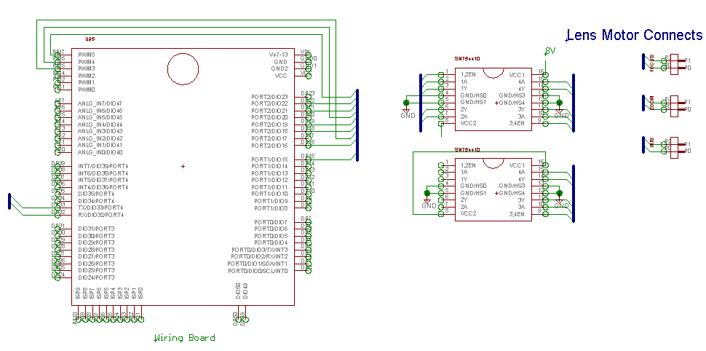
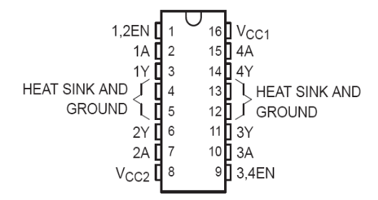
The main component of the lens motor circuit is the SN751140 Quad Half H driver chip. This IC was chosen because it is readily available, easy to use, and “smokeless,” i.e. no accidental combination of inputs will cause the chip to burn out. Each side of chip can be wired as to full H-bridge, allowing the chip to apply both positive and negative voltages. Since there are three motors in total, 2 chips were need for our board.
Figure 6: SN751140

Each side of the chip controls a single motor, and each motor has three control inputs: an enable and 2 separate A pins. These are connected to the microcontroller. There are also 4 total heat sink/ground pins which are tied into ground on the board. A VCC pin on each side is connected to the desired output voltage source; for the computer lens this is the 8V regulator. The two Y pins on each side of the chip act as the outputs and are connected to the terminal of the motors.

The chip can only power the motor when the enable is high; otherwise the output is high impedance. Once the enable pin is set, voltage is determined by the two A control pins.
Table 7: Logic Table for the Left Side of the SN751140 chip
Inputs |  |  | Outputs |  | Voltage output
1,2 EN | 1A | 2A | 1Y | 2Y | Voltage output
0 | X | X | Z | Z | Z
1 | 0 | 0 | 0 | 0 | 0V
1 | 0 | 1 | 0 | 1 | -8V
1 | 1 | 0 | 1 | 0 | +8V
1 | 1 | 1 | 1 | 1 | 0V

The logic table is the same for the 3,4EN and the 3A, 4A inputs.

Because the motor can only be moved when the moved when the EN pin is high, this input provides a method for speed control. These pins are connected to PWM pins on the microcontroller, and the duty cycle of the applied signal is increased and decreased to increase and decrease the speed of the motor.
Table 8: Lens Circuit Microcontroller Pins
Pin | Connected To | Functional Usage
DIO 15 | SN754410(2)  Pin 15 | Direction select 4A for motorized iris son lens
DIO 16 | SN754410(2)  Pin 10 | Direction select 3A for motorized iris on lens
DIO 18 | SN754410(1)  Pin 15 | Direction 4A select for motorized zoom on lens
DIO 19 | SN754410(1)  Pin 10 | Direction 3A select for motorized zoom on lens
DIO 21 | SN754410(1)  Pin 7 | Direction select 2A for motorized focus on lens
DIO 22 | SN754410(1)  Pin 2 | Direction select 1A for motorized focus on lens
PWM 3 | SN754410(2)  Pin 8 | Act as a speed control PWM signal for motorized focus on lens
PWM 4 | SN754410(1)  Pin 8 | Act as a speed control PWM signal for motorized zoom on lens
PWM 5 | SN754410(1)  Pin 1 | Act as a speed control PWM signal for motorized iris on lens

All that remains is to properly attach the lens to the circuit’s output ports.
Table 9: Motorized Lens Connections
Motor Port | Computar Cable Color | Cat-5 Color | SN754410 Connection
Focus Far | Green | Green | Chip 1, Pin 3 (1Y)
Focus Near | Black | Striped Green | Chip 1, Pin 6 (2Y)
Zoom Wide | Yellow | Orange | Chip 1, Pin 14 (4Y)
Zoom Tele | Red | Striped Orange | Chip 1, Pin 11 (3Y)
Iris Close | White | Brown | Chip 1, Pin 14 (4Y)
Irish Open | Brown | Stripped Brown | Chip 1, Pin 11 (3Y)

Ports are label on the board, with solid wire always placed to the right when reading text.

4.3.3 Lens Circuit Software Design
The software used for the lens is resident on the microcontroller, and thus is described in detail section 4.1.3 and listed in Appendix 8.7. The microcontroller receives commands to turn the laser on or off over its USB serial line, and knows control the lens circuit when it receives hardware ID of L. It then appends the rest of the command to determine the direction and the speed required. The appropriate pins are then set high, and the PWM signal created. The microcontroller will continue to move the motor until it receives the appropriate kill command.
Table 10: Lens Circuit Serial Commands
Hardware ID | Component | Serial Commands | Function
L | Lens | ZI*X | Zoom in at speed *; possible values are [0, 1023]
L | Lens | ZO*X | Zoom out at speed *; possible values are [0, 1023]
L | Lens | ZKX | Kill the zoom motor
L | Lens | FI*X | Focus near at speed *; possible values are [0, 1023]
L | Lens | FO*X | Focus far at speed *; possible values are [0, 1023]
L | Lens | FKX | Kill the focus motor
L | Lens | II*X | Open iris at speed *; possible values are [0, 1023]
L | Lens | IO*X | Close iris at speed *; possible values are [0, 1023]
L | Lens | IKX | Kill the iris motor

4.3.4 Interface with Other Subsystems
The laser interfaces with the microcontroller, the power circuit, and the attached lens. The microcontroller is responsible for providing the control inputs, so those pins are electrically tied to DIO pins and PWN pins. The VCC pins are connected to the 8V regulator. The lasers are physically connected to the circuit via female headers soldered to the output ports.

4.3.5 Lens Circuit Functionality Testing
The Lens circuit was tested as follows:
- Provided power to the board via the 12 DC power brick
- Ensured microcontroller was disconnected from board
- Checked to ensure VCC pins were receiving 8V from the regulator
- Attached 5V logic switches of an IDL logic board to the control inputs for the left side of the first motor chip.
- Created common ground connection between IDL and board
- Ensured that the motor port outputs showed no voltage while the EN was set low, no matter what the two A inputs were set at
- Set enable to high. Ensured that setting the pins to 01 produced - 8V at the motor outputs, and 10 produced + 8V, and 00 produced 0V. Checked that 11 did not damage the chip
- Repeated for the other two motor control H-bridges.
- Attached Microcontroller
- Created a serial connection to the microcontroller via hyperterminal
- Attached the lens and pulled up a live video feed of the attached camera
- Sent serial commands manually over hyperterminal to manipulate the lens. Ensured that it responded accordingly.
- Ensured that lens was not damaged when it reached its limitations but a voltage was still applied.

Pan/Tilt Unit Control
4.4.1 Pan/Tilt Circuit Functionality
In order for both the laser and the camera to be able to move they are attached to both pan and tilt units. These units are designed such that they are able to take a serial command for a location then subsequently move to that location. Our circuit allows four pan and tilt units to be connected. These connections allow both the transmission and reading of serial commands for sending commands and receiving feedback from the controller board built into the pan tilt unit.

4.4.2 Pan/Tilt Circuit Hardware Design
Figure 7: PTU Circuit Schematic
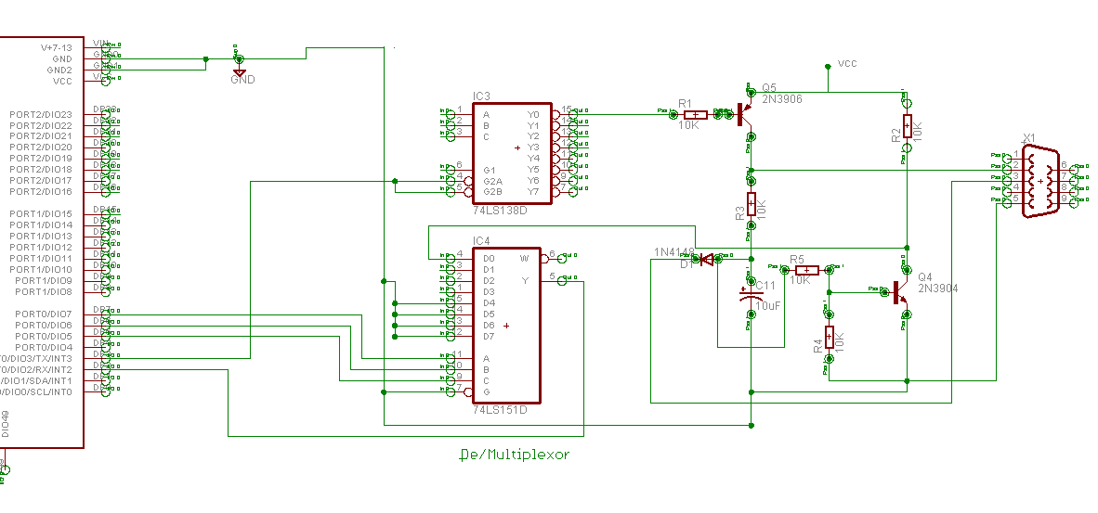
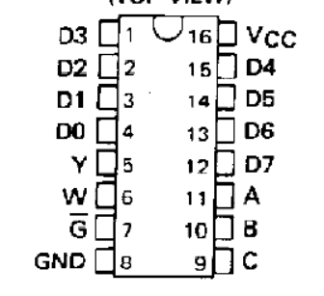
In order control four different serial ports with a single hardware serial line, it was necessary to demultiplex the Tx signal and multiplex the Rx signal also from the microcontroller. For the mux, a surface mount 74LS151D from Texas Instruments was used. This chip takes in the Rx line as its Y input. It then will direct it to D0-D7 depending on the values of the selector bits A, B, and C, which are connected to the microcontroller. Our circuit has outputs D0-D3 connected to PTU ports 1-4.
Figure 8: 74LS151 Mux
Table 11: Logic Table for 74LS151 Multiplexer
Inputs |  |  |  | Outputs
Selects |  |  | Strobe  G | Y | W
C | B | A | Strobe  G | Y | W
X | X | X | H | L | H
0 | 0 | 0 | L | D0 | */D0
0 | 0 | 1 | L | D1 | /D1
0 | 1 | 0 | L | D2 | /D2
0 | 1 | 1 | L | D3 | /D3
1 | 0 | 0 | L | D4 | /D4
1 | 0 | 1 | L | D5 | /D5
1 | 1 | 0 | L | D6 | /D6
1 | 1 | 1 | L | D7 | /D7
* / here stands for bar, or the opposite of the D value

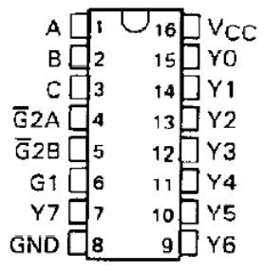
For the demux, the IC chosen was a 74LS138, also from TI. The TX line is connected to the two pin output G2A/G2B. It then will direct the output to follow Y0-Y7 depending on the values of the selector bits A, B, and C, which are connected to the microcontroller. Out circuit has inputs Y0-Y3 connected to PTU Ports 1.
Figure 9: 74LS138

Table 12: Logic Table for 74LS138 Demux
Inputs |  |  |  |  | Outputs
Enable |  | Select
G1 | G2 | C | B | A | Y0 | Y1 | Y2 | Y3 | Y4 | Y5 | Y6 | Y7
X | 1 | X | X | X | 1 | 1 | 1 | 1 | 1 | 1 | 1 | 1
0 | X | X | X | X | 1 | 1 | 1 | 1 | 1 | 1 | 1 | 1
1 | 0 | 0 | 0 | 0 | 0 | 1 | 1 | 1 | 1 | 1 | 1 | 1
1 | 0 | 0 | 0 | 1 | 1 | 0 | 1 | 1 | 1 | 1 | 1 | 1
1 | 0 | 0 | 1 | 0 | 1 | 1 | 0 | 1 | 1 | 1 | 1 | 1
1 | 0 | 0 | 1 | 1 | 1 | 1 | 1 | 0 | 1 | 1 | 1 | 1
1 | 0 | 1 | 0 | 0 | 1 | 1 | 1 | 1 | 0 | 1 | 1 | 1
1 | 0 | 1 | 0 | 1 | 1 | 1 | 1 | 1 | 1 | 0 | 1 | 1
1 | 0 | 1 | 1 | 0 | 1 | 1 | 1 | 1 | 1 | 1 | 0 | 1
1 | 0 | 1 | 1 | 1 | 1 | 1 | 1 | 1 | 1 | 1 | 1 | 0

Table 13: Microcontroller Pins for the PTU Circuit
Pin | Connected To | Functional Usage
DIO 2  (Serial1 RX) | 74LS151 (MUX)  Pin 5 | RX line connected to the muxed RX lines for all 4 possible PTUs.
DIO 3  (Serial1 TX) | 74LS38 (DEMUX)  Pin 4,5 | TX line connected to joint input pins to demuxed TX lines for all 4 possible PTU’s
DIO 5 | 74LS151 (MUX)  Pin 9 | Chip select C for multiplexer (MSB)
DIO 6 | 74LS151 (MUX)  Pin 10 | Chip select B for multiplexer
DIO 7 | 74LS1510 (MUX)  Pin 11 | Chip select A for multiplexer (LSB)
DIO 37 | 74LS151 (MUX)  Pin 3 | Chip select bit C for demultiplexer (MSB)
DIO 38 | 74LS151 (MUX)  Pin 2 | Chip select bit B for demultiplexer
DIO 39 | 74LS151 (MUX)  Pin 1 | Chip select bit A for demultiplexer (LSB)

From there we used a line driver to convert the logic level serial signal into compatible 232 voltages. To communicate over the serial port, it is necessary to invert and amplify the serial signal from the microcontroller to the EIA-232 standard. Since the PTU can read a +/-5V signal, it is not necessary to amplify up to the full +/- 12V. The circuit utilized the amplification characteristics of the PNP 3906 transistor and the NPN 3904 transistor.

4.4.3 Pan/Tilt Circuit Software Design
The software used to control the lasers is resident on the microcontroller, and thus is described in detail section 4.1.3 and listed in Appendix 8.7. The microcontroller receives commands to control the PTUs over its USB serial line, and they are requested when it receives a hardware ID of A-D. TP or PP determines if a pan or a tilt is requested, and the following numeric value specifies the position.

Hardware ID | Component | Serial Commands | Function
A  B  C  D | PTU 1  PTU 1  PTU 3  PTU 4 | PP*X | Pan PTU to the location specified by *; possible values are [3000,-3000]
A  B  C  D | PTU 1  PTU 1  PTU 3  PTU 4 | TP*X | Tilt PTU to the location specified by *; possible values are [100,-1000]
A  B  C  D | PTU 1  PTU 1  PTU 3  PTU 4 | PPX | Home PTU to the pan position of 0
A  B  C  D | PTU 1  PTU 1  PTU 3  PTU 4 | TPX | Home PTU to the tilt position of 0

Upon received the command, the microcontroller sets it select pins for both the mux and demux to route the signals to and from the correct PTU. For PTU1, the inputs are set at binary 0, for PTU 2 and binary 1, etc. Since the TP and PP alphanumeric commands are actually interpreted by the PTU’s own controller, the Wiring only needs to echo them out over the dedicated PTU serial line.

4.4.4 Interface with Other Subsystems
The laser interfaces with the microcontroller, the power circuit, and the PTUs. The microcontroller is responsible for providing the control inputs and the serial lines, so those pins are electrically tied to DIO pins and Rx/TX. The logic chips and the line driver are tied to the 5V regulator output. The PTUs are physically connected to the circuit via female DB-9 connectors soldered to the board.

The only interface that makes use of a standard is the output to the PTU controllers. These signals follow the EIA-232 (also called the RS-232) standard. This standard stipulates characteristics such as voltages level and signal timing. Logic 1 is defined as a negative voltage and logic 0 is positive voltage, though the actual voltage value varies depending on what is available. Common levels are +/-5V, +/-10V, +/-12V; the hardware is rated up to 25V. Our circuit uses +/-5V, since the PTU’s are designed to detect voltages of that range. The standard also defines the slew rate, or the time to switch between voltage levels, no matter the transmission speed.

The standard also defines a standard hardware pinot arrangement so that all devices can properly connect to each other. Since our board acts as a data terminal device (DTE), the pinout definitions are as follows for a DB-9 connector
Signal | Abbr. | Direction | Pin
Common Ground | G | - | 5
Transmitted Data | TX | Out | 3
Received Data | RX | In | 2
Data Terminal Ready | DTR | Out | 4
Data Set Ready | DSR | In | 6
Request to Send | RTS | Out | 7
Clear to Send | CTS | In | 8
Carrier Detect | DCD | In | 9
Ring Indicator | RI | In | 1

However, our PTU’s do not require hardware control, so we use the minimum “3-wire” RS-232 connection of just GND, RX and Tx.

Things the standard does not define are the character set, bit rate transmission (though standard baud rates are common), or character framing. These are defined by the needs of the individual device. For our PTU’s, the ASCII character set is used, and the rate of transmission is 9600 baud.

4.4.5 Pan/Tilt Circuit Functionality Testing
The pan/tilt circuit was tested as follows
- Used the IDL to simulate the logic selector controls from the microcontroller for both the demux and multiplexor to ensure proper pathways were created between the actual serial ports and the microcontroller.
- Used a function generator to ensure that a varying signal could be sustained when selected by the microcontroller. During an initial test of the circuit it was noted that a power line was not inserted in the line driver circuit and thus limited our test results. By using a power source in the lab and simulating its presence we were able to adjust by inserting jumpers in our current circuit to properly reflect the working circuit in the diagram above.
- Measured the output of the line driver with an oscilloscope to ensure that the line driver was properly converting from logic to RS-232 level.
- Attached the microcontroller Rx/TX pins to the board, and also common ground.
- Attached a USB serial cable to PTU port 1.
- Opened up hyperterminal communication to both the Wiring board and the USB serial cable
- Used logic selects to chose PTU 1 on the mux and demux.
- Wrote commands to the microcontroller and ensured that they were echoed back properly to over the USB serial terminal
- Repeated test for other PTU ports

Power Circuit
4.5.1 Power Circuit Functionality
The purpose of the power circuitry is to provide proper voltages to all other subsystems resident on the board. The main power is provided by an AC/DC 12V power brick that runs off of a wall socket, and plugs into the board via a power jack. This voltage was chosen because the microcontroller is run off of 7-13V external power. However, different modules required different voltages: 8V to the lens circuit, 5V to the PTU circuit, and 3.3V to the laser circuit. Therefore, three separate voltage regulators are used to cut down the 12V.

4.5.2 Power Circuit Hardware Design
Figure 10: Power Circuit Schematic
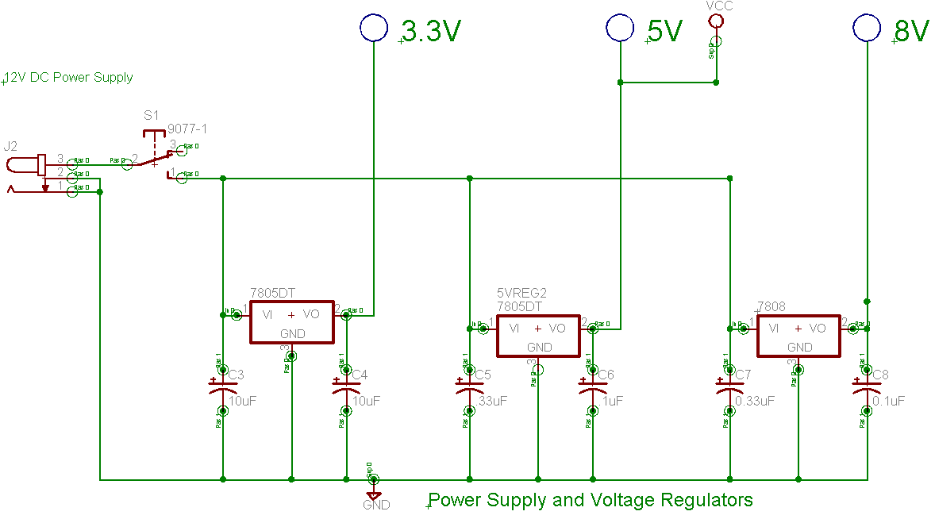
The design of the power circuit is very straightforward. The initial 12V from the brick is fed in through power and ground lines. The 12V line goes through a switch, allowing power to the board to be turned on and off without physically disconnecting the power jack.

The 12V is then fed to three separate regulators to cut down the voltage; a LP2905 3.3V regulator, a 7805 5V regulator, and a 7808 8V regulator. Capacitors are used to cut down ripple on the inputs and outputs, and are sized according to the individual regulators specifications.

4.5.3 Interface with Other Subsystems
The power circuit is electrically connected to the other subsystems in order to provide the proper voltages: 8V to the lens circuit, 5V to the PTU circuit, and 3.3V to the laser circuit.

4.5.4 Power Circuit Functionality Testing
The power circuit was tested as follows:
- Power was provided to the board via the 12V supply
- The inputs of the regulators were tested to insure they were receiving 12V.
- The outputs were tested to ensure they were providing the proper voltage
- All regulators were touch tested for overheating.

Host PC Software GUI
4.6.1 Software Functionality
The software GUI was implemented to give the user an easy way to interface with the functions developed for our system. Matlab was chosen to create the GUI because Matlab can perform image processing easily and can easily send serial messages. The GUI enables the user to input values and then observe the effects of these values. However, if the user is interested in using the functions multiple times, then it may be quicker to create a script with the included functions instead of using the GUI.

4.6.2 Software Design
Each time the user interfaces with a component of the GUI, whether it is a push button, a slider, or a radio button, a callback function is executed. These callback functions are predominantly the created functions, which in turn communicate with the microcontroller (full GUI code can be found in Appendix 8.6.)

Table 14: Listing of MATLAB FUNCTIONS
Script Name | Functionality
maincontrol.m | Main GUI Script
focus.m | Focuses the lens in or out
iris.m | Opens or closes the iris of the lens
zoom.m | Zooms the lens in or out
closeserial.m | Closes an open serial object
laserX.m | Toggles laser X on or off (X is from 1-4)
openserial.m | Opens a serial object
pancmd.m | Sends the command to pan the PTU
tiltcmd.m | Sends the command to tilt the PTU
purgeserial.m | Purges the data on the serial port to the Matlab command window

4.6.3 Interface with Other Subsystems
The GUI interfaces with the microcontroller through the created functions. These functions take the user-inputted data and format them into a message. Those strings are then sent serially to the microcontroller. Upon receipt of the message, the microcontroller can then process and execute the desired command. Essentially, the GUI is a gateway for the user into the system.

4.6.4 Software Functionality Testing
The functionality of the software was tested by having the microcontroller send data across the serial connection. This data was read from the serial port using the functions, and was then displayed on the Matlab command window. If the data received was the expected response, then the GUI functioned correctly.

UBOX USB/Network Interface
The UBOX was not designed for our project; instead, it was purchased from Lantronix. The UBOX makes whatever USB peripherals attached available over the network that the UBOX is connected to. Thus, it interfaces with the devices and the user; however its effect is transparent if working properly. Currently for our system, a full speed USB camera and the microcontroller are connected to the UBOX, thus allowing us to access them remotely.

The UBOX 2100 version was chosen because it can support high speed USB and full speed isochronous video transfers, allowing it to interface lower resolution cameras. It also can power the USB devices attached, with a maximum of 500mA to each port. In addition, the UBOX 2100 is specified to support full speed and high speed hubs, should more than one camera be needed.
The UBOX was tested as a system by installing the UBOX software and then connecting to it via the network. If the attached devices are detected by Windows, then the UBOX functioned correctly.

System Integration Testing
Since our system design yielded relatively autonomous subsystems, it was very straightforward to integrate the system as a whole. All the interfaces between the subsystems were tested during subsystem testing: communication between the PC and the microcontroller, between the microcontroller and the attached circuitry, and between the circuits and the attached hardware.

To ensure the system as a whole worked end to end, the microcontroller and a full speed webcam were attached to the UBOX and accessed over the network. The lens was mounted on one of the CDC cameras still physically attached to the host PC. The microcontroller was then attached to our controller board, which had the lens, laser pointers, and PTUs attached.

The overall functionality of controlling the devices with the GUI was then tested. We ensured that live feed could be received from both the networked and directly attached cameras, and that snap shots were taken. The lasers were turned on and off via selector boxes. The PTUs were moved, and we checked that all four PTU ports could run the device. Using the live feed off of the CDC camera, we checked that the lens responded correctly to the GUI commands at different speeds. The whole system was verified through visual inspection of functionality.

Users Manual

Attaching Hardware to the Controller Board
Figure 11: Photo of Controller Board
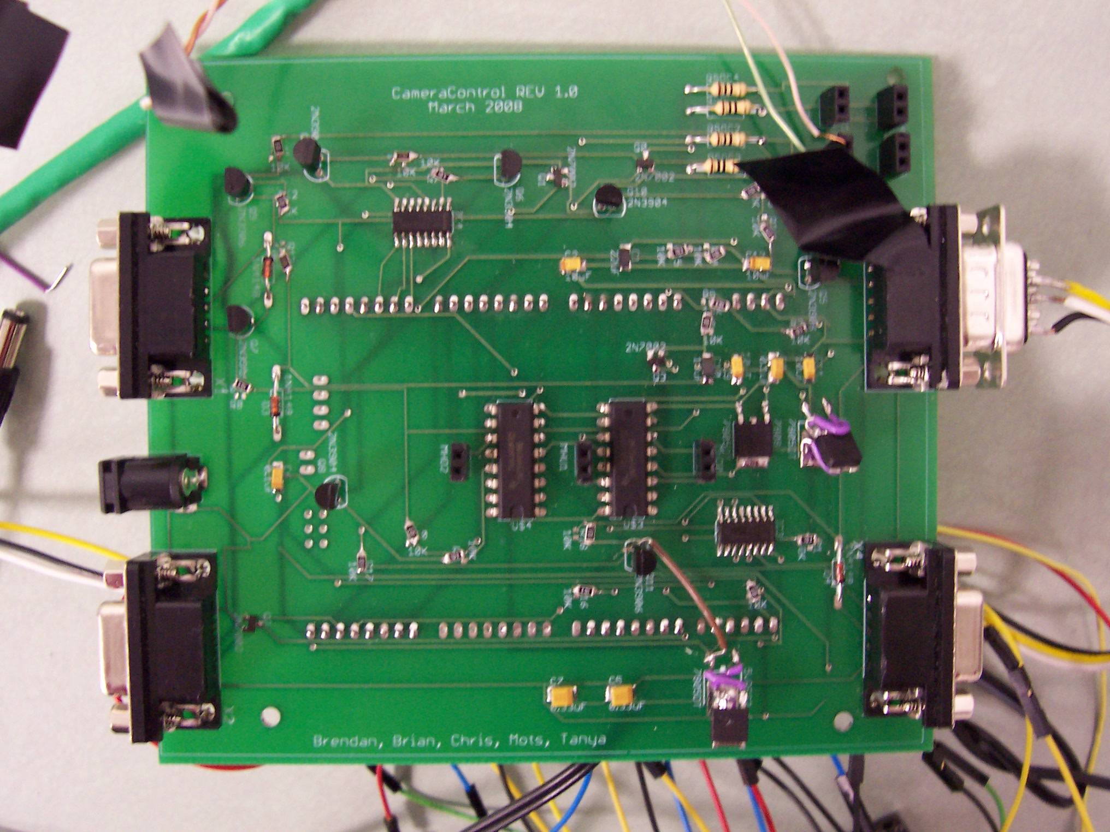
Serial Ports
Power Jack
Motor Controllers and Ports
Laser Ports
Wiring Board
(Underneath)

The photo above shows the physical location on the board of all the device hookups needed to use the board. The 12V power brick is plugged into the provided jack, the PTU controllers are plugged into the serial ports, and the microcontroller is plugged in vie female headers located on the bottom of the board. There are also female headers provided for plugging in the lasers, with +/- labeled on the board. The lens is also hooked up via labeled female headers.

Table 15: Voltages Provided by Laser Ports
Laser | Voltage Provided
1 | 8V
2 | 5V
3 | 3.3V
4 | 3.3V

Table 16: Lens Connections
Motor Port | Computar Cable Color | Cat-5 Color | SN754410 Connection
Iris Close | White | Brown | Iris Port, Right Side
Iris Open | Brown | Striped Brown | Iris Port, Left Side
Zoom Wide | Yellow | Orange | Zoom Port, Right side
Zoom Tele | Red | Striped Orange | Zoom Port, Left Side
Focus Far | Green | Green | Focus Port, Right Side
Focus Near | Black | Stripped Green | Chip 1, Focus Port, Left side

Users Manual/Installation Manual for using the UBOX
6.2.1 Installation
Our product is already installed in its final location so no further installation steps are needed. However, if the product were to be moved to another location, the installation process would be as follows. First, the user should ensure that they can connect to the UBOX from a computer using the packaged software. Next, the user should ensure they have a copy of Matlab to implement the provided functionality. Finally, the user should connect the cameras and control box to the UBOX. This is done by plugging the USB cables from the cameras and control box into the UBOX USB ports.

6.2.2 Setup
The physical setup of our product is already configured in its final state. However, to set up the product in a different location, the following process should be followed. The user should place the UBOX in a position where it within reach of a wired network as well as power. Next, the user should ensure the control box and cameras are placed within reach of the UBOX and power. Finally, the cameras and control box should be powered and connected to the UBOX as mentioned above.

6.2.3 Verification of Proper Operation
The user can tell if the product is working by checking the UBOX software. If the camera and control box are able to be connected to, then the product is working. Furthermore, the user should be able to control the connected devices over the UBOX. There are four status lights on the UBOX, and lights 2 and 3 indicate a failure somewhere within if they are orange. If these lights are on, then the UBOX should be reset by removing and then replacing the power cord.

6.2.4 Troubleshooting
Our product can be troubleshot by investigating the various components individually. If the devices connected do not appear in the UBOX software, then it is most likely a UBOX problem; the UBOX troubleshooting instructions can be found in the UBOX user’s manual. If the devices show up over the UBOX but cannot be connected to, then the user should first verify that the device is not being used by another user. If no other user is using the device, then the user should remove the device from the system and test compatibility with the user’s computer by directly connecting it. If the device is not recognized by the user’s computer, then other devices should be investigated by the user. If a problem occurs during use of the GUI, then the most likely solution would be to restart Matlab (which closes all connections to serial ports and imaging devices). If restarting Matlab does not correct the issue, then connection to the device in question should be attempted outside of Matlab (amcap.exe for cameras). If connection is unsuccessful outside of Matlab, then the device is probably not compatible with the UBOX and other alternatives should be explored.

Users Manual/Installation manual (GUI)
6.3.1 Installation and Setup
In order to use the GUI, the only required steps are to open Matlab and then run maincontrol.m. After GUI is loaded, if no errors show up in the Matlab command window, then the product is working properly.

6.3.2 Proper Use of GUI
The GUI is comprised of three tabs (screenshot of each tab shown below). In the Camera tab, the user can choose a winvideo camera (the camera for which the project was designed) by using the “Select Camera” list box. Once a camera is selected, a resolution should be selected from the “Select Resolution” list box. Once the resolution is selected, the user can view the output of the camera in the embedded window by clicking the start camera button. The brightness of the video can be changed using the “Brightness” slider. If the user wants a snapshot of the window, the “Autosave snapshot?” radio button must first be selected and a file name should be added to the adjacent text box. Once the desired filename is added in the textbox, the user can press the “Get Snapshot” button to take a snapshot named filename1.bmp. Multiple snapshots can be taken with the same file name, and a number will be appended to the end each time.

The Lens can be tested by first selecting the “Test Lens” radio button and selecting a source, which will open a separate preview window of the source. The zoom, focus, and iris can all be adjusted using the corresponding buttons with the speed of change being the “Zoom Speed” slider.
Figure 12: Camera GUI Tab
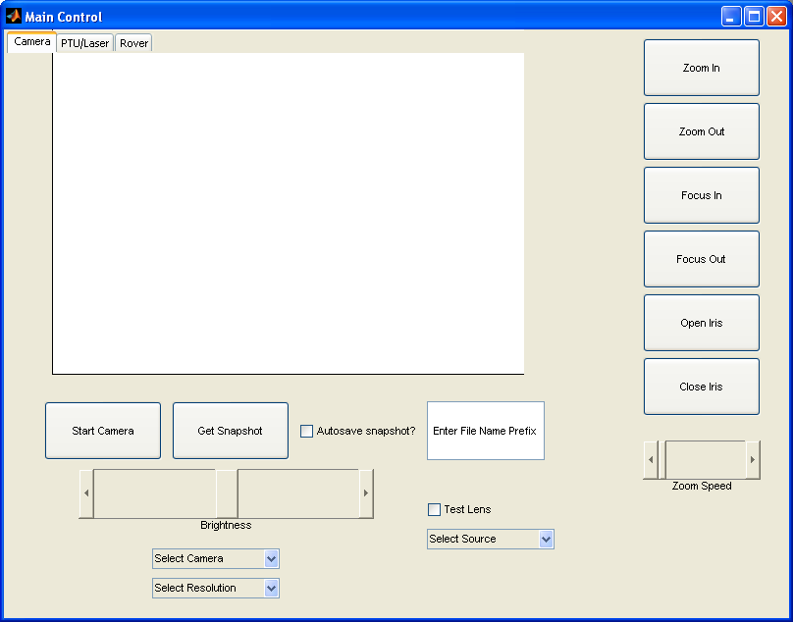

The next tab in the GUI is the PTU/Laser tab (screenshot shown below.) In order to access any of the functionality of the tab, the user must first ensure that the GUI is accessing the correct serial port, and then must click the “Push to Open Port” button. Once the serial port is successfully opened, the user can enter pan and tilt values into the provided boxes and either pan, tilt or pan and tilt to the values in the box by pressing the corresponding button; the user can select the PTU to manipulate using the list box. Lasers 1-4 can be turned on or off by selecting the appropriate radio buttons. Two other buttons were added for troubleshooting: the “Purge Serial” button reads any data that may be lingering within the system and outputs it to the Matlab command window, and the “Home PTU” button returns the PTU to it’s home coordinates (0,0.)
Figure 13: PTU/Laser GUI Tab
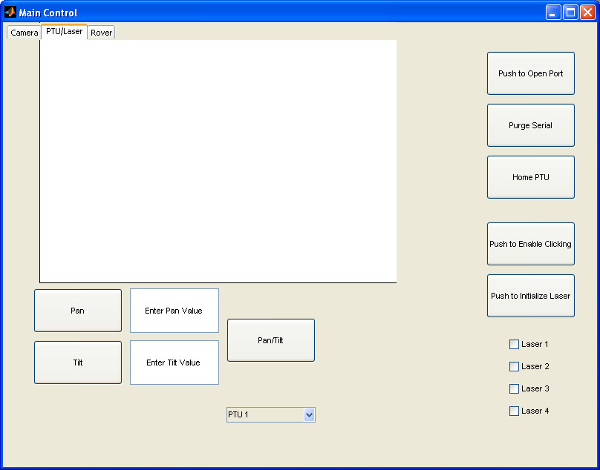

The final tab in the GUI is the Rover tab. This is not within the scope of our project, and was formulated by Dr. Skaar’s research group. However, it does demonstrate the compatibility of our system to the current setup.

Figure 14: Rover GUI Tab
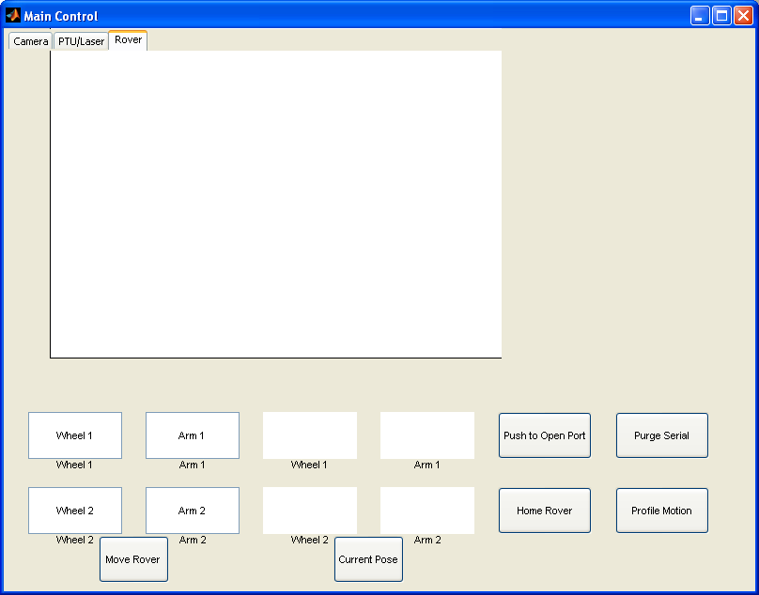

6.2.3 Troubleshooting
The user can troubleshoot the GUI by first ensuring that the functionality that is having problems has the proper devices connected either over the network or physically to the computer. If everything is connected properly, then the user should ensure proper use of the GUI. If GUI is not desired or does not work, the Matlab functions can be made into a simple script to provide the same functionality.

Conclusions
We came into this project with four main design requirements: update the hardware, simplify the interface, yield an option for greater mobility, and make the system easy to use and modify. Our system meets all of those requirements. We have begun to phase in the use of digital USB cameras to replace the older, analog units. Also, control of serial-pan/tilt units, lens motors, and the laser pointers can be achieved over a single USB connection to our board. The UBOX allows both the main controller board and certain USB cameras to be accessed remotely over the network. The software GUI can interface a variety of cameras, both the MATLAB code and the code resident on the microcontroller can be easily modified to adapt to hardware changes should the PTUs be changed in the future. Also, the design of our command library, which dictates how commands are sent from the host PC to the microcontroller, is straightforward and easily adapted to use with other GUIs and to accommodate hardware changes. We have already had success in integrating some of the programs currently used by Dr. Skaar’s research group into our GUI.

There are two main shortcomings of our system from what we hoped to achieve. First, we were not able to simplify down to a single interface for the entire system. Instead, the cameras still need to be attached separately to either the host PC or the UBOX, and cannot reside on our controller board. Second, the nature of UBOX limits remote cameras to slower, lower resolution versions. However, discussions with Dr. Skaar on the needs of his group indicate that these limitation wills will not prevent our system from being a useful addition to his lab.

Appendixes

References/Datasheets (Organized by Subsystem)
Wiring Board Microcontroller
Wiring Board (microcontroller):
< http://www.wiring.org.co/hardware/index.html >
Female Headers
< http://www.sparkfun.com/commerce/product_info.php?products_id=115>

Laser Circuit
NMOS Transistor: 2N7002K
<http://www.vishay.com/docs/71333/71333.pdf>
Laser Specification
<http://www.midwest-laser.com/html/laser_diode_modules.html>

Motorized Lens Control
Motor Chip for Lens, TI SN754410
< http://focus.ti.com/lit/ds/symlink/sn754410.pdf >
Computar Lens
< http://www.cbcamerica.com/sitemap_404.cfm >

Pan/Tilt Unit Control
NPN Transistor: 2N3904
<http://www.fairchildsemi.com/ds/2N/2N3904.pdf>
PNP Transistor: 2N3906TFR
<http://www.fairchildsemi.com/ds/2N/2N3906.pdf>
10 uF Capacitors:
<http://www.kemet.com/kemet/web/homepage/kechome.nsf/vapubfiles/F3102_T491.pdf/$file/F3102_T491.pdf>
8 to 1 line Selector (Surface Mount): SN74LS151DE4
<http://focus.ti.com/lit/ds/symlink/sn74ls151.pdf>
3-8 Line Decoder (Surface Mount): 296-14883-1-ND
<http://focus.ti.com/lit/ds/sdls014/sdls014.pdf>
10K Ohm Resistors (1206 Surface):
<http://www.yageo.com/pdf/Pu-RC1206_51_PbFree_L_2.pdf>
9 Pin Serial Female Connector (Surface Mount): PRT-00429
<http://www.sparkfun.com/datasheets/Prototyping/Connectors/DB9-PCB.pdf>

Power Circuit
8V Regulator 7808:
<http://www.st.com/stonline/products/literature/ds/2143/l7805.pdf>
5V Regulator 7805: L78xx, L78xxC
<http://www.st.com/stonline/products/literature/ds/2143/l7805.pdf>
3.3 Volt Regulator
< http://www.national.com/ds/LP/LP2950.pdf >

0.33 uF Capacitor & 0.1uF Capacitor: T491Series
<http://www.kemet.com/kemet/web/homepage/kechome.nsf/vapubfiles/F3102_T491.pdf/$file/F3102_T491.pdf>

UBOX Users Manuel
<http://www.lantronix.com/pdf/UBox_UG.pdf>

These PDFs can also be seen on our twiki website:
https://twiki.cse.nd.edu/twiki/bin/view/Main/CameraControlGroup

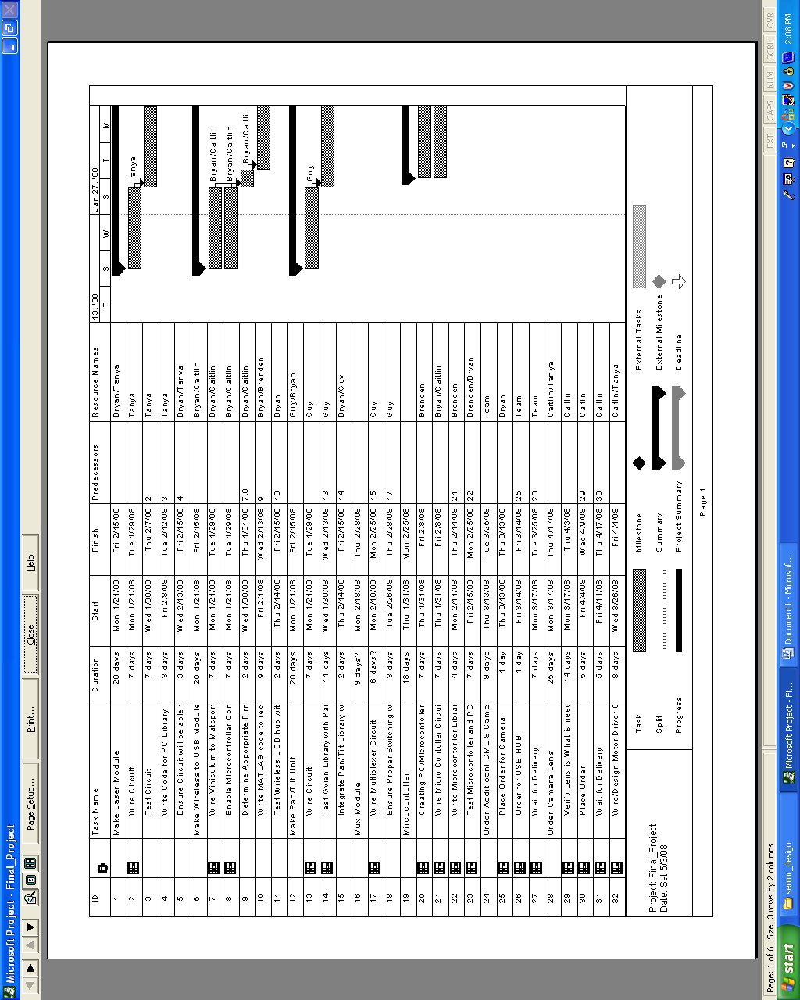
Semester’s Project File
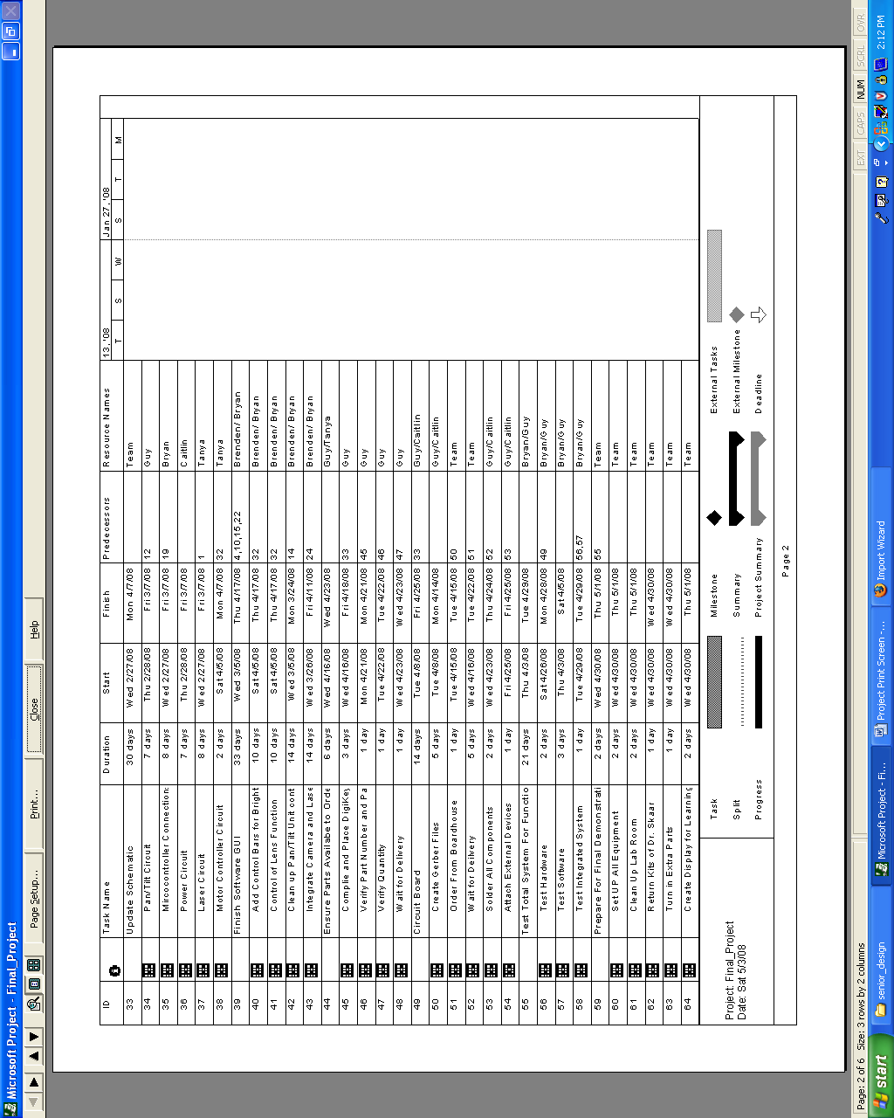
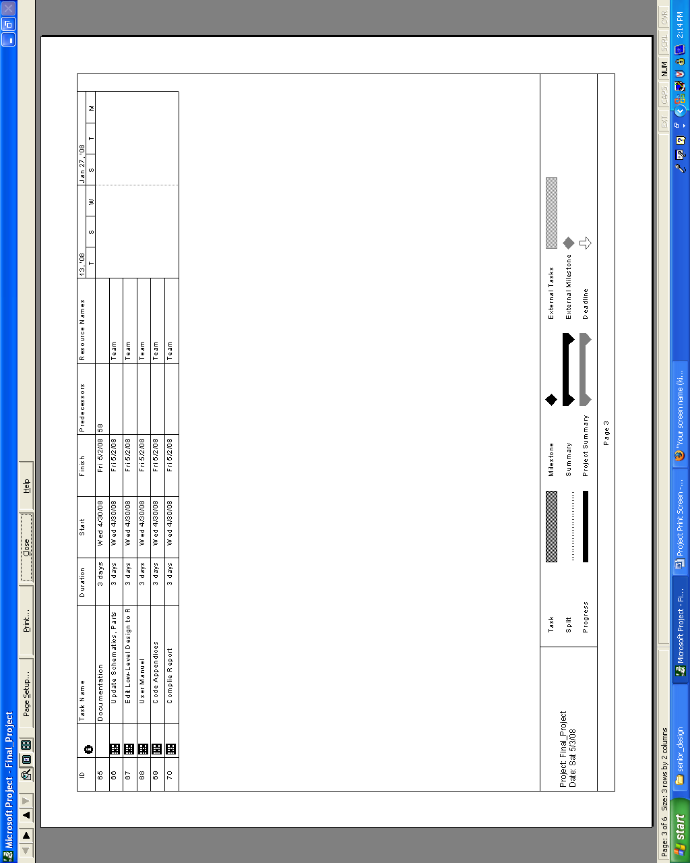
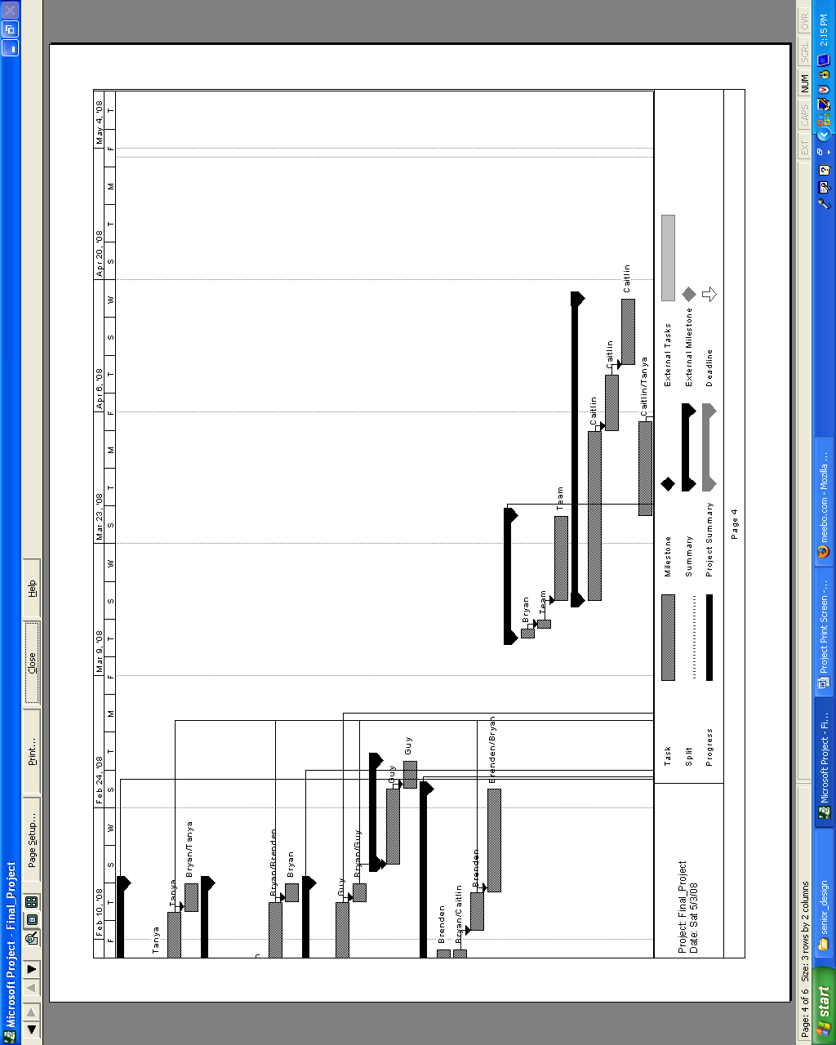
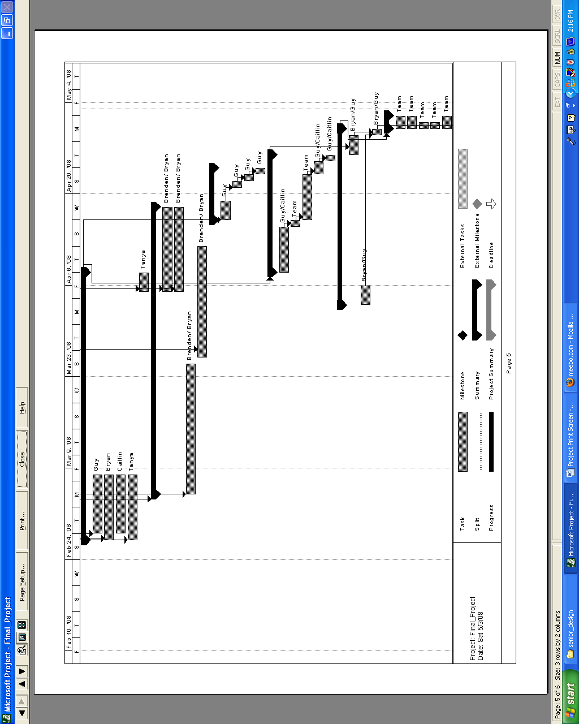
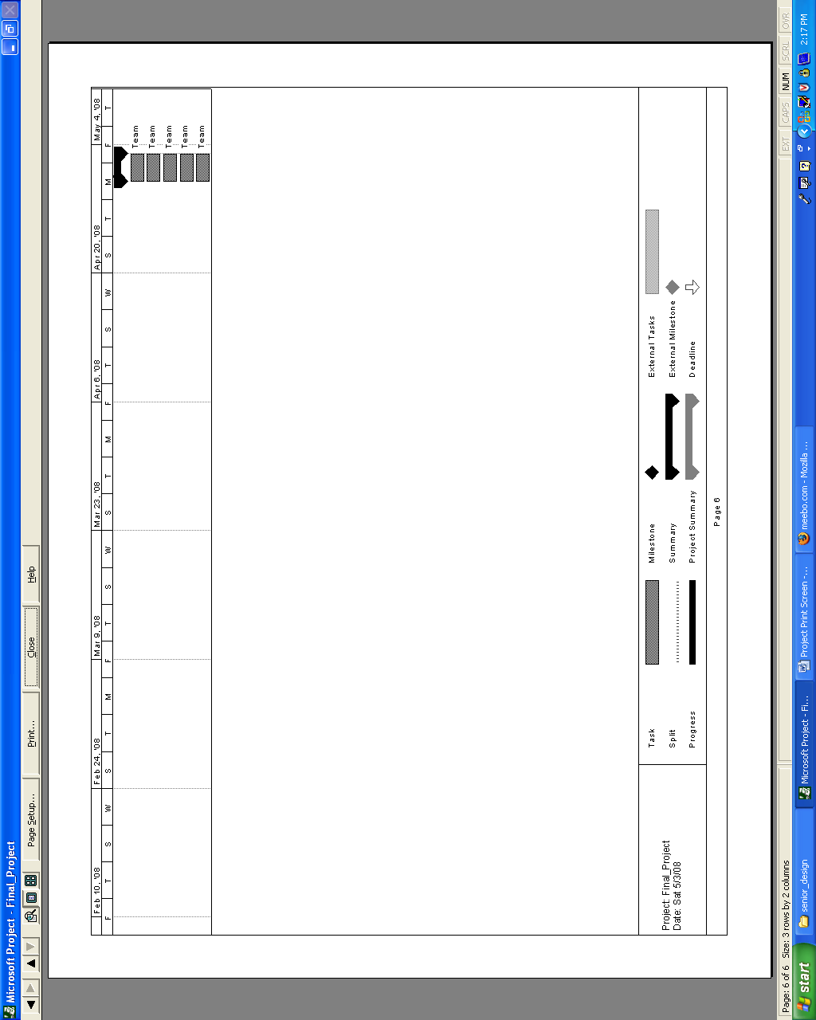

Complete Board Schematic
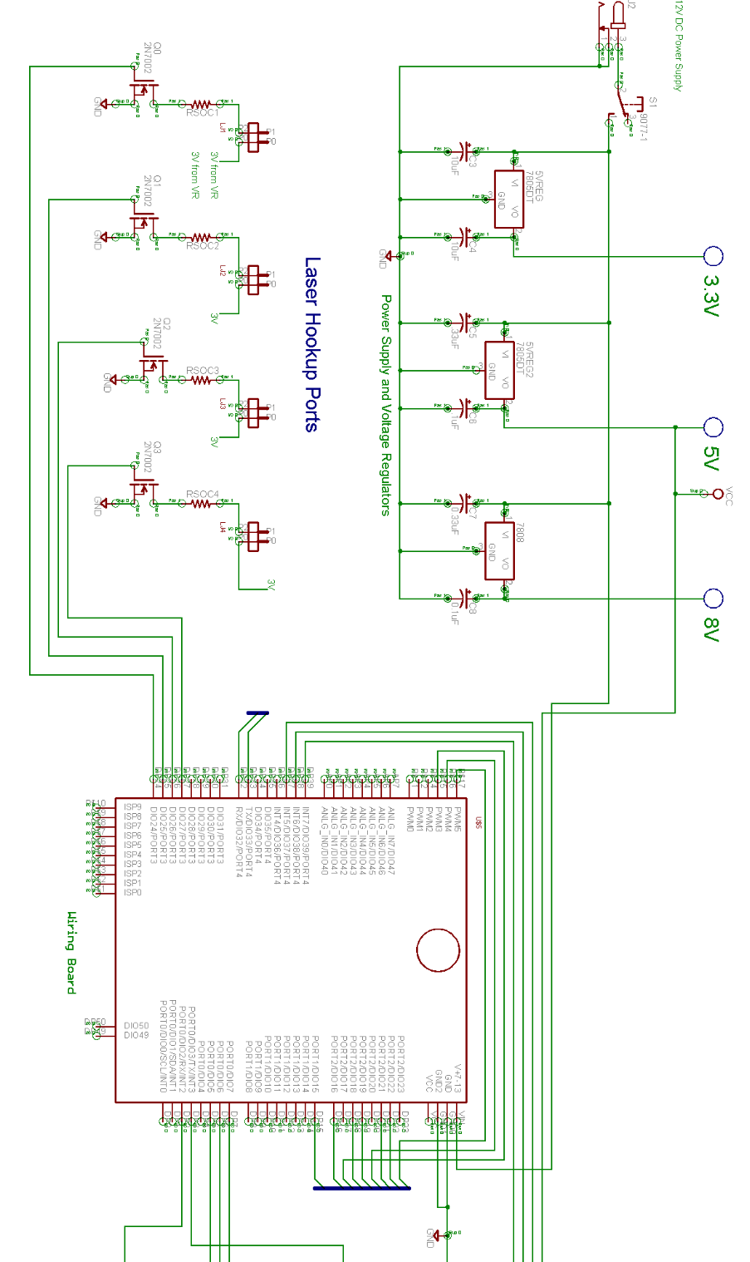
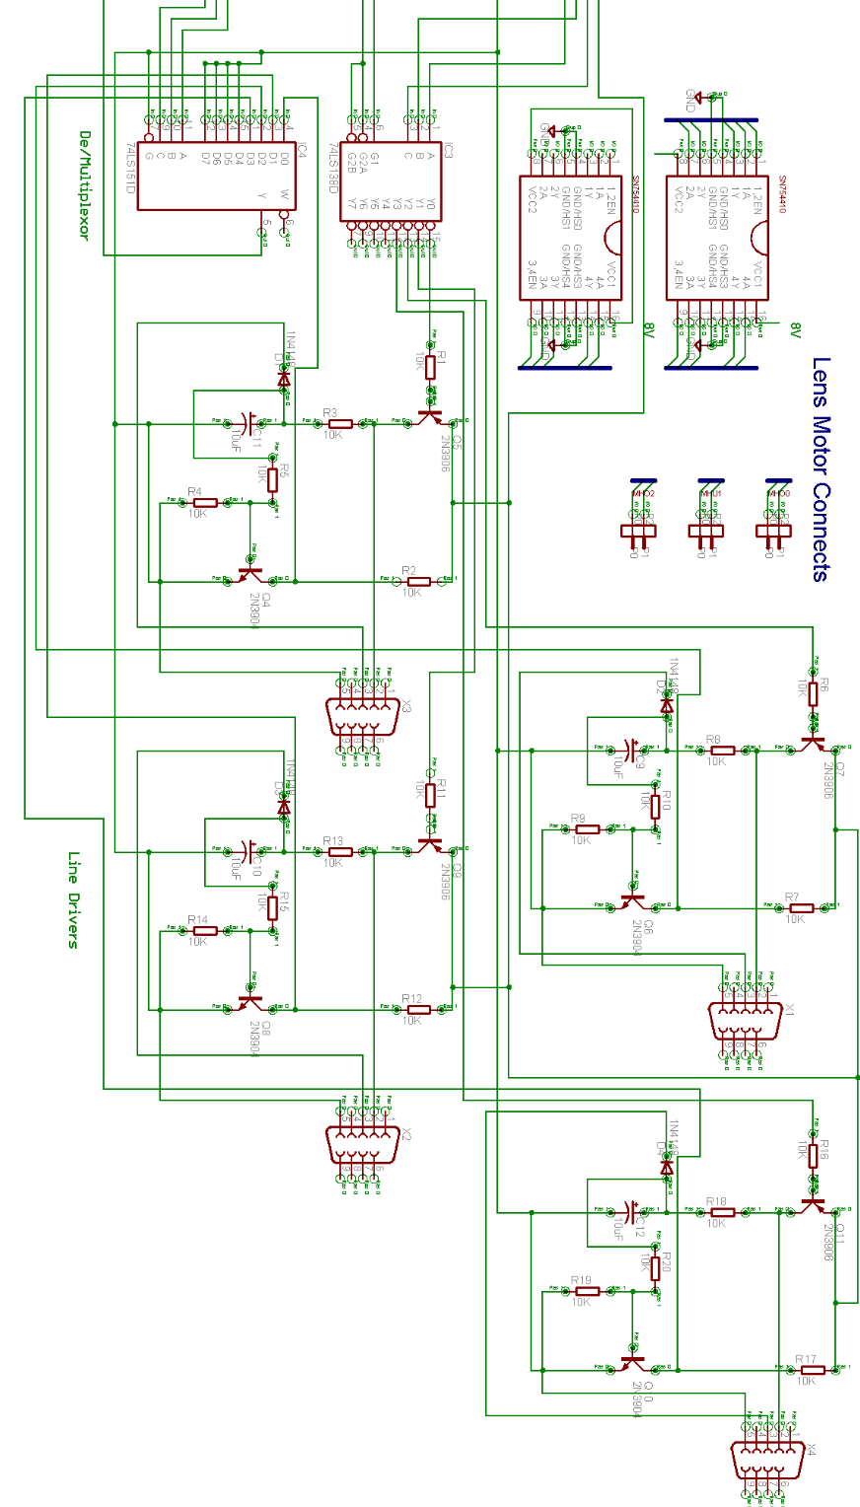

Board Layout
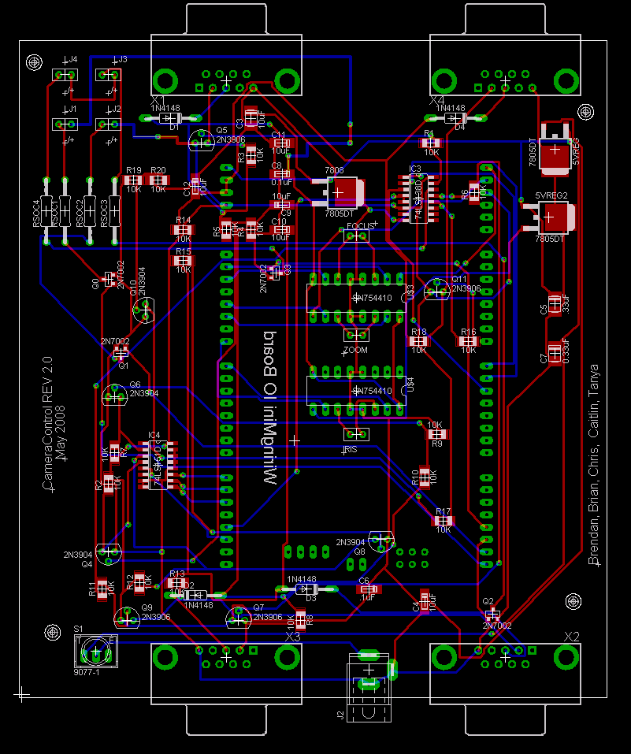

Controller Board Bill of Materials
Part Description | Source/  Supplier | Part Number | Quantity | Cost/Piece | Total Cost | Manufacturer | Manufacturer Part Number
NMOS Transistor | Digikey | 2N7002K-T1-E3CT-ND | 4 | $0.38 | $1.52 | Vishay/Siliconix | 2N7002K-T1-E3
0.33 uFCapacitor | Digikey | 399-3718-1-ND | 4 | $0.34 | $1.36 | Kemet | T491B334M050AT
8V Regulator 7808 | Digikey | 497-1174-1-ND | 1 | $0.90 | $0.90 | STMicroelectronics | L7808CD2T-TR
0.1 uF Capacitor | Digikey | 399-3676-1-ND | 4 | $0.19 | $0.76 | Kemet | T491A104K035AT
22 uF Capacitor | Digikey | 511-1465-1-ND | 2 | $0.33 | $0.66 | Rohm | TCA1A226M8R
8:1 Multiplexer | Digikey | SN74LS151DE4-ND | 1 | $0.29 | $0.29 | Texas Instruments | SN74LS151DE4
Switching Diode | Digikey | 1N4148-TPMSCT-ND | 4 | $0.53 | $2.12 | Micro Commercial Co | 1N4148-TP
Wiring Board | Sparkfun | DEV-00744 | 1 | $84.95 | $84.95 | Wiring.org
Motor Control Chip | Digikey | 296-9911-5-ND | 2 | $1.65 | $3.30 | Texas Instruments | SN754410NE
9 Pin Serial Connector Female | Sparkfun | PRT-00429 | 4 | $1.50 | $6.00
NPN Transistor | Digikey | 2N3904D26ZCT-ND | 4 | $0.19 | $0.76 | Fairchild Semiconductor | 2N3904TFR
10K Ohm Resistors | Digikey | 311-10KECT-ND | 20 | $0.08 | $1.56 | Yageo | 9C12063A1002JLHFT
10 uF Capacitors | Digikey | 399-3685-1-ND | 4 | $0.20 | $0.80 | Kemet | T491A106M006AT
PNP Transistor | Digikey | 2N3906D26ZCT-ND | 4 | $0.17 | $0.68 | Fairchild Semiconductor | 2N3906TFR
3.3 Volt Regulator | Digikey | LP2950CDT-3.3-ND | 1 | $1.34 | $1.34 | National Semiconductor | LP2950CDT-3.3/NOPB
Break Away Female Headers | Sparkfun | PRT-00115 | 2 | $1.50 | $3.00
5 Volt Regulator | Digikey | LM7805CDT-ND | 1 | $1.59 | $1.59 | National Semiconductor | LM78M05CDT/NOPB
3-8 Line Decoder | Digikey | 296-14883-1-ND | 1 | $0.72 | $0.72 | Texas Instruments | SN74LS138DR
2.1mm x 5.5mm Power Jack Connector | Digikey | CP-002AH-ND | 1 | $0.42 | $0.42 | CUI Inc | PJ-002AH
Total |  |  |  |  | $112.73sdo2hidiodhioghsoghsogishgoishgosighsdighsdgioigh

MATLAB GUI Code Listing
8.6.1 - maincontrol.m

function maincontrol
% Main Control GUI
%%%%%%%%%
clc
clear all
close all
addpath(genpath('..'))
%%%%%%%%%

f = figure('Visible','off','NumberTitle', 'off', 'Name', 'Main Control','MenuBar','none', 'Toolbar','none','Position', [1, 1, 800, 600]);
handles=guihandles(f);

h = uitabgroup;
drawnow;

handles.output=h;
%%%%%%%%%%%%%%%%%%%%%%%%%%%%%%%%%%%
%Tab for Camera %
%%%%%%%%%%%%%%%%%%%%%%%%%%%%%%%%%%%
t1 = uitab(h, 'title', 'Camera');
camera_group='on';
ptu_group='off';
rover_group='off';

%Initialize so custom close function will work
%serial ports
handles.ptuserial = 11;
handles.roverserial = 1;

handles.ptuSerialOpen = 0;
handles.roverSerialOpen = 0;

handles.videoOpen = 0;

win = imaqhwinfo('winvideo');
winList=[];
handles.cameraList = [];

%Check to see if winvideo cameras detected

if ~isempty(win.DeviceInfo)

if length(win.DeviceInfo)>=1
for i=1:length(win.DeviceInfo)
curDev = win.DeviceInfo(i).ObjectConstructor;
processedName = curDev(12:end-1);
winList = [winList; processedName];
end
end

handles.cameraList=[winList];

end

%default values if no winvideo cameras connected
handles.camSelect = 1;
handles.resList = [];%hwInfo.SupportedFormats; %list of available resolutions
handles.resSelect = 0;
propInfo.Brightness.ConstraintValue(1) = 0;
propInfo.Brightness.ConstraintValue(2) = 1;
propInfo.Brightness.DefaultValue = 0;

if ~isempty(win.DeviceInfo)

hwInfo = win.DeviceInfo(handles.camSelect); % list available adaptors
handles.hwInfo = hwInfo;
handles.win=win;
v = videoinput('winvideo',handles.camSelect); %video object to get brightness range
s = getselectedsource(v); %get source data
propInfo = propinfo(s); %property info -> propInfo.Brightness.ConstraintValue

end

%Position =[left bottom width height]
handles.startStopCamera = uicontrol(t1,'Style','pushbutton', 'Visible', camera_group, 'String','Start Camera','Position',[40,160,120,60], 'Callback', {@startStopCamera_Callback});
handles.cameraList = uicontrol(t1,'Style','popupmenu','Visible', camera_group, 'String', ['Select Camera'; handles.cameraList], 'Position',[150,40,130,30], 'Callback', {@cameraList_Callback});
handles.resolutionList = uicontrol(t1,'Style','popupmenu','Visible', camera_group, 'String', ['Select Resolution' handles.resList], 'Position',[150,10,130,30],'Enable', 'inactive', 'Callback', {@resolutionList_Callback});
handles.brightnessSlider = uicontrol(t1,'Style','slider','Visible', camera_group, 'Position',[75 100 301 51],'Min',propInfo.Brightness.ConstraintValue(1),'Max',propInfo.Brightness.ConstraintValue(2), 'Value', propInfo.Brightness.DefaultValue, 'Enable', 'inactive', 'Callback', {@brightnessSlider_Callback});
handles.brightnessLabel = uicontrol(t1, 'Style', 'text', 'Visible', camera_group, 'Position', [75 80 301 20], 'String', 'Brightness');
handles.getSnapshot = uicontrol(t1,'Style','pushbutton', 'String','Get Snapshot','Position',[170,160,120,60], 'Callback', {@getSnapshot_Callback});
handles.cameraAxes = axes('Units','pixels','Position',[50,250,480,360],'ytick',[],'xtick',[]);
handles.saveSnap = uicontrol(t1,'Style','checkbox', 'Visible', camera_group, 'String', 'Autosave snapshot?', 'Position',[300,160,120,60], 'Callback', {@saveSnap_Callback});
handles.snapName = uicontrol(t1,'Style','edit', 'Visible', camera_group,'String','Enter File Name Prefix','Position',[430,160, 120, 60], 'BackgroundColor', [1 1 1], 'Callback', {@snapName_Callback});

handles.snapshotSave = 0;
handles.snapNum = 1;

handles.dtList = ['VID0 ';
'VID1 ';
'VID2 ';
'VID3 '];

handles.dt = videoinput('dt',1);

% Lens
handles.lensTest = uicontrol(t1,'Style','checkbox', 'Visible', camera_group, 'String','Test Lens','Position',[430,80,120,60], 'Callback', {@lensTest_Callback});
handles.sourceList = uicontrol(t1,'Style','popupmenu','Visible', camera_group, 'String', ['Select Source'; handles.dtList], 'Position',[430,60,130,30],'Enable', 'inactive', 'Callback', {@sourceList_Callback});

handles.zoomIn = uicontrol(t1, 'Style', 'pushbutton', 'Visible', camera_group, 'String', 'Zoom In', 'Position', [650,530,120,60], 'Callback', {@zoomIn_Callback});
handles.zoomOut = uicontrol(t1,'Style','pushbutton', 'Visible', camera_group, 'String','Zoom Out','Position',[650,465,120,60], 'Callback', {@zoomOut_Callback});
handles.focusIn = uicontrol(t1,'Style','pushbutton', 'Visible', camera_group, 'String','Focus In','Position',[650,400,120,60], 'Callback', {@focusIn_Callback});
handles.focusOut = uicontrol(t1,'Style','pushbutton', 'Visible', camera_group, 'String','Focus Out','Position',[650,335,120,60], 'Callback', {@focusOut_Callback});
handles.irisOpen = uicontrol(t1,'Style','pushbutton', 'Visible', camera_group, 'String','Open Iris','Position',[650,270,120,60], 'Callback', {@irisOpen_Callback});
handles.irisClose = uicontrol(t1,'Style','pushbutton', 'Visible', camera_group, 'String','Close Iris','Position',[650,205,120,60], 'Callback', {@irisClose_Callback});
handles.speedSlider = uicontrol(t1,'Style','slider','Visible', camera_group, 'Position',[650 140 120 40],'Min',20,'Max',800, 'Value', 20, 'Callback', {@speedSlider_Callback});
handles.zoomSpeedLabel = uicontrol(t1, 'Style', 'text', 'Visible', camera_group, 'Position', [650 120 120 20], 'String', 'Zoom Speed');
handles.speed = 20;

guidata(f,handles);

%%%%%%%%%%%%%%%%%%%%%%%%%%%%%%%%%%%
%Tab for PTU/Laser %
%%%%%%%%%%%%%%%%%%%%%%%%%%%%%%%%%%%
t2 = uitab(h, 'title', 'PTU/Laser');
camera_group='off';
ptu_group='on';
rover_group='off';
%Position=[left bottom width height]
handles.openPTU_Port = uicontrol(t2, 'Style', 'togglebutton', 'Visible', ptu_group, 'String', 'Push to Open Port', 'Position', [650,500,120,60], 'Callback', {@openPTU_Port_Callback});
handles.purgePTU_Serial = uicontrol(t2,'Style','pushbutton', 'Visible', ptu_group, 'String','Purge Serial','Position',[650,430,120,60], 'Callback', {@purgePTU_Serial_Callback});
handles.panButton = uicontrol(t2,'Style','pushbutton', 'Visible', ptu_group, 'String','Pan','Position',[40,180,120,60], 'Callback', {@panButton_Callback});
handles.tiltButton = uicontrol(t2,'Style','pushbutton', 'Visible', ptu_group, 'String','Tilt','Position',[40,110,120,60], 'Callback', {@tiltButton_Callback});
handles.ptButton = uicontrol(t2,'Style','pushbutton', 'Visible', ptu_group, 'String','Pan/Tilt','Position',[300,140,120,60], 'Callback', {@ptButton_Callback});
handles.homePTU_Button = uicontrol(t2,'Style','pushbutton', 'Visible', ptu_group, 'String','Home PTU','Position',[650,360,120,60], 'Callback', {@homePTU_Button_Callback});
handles.panVal = uicontrol(t2,'Style','edit', 'Visible', ptu_group,'String','Enter Pan Value','Position',[170,180,120,60], 'BackgroundColor', [1 1 1], 'Callback', {@panVal_Callback});
handles.tiltVal = uicontrol(t2,'Style','edit', 'Visible', ptu_group,'String','Enter Tilt Value','Position',[170,110,120,60], 'BackgroundColor', [1 1 1], 'Callback', {@tiltVal_Callback});
handles.ptuSelected = uicontrol(t2,'Style','popupmenu', 'Visible', ptu_group, 'String', ['PTU 1'; 'PTU 2'; 'PTU 3'; 'PTU 4'], 'Position',[300,20,120,60], 'Callback', {@ptuSelected_Callback});
handles.laser1 = uicontrol(t2,'Style','checkbox', 'Visible', ptu_group, 'String', 'Laser 1', 'Position',[680,150,60,30], 'Callback', {@laser1_Callback});
handles.laser2 = uicontrol(t2,'Style','checkbox', 'Visible', ptu_group, 'String', 'Laser 2', 'Position',[680,120,60,30], 'Callback', {@laser2_Callback});
handles.laser3 = uicontrol(t2,'Style','checkbox', 'Visible', ptu_group, 'String', 'Laser 3', 'Position',[680,90,60,30], 'Callback', {@laser3_Callback});
handles.laser4 = uicontrol(t2,'Style','checkbox', 'Visible', ptu_group, 'String', 'Laser 4', 'Position',[680,60,60,30], 'Callback', {@laser4_Callback});

handles.targetLaser = uicontrol(t2, 'Style', 'pushbutton', 'Visible', ptu_group, 'String', 'Target Laser', 'Position', [650,270,120,60], 'Callback', {@targetLaser_Callback});
handles.initLaser = uicontrol(t2, 'Style', 'pushbutton', 'Visible', ptu_group, 'String', 'Initialize Laser', 'Position', [650,200,120,60], 'Callback', {@initLaser_Callback});
handles.laserX_Val = uicontrol(t2,'Style','edit', 'Visible', ptu_group,'String','Enter X Value','Position',[450,180,120,60], 'BackgroundColor', [1 1 1], 'Callback', {@laserX_Val_Callback});
handles.laserY_Val = uicontrol(t2,'Style','edit', 'Visible', ptu_group,'String','Enter Y Value','Position',[450,110,120,60], 'BackgroundColor', [1 1 1], 'Callback', {@laserY_Val_Callback});
handles.laserX_txt = uicontrol(t2,'Style','text', 'Visible', ptu_group, 'String', 'Laser X', 'Position',[580,190,60,30]);
handles.laserY_txt = uicontrol(t2,'Style','text', 'Visible', ptu_group, 'String', 'Laser Y', 'Position',[580,120,60,30]);

handles.ptuSelect = 1;
handles.ptu = ['A'; 'B'; 'C'; 'D'];

guidata(f,handles);

%%%%%%%%%%%%%%%%%%%%%%%%%%%%%%%%%%%
%Tab Rover Control %
%%%%%%%%%%%%%%%%%%%%%%%%%%%%%%%%%%%
t3 = uitab(h, 'title', 'Rover');
camera_group='off';
ptu_group='off';
rover_group='on';

handles.openRover_Port = uicontrol(t3, 'Style', 'togglebutton', 'Visible', rover_group, 'String', 'Push to Open Port', 'Position', [525,140,100,50], 'Callback', {@openRover_Port_Callback});
handles.purgeRover_Serial = uicontrol(t3,'Style','pushbutton', 'Visible', rover_group, 'String','Purge Serial','Position',[650,140,100,50], 'Callback', {@purgeRover_Serial_Callback});
handles.moveButton = uicontrol(t3,'Style','pushbutton', 'Visible', rover_group, 'String','Move Rover','Position',[100,8,75,50], 'Callback', {@moveButton_Callback});
handles.homeRover_Button = uicontrol(t3,'Style','pushbutton', 'Visible', rover_group, 'String','Home Rover','Position',[525,60,100,50], 'Callback', {@homeRover_Button_Callback});
handles.planeControl_Button = uicontrol(t3,'Style','pushbutton', 'Visible', rover_group, 'String','Plane Control','Position',[525,10,100,50], 'Callback', {@plnControl_Button_Callback});
handles.profileMotion_Button = uicontrol(t3,'Style','pushbutton', 'Visible', rover_group, 'String','Profile Motion','Position',[650,60,100,50], 'Callback', {@profileMotion_Button_Callback});
%handls.profileIncrement_button = uicontrol(t3,'Style','pushbutton', 'Visible', rover_group, 'String','Increment Motion','Position',[650,10,100,50], 'Callback', {@profileIncrement_Button_Callback});
handles.curPosButton = uicontrol(t3,'Style','pushbutton', 'Visible', rover_group, 'String','Current Pose','Position',[350,8,75,50], 'Callback', {@curPosButton_Callback});
handles.XdesiredVal = uicontrol(t3,'Style','edit', 'Visible', rover_group,'String','X Final','Position',[535,370,100,50], 'BackgroundColor', [1 1 1], 'Callback', {@XdesiredVal_Callback});
handles.YdesiredVal = uicontrol(t3,'Style','edit', 'Visible', rover_group,'String','Y Final','Position',[535,310,100,50], 'BackgroundColor', [1 1 1], 'Callback', {@YdesiredVal_Callback});
handles.PdesiredVal = uicontrol(t3,'Style','edit', 'Visible', rover_group,'String','Phi Final','Position',[535,250,100,50], 'BackgroundColor', [1 1 1], 'Callback', {@PdesiredVal_Callback});
handles.delay = uicontrol(t3,'Style','edit', 'Visible', rover_group,'String','Delay (s)','Position',[650,250,100,50], 'BackgroundColor', [1 1 1], 'Callback', {@delay_Callback});
handles.arm1Label2 = uicontrol(t3, 'Style', 'text', 'Visible', rover_group, 'Position', [675 225 50 20], 'String', 'Delay (s)');

handles.wheel1Val = uicontrol(t3,'Style','edit', 'Visible', rover_group,'String','Wheel 1','Position',[25,140,100,50], 'BackgroundColor', [1 1 1], 'Callback', {@wheel1Val_Callback});
handles.wheel2Val = uicontrol(t3,'Style','edit', 'Visible', rover_group,'String','Wheel 2','Position',[25,60,100,50], 'BackgroundColor', [1 1 1], 'Callback', {@wheel2Val_Callback});
handles.arm1Val = uicontrol(t3,'Style','edit', 'Visible', rover_group,'String','Arm 1','Position',[150,140,100,50], 'BackgroundColor', [1 1 1], 'Callback', {@arm1Val_Callback});
handles.arm2Val = uicontrol(t3,'Style','edit', 'Visible', rover_group,'String','Arm 2','Position',[150,60,100,50], 'BackgroundColor', [1 1 1], 'Callback', {@arm2Val_Callback});
handles.wheel1Cur = uicontrol(t3,'Style','text', 'Visible', rover_group, 'Position',[275,140,100,50], 'BackgroundColor', [1 1 1], 'Callback', {@wheel1Cur_Callback});
handles.wheel2Cur = uicontrol(t3,'Style','text', 'Visible', rover_group, 'Position',[275,60,100,50], 'BackgroundColor', [1 1 1], 'Callback', {@wheel2Cur_Callback});
handles.arm1Cur = uicontrol(t3,'Style','text', 'Visible', rover_group, 'Position',[400,140,100,50], 'BackgroundColor', [1 1 1], 'Callback', {@arm1Cur_Callback});
handles.arm2Cur = uicontrol(t3,'Style','text', 'Visible', rover_group, 'Position',[400,60,100,50], 'BackgroundColor', [1 1 1], 'Callback', {@arm2Cur_Callback});
handles.wheel1Label1 = uicontrol(t3, 'Style', 'text', 'Visible', rover_group, 'Position', [50 120 50 20], 'String', 'Wheel 1');
handles.wheel2Label1 = uicontrol(t3, 'Style', 'text', 'Visible', rover_group, 'Position', [50 40 50 20], 'String', 'Wheel 2');
handles.arm1Label1 = uicontrol(t3, 'Style', 'text', 'Visible', rover_group, 'Position', [175 120 50 20], 'String', 'Arm 1');
handles.arm1Label1 = uicontrol(t3, 'Style', 'text', 'Visible', rover_group, 'Position', [175 40 50 20], 'String', 'Arm 2');
handles.wheel1Label2 = uicontrol(t3, 'Style', 'text', 'Visible', rover_group, 'Position', [300 120 50 20], 'String', 'Wheel 1');
handles.wheel2Label2 = uicontrol(t3, 'Style', 'text', 'Visible', rover_group, 'Position', [300 40 50 20], 'String', 'Wheel 2');
handles.arm1Label2 = uicontrol(t3, 'Style', 'text', 'Visible', rover_group, 'Position', [425 120 50 20], 'String', 'Arm 1');
handles.arm1Label2 = uicontrol(t3, 'Style', 'text', 'Visible', rover_group, 'Position', [425 40 50 20], 'String', 'Arm 2'); %Position=[left bottom width height]

guidata(f,handles);

%%%%%%%%%%%%%%%%%%%%%%%%%%%%%%%%%%%
% Initialize GUI %
%%%%%%%%%%%%%%%%%%%%%%%%%%%%%%%%%%%
% Move the GUI to the center of the screen.
movegui(f,'center')
% Make the GUI visible.
set(f,'Visible','on');
set(f,'CloseRequestFcn', @shutdown)
%%%%%%%%%%%%%%%%%%%%%%%%%%%%%%%%%%%

%%%%%%%%%%%%%%%%%%%%%%%%%%%%%%%%%%%%%%%%%%%%%%%%%%%%%%%%%%%%%%%%%%%%%%%%%%%
% Camera Functions %
%%%%%%%%%%%%%%%%%%%%%%%%%%%%%%%%%%%%%%%%%%%%%%%%%%%%%%%%%%%%%%%%%%%%%%%%%%%

%%%%%%%%%%%%%%%%%%%%%%%%%%%%%%%%%%%%%%%%%%%%%%%%%%%%%%%%%%%%%%%%%%%%%%%%%%%
function cameraList_Callback(f,source,eventdata,handles)
handles = guidata(f);

contents = get(handles.cameraList,'String'); % returns ResolutionList contents as cell array
handles.camSelect = get(f,'Value') - 1;
handles.hwInfo = handles.win.DeviceInfo(handles.camSelect); % list available adaptors
handles.resList = handles.hwInfo.SupportedFormats; %list of available resolutions
handles.resSelect = 0;
set(handles.resolutionList,'String',['Select Resolution' handles.resList]);
set(handles.resolutionList,'Enable','on')

guidata(f,handles)
%%%%%%%%%%%%%%%%%%%%%%%%%%%%%%%%%%%%%%%%%%%%%%%%%%%%%%%%%%%%%%%%%%%%%%%%%%%

%%%%%%%%%%%%%%%%%%%%%%%%%%%%%%%%%%%%%%%%%%%%%%%%%%%%%%%%%%%%%%%%%%%%%%%%%%%
function resolutionList_Callback(f,source,eventdata,handles)
handles = guidata(f);

contents = get(handles.resolutionList,'String'); % returns ResolutionList contents as cell array
handles.resSelect = get(f,'Value') - 1;

guidata(f,handles)
%%%%%%%%%%%%%%%%%%%%%%%%%%%%%%%%%%%%%%%%%%%%%%%%%%%%%%%%%%%%%%%%%%%%%%%%%%%

%%%%%%%%%%%%%%%%%%%%%%%%%%%%%%%%%%%%%%%%%%%%%%%%%%%%%%%%%%%%%%%%%%%%%%%%%%%
function startStopCamera_Callback(f,source,eventdata,handles)
handles = guidata(f);

if (handles.resSelect > 0) && (handles.camSelect > 0)

% Create video object
a=handles.resList(handles.resSelect);
newRes=cell2str(a);
newRes=newRes(3:end-2);
handles.video = videoinput('winvideo', handles.camSelect, newRes);
handles.videoOpen = 1;

vidRes = get(handles.video, 'VideoResolution');
nBands = get(handles.video, 'NumberOfBands');
handles.hImage = image( zeros(vidRes(2), vidRes(1), nBands) );

set(handles.video,'TimerPeriod', 0.05);
set(handles.video, 'TimerFcn', ['if(~isempty(gco)),' 'handles=guidata(gcf);' 'image(getsnapshot(handles.video));'...
'set(handles.cameraAxes,''ytick'',[],''xtick'',[]),' 'else ' 'delete(imaqfind);' 'end']);
set(handles.cameraAxes, 'ytick', [], 'xtick', []);

triggerconfig(handles.video,'manual');
%end video object
handles.src = getselectedsource(handles.video);

if strcmp(get(handles.startStopCamera,'String'),'Start Camera')
% Camera is off. Change button string and start camera.
set(handles.startStopCamera,'String','Stop Camera')
set(handles.cameraList,'Enable', 'off')
set(handles.resolutionList,'Enable', 'off')
set(handles.brightnessSlider, 'Enable', 'on')
start(handles.video)

elseif strcmp(get(handles.startStopCamera,'String'),'Stop Camera')
% Camera is on. Stop camera and change button string.
set(handles.startStopCamera,'String','Start Camera')
stop(handles.video)
handles.videoOpen = 0;
set(handles.cameraList,'Enable','on')
set(handles.resolutionList,'Enable','off')
set(handles.brightnessSlider, 'Enable', 'off')
else
end
end

guidata(f,handles)
%%%%%%%%%%%%%%%%%%%%%%%%%%%%%%%%%%%%%%%%%%%%%%%%%%%%%%%%%%%%%%%%%%%%%%%%%%%

%%%%%%%%%%%%%%%%%%%%%%%%%%%%%%%%%%%%%%%%%%%%%%%%%%%%%%%%%%%%%%%%%%%%%%%%%%%
function brightnessSlider_Callback(f,source,eventdata,handles)
handles = guidata(f);

brightnessValue = get(handles.brightnessSlider,'Value');
stop(handles.video)
handles.src.Brightness = brightnessValue;
start(handles.video)

guidata(f,handles)
%%%%%%%%%%%%%%%%%%%%%%%%%%%%%%%%%%%%%%%%%%%%%%%%%%%%%%%%%%%%%%%%%%%%%%%%%%%

%%%%%%%%%%%%%%%%%%%%%%%%%%%%%%%%%%%%%%%%%%%%%%%%%%%%%%%%%%%%%%%%%%%%%%%%%%%
function getSnapshot_Callback(f,source,eventdata,handles)
handles = guidata(f);

stop(handles.video)
set(handles.startStopCamera,'String','Stop Camera')
handles.ss=figure('NumberTitle', 'off','Name', 'Snapshot');
preview(handles.video)
pause(2)
im=image(getsnapshot(handles.video));

%remove tick marks on picture
axis off
pause(.1)
axis on
pause(.1)
axis off
if handles.snapshotSave == 1
filename = [handles.sN, int2str(handles.snapNum)];
saveas(gcf, filename,'bmp')
end
handles.snapNum = handles.snapNum + 1;
guidata(f,handles)

start(handles.video)
%%%%%%%%%%%%%%%%%%%%%%%%%%%%%%%%%%%%%%%%%%%%%%%%%%%%%%%%%%%%%%%%%%%%%%%%%%%

%%%%%%%%%%%%%%%%%%%%%%%%%%%%%%%%%%%%%%%%%%%%%%%%%%%%%%%%%%%%%%%%%%%%%%%%%%%
function snapName_Callback(f, source, eventdata, handles)
handles = guidata(f);

txt = get(f,'String');
handles.sN = txt;

guidata(f,handles);
%%%%%%%%%%%%%%%%%%%%%%%%%%%%%%%%%%%%%%%%%%%%%%%%%%%%%%%%%%%%%%%%%%%%%%%%%%%

%%%%%%%%%%%%%%%%%%%%%%%%%%%%%%%%%%%%%%%%%%%%%%%%%%%%%%%%%%%%%%%%%%%%%%%%%%%
function saveSnap_Callback(f, source, eventdata, handles)
handles = guidata(f);

if get(f,'Value') == 1
handles.snapshotSave = 1;
else
handles.snapshotSave = 0;
end

guidata(f,handles)
%%%%%%%%%%%%%%%%%%%%%%%%%%%%%%%%%%%%%%%%%%%%%%%%%%%%%%%%%%%%%%%%%%%%%%%%%%%

%%%%%%%%%%%%%%%%%%%%%%%%%%%%%%%%%%%%%%%%%%%%%%%%%%%%%%%%%%%%%%%%%%%%%%%%%%%
function lensTest_Callback(f, source, eventdata, handles)
handles = guidata(f);
if get(f,'Value') == 1
preview(handles.dt)
set(handles.sourceList, 'Enable', 'on')
else
closepreview(handles.dt)
set(handles.sourceList, 'Enable', 'inactive')
end

guidata(f,handles)
%%%%%%%%%%%%%%%%%%%%%%%%%%%%%%%%%%%%%%%%%%%%%%%%%%%%%%%%%%%%%%%%%%%%%%%%%%%

%%%%%%%%%%%%%%%%%%%%%%%%%%%%%%%%%%%%%%%%%%%%%%%%%%%%%%%%%%%%%%%%%%%%%%%%%%%
function sourceList_Callback(f, source, eventdata, handles)
handles = guidata(f);
if get (handles.lensTest,'Value') == 1

contents = get(handles.sourceList,'String'); % returns Source List contents as cell array
select = get(f,'Value') - 1;
switch select
case 1
cam = 'VID0';
case 2
cam = 'VID1';
case 3
cam = 'VID2';
case 4
cam = 'VID3';
otherwise
cam = 'VID0';
end

set(handles.dt, 'SelectedSource', cam);
end

guidata(f,handles)
%%%%%%%%%%%%%%%%%%%%%%%%%%%%%%%%%%%%%%%%%%%%%%%%%%%%%%%%%%%%%%%%%%%%%%%%%%%

%%%%%%%%%%%%%%%%%%%%%%%%%%%%%%%%%%%%%%%%%%%%%%%%%%%%%%%%%%%%%%%%%%%%%%%%%%%
function zoomIn_Callback(f, source, eventdata, handles)
handles = guidata(f);

if (get(f,'Value') == get(f,'Max'))
[r1, r2] = zoom('I', int2str(handles.speed), handles.s1);
end

%killmotor(handles.s1);

guidata(f,handles)
%%%%%%%%%%%%%%%%%%%%%%%%%%%%%%%%%%%%%%%%%%%%%%%%%%%%%%%%%%%%%%%%%%%%%%%%%%%

%%%%%%%%%%%%%%%%%%%%%%%%%%%%%%%%%%%%%%%%%%%%%%%%%%%%%%%%%%%%%%%%%%%%%%%%%%%
function zoomOut_Callback(f, source, eventdata, handles)
handles = guidata(f);

if (get(f,'Value') == get(f,'Max'))
[r1, r2] = zoom('O', int2str(handles.speed), handles.s1);
end

%killmotor(handles.s1);

guidata(f,handles)
%%%%%%%%%%%%%%%%%%%%%%%%%%%%%%%%%%%%%%%%%%%%%%%%%%%%%%%%%%%%%%%%%%%%%%%%%%%

%%%%%%%%%%%%%%%%%%%%%%%%%%%%%%%%%%%%%%%%%%%%%%%%%%%%%%%%%%%%%%%%%%%%%%%%%%%
function focusIn_Callback(f, source, eventdata, handles)
handles = guidata(f);

if (get(f,'Value') == get(f,'Max'))
[r1, r2] = focus('I', int2str(handles.speed), handles.s1);
end

%killmotor(handles.s1);

guidata(f,handles)
%%%%%%%%%%%%%%%%%%%%%%%%%%%%%%%%%%%%%%%%%%%%%%%%%%%%%%%%%%%%%%%%%%%%%%%%%%%

%%%%%%%%%%%%%%%%%%%%%%%%%%%%%%%%%%%%%%%%%%%%%%%%%%%%%%%%%%%%%%%%%%%%%%%%%%%
function focusOut_Callback(f, source, eventdata, handles)
handles = guidata(f);

if (get(f,'Value') == get(f,'Max'))
[r1, r2] = focus('O', int2str(handles.speed), handles.s1);
end

%killmotor(handles.s1);

guidata(f,handles)
%%%%%%%%%%%%%%%%%%%%%%%%%%%%%%%%%%%%%%%%%%%%%%%%%%%%%%%%%%%%%%%%%%%%%%%%%%%

%%%%%%%%%%%%%%%%%%%%%%%%%%%%%%%%%%%%%%%%%%%%%%%%%%%%%%%%%%%%%%%%%%%%%%%%%%%
function irisOpen_Callback(f, source, eventdata, handles)
handles = guidata(f);

if (get(f,'Value') == get(f,'Max'))
[r1, r2] = iris('O', int2str(handles.speed), handles.s1);
end

%killmotor(handles.s1);

guidata(f,handles)
%%%%%%%%%%%%%%%%%%%%%%%%%%%%%%%%%%%%%%%%%%%%%%%%%%%%%%%%%%%%%%%%%%%%%%%%%%%

%%%%%%%%%%%%%%%%%%%%%%%%%%%%%%%%%%%%%%%%%%%%%%%%%%%%%%%%%%%%%%%%%%%%%%%%%%%
function irisClose_Callback(f, source, eventdata, handles)
handles = guidata(f);

if (get(f,'Value') == get(f,'Max'))
[r1, r2] = iris('I', int2str(handles.speed), handles.s1);
end

%killmotor(handles.s1);

guidata(f,handles)
%%%%%%%%%%%%%%%%%%%%%%%%%%%%%%%%%%%%%%%%%%%%%%%%%%%%%%%%%%%%%%%%%%%%%%%%%%%

%%%%%%%%%%%%%%%%%%%%%%%%%%%%%%%%%%%%%%%%%%%%%%%%%%%%%%%%%%%%%%%%%%%%%%%%%%%
function speedSlider_Callback(f,source,eventdata,handles)
handles = guidata(f);

handles.speed = floor(get(f,'Value'));
speed=handles.speed;

guidata(f,handles)
%%%%%%%%%%%%%%%%%%%%%%%%%%%%%%%%%%%%%%%%%%%%%%%%%%%%%%%%%%%%%%%%%%%%%%%%%%%

%%%%%%%%%%%%%%%%%%%%%%%%%%%%%%%%%%%%%%%%%%%%%%%%%%%%%%%%%%%%%%%%%%%%%%%%%%%
% PTU Functions %
%%%%%%%%%%%%%%%%%%%%%%%%%%%%%%%%%%%%%%%%%%%%%%%%%%%%%%%%%%%%%%%%%%%%%%%%%%%

%%%%%%%%%%%%%%%%%%%%%%%%%%%%%%%%%%%%%%%%%%%%%%%%%%%%%%%%%%%%%%%%%%%%%%%%%%%
function openPTU_Port_Callback(f, eventdata, handles)
handles = guidata(f);

state = get(f,'Value');
if state == get(f,'Max') %pressed the first time so open port
% Create COM Port to communicate with serial
handles.s1 = openserial(handles.ptuserial);
handles.ptuSerialOpen = 1;
set(f, 'String', 'Push to Close Port'); % Change button text
else
set(f, 'String', 'Push to Open Port'); % Change button text
closeserial(handles.s1);
handles.ptuSerialOpen = 0;
end

guidata(f,handles);
%%%%%%%%%%%%%%%%%%%%%%%%%%%%%%%%%%%%%%%%%%%%%%%%%%%%%%%%%%%%%%%%%%%%%%%%%%%

%%%%%%%%%%%%%%%%%%%%%%%%%%%%%%%%%%%%%%%%%%%%%%%%%%%%%%%%%%%%%%%%%%%%%%%%%%%
function purgePTU_Serial_Callback(f, eventdata, handles)
handles = guidata(f);

purgedData = purgeserial(handles.s1)

guidata(f,handles);
%%%%%%%%%%%%%%%%%%%%%%%%%%%%%%%%%%%%%%%%%%%%%%%%%%%%%%%%%%%%%%%%%%%%%%%%%%%

%%%%%%%%%%%%%%%%%%%%%%%%%%%%%%%%%%%%%%%%%%%%%%%%%%%%%%%%%%%%%%%%%%%%%%%%%%%
function panButton_Callback(f, eventdata, handles)
handles = guidata(f);

[response1, response2] = pancmd(handles.ptu(handles.ptuSelect), int2str(handles.panVal), handles.s1);

guidata(f,handles);
%%%%%%%%%%%%%%%%%%%%%%%%%%%%%%%%%%%%%%%%%%%%%%%%%%%%%%%%%%%%%%%%%%%%%%%%%%%

%%%%%%%%%%%%%%%%%%%%%%%%%%%%%%%%%%%%%%%%%%%%%%%%%%%%%%%%%%%%%%%%%%%%%%%%%%%
function tiltButton_Callback(f, eventdata, handles)
handles = guidata(f);

[response1, response2] = tiltcmd(handles.ptu(handles.ptuSelect), int2str(handles.tiltVal), handles.s1);

guidata(f,handles);
%%%%%%%%%%%%%%%%%%%%%%%%%%%%%%%%%%%%%%%%%%%%%%%%%%%%%%%%%%%%%%%%%%%%%%%%%%%

%%%%%%%%%%%%%%%%%%%%%%%%%%%%%%%%%%%%%%%%%%%%%%%%%%%%%%%%%%%%%%%%%%%%%%%%%%%
function ptButton_Callback(f, eventdata, handles)
handles = guidata(f);

[response1, response2] = pancmd(handles.ptu(handles.ptuSelect), int2str(handles.panVal), handles.s1);
[response1, response2] = tiltcmd(handles.ptu(handles.ptuSelect), int2str(handles.tiltVal), handles.s1);

guidata(f,handles);
%%%%%%%%%%%%%%%%%%%%%%%%%%%%%%%%%%%%%%%%%%%%%%%%%%%%%%%%%%%%%%%%%%%%%%%%%%%

%%%%%%%%%%%%%%%%%%%%%%%%%%%%%%%%%%%%%%%%%%%%%%%%%%%%%%%%%%%%%%%%%%%%%%%%%%%
function homePTU_Button_Callback(f, eventdata, handles)
handles = guidata(f);

[response1, response2] = pancmd(handles.ptu(handles.ptuSelect), '0', handles.s1);
[response1, response2] = tiltcmd(handles.ptu(handles.ptuSelect), '0', handles.s1);

guidata(f,handles);
%%%%%%%%%%%%%%%%%%%%%%%%%%%%%%%%%%%%%%%%%%%%%%%%%%%%%%%%%%%%%%%%%%%%%%%%%%%

%%%%%%%%%%%%%%%%%%%%%%%%%%%%%%%%%%%%%%%%%%%%%%%%%%%%%%%%%%%%%%%%%%%%%%%%%%%
function panVal_Callback(f, eventdata, handles)
handles = guidata(f);

val = get(f,'String');
newVal = str2double(val);
handles.panVal = newVal;

guidata(f,handles);
%%%%%%%%%%%%%%%%%%%%%%%%%%%%%%%%%%%%%%%%%%%%%%%%%%%%%%%%%%%%%%%%%%%%%%%%%%%

%%%%%%%%%%%%%%%%%%%%%%%%%%%%%%%%%%%%%%%%%%%%%%%%%%%%%%%%%%%%%%%%%%%%%%%%%%%
function tiltVal_Callback(f, eventdata, handles)
handles = guidata(f);

val = get(f,'String');
newVal = str2double(val);
handles.tiltVal = newVal;
guidata(f,handles);
%%%%%%%%%%%%%%%%%%%%%%%%%%%%%%%%%%%%%%%%%%%%%%%%%%%%%%%%%%%%%%%%%%%%%%%%%%%

%%%%%%%%%%%%%%%%%%%%%%%%%%%%%%%%%%%%%%%%%%%%%%%%%%%%%%%%%%%%%%%%%%%%%%%%%%%
function ptuSelected_Callback(f, eventdata, handles)
handles = guidata(f);

handles.ptuSelect=get(f,'Value');

guidata(f, handles);
%%%%%%%%%%%%%%%%%%%%%%%%%%%%%%%%%%%%%%%%%%%%%%%%%%%%%%%%%%%%%%%%%%%%%%%%%%%

%%%%%%%%%%%%%%%%%%%%%%%%%%%%%%%%%%%%%%%%%%%%%%%%%%%%%%%%%%%%%%%%%%%%%%%%%%%
function laser1_Callback(f, eventdata, handles)
handles = guidata(f);

if get(f,'Value') == 1
[response1, response2] = laser1(1, handles.s1);
else
[response1, response2] = laser1(0, handles.s1);
end

guidata(f,handles);
%%%%%%%%%%%%%%%%%%%%%%%%%%%%%%%%%%%%%%%%%%%%%%%%%%%%%%%%%%%%%%%%%%%%%%%%%%%

%%%%%%%%%%%%%%%%%%%%%%%%%%%%%%%%%%%%%%%%%%%%%%%%%%%%%%%%%%%%%%%%%%%%%%%%%%%
function laser2_Callback(f, eventdata, handles)
handles = guidata(f);

if get(f,'Value') == 1
[response1, response2] = laser2(1, handles.s1);
else
[response1, response2] = laser2(0, handles.s1);
end

guidata(f,handles);
%%%%%%%%%%%%%%%%%%%%%%%%%%%%%%%%%%%%%%%%%%%%%%%%%%%%%%%%%%%%%%%%%%%%%%%%%%%

%%%%%%%%%%%%%%%%%%%%%%%%%%%%%%%%%%%%%%%%%%%%%%%%%%%%%%%%%%%%%%%%%%%%%%%%%%%
function laser3_Callback(f, eventdata, handles)
handles = guidata(f);

if get(f,'Value') == 1
[response1, response2] = laser3(1, handles.s1);
else
[response1, response2] = laser3(0, handles.s1);
end

guidata(f,handles);
%%%%%%%%%%%%%%%%%%%%%%%%%%%%%%%%%%%%%%%%%%%%%%%%%%%%%%%%%%%%%%%%%%%%%%%%%%%

%%%%%%%%%%%%%%%%%%%%%%%%%%%%%%%%%%%%%%%%%%%%%%%%%%%%%%%%%%%%%%%%%%%%%%%%%%%
function laser4_Callback(f, eventdata, handles)
handles = guidata(f);

if get(f,'Value') == 1
[response1, response2] = laser4(1, handles.s1);
else
[response1, response2] = laser4(0, handles.s1);
end

guidata(f,handles);
%%%%%%%%%%%%%%%%%%%%%%%%%%%%%%%%%%%%%%%%%%%%%%%%%%%%%%%%%%%%%%%%%%%%%%%%%%%

%%%%%%%%%%%%%%%%%%%%%%%%%%%%%%%%%%%%%%%%%%%%%%%%%%%%%%%%%%%%%%%%%%%%%%%%%%%
function laserX_Val_Callback(f, eventdata, handles)
handles = guidata(f);

val = get(f,'String');
newVal = str2double(val);
handles.laserX_Val = newVal;

guidata(f,handles);
%%%%%%%%%%%%%%%%%%%%%%%%%%%%%%%%%%%%%%%%%%%%%%%%%%%%%%%%%%%%%%%%%%%%%%%%%%%

%%%%%%%%%%%%%%%%%%%%%%%%%%%%%%%%%%%%%%%%%%%%%%%%%%%%%%%%%%%%%%%%%%%%%%%%%%%
function laserY_Val_Callback(f, eventdata, handles)
handles = guidata(f);

val = get(f,'String');
newVal = str2double(val);
handles.laserY_Val = newVal;

guidata(f,handles);
%%%%%%%%%%%%%%%%%%%%%%%%%%%%%%%%%%%%%%%%%%%%%%%%%%%%%%%%%%%%%%%%%%%%%%%%%%%

%%%%%%%%%%%%%%%%%%%%%%%%%%%%%%%%%%%%%%%%%%%%%%%%%%%%%%%%%%%%%%%%%%%%%%%%%%%
function targetLaser_Callback(f, eventdata, handles)
handles = guidata(f);

% [x y] = getClickedPoint(handles.ss);
x = handles.laserX_Val;
y = handles.laserY_Val;
[pan tilt] = laser_calibrate(handles.Xc1, handles.Yc1, x, y, handles.Jacob, handles.qp1, handles.qt1);

[response1, response2] = laser1(1, handles.s1); % laser on
[response1, response2] = pancmd(handles.ptu(handles.ptuSelect), num2str(pan), handles.s1);
[response1, response2] = tiltcmd(handles.ptu(handles.ptuSelect), num2str(tilt), handles.s1);

handles.panVal = pan;
handles.tiltVal = tilt;

guidata(f, handles);
%%%%%%%%%%%%%%%%%%%%%%%%%%%%%%%%%%%%%%%%%%%%%%%%%%%%%%%%%%%%%%%%%%%%%%%%%%%

%%%%%%%%%%%%%%%%%%%%%%%%%%%%%%%%%%%%%%%%%%%%%%%%%%%%%%%%%%%%%%%%%%%%%%%%%%%
function initLaser_Callback(f, eventdata, handles)
handles = guidata(f);

t = handles.tiltVal;
p = handles.panVal;
% Pan/Tilt values for differencing
% qp1 = p - 125;
% qp2 = p - 20;
% qp3 = p + 160;
% qp4 = p + 80;
% qt1 = t - 50;
% qt2 = t + 123;
% qt3 = t + 75;
% qt4 = t - 152;
qp1 = p - 50;
qp2 = p - 50;
qp3 = p + 50;
qp4 = p + 50;
qt1 = t - 50;
qt2 = t + 50;
qt3 = t + 50;
qt4 = t - 50;

Q = [qp1 qt1;qp2 qt2;qp3 qt3;qp4 qt4];

[response1, response2] = pancmd(handles.ptu(handles.ptuSelect), num2str(qp1), handles.s1);
[response1, response2] = tiltcmd(handles.ptu(handles.ptuSelect), num2str(qt1), handles.s1);
[response1, response2] = laser2(1, handles.s1); % laser on
% figure(10)
stop(handles.video)
% set(handles.startStopCamera,'String','Stop Camera')

preview(handles.video)
pause(5)

im1=getsnapshot(handles.video);
% figure
% image(im1)

[response1, response2] = pancmd(handles.ptu(handles.ptuSelect), num2str(qp2), handles.s1);
[response1, response2] = tiltcmd(handles.ptu(handles.ptuSelect), num2str(qt2), handles.s1);
% figure(11)
pause(3)
im2=getsnapshot(handles.video);
% figure
% image(im2)

[response1, response2] = pancmd(handles.ptu(handles.ptuSelect), num2str(qp3), handles.s1);
[response1, response2] = tiltcmd(handles.ptu(handles.ptuSelect), num2str(qt3), handles.s1);
% figure(12)
pause(3)
im3=getsnapshot(handles.video);
% figure
% image(im3)

[response1, response2] = pancmd(handles.ptu(handles.ptuSelect), num2str(qp4), handles.s1);
[response1, response2] = tiltcmd(handles.ptu(handles.ptuSelect), num2str(qt4), handles.s1);
% figure(13)
pause(3)
im4=getsnapshot(handles.video);
% figure
% image(im4)
% closepreview(handles.video)
% image(im4)

%turn off laser
pause(2)
[response1, response2] = laser2(0, handles.s1);

closepreview(handles.video)

[Xc1, Yc1, J, qp1, qt1] = laser_jacobian(im1,im2,im3,im4,Q);

handles.Xc1 = Xc1;
handles.Yc1 = Yc1;
handles.Jacob = J;
handles.qp1 = qp1;
handles.qt1 = qt1;

guidata(f, handles);
start(handles.video)
%%%%%%%%%%%%%%%%%%%%%%%%%%%%%%%%%%%%%%%%%%%%%%%%%%%%%%%%%%%%%%%%%%%%%%%%%%%

%%%%%%%%%%%%%%%%%%%%%%%%%%%%%%%%%%%%%%%%%%%%%%%%%%%%%%%%%%%%%%%%%%%%%%%%%%%
% Rover Functions %
%%%%%%%%%%%%%%%%%%%%%%%%%%%%%%%%%%%%%%%%%%%%%%%%%%%%%%%%%%%%%%%%%%%%%%%%%%%

%%%%%%%%%%%%%%%%%%%%%%%%%%%%%%%%%%%%%%%%%%%%%%%%%%%%%%%%%%%%%%%%%%%%%%%%%%%
function openRover_Port_Callback(f, eventdata, handles)
handles = guidata(f);

state = get(f,'Value');
if state == get(f,'Max') %pressed the first time so open port
% Create COM Port to communicate with serial

[handles.s2, P] = initRover(handles.roverserial); % Port to initialize rover on
handles.roverSerialOpen = 1;

set(handles.wheel1Cur,'String',num2str(P(1))); % init gui box
set(handles.wheel2Cur,'String',num2str(P(2))); % init gui box
set(handles.arm1Cur,'String',num2str(P(3))); % init gui box
set(handles.arm2Cur,'String',num2str(P(4))); % init gui box

guidata(f,handles);

set(f, 'String', 'Push to Close Port'); % Change button text

else

set(f, 'String', 'Push to Open Port'); % Change button text
closeserial(handles.s2);
handles.roverSerialOpen = 0;

% fclose(handles.s2) % Disconnect from Serial Port
% delete(handles.s2) % Delete Serial Object from System
end
%%%%%%%%%%%%%%%%%%%%%%%%%%%%%%%%%%%%%%%%%%%%%%%%%%%%%%%%%%%%%%%%%%%%%%%%%%%

%%%%%%%%%%%%%%%%%%%%%%%%%%%%%%%%%%%%%%%%%%%%%%%%%%%%%%%%%%%%%%%%%%%%%%%%%%%
function purgeRover_Serial_Callback(f, eventdata, handles)
handles = guidata(f);
purgedData = purgeserial(handles.s2)
%%%%%%%%%%%%%%%%%%%%%%%%%%%%%%%%%%%%%%%%%%%%%%%%%%%%%%%%%%%%%%%%%%%%%%%%%%%

%%%%%%%%%%%%%%%%%%%%%%%%%%%%%%%%%%%%%%%%%%%%%%%%%%%%%%%%%%%%%%%%%%%%%%%%%%%
function moveButton_Callback(f, eventdata, handles)
handles = guidata(f);

x = cell2str(handles.wheel1Val) % from gui
y = cell2str(handles.wheel2Val) % from gui
z = cell2str(handles.arm1Val) % from gui
w = cell2str(handles.arm2Val) % from gui

P = jointMove(handles.s2,x,y,z,w,handles.delay); %Send desired positions to rover

set(handles.wheel1Cur,'String',num2str(P(1))); % init gui box
set(handles.wheel2Cur,'String',num2str(P(2))); % init gui box
set(handles.arm1Cur,'String',num2str(P(3))); % init gui box
set(handles.arm2Cur,'String',num2str(P(4))); % init gui box
guidata(f,handles);
%%%%%%%%%%%%%%%%%%%%%%%%%%%%%%%%%%%%%%%%%%%%%%%%%%%%%%%%%%%%%%%%%%%%%%%%%%%

%%%%%%%%%%%%%%%%%%%%%%%%%%%%%%%%%%%%%%%%%%%%%%%%%%%%%%%%%%%%%%%%%%%%%%%%%%%
function homeRover_Button_Callback(f, eventdata, handles)
handles = guidata(f);

P = jointMove(handles.s2,'0','0','45','-105',handles.delay); % Send zero positions to rover

set(handles.wheel1Cur,'String',num2str(P(1))); % init gui box
set(handles.wheel2Cur,'String',num2str(P(2))); % init gui box
set(handles.arm1Cur,'String',num2str(P(3))); % init gui box
set(handles.arm2Cur,'String',num2str(P(4))); % init gui box

guidata(f,handles);
%%%%%%%%%%%%%%%%%%%%%%%%%%%%%%%%%%%%%%%%%%%%%%%%%%%%%%%%%%%%%%%%%%%%%%%%%%%

%%%%%%%%%%%%%%%%%%%%%%%%%%%%%%%%%%%%%%%%%%%%%%%%%%%%%%%%%%%%%%%%%%%%%%%%%%%
function plnControl_Button_Callback(f, eventdata, handles)
handles = guidata(f);

[X,Y,Z,W] = plnCntrl(handles.XdesiredVal,handles.YdesiredVal,handles.PdesiredVal);
P = profileIncrement(handles.s2,X,Y,Z,W);

guidata(f,handles);
%%%%%%%%%%%%%%%%%%%%%%%%%%%%%%%%%%%%%%%%%%%%%%%%%%%%%%%%%%%%%%%%%%%%%%%%%%%

%%%%%%%%%%%%%%%%%%%%%%%%%%%%%%%%%%%%%%%%%%%%%%%%%%%%%%%%%%%%%%%%%%%%%%%%%%%
function profileMotion_Button_Callback(f, eventdata, handles)
handles = guidata(f);

P = profileMove(handles.s2,handles.delay); % Send zero positions to rover

set(handles.wheel1Cur,'String',num2str(P(1))); % init gui box
set(handles.wheel2Cur,'String',num2str(P(2))); % init gui box
set(handles.arm1Cur,'String',num2str(P(3))); % init gui box
set(handles.arm2Cur,'String',num2str(P(4))); % init gui box

guidata(f,handles);
%%%%%%%%%%%%%%%%%%%%%%%%%%%%%%%%%%%%%%%%%%%%%%%%%%%%%%%%%%%%%%%%%%%%%%%%%%%

%%%%%%%%%%%%%%%%%%%%%%%%%%%%%%%%%%%%%%%%%%%%%%%%%%%%%%%%%%%%%%%%%%%%%%%%%%%
function profileIncrement_Button_Callback(f, eventdata, handles)
handles = guidata(f);

profileIncrement(handles.s2); % Send zero positions to rover

guidata(f,handles);
%%%%%%%%%%%%%%%%%%%%%%%%%%%%%%%%%%%%%%%%%%%%%%%%%%%%%%%%%%%%%%%%%%%%%%%%%%%

%%%%%%%%%%%%%%%%%%%%%%%%%%%%%%%%%%%%%%%%%%%%%%%%%%%%%%%%%%%%%%%%%%%%%%%%%%%
function curPosButton_Callback(f, eventdata, handles)
handles = guidata(f);

fprintf(handles.s2,'TP') % Send command for current position
response = fscanf(handles.s2); % Gets response from controller
P = getCoords(response);

set(handles.wheel1Cur,'String',num2str(P(1))); % init gui box
set(handles.wheel2Cur,'String',num2str(P(2))); % init gui box
set(handles.arm1Cur,'String',num2str(P(3))); % init gui box
set(handles.arm2Cur,'String',num2str(P(4))); % init gui box
guidata(f,handles);
%%%%%%%%%%%%%%%%%%%%%%%%%%%%%%%%%%%%%%%%%%%%%%%%%%%%%%%%%%%%%%%%%%%%%%%%%%%

%%%%%%%%%%%%%%%%%%%%%%%%%%%%%%%%%%%%%%%%%%%%%%%%%%%%%%%%%%%%%%%%%%%%%%%%%%%
function XdesiredVal_Callback(f, eventdata, handles)
handles = guidata(f);

val = get(f,'String');
newVal = str2double(val);
handles.XdesiredVal = newVal;
guidata(f,handles);
%%%%%%%%%%%%%%%%%%%%%%%%%%%%%%%%%%%%%%%%%%%%%%%%%%%%%%%%%%%%%%%%%%%%%%%%%%%

%%%%%%%%%%%%%%%%%%%%%%%%%%%%%%%%%%%%%%%%%%%%%%%%%%%%%%%%%%%%%%%%%%%%%%%%%%%
function YdesiredVal_Callback(f, eventdata, handles)
handles = guidata(f);

val = get(f,'String');
newVal = str2double(val);
handles.YdesiredVal = newVal;
guidata(f,handles);
%%%%%%%%%%%%%%%%%%%%%%%%%%%%%%%%%%%%%%%%%%%%%%%%%%%%%%%%%%%%%%%%%%%%%%%%%%%

%%%%%%%%%%%%%%%%%%%%%%%%%%%%%%%%%%%%%%%%%%%%%%%%%%%%%%%%%%%%%%%%%%%%%%%%%%%
function PdesiredVal_Callback(f, eventdata, handles)
handles = guidata(f);

val = get(f,'String');
newVal = str2double(val);
handles.PdesiredVal = newVal;
guidata(f,handles);
%%%%%%%%%%%%%%%%%%%%%%%%%%%%%%%%%%%%%%%%%%%%%%%%%%%%%%%%%%%%%%%%%%%%%%%%%%%

%%%%%%%%%%%%%%%%%%%%%%%%%%%%%%%%%%%%%%%%%%%%%%%%%%%%%%%%%%%%%%%%%%%%%%%%%%%
function delay_Callback(f, eventdata, handles)
handles = guidata(f);

val = get(f,'String');
newVal = str2double(val);
handles.delay = newVal;
guidata(f,handles);
%%%%%%%%%%%%%%%%%%%%%%%%%%%%%%%%%%%%%%%%%%%%%%%%%%%%%%%%%%%%%%%%%%%%%%%%%%%

%%%%%%%%%%%%%%%%%%%%%%%%%%%%%%%%%%%%%%%%%%%%%%%%%%%%%%%%%%%%%%%%%%%%%%%%%%%
function wheel1Val_Callback(f, eventdata, handles)
handles = guidata(f);

val = get(f,'String');
newVal = str2double(val);
handles.wheel1Val = newVal;
guidata(f,handles);
%%%%%%%%%%%%%%%%%%%%%%%%%%%%%%%%%%%%%%%%%%%%%%%%%%%%%%%%%%%%%%%%%%%%%%%%%%%

%%%%%%%%%%%%%%%%%%%%%%%%%%%%%%%%%%%%%%%%%%%%%%%%%%%%%%%%%%%%%%%%%%%%%%%%%%%
function wheel2Val_Callback(f, eventdata, handles)
handles = guidata(f);

val = get(f,'String');
newVal = str2double(val);
handles.wheel2Val = newVal;
guidata(f,handles);
%%%%%%%%%%%%%%%%%%%%%%%%%%%%%%%%%%%%%%%%%%%%%%%%%%%%%%%%%%%%%%%%%%%%%%%%%%%

%%%%%%%%%%%%%%%%%%%%%%%%%%%%%%%%%%%%%%%%%%%%%%%%%%%%%%%%%%%%%%%%%%%%%%%%%%%
function arm1Val_Callback(f, eventdata, handles)
handles = guidata(f);

val = get(f,'String');
newVal = str2double(val);
handles.arm1Val = newVal;
guidata(f,handles);
%%%%%%%%%%%%%%%%%%%%%%%%%%%%%%%%%%%%%%%%%%%%%%%%%%%%%%%%%%%%%%%%%%%%%%%%%%%

%%%%%%%%%%%%%%%%%%%%%%%%%%%%%%%%%%%%%%%%%%%%%%%%%%%%%%%%%%%%%%%%%%%%%%%%%%%
function arm2Val_Callback(f, eventdata, handles)
handles = guidata(f);

val = get(f,'String');
newVal = str2double(val);
handles.arm2Val = newVal;
guidata(f,handles);
%%%%%%%%%%%%%%%%%%%%%%%%%%%%%%%%%%%%%%%%%%%%%%%%%%%%%%%%%%%%%%%%%%%%%%%%%%%

%%%%%%%%%%%%%%%%%%%%%%%%%%%%%%%%%%%%%%%%%%%%%%%%%%%%%%%%%%%%%%%%%%%%%%%%%%%
function shutdown(f, eventdata, handles)
handles = guidata(f);

if (handles.ptuSerialOpen == 1) || (handles.roverSerialOpen == 1) || (handles.videoOpen == 1)
display('Close serial and video objects')
else
closereq
end
%%%%%%%%%%%%%%%%%%%%%%%%%%%%%%%%%%%%%%%%%%%%%%%%%%%%%%%%%%%%%%%%%%%%%%%%%%%

8.6.2 - focus.m

function [r1, r2] = focus(dir, speed, serialobj)
% FOCUS command focuses lens in or out
% [r1, r2] = focus(dir, speed, serialobj)
% r1 - first response
% r2 - second response
% dir - direction to zoom 'I' for in and 'O' for out
% speed - speed to zoom
% serialobj - serial object

f = ['LF' dir speed 'X'];
fprintf(serialobj, f)
r1 = fscanf(serialobj); % Gets first response
r2 = fscanf(serialobj); % Gets second response
% r3 = fscanf(serialobj); % garbage
pause(2)

8.6.3 - iris.m
function [r1, r2] = iris(dir, speed, serialobj)
% IRIS command changes iris
% [r1, r2] = iris(dir, speed, serialobj)
% r1 - first response
% r2 - second response
% dir - direction to zoom 'I' for in and 'O' for out
% speed - speed to zoom
% serialobj - serial object

i = ['LI' dir speed 'X'];
fprintf(serialobj, i)
r1 = fscanf(serialobj); % Gets first response
r2 = fscanf(serialobj); % Gets second response
% r3 = fscanf(serialobj); % garbage
pause(2)

8.6.4 - zoom.m
function [r1, r2] = zoom(dir, speed, serialobj)
% ZOOM command zooms lens in or out
% [r1, r2] = zoom(dir, speed, serialobj)
% r1 - first response
% r2 - second response
% dir - direction to zoom 'I' for in and 'O' for out
% speed - speed to zoom
% serialobj - serial object

z = ['LZ' dir speed 'X'];
fprintf(serialobj, z)
r1 = fscanf(serialobj); % Gets first response
r2 = fscanf(serialobj); % Gets second response
% r3 = fscanf(serialobj); % garbage
pause(2)

8.6.5 - closeserial.m
function closeserial(serialobj)
% CLOSESERIAL closes and deletes a serial object.
%
%closeserial(serialobj)
% serialobj - serial object to be closed and deleted

fclose(serialobj) % Disconnect from Serial Port
delete(serialobj) % Delete Serial Object from System

8.6.6 – laser1.m
function [r1, r2] = laser1(status, serialobj)
%LASER1 toggles laser 1 on or off
%[r1, r2] = laser1(status, serialobj)
% r1 - first response from system
% r2 - second response from system
% status - 1 for on or 0 for off
% serialobj - serial object

if status == 1
fprintf(serialobj, 'E1X') % Send command for laser on
r1 = fscanf(serialobj); % Get first response from system
r2 = fscanf(serialobj); % Get second response from system
%r3 = fscanf(serialobj) % Get third (garbage) response from system

else
fprintf(serialobj, 'E0X') % Send command for laser on
r1 = fscanf(serialobj); % Get first response from system
r2 = fscanf(serialobj); % Get second response from system
%r3 = fscanf(serialobj) % Get third (garbage) response from system
end
pause(1)

8.6.7 – laser2.m
function [r1, r2] = laser2(status, serialobj)
%LASER2 toggles laser 2 on or off
%[r1, r2] = laser2(status, serialobj)
% r1 - first response from system
% r2 - second response from system
% status - 1 for on or 0 for off
% serialobj - serial object

if status == 1
fprintf(serialobj, 'F1X') % Send command for laser on
r1 = fscanf(serialobj); % Get first response from system
r2 = fscanf(serialobj); % Get second response from system
% r3 = fscanf(serialobj); % Get third (garbage) response from system

else
fprintf(serialobj, 'F0X') % Send command for laser on
r1 = fscanf(serialobj); % Get first response from system
r2 = fscanf(serialobj); % Get second response from system
% r3 = fscanf(serialobj); % Get third (garbage) response from system
end
pause(1)

8.6.8 – laser3.m
function [r1, r2] = laser3(status, serialobj)
%LASER3 toggles laser 3 on or off
%[r1, r2] = laser3(status, serialobj)
% r1 - first response from system
% r2 - second response from system
% status - 1 for on or 0 for off
% serialobj - serial object

if status == 1
fprintf(serialobj, 'G1X') % Send command for laser on
r1 = fscanf(serialobj); % Get first response from system
r2 = fscanf(serialobj); % Get second response from system
% r3 = fscanf(serialobj); % Get third (garbage) response from system

else
fprintf(serialobj, 'G0X') % Send command for laser on
r1 = fscanf(serialobj); % Get first response from system
r2 = fscanf(serialobj); % Get second response from system
% r3 = fscanf(serialobj); % Get third (garbage) response from system
end
pause(1)

8.6.9 – laser4.m
function [r1, r2] = laser4(status, serialobj)
%LASER4 toggles laser 4 on or off
%[r1, r2] = laser4(status, serialobj)
% r1 - first response from system
% r2 - second response from system
% status - 1 for on or 0 for off
% serialobj - serial object

if status == 1
fprintf(serialobj, 'H1X') % Send command for laser on
r1 = fscanf(serialobj); % Get first response from system
r2 = fscanf(serialobj); % Get second response from system
% r3 = fscanf(serialobj); % Get third (garbage) response from system

else
fprintf(serialobj, 'H0X') % Send command for laser on
r1 = fscanf(serialobj); % Get first response from system
r2 = fscanf(serialobj); % Get second response from system
% r3 = fscanf(serialobj); % Get third (garbage) response from system
end
pause(1)

8.6.10 - openserial.m
function serialobj = openserial(comPortNum)
%OPENSERIAL creates a serial object and opens a serial connection.
%
%serialobj = openserial(comPortNum)
% comPortNum - the number of the desired COM port to connect
% serialobj - returned serial object

sPort = ['COM' num2str(comPortNum)]; % Which Port to use
s=serial(sPort); % Create Serial Object
set(s,'BaudRate',9600,'StopBits',1); % Specify settings
set(s,'Terminator','CR','Parity','none'); % Specify settings
set(s,'FlowControl','none'); % Specify settings

fopen(s); % Connect to Serial port

serialobj = s;

8.6.11 - pancmd.m
function [r1, r2] = pancmd(num, val, serialobj)
%PANCMD sends pan command to PTU
%[r1, r2] = pancmd(num, val, serialobj)
% r1 - first response from PTU
% r2 - second response from PTU
% num - number of PTU
% val - pan value
% serialobj - serial object

p = [num 'PP' val 'X'];
fprintf(serialobj, p)
r1 = fscanf(serialobj); % Gets first response from PTU
r2 = fscanf(serialobj); % Gets second response from PTU
% r3 = fscanf(serialobj); % Gets third (garbage) response from PTU
pause(1)

8.6.12 - purgeserial.m
function data = purgeserial(serialobj)
%PURGESERIAL purges the data on a serial port
%data = purgeserial(serialobj)
% data - the data currently on the serial port
% serialobj - serial object

data = fscanf(serialobj);

8.6.13 - tiltcmd.m
function [r1, r2] = tiltcmd(num, val, serialobj)
%TILTCMD sends tilt command to PTU
%[r1, r2] = tiltcmd(num, val, serialobj)
% r1 - first response from PTU
% r2 - second response from PTU
% num - number of PTU
% val - tilt value
% serialobj - serial object

t = [num 'TP' val 'X'];
fprintf(serialobj, t)
r1 = fscanf(serialobj); % Gets first response from PTU
r2 = fscanf(serialobj); % Gets second response from PTU
% r3 = fscanf(serialobj); % Gets third (garbage) response from PTU
pause(1)

Wiring Board Microcontroller Software Listing
// Board Firmware
// by Bryan Marek <bcmarek@gmail.com>
// Created 3 May 2008

// Laser Pin Numbers
int LASER1 = 24;
int LASER2 = 25;
int LASER3 = 26;
int LASER4 = 27;
int TEST = 48; //onboard LED

//PTU MUX Pin Numbers
int txMux0 = 39;
int txMux1 = 38;
int txMux2 = 37;

int rxMux0 = 7;
int rxMux1 = 6;
int rxMux2 = 5;

//Motor Pin Numbers
int PWM_Focus = 3;
int PWM_Zoom = 4;
int PWM_Iris = 5;

int Focus_in = 21;
int Focus_out = 22;
int Zoom_in = 18;
int Zoom_out = 19;
int Iris_in = 15;
int Iris_out = 16;

//Serial values
char val;//value read from serial port
int flag;//flag to stop reading serial port
String command; //command formatted from host

//device values
char deviceID;//hardware identifier
String command2; //Device specific command
String command3; //Sub command for device functionality
String response;//response from PTU

//hardware properties
char laserStatus; //on or off indicator 1 - on, 0 - off
int laserPin; // pin for selected laser
char lensDir; //direction of lens
int lensSpd; //speed of lens
char lensFunction; //zoom,focus,iris
int Llen; //length of speed array

//This function initializes hardware parameters for the wiring board
//it sets the desired pin states and indicates when initialization
//is complete
void setup()
{
//Initialize Laser Pins
pinMode(LASER1, OUTPUT); // sets the digital pin as output
pinMode(LASER2, OUTPUT); // sets the digital pin as output
pinMode(LASER3, OUTPUT); // sets the digital pin as output
pinMode(LASER4, OUTPUT); // sets the digital pin as output
pinMode(TEST, OUTPUT); // sets the digital pin as output
//Initialize MUX Pins
pinMode(txMux0, OUTPUT); // sets the digital pin as output
pinMode(txMux1, OUTPUT); // sets the digital pin as output
pinMode(txMux2, OUTPUT); // sets the digital pin as output
pinMode(rxMux0, OUTPUT); // sets the digital pin as output
pinMode(rxMux1, OUTPUT); // sets the digital pin as output
pinMode(rxMux2, OUTPUT); // sets the digital pin as output

//Initialize Motor Pins
pinMode(Zoom_in, OUTPUT); // sets the digital pin as output
pinMode(Zoom_out, OUTPUT); // sets the digital pin as output
pinMode(Focus_in, OUTPUT); // sets the digital pin as output
pinMode(Focus_out, OUTPUT); // sets the digital pin as output
pinMode(Iris_in, OUTPUT); // sets the digital pin as output
pinMode(Iris_out, OUTPUT); // sets the digital pin as output

//Initialize Serial
Serial.begin(9600); //open up usb serial port for coms
Serial1.begin(9600); //open up serial port for PTUs
delay(500);
Serial.println("Serial Port Active");
}//setup()

//this function turns off the laser specified by the current
//laserPin setting
void laserOff()
{
digitalWrite(laserPin,LOW);//set pin low
//print response to serial port
Serial.print("PIN ");
Serial.print(laserPin);
Serial.println(" Off");
}//laserOff()

//this function turns off the laser specified by the current
//laserPin setting
void laserOn()
{
digitalWrite(laserPin,HIGH);//set pin high
//print response to serial port
Serial.print("PIN ");
Serial.print(laserPin);
Serial.println(" On");
}

//this function turns the laser on or off as specified by the current
//laserStatus setting
void toggleLaser()
{
laserStatus = command2.charAt(0); //Get status of laser
//used to debug, uncomment for checking code
//Serial.print("lStatus: ");
//Serial.println(lStatus);
//Serial.print("lPin: ");
//Serial.println(laserPin);
if(laserStatus == '1'){
laserOn();//turn laser on
}
else if(laserStatus == '0'){
laserOff();//turn laser off
}
}

//This function controls the motor controller for the zoom, taking lensDir from
//the main program it either moves the motor in, out, or stops motor operation
void Zoom()
{

if(lensDir == 'I') //Zoom in
{
//set pwm pin to desired speed and enable proper pins
analogWrite(PWM_Zoom,lensSpd);
digitalWrite(Zoom_in, HIGH);
digitalWrite(Zoom_out, LOW);
}
else if(lensDir == 'O') //Zoom out
{
//set pwm pin to desired speed and enable proper pins
analogWrite(PWM_Zoom,lensSpd);
digitalWrite(Zoom_in, LOW);
digitalWrite(Zoom_out, HIGH);
}
else if(lensDir == 'K') //Kill motor
{
//set pwm pin to desired speed and enable proper pins
analogWrite(PWM_Zoom,lensSpd);
digitalWrite(Zoom_in, LOW);
digitalWrite(Zoom_out, LOW);
}
}//Zoom()

//This function controls the motor controller for the focus, taking lensDir from
//the main program it either moves the motor in, out, or stops motor operation
void Focus()
{
if(lensDir == 'I') //Focus in
{
//set pwm pin to desired speed and enable proper pins
analogWrite(PWM_Focus,lensSpd);
digitalWrite(Focus_in, HIGH);
digitalWrite(Focus_out, LOW);
}
else if(lensDir == 'O') //Focus out
{
//set pwm pin to desired speed and enable proper pins
analogWrite(PWM_Focus,lensSpd);
digitalWrite(Focus_in, LOW);
digitalWrite(Focus_out, HIGH);
}
else if(lensDir == 'K') //Kill motor
{
//set pwm pin to desired speed and enable proper pins
analogWrite(PWM_Focus,lensSpd);
digitalWrite(Focus_in, LOW);
digitalWrite(Focus_out, LOW);
}
}//Focus()

//This function controls the motor controller for the iris, taking lensDir from
//the main program it either moves the motor in, out, or stops motor operation
void Iris()
{
if(lensDir == 'I') //Iris in
{
//set pwm pin to desired speed and enable proper pins
analogWrite(PWM_Iris,lensSpd);
digitalWrite(Iris_in, HIGH);
digitalWrite(Iris_out, LOW);
}
else if(lensDir == 'O') //Iris out
{
//set pwm pin to desired speed and enable proper pins
analogWrite(PWM_Iris,lensSpd);
digitalWrite(Iris_in, LOW);
digitalWrite(Iris_out, HIGH);
}
else if(lensDir == 'K') //Kill motor
{
//set pwm pin to desired speed and enable proper pins
analogWrite(PWM_Iris,lensSpd);
digitalWrite(Iris_in, LOW);
digitalWrite(Iris_out, LOW);
}
}//Iris()

//This function takes the lens command, stripping the function, direction
//and speed parameters and calls the desired subroutines to execute
void moveLens()
{
lensFunction = command2.charAt(0); //Z - Zoom, F - Focus, I - Iris
lensDir = command2.charAt(1); //Get Direction I - In, O - Out
command3 = command2.substring(2); //get speed
Llen = command3.length(); //lens speed length
lensSpd = 0; //Final lens speed, integer value

// convert lens speed from serial characters to integer value
if (Llen == 1){
lensSpd = int(command3.charAt(0)) - 48;
}
else if (Llen == 2){
lensSpd = (int(command3.charAt(0))-48)*10 + (int(command3.charAt(1)) - 48);
}
else if (Llen == 3){
lensSpd = (int(command3.charAt(0)) - 48)*100 + (int(command3.charAt(1)) - 48)*10 + (int(command3.charAt(2)) - 48);
}
else if (Llen == 4){
lensSpd = (int(command3.charAt(0)) - 48)*1000 + (int(command3.charAt(1)) - 48)*100 + (int(command3.charAt(2)) - 48)*10 + (int(command3.charAt(3)) - 48);
}

//output final speed to serial port
Serial.print("Lens Speed = ");
Serial.println(lensSpd);

//make sure lens speed is within reasonable bounds for pwm
if (lensSpd < 0 || lensSpd > 1023)
{
lensSpd = 125;
}

//check desired functionality and carry out function
if (lensFunction == 'Z')
{
Zoom(); //Zoom
delay(1000);
lensDir = 'K';//kill
Zoom(); //stop zoom
}
else if (lensFunction =='F')
{
Focus(); //focus
delay(1000);
lensDir = 'K';//kill
Focus();//stop focus
}
else if (lensFunction == 'I')
{
Iris();//iris
delay(1000);
lensDir = 'K';//kill
Iris();//stop iris
}
}//readLens()

//this function sets the select pins on the MUX and DEMUX chips
//for serial communication send and recieve
void muxPTU(){

if (deviceID == 'A') //MUX PTU 1
{
digitalWrite(txMux0, LOW);
digitalWrite(txMux1, LOW);
digitalWrite(txMux2, LOW);

digitalWrite(rxMux0, LOW);
digitalWrite(rxMux1, LOW);
digitalWrite(rxMux2, LOW);
}

else if (deviceID == 'B') //MUX PTU 2
{
digitalWrite(txMux0, HIGH);
digitalWrite(txMux1, LOW);
digitalWrite(txMux2, LOW);

digitalWrite(rxMux0, HIGH);
digitalWrite(rxMux1, LOW);
digitalWrite(rxMux2, LOW);

}
else if (deviceID == 'C') //MUX PTU 3
{
digitalWrite(txMux0, LOW);
digitalWrite(txMux1, HIGH);
digitalWrite(txMux2, LOW);

digitalWrite(rxMux0, LOW);
digitalWrite(rxMux1, HIGH);
digitalWrite(rxMux2, LOW);
}
else if (deviceID == 'D') //MUX PTU 4
{
digitalWrite(txMux0, HIGH);
digitalWrite(txMux1, HIGH);
digitalWrite(txMux2, LOW);

digitalWrite(rxMux0, HIGH);
digitalWrite(rxMux1, HIGH);
digitalWrite(rxMux2, LOW);
}
}//muxPTU()

//This function gets a response back from the PTU in terms of current position
void readPTU()
{
response = null;
flag = 0;
Serial.println("Start of readPTU()");
delay(5000);
//Serial.print("bits available: ");
//Serial.println(Serial.available());
while(flag == 0){
if(Serial1.available() > 0)
{
val = Serial1.read();
response.append(val);
Serial.println(val);
}
else
{
val = Serial1.read();
response.append(val);
Serial.println(val);
flag = 1; //return to main, no end character or data left
Serial.print("Command Timeout: ");
Serial.println(response);

}
}

}//readPTU()

//This function takes the command sent from the host PC for the PTU
//and outputs it onto the multiplexed serial port
void echoPTU()
{
//command2 = pp2500, tp-450, etc, as sent from the pc
Serial1.println(command2); //Print to PTU
Serial.println(command2); //Print to Host
//readPTU(); //read response from PTU

}//echoPTU()

//This function takes the first value of the command sent from the host
//corrseponding to the hardware ID and initializes the hardware for
//the desired functionality
void hardAct() //activate hardware
{
deviceID = command.charAt(0); //first character of command for hardware code
command2 = command.substring(1); //get device specific command
//Serial.print("Device ID: ");
//Serial.println(deviceID);
//Serial.print("Device Command: ");
//Serial.println(command2);

if(deviceID != null){
switch(deviceID){
case 'A'://PTU1 Device ID
muxPTU(); //set active PTU 1
Serial.println("Accessed PTU1");
echoPTU();//print command on serial out
break;
case 'B':
muxPTU(); //set active PTU 2
Serial.println("Accessed PTU2");
echoPTU();//print command on serial out
break;
case 'C':
muxPTU(); //set active PTU 3
Serial.println("Accessed PTU3");
echoPTU();//print command on serial out
break;
case 'D':
muxPTU(); //set active PTU 4
Serial.println("Accessed PTU4");
echoPTU();//print command on serial out
break;
case 'E'://Laser1 device ID
Serial.println("Accessed Laser_1");
laserPin = LASER1;
toggleLaser();
break;
case 'F': // Laser 2
Serial.println("Accessed Laser_2");
laserPin = LASER2;
toggleLaser();
break;
case 'G': // Laser 3
Serial.println("Accessed Laser_3");
laserPin = LASER3;
toggleLaser();
break;
case 'H': // Laser 4
Serial.println("Accessed Laser_4");
laserPin = LASER4;
toggleLaser();
break;
case 'L': //Lens Control
Serial.println("Accessed Lens");
moveLens();
break;
case 'T': // test - turn on onboard test led to ensure program operability
Serial.println("test");
laserPin = TEST;
toggleLaser();
break;
default:
//Serial.println("No Valid Command Issued");
break;
}
}
}//hardAct()

//Gets command from serial port
void getCommand()
{
//reset variables
command = null;//command from host, full command
command2 = null;//command for device, remove device id
command3 = null;//command for functionality
deviceID = null;//Hardware identifier

flag = 0;
//Serial.println("Start of getCommand()");
while(flag == 0){//loop to get serial data
if(Serial.available() > 0)//while there is data, append to command
{
val = Serial.read();//gets current character from serial port
if(val != 'X') //check for escape character
{
//Serial.println(val);
command.append(val);//append value to response
}
else//reached escape character, end loop and enable hardware
{
flag = 1;
// Serial.print("Command Sent: ");
//Serial.println(command);
//Serial.println("Start of hardAct()");
hardAct();//process command, end character was reached
}
}
else//no valid command issued, return to main loop
{
flag = 1; //return to main, no end character or data left
//Serial.print("Command Timeout: ");
//Serial.println(command);

}
}
}//getCommand()

//this function is the main loop that checks for serial data and executes
//subroutines when available, it will wait for commands otherwise
void loop()
{
if(Serial.available() > 0){//check for serial data
getCommand(); //check for command from serial port
}
delay(100);//wait .1s
}

