Team Five-O
Mark II

Jared Bauters
Christian Sagardia
James Samilo

University of Notre Dame
Department of Electrical Engineering
Senior Design 2008
Final Documentation

Contents:

1) Cover Page
2) Table of Contents
3) Introduction
3.1) Problem Statement
3.2) Proposed Solution
3.3) General Description
3.4) Final Results
4) High Level Overview
5.1) System Block Diagram
5) In-Depth Subsystem Review
5.1) Control
5.2) Sensing
5.3) Switching
5.4) Data Storage
5.5) USB Interface
6) Initial Testing
- System Integration
- Final Automotive Testing
- Installation/Setup Manual
- Conclusions
- Acknowledgments
- Appendices & Notes

3.0) Introduction:

In 2006, the South Bend Police Department approached Notre Dame’s electrical engineering department with a problem concerning power consumption in their officers’ vehicles. The department was replacing car batteries at an unexpectedly high rate due to damaging deep discharges that occurred both on duty and overnight. The members of the force and the garage crew could not agree on a specific cause of the drains, and the problem became a senior design project. Four students, Team Five-0, completed a prototype system solution in the summer of 2007. The unit was designed to monitor the current generated by the alternator, leaving the battery, and supplied to up to six generic loads that can be found in a common police car. It also measures the battery’s voltage as a way to provide state-of-charge information. As the battery approaches a deep discharge, the system sheds loads in a prioritized manner, hopefully saving the battery while keeping vital loads in operation. Their prototype performed some aspects of this system function very well, while failing in others.
In 2007, we took on the project with the objective of producing an improved prototype working from Team 5-0’s design. Our design goals were straightforward: build upon the current prototype, improve performance (i.e. get all subsystems working), and reduce the overall size of the system. The following sections of this document outline our team’s progress, explain how we chose to meet the system’s requirements, and provide explanations for design decisions.

3.1) Problem Statement

The main problem to be solved is the rapid discharge of car batteries in law enforcement vehicles that have several electronic devices loading a single 12 V automotive battery.
Two major headaches occur when a police officer’s car battery undergoes a deep discharge. First, vital systems such as the video camera, the radio, and the starter are inoperable. Second, the department most likely has to buy a new battery, or at the very least, that battery’s lifetime is greatly decreased. These issues are detrimental to the officer and the public’s safety, and they put undue burden on the city, county, or state budget. The vehicle’s operator may prevent some instances of deep discharge. Yet, the officer can usually only guess why his battery failed and may not recognize the problem if it recurs.

3.2) Proposed Solution

To solve the above problems, one must develop a system to monitor the current produced by the alternator and drawn by the various electronic devices that are loading the battery. The system should then make intelligent decisions from this information about the state of the car and the six generic loads. The state logic for each device is simple:

With state variables for all devices known, the system should then have a set of conditions to check that prevent or warn of the occurrence of battery-draining events (e.g. current coming out of the battery is greater than the current going into the battery). Power-conserving measures may also be implemented to sustain the operation of a vital load (generic load 1 in our design) as the charge becomes dangerously low. By design, this “load suite” is reserved for the officer’s camera since its continued operation is necessary for the resolution of lawsuits. All current and voltage data should also be stored so that in the case of failure, the garage crew can determine a cause. In this manner, the system acts also like the vehicle’s “black box” for post failure diagnostics. This system should be low power, small, and easy to install in the officer’s car.
It has also been determined that our system could function usefully as a “black box” only, so that useful data on a police car’s electronic systems can be taken over a long period of time. To do this, our system allows for data collection over a three-month period at 5-minute intervals. In this mode, the design will not use its switching capability, but will use four 1024K EEPROMs to meet the requirement of three months’ worth of data.

  - General Description

Our main system consists of five major functional blocks: sensing, switching, control, data storage, and a USB interface. Below is an overview of each system:

Sensing – The sensing block can be broken into two: local sensing of auxiliary loads and remote sensing of the battery and alternator currents. Local sensing is achieved with the Allegro ACS755xCB-050 family of unidirectional current sensors. These sensors sense up to 50 amps and output a voltage signal between 0 and 5 volts to one of the 12 A/D input pins on the PIC18LF4620 microcontroller. Remote sensing is achieved with a larger, coiled-wire, bidirectional, through-hole current sensor, the Tamura L01Z200S05, that must be installed around the main battery and alternator lines. These sensors will also output a voltage signal to one of the 12 A/D input pins on the PIC18LF4620 microcontroller, but the voltage swings by ±1.5 volts from a quiescent volage of 2.5 volts. The Tamura sensors sense currents between ±200 amps.

Switching – The switching block consists of Fairchild NDP7050 E-mode switching NMOSFETs driven by Linear Technology LTC1255 MOSFET drivers. The drivers accept a digital input from the PIC18LF4620 microcontroller I/O and drive the transistor gates on or off accordingly. In addition to on-board MOSFET switches, there will be manual override flip switches that allow the user to cut out the system entirely and switch loads on or off.

Control – The control block’s main component is the Microchip PIC18LF4620 microcontroller. It accepts a voltage signal input from the Allegro and Tamura current sensors on 8 of its 12 A/D input pins from the sensing block and send a digital output to the Linear Technology LTC1255 MOSFET drivers in the switching block, controlling which auxiliary loads are connected to the 12 volt battery. The microcontroller polls the 8 connected A/D input pins from the sensing block and sends state data via I²C to an EEPROM for storage. If the user wants to upload the data to his computer, the microcontroller will sense that a USB cable has been plugged in and send data to the FTDI UART-to-USB transceiver for dumping to a Mircosoft Excel spreadsheet via our Visual Basic code on the computer.

Data Storage – The data storage block consists of a real-time clock and four EEPROMs. The block receives system state data from the microcontroller via the I²C protocol about every 5 minutes and stores this data along with the real-time clock’s value. The EEPROM sends this system state and time information back to the microcontroller via I²C when a user is dumping the data to his personal computer via the USB interface. The EEPROMs on our system are capable of storing three months worth of data. The hardware implementation is a setup of four Microchip 1024 K I²C EEPROMs. Each save state will contain less than 16 bytes of data, thus we will buffer 16 save states in the microcontroller before sending every 256-byte page to the EEPROM. This will allow for one save every five minutes.

USB Interface – The heart of the USB interface is the FTDI FT232R UART-to-USB transceiver. This IC accepts data from the microcontroller via its serial UART and acts as the USB transmitter to the user’s computer.

  - Final Results

As of the time of this writing, we have a working prototype that successfully integrates all subsystems as planned. In our final design review demo, we were able to demonstrate current sensing, load switching, data storage, a user interface, and a USB interface to the reviewers. Installation of the device was more difficult than anticipated. It is our recommendation that the hook up wire for the remote sensors be made sufficiently long to accommodate fitting the sensors into a crowded space. Further design work should go toward placement of external terminals for hooking up the auxiliary loads as well. In the police cruiser we were given, a rack mount was placed between the driver and passenger seats in the vehicle. The next group should research whether such a rackmount is standard so that the next design may fit in it.

  - High Level Overview

The high level design of our system is visualized using the block diagram shown below:

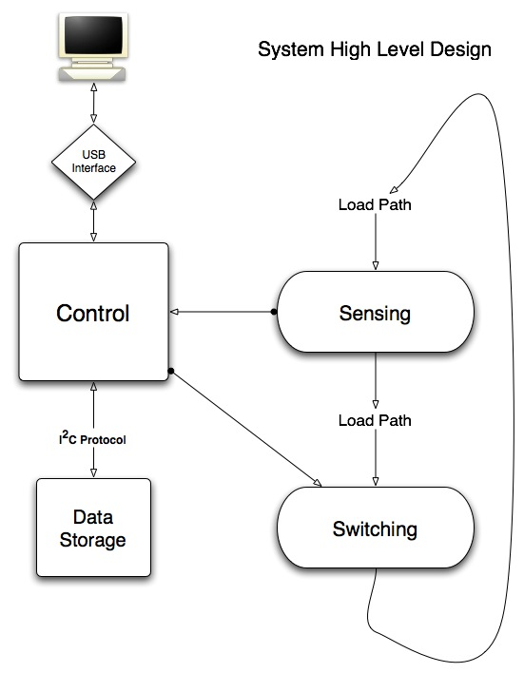
Figure 1: Block Diagram of Entire System
  - Subsystem General Requirements

Control: The microcontroller should be able to fulfill the following requirements:
  - The control subsystem should have a microcontroller with enough I/O ports to receive analog signals from the sensors and send digital signals to the MOSFET drivers.
  - The microcontroller should be able to operate in low-power modes.

Sensing: The sensing subsystem must fulfill the following requirements:
  - The sensing subsystem should have sensors that are capable of handling the battery, alternator, and auxiliary current loads.
  - They should output an analog voltage signal to the microcontroller and not require adverse rail voltages.
  - There will necessarily be different sensors used for the remote sensing of large battery and alternator currents than are used for the auxiliary loads.
    - The Allegro ACS755x family of Hall current sensors meets these requirements for the auxiliary loads.
    - For the larger battery and alternator loads, we are using Tamura L01Z200S05 current sensors that are capable of measuring up to ±200 amps.

Switching – The switching subsystem must fulfill the following requirements:
  - On-board switching controlled by the control subsystem as well as manual overrides.
    - Both switching systems will need to be able to turn off large current loads. Fairchild NDP7050 E-mode switching nMOSFETs driven by Linear Technology LTC1255 MOSFET drivers have proven to be sufficient up to a 32 amps in heat tests.

Data Storage – The data storage subsystem must fulfill the following requirements:
  - Must be able to store several months worth of data
    - We achieve this through the usage of 4 Microchip 1024k I²C EEPROMs linked in parallel.

USB Interface – The USB interface subsystem must fulfill the following requirements:
  - Must be able to receive data from the UART at the UART’s baud rate and then send the data to a computer.
    - We will use the FTDI FT232R to allow us to interface our system with a computer via USB.

  - In-Depth Subsystem Review & Implementation

  - Control:
The Microchip PIC18F4620 microcontroller is the main component of this subsystem. Below is a schematic of the control subsystem:

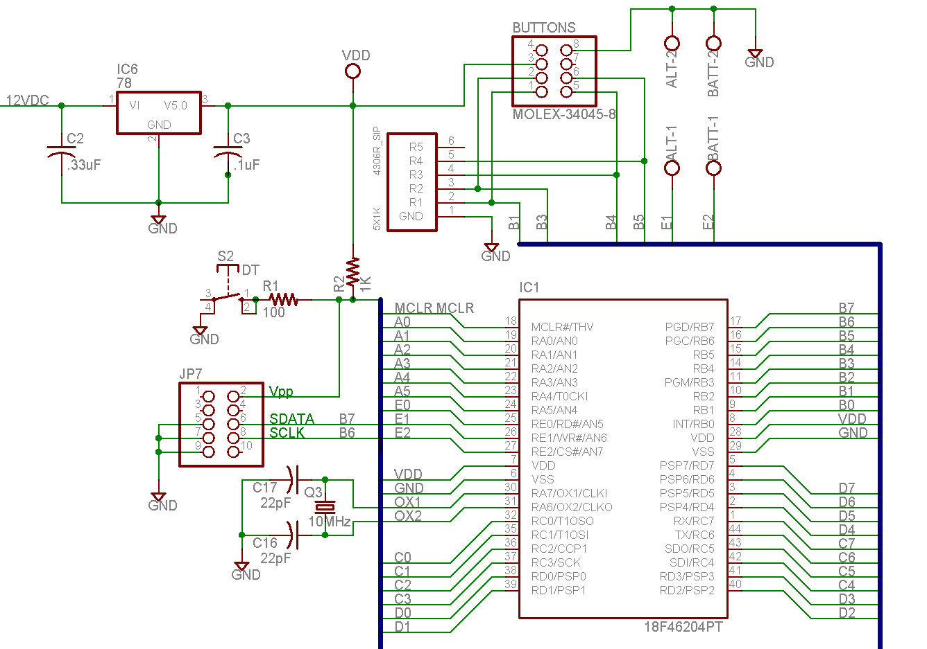

Figure 2: Microchip 18F4620 microcontroller with attached peripherals

-I/O and A/D Considerations:
The 18F4620 has 36 I/O pins. Thirteen of these are multiplexed to the built-in A/D converter. Our system requires only nine of these for sensing six auxiliary currents, one battery current, one alternator current, and one battery voltage. This leaves 27 I/O pins for digital use, and this is just enough.

Pin Name | Use | Pin Name | Use
A0/AN0 | Suite 1 A/D | B3/AN9 | Up Button
A1/AN1 | Suite 2 A/D | B1/AN10 | Menu Button
A2/AN2 | Suite 3 A/D | B4/AN11 | Down Button
A3/AN3 | Suite 4 A/D | B5/AN12 | Set Button
A5/AN4 | Suite 5 A/D | A4/TOCKI | USB enable
E0/AN5 | Suite 6 A/D | A6/CLKO | Crystal
E1/AN6 | Alt Current A/D | A7/CLKI | Crystal
E2/AN7 | Bat Current A/D | C0/T10SO | Suite 5 Switch
B2/AN8 | Bat Voltage A/D | C1/T10SI | Suite 6 Switch
Pin Name | Use | Pin Name | Use
C2/CCP1 | LCD control | D3/PSP3 | Suite 4 Switch
C3/SCK | Clock to EEPROM | D4/PSP4 | LCD bit
C4/SDI | EEPROM data | D5/PSP5 | LCD bit
C5/SDO | LCD control | D6/PSP6 | LCD bit
C6/TX | UART to FT232R | D7/PSP7 | LCD bit
C7/RX | UART to FT232R | B0/INT | USB plugged in
D0/PSP0 | Suite 1 Switch | B6/PGC | Serial Programmer
D1/PSP1 | Suite 2 Switch | B7/PGD | Serial Programmer
D2/PSP2 | Suite 3 Switch | E3/MSRST | Push button reset

The USB interface requires one more I/O pin than used previously to alert the microcontroller when a USB cable has been plugged into the system. The addition of 3 more EEPROMs in our data controller also does not affect I/O use since 4 addressable EEPROMs can be operated from a single bus.

-Processing Considerations:
Team Five-Oi expressed concern over the fact that the UI menu interrupts the main control function. We feel that this is acceptable as long as care is taken in the programming. Instead of waiting for the “set” button to be pushed or for the menu timout to run the control function, the control code should be run quickly in the background every time the user presses a button or on a shorter timer that does not exit the UI menu. The microcontroller is easily fast enough to take, process, and store A/D port readings upon an interrupt without any long delay to the UI menu program.

-Power Considerations:
The microcontroller is low power with the ability to sleep or idle when not processing a task. The microcontroller’s power consumption should be permissible at all times.

Now that we know our microcontroller can handle the requirements of our design, we will look more closely at its function in each task:

-Analog to Digital Conversion:
The 18F4620 has a built-in 10-bit A/D module for converting analog inputs into “raw” numbers between 0 and 1023. The MCU stores the raw data in an EEPROM. When dumping the data or displaying it on the LCD screen, the raw value is converted in the microcontroller to a meaningful value using the sensor’s characteristic.

-Monitoring Battery Health and Vehicle State:
To make informed decisions in some of its other tasks, the microcontroller should maintain some state variables in software that reflect the health of the battery and whether the car is on or off. To determine whether the car (engine) is on or off, the 18F4620 should examine the alternator current level. A significant output of current from the alternator indicates that the engine is running. To determine whether the battery is in a healthy or critical state when the car is on, the 18F4620 should examine the alternator current relative to the outgoing battery current. If the alternator current is larger than the outgoing battery current, the battery is safe. If the outgoing battery current exceeds the alternator current, the 18F4620 should set the state to “critical on.” To determine whether the battery in a healthy or critical state when the car is off, the 18F620 should examine the outgoing battery current. If the battery current is abnormally large for a vehicle that is turned off, the 18F620 should set the state to “critical off.”

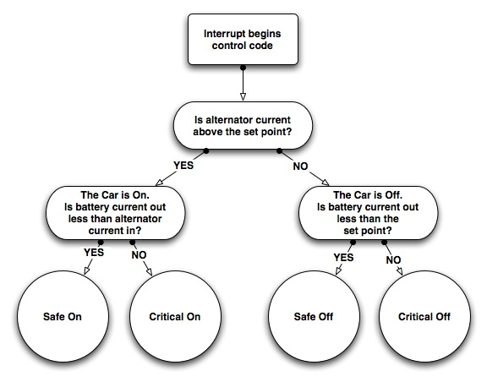

Figure 3: Logic Flow Chart

-Auxiliary Current Shedding:
The 18F4620 uses six digital output ports to control the Linear Technology LTC1255 MOSFET drivers. If the microcontroller sends a high signal to the input of an LTC1255, the LTC1255 drives the gate of the connected FET higher than its source, thus keeping that suite’s current on. If the microcontroller sends a low signal to the input of an LTC1255, the LTC1255 keeps the gate of the connected FET equal to the source, thus switching that suite’s current off. In software, the microcontroller will use information about current loads from the sensing subsystem to determine the overall system’s state as shown in the above diagram. Each of the four overall system states is associated with a loop that switches off auxiliary loads if necessary.

-Programming the MCU:
Programming the MCU requires only a data (B7) and a clock (B6) port. These are hooked up to jumper 7 in the schematic. With this setup, the microcontroller can be easily programmed in the board.

-LCD Display:
The 18F4620 uses 4 I/O ports, D4-D7, as a 4-bit data bus to the LCD display. It uses two additional ports, C2 and C5, to control the data sent to the display. Things sent from the microcontroller to the display include the date and time from the DS1337 I²C real-time clock and the menu interface stored in the microcontroller. The 18F4620 also sends warning messages and status updates to the LCD display.

-User Interface Buttons:
The 18F4620 uses four I/O ports as inputs from the four user interface buttons (B1, B3, B4, and B5). The “menu” button interrupts the program that is running on the microcontroller and begins the UI code. The “up” and “down” buttons, when high, indicate a navigation attempt from the user. The “set” button is used to select options.

-Data Control:
The 18F4620 must write data from the A/D converter results registers and the I²C real-time clock to an EEPROM. It also must read data from the EEPROM via I²C. In our data-collector design, the MCU must also select one of four EEPROMs to read or write. The MCU provides a master clock while reading or writing an EEPROM. The MCU also sends data to the FTDI FT232R in the event of a data dump. These functions are explained in more detail under the data storage and USB interface blocks.

  - Sensing:

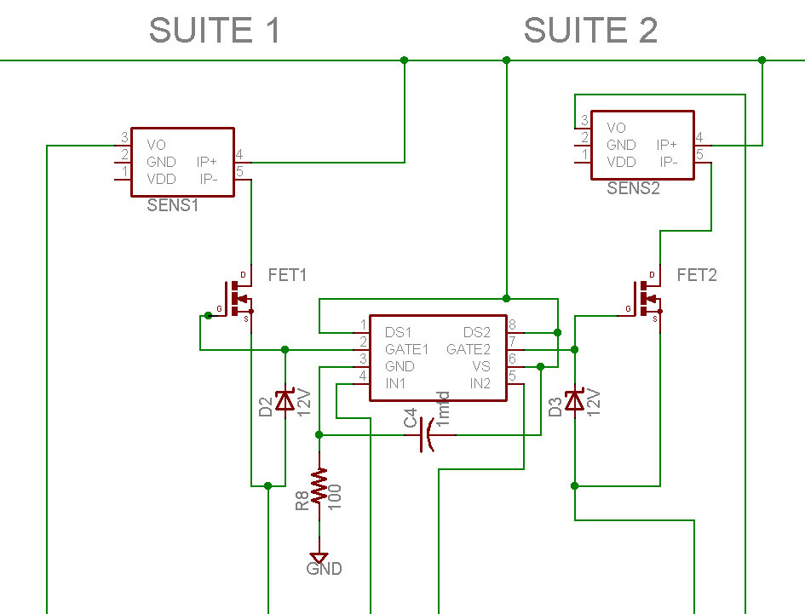

Figure 4: Auxiliary Sensing Stage

-Auxiliary Current Sensing:
The Allegro ACS755xCB-050 chip is our generic auxiliary load current sensing element. This monolithic IC features a Hall effect current sensing element capable of operating linearly with up to 50A of current. Current flows through two wide-dimension leads, and these segments are isolated with a 3kV breakdown rating ensuring that our microcontroller is not exposed to the load voltage. The other side of the device has a ground pin, power pin, and voltage out pin. The output pin returns a voltage proportional to the current flowing through the device centered at V_{DD}/2 so that the device can report positive and negative currents. This output will be digitized by the microcontroller's 10-bit ADC and converted to a current value. Because the power to the devices will actually be flowing through this sensor it is important that it not fail open, leaving the potentially critical device unpowered. Therefore careful consideration was taken when choosing the sensor to minimize this possibility. These Allegro parts are rated to handle 5 times the current they are designed to measure without failing, which means that they can handle 250 A of current continuously. This is far beyond the current rating of any of the devices we are measuring, so the only way the Allegro will be exposed to this level of current is if the device and its protective fuse have catastrophically failed. Care was also taken to heatsink the sensors with plenty of conductor attached to each conducting lead on the PCB.

-Battery Voltage Sensing:
Battery voltage sensing: The battery voltage sensing will be achieved with a simple voltage divider that decreases the voltage by a factor of 3 making the battery nominal voltage 4V. Car electrical systems have a fairly wide range of operating voltages when the alternator is turning but the nominal value is typically 14VDC meaning that when the car is running the microcontroller will see approximately 4.66VDC. This is relatively close to 5V and has a significant probability of exceeding 5V during transients, so to protect the microcontroller, the signal will be fed through an op-amp voltage follower operating from our regulated 5V supply clamping the input to the microcontroller's ADC pin to 5VDC. This again will be read into the microcontroller using its on-board 10-bit ADC and converted into a proper voltage value by multiplication by 3.

-Alternator current sensing:
Our current alternator and battery current sensing systems use the Tamura L01Z200, rated at ±200 A. The Tamura outputs a voltage signal to one of the 12 A/D input pins on the PIC18LF4620 microcontroller, and the voltage swings by ±1.5 volts from a quiescent voltage of 2.5 volts. Since the remote sensors are…remote, a unity-gain amplifier is used to insure the integrity of the signal as it travels to the main system box.

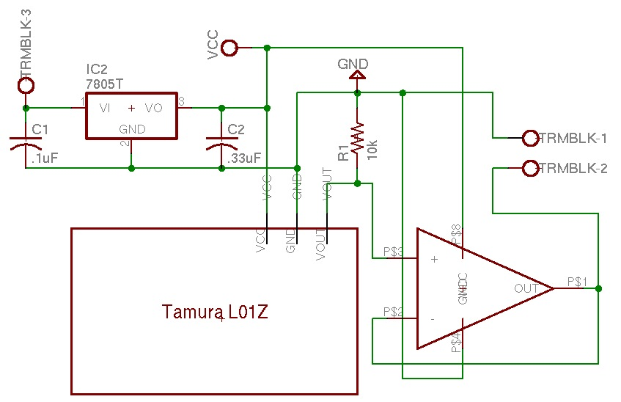

Figure 5: Tamura Battery & Alternator Sensing Circuit
-Battery current sensing:
Measuring the battery current is particularly challenging due to the fact that current into the battery can vary from anywhere between a (negative) charging current on the order of 10-50 A up to the starting current on the order of 500-1000A. After a bit of research we have determined that modern cars have two positive battery cables, one to the starting solenoid, and another to the main power distribution box for all the other loads, so we can neglect the huge starting current in our current sensor design. Still, the battery potentially delivers more than the 200A limit of the largest Allegro current sensor during times such as the car off with all the police accessories running, so we need a sensor capable of reading this level. The Tamura L01Z200105 sensor fits the bill here, being rated for 200 A continuous and having a good threshold for current spikes in the line. We designed two identical boards according to the schematic above, one for the alternator and one for the batter connection. These two Tamura-based sensor setups will be the main method of detecting these large currents and sending the readings into the microcontroller.

5.3) Switching:

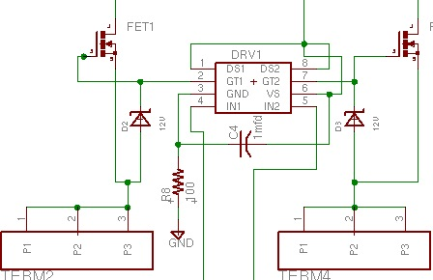

Figure 6: NDP7050 switching nFET attached to LTC1255 MOSFET driver

Our main switching control block is comprised of Fairchild NDP7050 switching NMOSFET transistors driven by Linear Technologies LTC1255 MOSFET drivers. The Linear FET drivers accept a digital input at the IN pin from the microcontroller and switch on or off the Fairchild NFETs. If the input to IN is high, the FET driver increases the potential difference between the gate and source well above Vs, turning the transistor on. The NFETS are in series with the flow of current from the main battery to each auxiliary device and can withstand a high current going through them. These high-current transistors serve as cutoff switches that will disable an auxiliary load when the microcontroller pulls the IN pin low. This Linear Technologies FET driver maintains zero potential difference between the gate and source to turn the e-mode transistor off. There are toggle override switches that will allow the user to directly turn an auxiliary load on or off manually.

  - Data Storage:

Because our unit is acting to help police agencies track down problems with their vehicle's electrical systems, it needs to record the state of all the measured values with some regularity. Since the system is intended to be used to determine the failure of a car's electrical system, it must be able to retain this data even if external power is lost. A battery backed solution would work but is more complicated than is necessary for this application. Therefore, we chose to use nonvolatile memory in the form of I²C EEPROMs to store the historical measurements. These chips can interface directly to the microcontroller's I²C bus for ease of programming and have a data retention rating of over 200 years so they will work perfectly for this application.

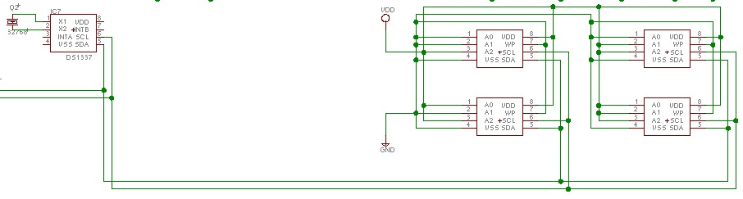
Figure 7: Four Microchip 24LC1025 EEPROMs in series

-Data Collection details:
For data collection, we wish to take many snapshots of the system so that a diagnostic technician can analyze them to see what the problem is. We decided for a baseline we would strive for taking and storing a reading every 5 minutes for a 3 month period. This necessitates the ability to store 26784 frames of data. To determine how big the EEPROM needs to be, we need to calculate the size of our frames. In each frame we need to store 9 10-bit ADC readings and a timestamp. These ADC readings will take 90 bits of data storage and the timestamp, using a Unix-style format, will consume 32 bits of data. For programming ease, a power-of-two sized frame is desired, leaving us with a 128-bit (16-Byte) frame. The data we wish to put in the EEPROM is 122 bits, leaving us with 6 extra bits to apply a parity check such as a 6-bit CRC to detect errors in transmission of the data that would invalidate the samples contained within it.
With the 128-bit frame size and the number of frames we wish to take, we will need 4 Mbits of EEPROM storage to store the data. The largest I²C EEPROM manufactured by Microchip is the 1Mbit part 24LC1025 so we will need to daisy-chain 4 of these on the I²C bus. Fortunately the 24LC1025 allows up to 4 ICs to be daisy-chained together so these chips are a viable solution.

  - USB Interface:

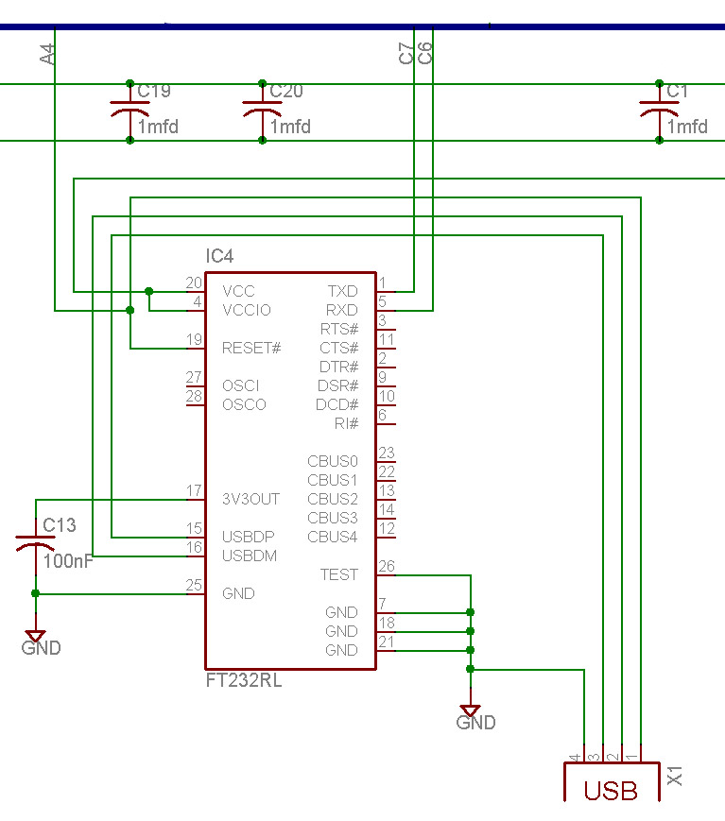

We are replacing the RS-232 serial interface from last year’s design with a USB interface. In doing so, we removed the Maxim RS-232 transceiver from the design and replaced it with an FTDI FT232R chip. Since USB uses a scheduled system to transfer data, there exists the danger of losing data if handshaking is not used [1]. We would have hooked up the RTS and CTS pins of the FT232R to I/O ports B0 and A4, but we needed on port for the USB “plug-in” function. If impletmented, the MCU can pull the CTS pin low to enable data transmission from the FT232R. The FT232R signals to the MCU that its receive buffer is full by dropping RTS low.
Serial data is sent to the FT232R’s RXD pin from the MCU port C6 (TX). Serial data is sent from the FT232R’s TXD pin to the MCU port C7 (RX). Four capacitors and are used to clean up the car battery powered FT232R chip. We are using the internal clock and EEPROM. The FT232R handles all USB handshaking between it and the computer.

6.0) Initial Testing

For the initial testing phase, we constructed our circuit with preliminary prototype parts on a protoboard. During our second milestone review each of the five subsystems were tested. Our test load consisted of several 100 W light bulbs that simulated a standard “device” on a police vehicle. The alternator and battery current sensing boards were also tested using a 12 V automotive battery.

We tested the Allegro sensors with the 100 W bulbs. The bulbs were attached to the switching FET and Allegro sensor board, and all the bulb cables were run through the Tamura sensor. The devices in a police car sink (at the median) around 30 A, so to simulate this we combined five bulbs in parallel to produce a test load that could sink 45 A (8 A per bulb). Our Allegro sensors were able to properly detect the current running through our test load and could output the results to both the connected LCD display and to the storage EEPROMs.

The USB & Storage subsystems were tested by running a Visual Basic script that would read the data from the USB controller, dump the data onto a laptop, and parse the data into a readable format in Excel. This would allow a service technician to properly read the data coming from the internal sensors and troubleshoot any problems that may arise, or to see when the battery needs to be replaced.

7.0) System Integration & Final Test

After soldering and assembling all the final components onto the main board, we integrated the entire system into our test rig, a Dodge Intrepid police cruiser donated by the South Bend Police Department, as well as we could. The cruiser came with all the standard loads that any officer would have in his or her patrol car when on duty. The battery and alternator boards were connected to leads going to the battery and alternator. We constructed our sensor boards to have a 4-gauge wire going through the sensor that would be connected between the battery/alternator and the rest of the car. A third wire of smaller gauge goes from the sensor boards, through the dashboard, and into the main Allegro/logic box. We tried to attach loads inside the car as best as we could without physically damaging the dashboard or existing cables. In the end, we were able to connect several loads, such as the camera, radio, and warning lights and were able to determine proper battery and alternator currents, along with proper load currents. Our system was also able to switch these loads when a demo simulation was run.

9.0) Setup Manual

To begin using our system, one must install the alternator and battery current sensors under the hood of the vehicle and hook up any generic auxiliary loads. There is no efficient or good way of completing this task at this time. After receiving power from the battery, our system will require that you set the time using the user interface. Use the ‘up’ and ‘down’ buttons to alter the variables and press ‘set’ to select them.

10.0) Conclusions

In a year’s time, Team 5-O Mark II was able to get all subsystems of the power management system working and fully integrated. The Team5-Oii Automotive Power Management System (APMS) performed all of the necessary tasks at the demo and was able to fulfill most of the design objectives that we had planned for it. Last year’s team paved the way, and without their work our team would not have gotten as far as we did. We owe much of our success to their work and contribution to the project as a whole. There is still much work that can be done on the design system, specifically pertaining to its installation. This yearlong project was grueling at times and demanded a considerable amount of work and time, but it was a unique experience that gave us insight into how a project can go from an idea on paper to a fully-built, capable system.

11.0) Acknowledgements

Team 5-O Mark II would like to acknowledge the original Team 5-O and their previous work done; their guidance provided a stepping-stone and a direction for the new Team 5-O Mark II during this past year. They would also like to thank Dr. R.M. Schafer, for his guidance and help as advisor during the design process and for keeping them on task and on time. Team 5-O also thanks the South Bend Police Department and Chief Jeff Walters, for his donation of a test patrol car; Notre Dame Security Police Detective Patrick Cottrell, for his continued support and enthusiasm about the project; and Clint Manning, for his technical support and for allowing the senior EEs to take over his electronics lab. The members of Team 5-O Mark II would also like to thank their friends and significant others for their support and patience. Last, but not least, the team would like to acknowledge their fellow senior EEs for all the hard work that everyone has put forth during their last year at Notre Dame.

