University of Notre Dame
Team GreenHouse
Low Level Design
EE Senior Design 2008-2009
Patrick Cash, Angela Comana, Riley Fenlon, Katie Pierret, David Venker
11/25/2008

This is the Low Level Design component of Team GreenHouse’s Electrical Engineering Senior Design 2008-2009 course project. The project described in this document is a wireless sensor network that is capable of detecting fires and directing occupants to a safe exit via informational LED arrows.

Table of Contents

Table of Contents 1
Introduction 2
Problem Statement & Proposed Solution 3
System Description and Block Diagram 4
System Requirements 6
Overall System Requirements 6
Subsystem Requirements 7
Future Enhancements 9

Low Level Design 10
Microcontroller 10
Sensors 12
Power Regulator 12
USB-Serial UART 14
Debugging 14
Directional Indicator Board 15
Wireless Communication 15

Schematic 22
Preliminary Bill of Materials 23
Conclusions 24
References 25

Introduction
Over the past decade, the world has undergone a rapid Information Technology Revolution. Ideas that were once unfeasible due to technological and physical limitations are receiving renewed interest thanks in large part to developments in wireless communications. This movement, in conjunction with environmental calls for increased efficiency in power consumption, has given rise to the idea of a “Smart Building”—a building that actively monitors the conditions and people inside and makes informed decisions about internal temperatures, lighting, and safe exit pathways in the event of an emergency. Today’s buildings are so large in size that a simple fire alarm does not give the occupants enough information for a safe evacuation. For instance, if a fire were to break out on the lower level of a high rise, the people in the upper floors would not know which stairways offer the safest exit. Conventional smoke detectors do not give any information about the localization of the fire.

Our idea is to implement a wireless sensor network with the ability to detect fires and relay the information to a central base station. With the layout of the building taken into consideration, this central base station will then transmit a signal back to the sensor modules and illuminate lighting to indicate the safest route for exit. Our sensor modules and base station will be robust enough for future expansions in other areas related to safety and power efficiency.

Problem Statement & Proposed Solution
The problem we are addressing is the implementation of a sensor network with the purpose of safety applications. By placing sensor boards throughout a building, we will be able to collect information on the building’s status, process and organize this information, and then relay any important information to the building’s occupants. More specifically, the problem will require the following characterizations:

Sensor module boards that…
Operate independently: Sensor boards should be able to operate off battery power for a minimum of two weeks. This may be improved in future iterations, as our focus of this revision is to implement the core functionality.
Detect both fire hazards and people in the area: Temperature sensors will be used to detect fire hazards, while a passive infrared motion detector will be used to detect human presence.
Receive and transmit wireless data with a central base station: This will require the development of a wireless protocol and the designing of a signal architecture. Transmitted information will include data from the sensors, while received information will include LED instructions.
Are presented in practical packaging for robust mounting and aesthetics: Packaging will allow us to protect internal circuitry, as these devices may face environmental hazards. A mounting bracket will secure the module to a wall or ceiling using screws.

A central control board that…
Receives and transmits wireless data with the sensors modules: Central control board will receive sensor information, process the data, and send the appropriate response to each sensor board.
Processes information from sensor boards and responds appropriately: In the case of fire detection, the central control board will determine the location of the fire and tell each sensor module to illuminate appropriate arrows to direct building occupants toward a safe exit.
Communicates with a computer: A computer interface will provide a clean interface for displaying sensor information and processing data.

System Description and Block Diagram
Our project can be broken down into the following functions:
- Main controller board: A central hub device will be used to coordinate information and processing between the individual sensor/control boards. It will have the same wireless capability as the other boards, but may not have the same sensing or controlling capabilities.
  - Computer connection could be used to display information that the controller is processing. As a reach goal, we may try to implement human interactive interface for the device, if time permits.
- Sensor/controller boards: The heart of the project. Each of these self-designed boards will be controlled by a microcontroller and will have the capabilities to process any of our proposed sensors or actuators, though each sensor/actuator may not necessarily be hardware-implemented on every board. Designing a generic, plug-and-play style sensor/controller board will be more cost and time efficient than designing individual, purpose specific boards.
  - Sensors
    - Temperature sensor for the detection of fire hazards
    - Motion detector for determining human presence in an area.
  - Actuators
    - LED indicators that will be enabled to indicate the direction to an exit in case of an emergency
    - Light controller to power on/off room lights
  - Communication
    - S/C boards will communicate via a wireless interface.
    - Communication may either be ad-hoc or a hub-and-spoke based system, although information processing and control will likely occur at a central point
  - Power
    - Devices will be battery powered and be designed to have low operating powers, based on consumption profiles of microcontroller, sensors, actuators, and communication blocks.
Major interfaces between system components include the following: wireless communication between the sensor and main controller boards, transmission of sensory information between a temperature or motion sensor and the sensor board, and implementation of a command between a sensor board and an actuator.
Action information
Communications protocol: ZigBee
Main controller
Sensor/actuator boards
Power, Programming, Clock
Sensor inputs: heat, motion, smoke
Outputs: LED arrows, lights
Power, Programming, Clock
Sensor data
User Interface
RF Link

System Requirements

Overall System Requirements
- Passive network that operates independent of human control
- Sensor modules that can detect fires and human presence
- Sensor modules wirelessly relay information to central base station
- Base station can localize fire in building and identify safest exit path
- Base station wirelessly relays information to sensor modules to illuminate exit lights
- Sensor Module Board
  - Low power consumption via battery power source that lasts a minimum of two weeks
  - Utilize passive infrared sensor to detect human presence within 5 ft.
  - Detect fire with ambient temperature above 100°C using a temperature sensor
  - Digest input from sensors and wirelessly relay relevant information
  - Receive wireless communication from controller and light LED arrows to illuminate safe pathway
- Central Base Station
  - Low power consumption (<200 mA) via AC power adaptor plugged into 120 VAC outlet
  - Poll wireless sensor network (<1min per sensor) for information in controlled fashion
  - Take network inputs to locate human presence and fire in a building
  - Use location information to determine safest exit routes
  - Send wireless command to sensor network to illuminate correct LED’s on exit route

Subsystem Requirements
- Microcontroller
  - 3.3V logic
  - SPI interface for Zigbee communications and temperature sensor
  - Additional pins for chip select on SPI
  - 4 additional pins for Zigbee
  - USART for USB connection
  - 8 pins for LCD display
  - DC to DC converter for the 5V LCD logic
  - 2 pins for passive IR sensor
  - Multiple pins for LED control
  - Internal timer
  - SPI EEPROM for nonvolatile storage
  - Interrupt capabilities
  - Surface mount packaging
  - Low power consumption

I/O | Pins required
SPI | 3
Zigbee | 4
chip select | 2
LCD | 8
USART | 4
PIR | 1
LED | 2
Total | 24
- Sensors
  - Presence detection
  - Temperature, via SPI interface
- Power
  - Regulator
    - Provide 3.3V from an input of 6-12V
    - Source, at a maximum, at least 300mA
  - Batteries
    - Removable and/or rechargeable
    - Small package, so can easily be integrated into the device enclosure
    - Lifetime of over two weeks under normal device operation
- USB-Serial UART
  - Serial to USB conversions
  - Enable programming of microcontroller over USB from computer
  - Enable communications between central base station to display debug and informational data
- Debugging
  - LCD screen to display text
  - Pin headers for testing
- Directional indicators
  - Indicate the direction of a safe exit
  - Maintain low power consumption
- Wireless Protocol
  - Relay information indicating fire and human presence
  - Periodic transmission able to handle multiple transmitters on the network
  - Collision detection so no data is lost
  - Identification of which sensor on network is sending information
  - Route information through other sensor modules to base station to enable farther reach of system

Future Enhancements
- Control of building HVAC system from the ambient temperature sensor
- Control of lighting and outlets based on human presence in the area
- Wider mesh network that can span multiple floors
- Lower power consumption for longer battery life
- Base station interface with a computer for easy network implementation
  - Quick addition of sensors to network
  - Easy relocation of sensors on the floor layout
  - Easy editing of floor layout

Low Level Design

Microcontroller
A number of affordable microcontrollers easily meet our microcontroller requirements. This system does not require a significant amount of processing speed or memory given today’s standards. We want to choose a controller to fit our requirements, but also have some extra I/O pins for the easy addition of other sensors and applications. We are currently projecting using 23 I/O pins. While a controller with 25 I/O pins may be a long term, cost effective solution, choosing a controller with a few extra I/O pins will allow for some flexibility in the prototyping stage. Our choice for our microcontroller is the PIC18F4525, which is essentially a scaled down version of the 4620. This controller fits our specifications while providing extra I/O pins (36 total). Additionally, the nearly 4kB of RAM, 48kB of memory, and 1kB of EEPROM data are higher than most other controllers of this size and price range, providing us a buffer on those requirements. That extra space will allow us to proceed with the rest of the project without concerning ourselves with those specifications until cost becomes more of a concern in a production unit. We decided that having multiple SPI interfaces and onboard USB would be unnecessary. These issues will be addressed using chip select pins for SPI, and a serial to USB converter for communications with a PC.

Testing procedures for microcontroller:
To test the microcontroller, we can use the procedures developed in the tasks. Simple code, such as that in Task 8b, can be written to output values to each of the output pins. With the logic analyzer, we can look at these pins to check that they are outputting as the code demands.

Microcontroller pin assignments
Pin Number | Name | Use | Input/Output | Variable or fixed
1 | RC7/RX/DT | USART | input | fixed
2 | RD4/PSP4 | LCD | output | variable
3 | RD5/PSP5/P1B | LCD | output | variable
4 | RD6/PSP6/P1C | LCD | output | variable
5 | RD7/PSP7/P1D | LCD | output | variable
6 | VSS | VSS |  | fixed
7 | VDD | VDD |  | fixed
8 | RB0/INT0/FLTO/AN12 | Zigbee interrupt | input | fixed
9 | RB1/INT1/AN10 | Interrupt | input
10 | RB2/INT2/AN8 | Interrupt | input
11 | RB3/AN9/CCP2 | LEDs | output | variable
12 | NC |  |  | fixed
13 | NC |  |  | fixed
14 | RB4/KBI0/AN11 | LEDs | output | variable
15 | RB5/KB11/PGM | programming enable | input | fixed
16 | RB6/KBI2/PGC | programming clock | input | fixed
17 | RB7/KBI3/PGD | programming data | input | fixed
18 | MCLR/Vpp/RE3 | MCLR or prgm input | input | fixed
19 | RA0/AN0
20 | RA1/AN1
21 | RA2/AN2/Vref-
22 | RA3/AN3/Vref+
23 | RA4/TOCKI/C1out
24 | RA5/AN4/SS/HLVDIN/C2out
25 | RE0/RD/AN5 | LCD | output | variable
26 | RE1/WR/AN6 | LCD | output | variable
27 | RE2/CS/AN7 | Temp chip select | output | variable
28 | VDD | VDD |  | fixed
29 | VSS | VSS |  | fixed
30 | OSC1/CLK1/RA7 | clock | input | fixed
31 | OSC2/CLKO/RA6 | clock | output | fixed
32 | RC0/T1OSI/CCP2 | PIR sensor | input | variable
33 | NC |  |  | fixed
34 | NC |  |  | fixed
35 | RC1/T1OSI/CCP2 | EEPROM chip select | output | variable
36 | RC2/CCP1/P1A | Zigbee sleep | output | variable
37 | RC3/SCK/SCL | SPI CLK | output | fixed
38 | RD0/PSP0 | Zigbee chip select | output | variable
39 | RD1/PSP1 | Ziebee reset | output | variable
40 | RD2/PSP2 | RTS# | input | variable
41 | RD3/PSP3 | CTS# | output | variable
42 | RC4/SDI/SDA | SPI in | input | fixed
43 | RC5/SDO | SPI out | output | fixed
44 | RC6/TX/CK | USART | output | fixed

Sensors
After consideration of features and costs, we have decided to connect a thermostat to our sensor boards rather than a smoke detector. The thermostat will be used for fire detection; an infrared sensor will be used to detect human presence. We have chosen the following two sensors to place in our network.

Microchip TC77-5.0MCTTR - $1.35
- Outputs a 12 bit value of temperature – no ADC required
- Operates up to 125 ºC
- 3.3V logic
- Ability to communicate via SPI interface
- http://delta.octopart.com/Microchip__TC77-5.0MCTTR.pdf
Parallax Inc. PIR Sensor - $9.99
  - Needs an ADC and a 3 pin connection
  - 3.3V and 5V operation with <100uA current draw
  - 20 ft. range
  - Sample code and schematics online
  - http://www.parallax.com/Portals/0/Downloads/docs/prod/audiovis/PIRSensor-V1.2.pdf
Testing procedures for sensor devices:
For the PIR sensor: First we will check to make sure the sensor is working by testing the voltage output when a person walks by. Then we will program the chip to take the input and have an LED light when a person walks past. We can test the range by having more LEDs light up as a person becomes closer to the sensor and fewer as they become farther away.
For the Temperature sensor: We will program the microcontroller and check to see that the initial temperature is the ambient temperature. We can then light a match under the sensor and check that the temperature raises, also verifying that the rate of rising changes based on distance of match from sensor. Finally, we will set a threshold and check that when the threshold is crossed, an interrupt is generated.

Power Regulator
Our sensor boards and main controller boards will run off 3.3V logic. Also, all of our ICs and sensors can be powered with 3.3V. Since, we will have lower current draw, it will only be necessary for the board voltage regulators to source 100mA maximum. Thus, we selected the National Semiconductor LM2937-3.3, which provides a single 3.3V output and sources up to 500mA.

 | National LM2937-3.3
Cost | $2.05
Output Voltage | 3.3 V
Output Tolerance | ±3%
Output Current | 500 mA
Input Voltage (min) | 4.75 V
Quiescent Current | 2 mA
Coupling Caps | 0.1 uF, 10 uF

Major Component | Voltage (V) | Current (mA) |  | Active Duty Cycle | Avg Current (mA) | Avg Power (mW) | %Total
 |  | Idle | Active
USB-Serial UART (FT232RL) | 3.3 | 0.07 | 15 | 0% | 0.07 | 0.23 | 1%
Zigbee (AT86RF231) | 3.3 | 0.4 | 13.75 | 10% | 1.74 | 5.73 | 21%
Microcontroller (PIC18F4525) | 3.3 | 0.0025 | 0.011 | 100% | 0.01 | 0.04 | 0%
Vreg (LM2937-3.3) | 3.3 | 0 | 2 | 100% | 2.00 | 6.60 | 24%
LEDs | 3.3 | 4 | 14 | 5% | 4.50 | 14.85 | 54%
PIR | 3.3 | 0.0001 | 0.1 | 10% | 0.01 | 0.03 | 0%
Temperature Sensor | 3.3 | 0.0001 | 0.25 | 10% | 0.03 | 0.08 | 0%
 |  |  |  | Totals | 8.35 | 27.56 | 100%

Battery | Capacity (mAh) | Voltage (V) | Lifetime (h) | Lifetime (days)
Single 9V non-rechargable | 600 | 9.0 | 71.85 | 2.99
Four AA non-rechargable | 2600 | 6.0 | 311.33 | 12.97
Four High Capactiy AA non-rechargable | 6000 | 6.0 | 718.46 | 29.94
Four Energizer NiMH AA rechargable | 10000 | 6.0 | 1197.44 | 49.89

Testing procedures – Power:

The voltage regulator and accompanying circuitry will be soldered to the board before the other components. Once this is connected, we will inspect the board for shorts and disconnects, using a DMM. The power supply will be connected to the board, and the output voltage from the voltage regulator will be verified to be within its specified range.

USB-Serial UART
A USB interface will allow us to connect to a computer in order to download the necessary code for our network to function. USB could also be used as a power source.

FTDI FT232RL - $4.50
- Internal Clock
- Single chip USB to asynchronous serial data transfer interface
- Entire USB protocol handled on the chip
- +3.3V to +5.25V Single Supply Operation

Testing procedures – USB:
After programming the FT232RL chip to interface with our microcontroller, we will test USB communications. Assuming the device installs correctly on a computer using the manufacturer-provided driver, we will open a serial communication port with the device. We will send a predetermined message (e.g., a string of characters such as "test") over the communications port to the FT232RL chip, which will relay the message to our microcontroller. The microcontroller will be programmed in its main loop to continually check for new data in its serial buffer. This data will be compared with the predetermined message. When a match is detected, the microcontroller will light up a debugging LED or send a message to the LCD.

Debugging
Our sensor and controller boards need to be equipped with debugging tools, to allow multiple forms of troubleshooting. We are going to populate our boards with both an LCD display and various types of LEDs.

Hitachi’s HD44780U
This LCD display is the display that is contained in our senior design kit. It is a convenient choice, as we are already familiar with many of its characteristics. This device has the capacity to display 80 characters, although not all of them are visible on the LCD screen. The display is capable of operating on 3.3 V, so will require no extra voltage conversion circuitry on the board. The device also has low power consumption, which is essential to a battery-run circuit board.

Directional Indicator Board
The LEDs used on the directional indicator board need to be bright to ensure their visibility in an emergency. Thus, we chose LEDs rated with a high luminosity and viewing angle.

SuperBrightLeds.com RL5-R12120
- Wavelength – 625 nm
- Intensity – 300 mCd
- Viewing Angle – 120 degrees
- Forward Voltage – 1.8 V
- Current – 10 mA
- Power – 18 mW

SuperBrightLeds.com RL5-G16120
- Wavelength – 523 nm
- Intensity – 400 mCd
- Viewing Angle – 120 degrees
- Forward Voltage – 2.9 V
- Current – 5 mA
- Power – 14.5 mW

Testing for emergency exit LEDs:

The testing will be done by sending different commands to the LED circuitry. First, we will verify that the LEDs are always off unless a fire is detected. Then a command will be sent to the microcontroller to indicate that a fire has occurred, including instructions as to which direction the arrow should point. We will check that the arrow has been lit and that it is pointing in the correct direction.

Wireless Communication
We have decided to use Zigbee specification as our form of wireless communication between the base station and the sensor modules. Zigbee is the cost effective and low power wireless alternative that made it more attractive for our project over competitors like Bluetooth. It operates at 2.4GHz globally and can transmit at data rates from 250kbit/s to 2 Mbit/s.
A wide variety of signal routing frameworks including point-to-point, star, mesh, and cluster tree are supported. Our signal architecture will be a variation of the point-to-point model and function as shown in Figure 1 below.

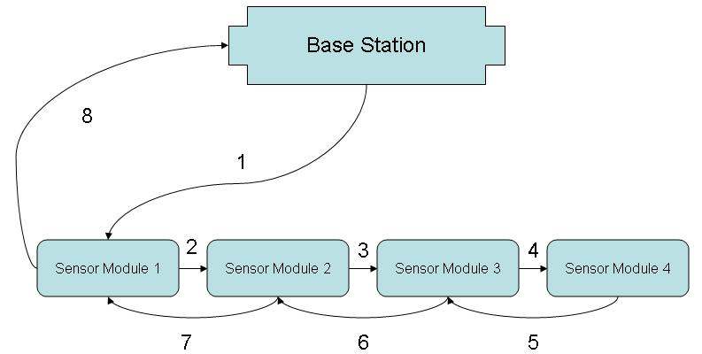
Figure 1: Signal flow to farthest sensor module

Notice, that for the signal to reach the furthest sensor, Sensor Module 4, the signal must be routed by all three closer sensor modules. We understand that this is a rather redundant and inefficient system, but it ensures the most reliable communication of the signal. Each transceiver can reach a range of 10-75m, but our range will be on the lower end of that spectrum because we will be operating indoors and expecting the signal to pass through thick, concrete walls. The network will consist of three types of transceivers:
(1) Zigbee coordinator: one of these in each network will control main routing
(2) Zigbee router: passes data between other devices
(3) Zigbee end device: cannot route packages, but can talk to other units
In our network, the central base station acts as the coordinator and the sensor modules act as the routers and the end devices. Zigbee communications can occur on a beacon (periodic transmission) or non-beacon (continuous transmission) network. The beacon network is preferable because it leads to less power consumption and it drains the batteries more symmetrically. A central router in the network, for instance, would have its battery drained faster in a non-beacon framework. One drawback to this design is that the signal from peripheral sensor modules is not immediately sent to the central base station—there will be inherent latency (~1 s) to the network, which is acceptable. A significant problem will be timing when the Zigbee transceivers will be listening and transmitting because they cannot do both at the same time. It makes sense to have the base station transmit and receive for longer durations because it does not have to operate on battery power and then have the sensor modules listen for brief periods of time to see if a signal pertains to them.
The Zigbee transceiver comes complete with many built in functions, but we will still need to do a significant amount of programming. At the ground level, the transceiver must be able to initialize the SPI interface and send/receive data over the SPI. The next step would be to write functions that could read/write to registers. With these basics taken care of, higher level functions like detecting valid 802.15.4 packages, setting bits in our frame, and setting states for the transceiver will be written. The finite state machine of the transceiver is shown below.
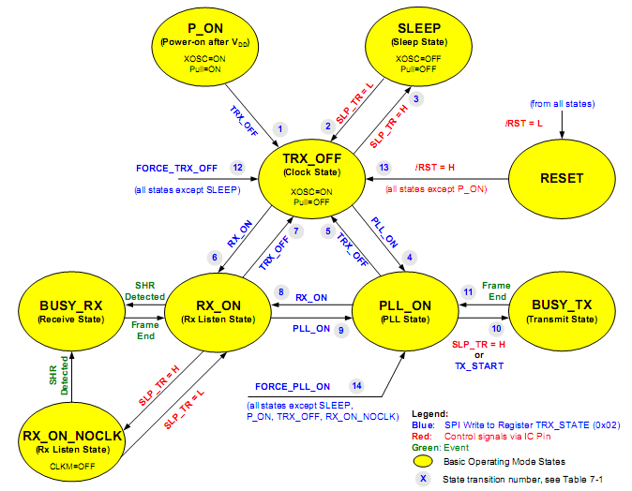
Considering that there are so many levels to the development of the software for the transceivers, it is logical to break the testing of this subsystem down by level. After we check that the daughter card receives power, we will test the various levels, starting at Level 0 and ending at Level 3. The following table summarizes the functions to be tested for each level in the design.

Testing Procedure
Level 0 | Init_SPI | Writes to proper configuration registers to initialize SPI communication between the micro and the transceiver
Level 0 | read_SPI | Writes to proper configuration registers to read SPI data
Level 0 | write_SPI | Writes to proper configuration registers to write SPI data
Level 1 | Write_reg | Writes to a register on transceiver
Level 1 | Read_reg | Reads a register on transceiver
Level 2 | Valid_pack | Checks to see if packet received is a valid 802.15.4 signal
Level 2 | Set_addr | Sets the address of module to send packet
Level 2 | Set_xmit_pow | Sets power of the transmission
Level 2 | Set_fire | Sensor sets fire bit
Level 2 | Set_channel | Sets channel of transmission
Level 2 | Set_evac | Base station sets evac bit
Level 2 | Set_state | Sets the next state of the transceiver
Level 3 | Xmit_frame | Sends our frame
Level 3 | Rxd_frame | Receives a frame

The frames referenced in Level 2 and 3 of the design will be the heart of the wireless transmissions. They will consist of a 4-bit destination address to let all of the modules know where the signal should be routed. Also, the frame contains a fire bit to be set if the sensor detects a fire, an evac bit to indicate if an evacuation is underway, and an evac_dir bit to let the sensor module know which LED’s to illuminate. After the functions are written and the transceiver is confirmed to be operating properly, we will begin writing our higher level code to meet the needs of our individual units. The central base station will run under considerably different software than the sensor module. Pseudocode for each unit is given in the below figures.
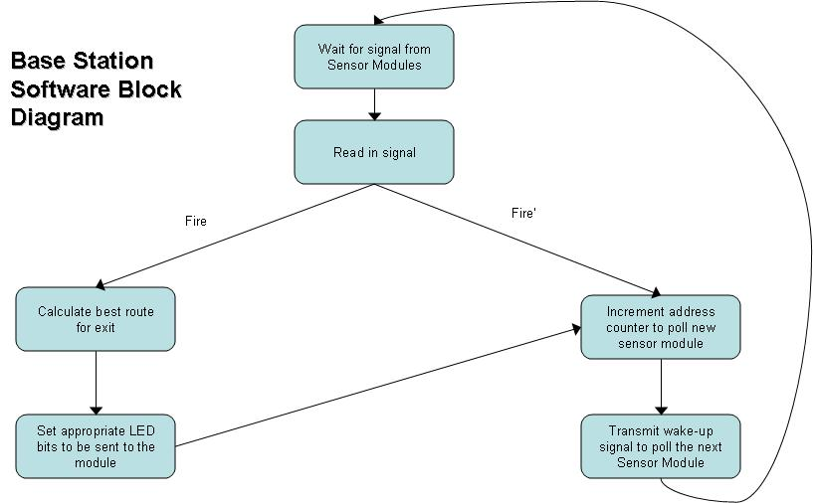
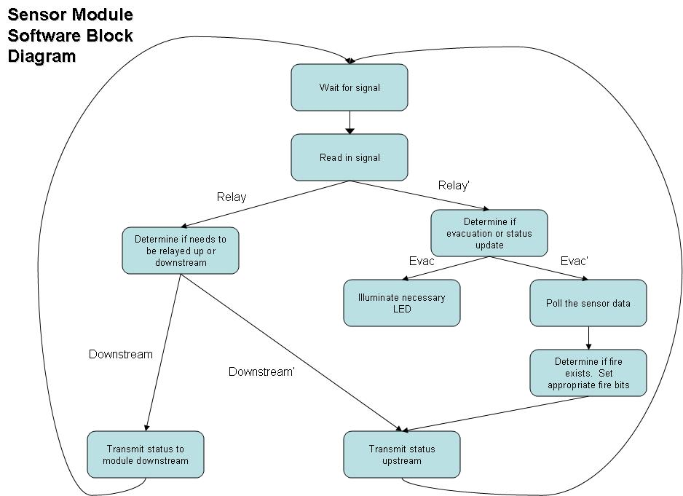
As can be seen from the figures, the base station and the sensor modules will operate as finite state machines in a manner similar to the transceiver. We have chosen the Atmel AT86RF231 as the IC transceiver. Its supply voltage and currents for each mode of operation are shown in the table below.
AT86RF231
IC Type | Transceiver
Operating Frequency | 2.4 GHz
Channels | 16
Supply Voltages | 2.0V – 3.4V
Transceiver Sleep Mode Current | 0.02 uA
Transceiver Idle Mode Current | 0.4 mA
Transmit Mode Current | 14.3 mA
Receive Mode Current | 13.2 mA
Single unit price | $3.52

The ATMEL transceiver will require a few external components as shown in the figure below. From the diagram, we can see that we will need an antenna, crystal oscillator, and decoupling capacitors. These external components, however, will not have any connections to the microcontroller. The transceiver is connected via an SPI interface and 3 other input/output controls as shown in the figure below. The CLKM will not be used because it makes more sense to run the transceiver from the microcontroller, rather than the other way around. The DIG2 is connected to ground.

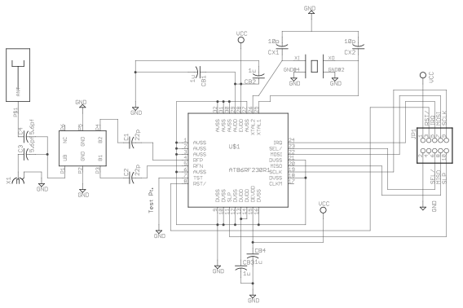

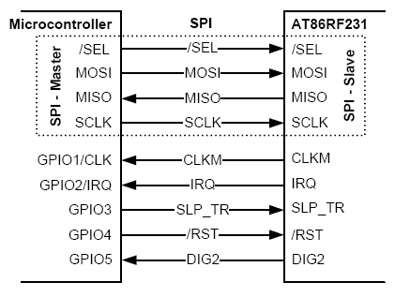

Schematic
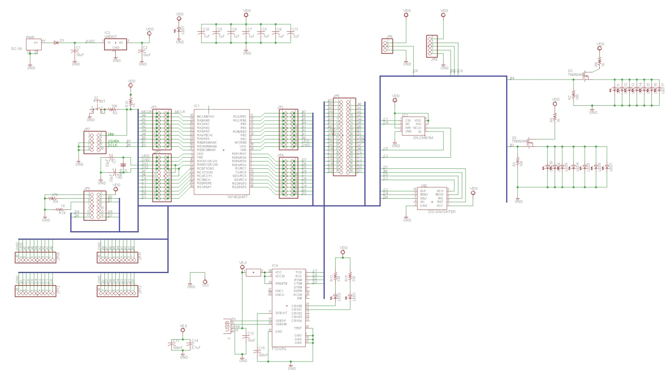

Preliminary Bill of Materials
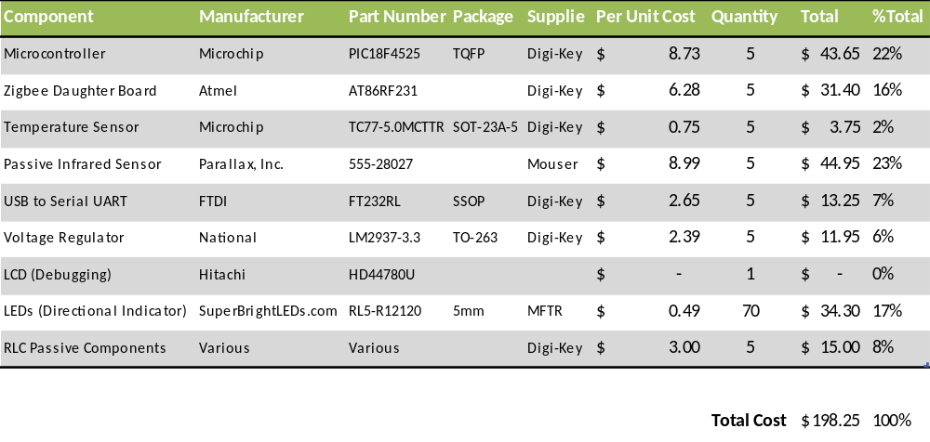

Conclusions
Smart buildings are a hot topic in control systems today. The ability to passively control the basic functions of a building can provide a large degree of freedom and safety. Our group will be focusing on creating a safety system that can detect and localize fire in a large building. A passive sensor network will detect human presence and fire in a building. The sensors in the network will wirelessly send this information to a controller that will process the information. It will make decisions using where the fire and people are located to determine the safest exit route. Using the safest exit route, it will send a command signal to light a safe exit route with LED arrows on the sensor boards. We have identified the major components of this system, chosen specific parts to equip our circuit, and made a schematic diagram for our circuit boards. We have also created a testing plan to verify the abilities of our network. Through this low-level design, we have established a detailed plan for our sensor network, which, after further optimizations and future enhancements, will be constructed to create smart building.

References
Mouser.com
Microchip.com
http://pdf.directindustry.com/

