Home Monitoring Sensor Network
Final Report

5/5/2010

Eroding Sines:

Kat Engstrom
Scott Garvey
Dan Myers
Mike Padberg

Table of Contents

Introduction 4
Problem Statement and Proposed Solution Error! Bookmark not defined.
System Description and Block Diagram 7
System Requirements 9
Overall System Requirements: 9
Subsystem Requirements: 9
Future Requirements: 10
Low Level Design 10
SitePlayer 10
Website Functionality 13
Cron 13
Wireless Communication 13
Basic Software Flow 17
Central Node 17
Secondary Nodes 17
Sensors 18
Temperature Sensor: 18
Light Sensor 19
Passive Infrared Sensor 19
Power Relay 20
Power 22
System Integration Testing 22
Installation and Setup Instructions 25
How to Tell It is Working 26
Troubleshooting Guide 26
If you try all of this, and still nothing will upload, email dmyers4@gmail.com 27
Conclusion 27
Appendices 28
Schematics & Circuit Board 28
Complete Software listings 31
Siteplayer Software 31
Microcontroller Software 34
Bill of Materials 50
References 51

Introduction
Technology is a key example of human evolution. As we progress, our technology improves to offer more support in daily life. The home is the focal point of human life. A given room is generally used fairly inefficiently. It is intuitive to apply technology to the home as it incorporates itself more thoroughly into our lives. A “Smart Home” is created through a sensor network that connects to a base. Sensor networks are able to collect data and organize this data into an efficient system for the home owner to process. Internet monitoring allows for easy accessibility.
Every year, consumers become more and more dependent upon new electrical gadgets. Most of these gadgets have one thing in common: standby power. People find it much easier to keep their chargers constantly plugged in, regardless of whether they are actually charging. Electronic appliances that are plugged in, but turned off or in a standby mode, consume electric power known as standby power. Standby power is also known as vampire power or phantom load. Our technology will actually alleviate vampire power instead of increase it.
Our goal is to monitor power consumption and reduce this standby power. The more that we are aware of a problem, the more opportunity we have to alleviate it. With real-time monitoring, a user can better understand where their power goes. The PlayStation 3 has been reported to use as much as 35W when on idle. Further, a user can employ her power more efficiently. Standby power wastes energy, generates unnecessary heat, and increases fire risks. A single appliance does not draw that much power, but an American home has an average of forty products constantly drawing standby power. Less vampire power means less weight on power plants. Less weight on power plants is better for the environment. Efficient energy saves money, saves lives, and saves the environment.
Another use for our system is to turn off items in a home that have been left on and are consuming full power, not only the relatively smaller amount used by standby power consumption. For example a light sensor may be placed near a lamp which would enable the user to determine if a light has been left on and cut the power to it in order to save energy.
The goal of the Electrical Engineering Senior Design project was to create a fully functional prototype of a design which utilizes an Eagle-designed circuit board and programming of a specific microchip. Team Eroding Sines decided to create a wireless sensor network, such as one utilized in a “smart home.” The main advantages of this network would be that it would provide otherwise un-utilized data regarding a room system and would also be able to cut back on energy waste. Our project was basically "making every home a smart home."
Eroding Sines is a team of four individuals with different specialties and interests. To accomplish this project within a limited timeline, it was necessary to divide up the work so that each member was in charge of a sub-task. The high-level topic division was decided last semester. Kat was in charge of the website/GUI interface. Scott was in charge of the microchip software and zigbee communication. Dan dealt with all of the hardware accessories, such as the power relay and different sensors. Mike handled all of the Eagle board design. We met weekly to update the group and Professor Schafer as to the project as a whole. Each member of the group rotated through positions in the weekly meetings. These weekly meetings rotate through the group with each member having the opportunity to be group leader and in charge of minutes.
Essentially our project was to make a wireless sensor network. This sensor network was made out of nodes. The nodes contained our board along with sensors to detect light, temperature, and motion. A node would be placed in a room and would gather information about the location via the three sensors. Then, the node would transmit this information via Zigbee to the central node. Zigbee is a wireless communication device that uses radio frequencies to send messages. The only hardware difference between the central node and the peripheral nodes is that the central node is plugged into an ethernet jack and has the Siteplayer attachment installed. Once the information has made it to the central node, the central node loads this data to a website via a Siteplayer. The Siteplayer is an embedded ethernet server. The Siteplayer displays the raw data it has gathered on the website, "Serial.htm." This information is then processed using perl. Perl is a scripting language that is particularly adept at handling text. If a device is plugged into one of our nodes, the user can turn the device on and off via the website's GUI. Anything can be controlled that draws less than 10 A. This is possible due to a power relay installed in every node. A heavier load can easily be accommodated with the installation of a different relay.
Last semester, our idea for the project was fairly similar. The only major difference is that we refined our sensor accessories to only 3 sensors for the prototype: light, temperature, and motion. We believe these sensors provided the most relevant data for the average user. In the future, it would be very easy to add additional sensors to gather more data. For example, a GPS would allow easier movement of a node so that the user no longer has to keep track of where each node is. We also switched from "locking/unlocking a door" via the GUI to the more flexible turning something on or off. This switch allowed a more practical skill and better incorporated with our design theme of going green. Not only can you monitor how often the lights are left one, you can turn them off if you're not at home. Similarly, it is also very easy to program the node so that if there is no motion in the room, the accessory which is plugged into the node is turned off. A 100 watt lightbulb spends 750kWatt-hours per year if left on. A single node only draws 63-kWatt hours. If a node is used to continually turn off a wasted lightbulb, up to 687kWatt-hours could be saved. This way, the node not only provides information that allows a better understanding of waste, it actually eliminates waste.
The final design definitely met expectations. It fulfills all of our expected requirements. It would've been very helpful to get a second board design in, but we were able to correct all of the mistakes on the first version. The temperature node is not as accurate as we would like, but otherwise everything performs acceptably. It would also be useful to have a stronger power relay in the future, but for the average user, the power relay rating is completely acceptable. We hadn't thought of minimizing the board last semester, but having created a board it definitely seems feasible to cut off at least 30% of it. Although functional, it would also be helpful to choose a microchip which would be easier to solder. Our current microchip is much more powerful than what we need. By switching microchips, we could cut cost and make production easier.

System Description and Block Diagram
Central Node

Power Relay
PIR sensor

Light Sensor
MicroController
Temp Sensor

SitePlayer
ZigBee

Node

Node

ZigBee
PIR sensor

ZigBee
PIR sensor

MicroController
MicroController

Light Sensor
Power Relay
Temp Sensor
Power Relay

Temp Sensor
Light Sensor

Central Node vs. Secondary Nodes– There are several significant differences in the role of the central node. The first of these is that the central node is the only one which is actually connected to the internet through the SitePlayer. It gathers data from all of the secondary nodes and sends the total information gathered. By sending the information to the SitePlayer we will display the sensor data on the internet for the user to view and possibly act on. The SitePlayer will also allow input from the internet so that the user is able to send a signal to the nodes. This will be used to turn on or off the power relays attached to the nodes. The other difference in the design of the central node is how the ZigBee communication will operate. The secondary nodes will only need to talk to the central node. The central node will have to use its ZigBee transceiver to talk to all of the secondary nodes relaying information between those nodes and the SitePlayer.
SitePlayer – The central node differs from the other nodes primarily by the addition of a SitePlayer. The SitePlayer will allow us to post all of our nodes’ sensor data on the internet for access from anywhere with a web browser. The SitePlayer will also allow a user to send a signal from her web browser to the microcontroller telling it to enable or disable the power relay.
Temperature Sensor - Each of our nodes will be equipped with a temperature sensor. This will enable each node to determine the temperature of its environment and send that information to the central node to be displayed.
Light Sensor - Each of our nodes will also be equipped with a light sensor. This will enable each node to determine the intensity of light where the sensor is placed and display it.
PIR Sensor – The PIR Sensor will be used to check rooms for occupancy and give this information to central node.
ZigBee – Each node will be equipped with a ZigBee Transceiver in order to send or receive the readings of sensors and instructions to operate its power relay.
Power Relay– A power relay will be controlled by each microcontroller and will enable the user to turn on and off appliances from a remote location. This could be useful in many situations to save power when appliances are left on or to turn them off fully to eliminate standby power.

System Requirements

Overall System Requirements:
- Sensor Data is transferred to central node from secondary nodes using ZigBee wireless communication.
- Central node transmits orders to secondary nodes to control the power relays attached to them.
- Central node displays sensor data from all nodes on a web page via SitePlayer.
- SitePlayer can receive a command from the internet and transmit this command to the Central node’s microcontroller.
- Low power usage. Using a large amount of power would defeat the purpose of the project.

Subsystem Requirements:
- Wireless transceivers
  - Central node is able to communicate with multiple secondary nodes.
  - Central node must know which secondary node is sending sensor data in order to control the proper relay.
  - Transceivers should be able to transmit data 50 feet so that secondary nodes can be a reasonable distance from the central node.
- Microcontroller
- Pins for connecting programmer to microcontroller
- Pins for receiving data from sensors
- USART for USB connection
- SPI interface for communicating with ZigBee transceivers
- Serial interface for communication with the SitePlayer attached to central node.

Future Requirements:
- Allow secondary nodes to forward messages to and from the central node in order to extend the range of the sensor network.
- Allow automatic programming through website to turn appliances on and off at certain times of the day or month.
- Additional sensors in order to increase the capabilities of the monitoring aspect of our sensor network.

Low Level Design

SitePlayer

The SitePlayer communicates with the PIC18LF6722 microcontroller through a serial interface. This communication is accomplished by connecting ground, send and receive lines as shown in below. One thing that must be kept in mind for the physical connection is that the microcontroller runs at 3.3V while the SitePlayer operates at 5V. The SitePlayer threshold voltage is low enough that it sees a logic 1 at 3.3V. This means that no modification is needed on the line from the microcontroller to the SitePlayer. The 5V output from the SitePlayer is too high to be allowed to directly connect to the microcontroller. This could cause the pin on the microcontroller to fail. The microcontroller pins have protective diodes to Vdd and Ground which allow a 5V connection as long as the current is kept sufficiently low. To protect from this, a 20K resister is placed between the two pins which will limit the current to a maximum of 250 micro amps.

PIC to SP
SP to PIC
PIC18LF6722
SitePlayer
Web
Ethernet
10-Base T Filter
Ground
Pin 6
GND
Pin 8
Pin 7
C6
C7

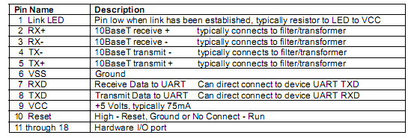

In our implementation all communication between the microcontroller and the SitePlayer will be initiated from the central microcontroller. The SitePlayer is purely responsive. Packets sent to the SitePlayer are between 2 and 19 bytes. The first byte of the transmission is the command byte which informs the SitePlayer what action is to be taken. The form of the packet and the available commands are shown below.

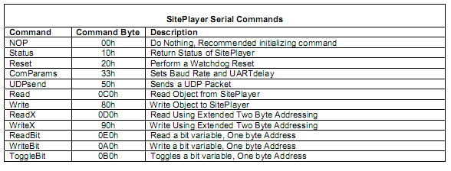

Upon startup 20 bytes of nulls or NOP commands are sent to the microcontroller. At this point it can be known that the SitePlayer is not in the middle of any function and is ready to accept new commands. The SitePlayer is then sent a command which will properly set the IP address in use. This is necessary since a static IP is being used. This command is not actually listed in the software manual but pc program serial tester has this function which was able to be adapted for use on the microcontroller.
All sensor data accumulated on the central node is sent to the SitePlayer using the Write command at a regular interval. WriteX is not needed since 8 bit addressing is sufficient for our purpose. This data will then be read from our website in order to be put on display for the user. When any data needs to be sent from the internet to the microcontroller a byte is first changed on the SitePlayer through the web interface. There is no interrupt from the SitePlayer since this is not a time sensitive application. Using the Read command, the microcontroller will poll a byte on the SitePlayer at regular intervals that contains information on what lights should be on or off. This information is then sent to the relevant node so that it can be put to use.
The subsystem has been tested on the SPK1 development board included in the SitePlayer development kit. The SitePlayer is viewable over the network and it is possible to write to and read from the SitePlayer/website. The first thing that will need to be tested when the 10-base t Ethernet filter is ordered is that the circuit diagram we have designed will allow the SP1 to properly connect to the internet. Communication between the SitePlayer and microcontroller should not be affected by removing the development board.
The SitePlayer does involve some programming outside of the microcontroller. The HTML for the website to be hosted is very similar to normal HMTL. There are some keywords that can be used which will display the value of an object in the SitePlayer memory as shown below. The website will consist of the readings from the various sensors on the network as well as a method of changing whether the light at a certain node should be lit. An object can be changed on the SitePlayer with a button form displayed on the website. For example “<b><font size="4"><a href="Serial.spi?object7=118"> Set object 7 to v(decimal 118) </a></font> </b><br>” will display a button that will change object 7 to decimal value 118 when clicked.

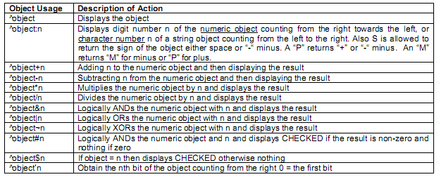

Website Functionality
The user uses a website to monitor the nodes from anywhere she wishes. The raw data is initially created through the Siteplayer’s use of a static IP Address. Once this initial page is available at erodingsines.ee.nd.edu, a perl script extracts the necessary data to run helpful statistics and creates a webpage at ee.nd.edu/~kengstro/kat.cgi. By putting this information on the internet, the user has access and control of the power relays connected to the node regardless of her geographic location. She also has an easily readable breakdown of exactly what’s on/off, temperature, etc at any given time. Since information for all of the nodes is sent to the website via the central node, the user will have more information than if she was at a single given location. It will be very easy to compare the energy load in location to another because all locations will be displayed simultaneously. Because the data is displayed in such an organized manner, the website will facilitate power management of all locations covered by the nodes.

Cron
Archiving all of the data was accomplished with the combination of a second perl script (katOutput.pl) and cron. The second perl script appends the output.txt text file by adding the current data at the start of the hour. The script is run by using cron, which is a unix time-based job scheduler. By archiving all of the data, we have created a system of record keeping. Record keeping allows this information to be archived in a database. The more time that information is allowed to be collected, the better understanding the user will have of general usage trends at any given node. The user will know when peak hours are and when a location is unlikely to be in use. If a location is given over to a new user, this new user will be able to gain a better understanding of how the location is used by quickly looking at past trends.

Wireless Communication
Our wireless communication will be accomplished using the ZigBee specification based on the IEEE 802.15.4-2003 standard for wireless personal area networks. The low cost, low power and accessibility made this the specification best suited to meet our needs. We will use the AT86RF231 Atmel Zigbee daughter card in order to provide wireless capability. This chip can be powered at the same 3.3 V that our board operates at and operates at 2.4 GHz. The transfer rate is limited to 250 Kbits/s which is well above what is required for our scenario.
In order to conserve battery life as much as possible for secondary nodes they will refrain from transmitting and receiving as much as possible. The central node will always be connected to AC power which will allow it to always remain on and ready to receive transmissions from the secondary nodes. The secondary nodes will periodically, every minute or so, come online and send their data to the central node. For our demo the secondary nodes were not put to sleep in order to more easily demonstrate functionality. These secondary nodes will then stay in a receive state for a brief time in order to allow the central node to reply with whether their relay should be supplying power to any device connected. There is no time sensitive data being transmitted in the system which allows ZigBee power consumption to remain at a minimum. This all means that a beacon (periodic transmission) network will be utilized in order to conserve power as much as possible. Source addressing will be used so that the nodes are able to determine which is supposed to be receiving the transmission. The packet will contain five bytes of payload consisting of the node address, the status of the three sensors and the current status of the power relay.
The basic functions for operation of the ZigBee transceiver have been completed. These are listed below.
Function Name | Description
Init_zigbee | Initializes Microcontroller to properly communicate with the ZigBee transceiver
Reset_zigbee | Flips the reset pin connected to the transceiver
Read_spi_reg | Reads a register on the transceiver through the SPI interface
Write_spi_reg | Writes to a register on the transceiver through the SPI interface
receive_frame | When a transmit end interrupt is found, this reads the frame that has been received
Generate_frame | Creates a frame to be sent carrying sensor data
Write_frame | Writes the generated frame to the transceiver to be sent when placed in transmit state. This is only called from the generate_frame function.
Zig_state | Function used to change the state of the ZigBee Transceiver(Finite State Machine shown below)

The structure of the packet used is as follows :
Byte 1 | Byte2 | Byte 3 | Byte 4 | Byte 5
Node Address | Temp data | Light Data | PIR data | Relay

The Node address simply states which node the data refers to. This allows secondary nodes to verify that data from the central node is intended for them. It also allows the central node to update the proper sensor data on the SitePlayer. The relay status is not transmitted from secondary to central nodes, only the other way. Likewise no sensor data is sent from the central node to the secondary node. The secondary node only reports its sensor data.

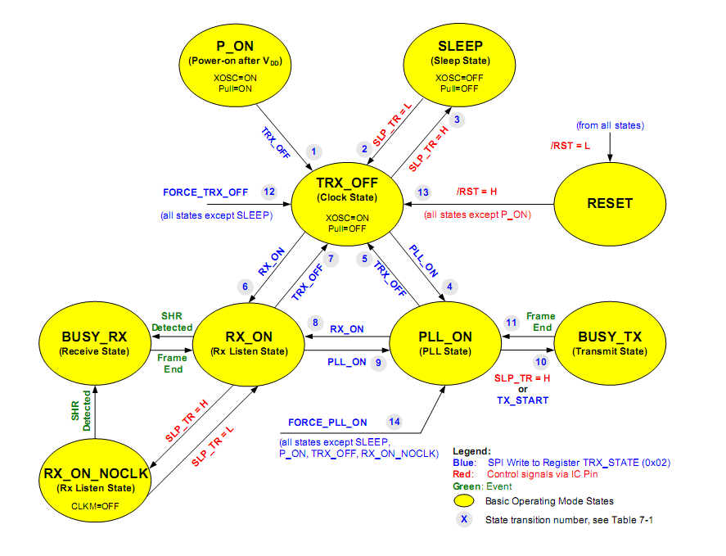
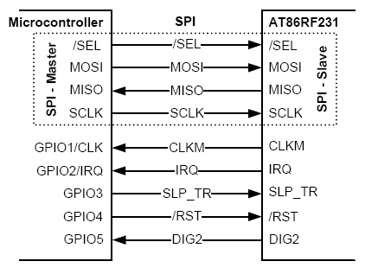
The connections between the ZigBee and microcontroller are shown below and in more detail in the schematic section.

Basic Software Flow

Central Node

Wait for sensor data from secondary nodes

Check central node sensor data
Send all sensor data to SitePlayer, check for relay information

Send relay information as response back to secondary nodes.
Set Relay attached to central node

Secondary Nodes

Check Sensor Data

Send Sensor data to central node
Wait for next transmission
If no response

Wait for response from central node
Set Relay as instructed

Sensors

Temperature Sensor:
Our chosen temperature sensor will be an LM19, manufactured by National Semiconductor. At 3.5V supply voltage, the range of accurate measurements is -55°C to 130°C, which is greater than our application will need, but it seems to be the range of most temperature sensors out there. It is most accurate in the middle of this range, ~30°C, where it will be ±2.5°C. It follows our objective of being very lower power, as the current drawn by the device is only 10 μA, and being such low power, it heats up less than 0.02°C.
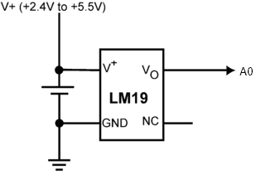
V+ will be connected to the supply voltage on the board, GND will be grounded, and Vo will be connected to an analog to digital pin, A0. Currently for testing purposes, the ADC outputs its data to the LCD in the form of 2V = 200 displayed, or 1.5V = 150 displayed.

Function Name | Description
enable_ADC(A0) | Sets A0 as an analog, sets time to wait until pin stabilizes; turns on the ADC module and starts the conversion; waits again until conversion has completed.
display_ADC_temp | Formats the output from enable_ADC into voltage and displays it on the LCD screen into X number of hundredths of a volt. Eventually this will be converted to display the temperature that voltage corresponds to.

Light Sensor
A TEPT5700, an NPN phototransistor, was chosen to be our ambient light sensor. It is designed to detect light in the same range that the human eye is sensitive to. It is T-1¾ style packaging, and has a very large angle that it can detect light from. This will also be a very low power device, with the current being drawn by it determined by the resistor connected between collector and ground. A 10k ohm resistor was chosen, making the maximum current drawn by the device to be .35mA.
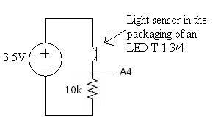
The emitter of the device will be connected to our supply voltage, the base is the detector itself, and the collector is connected to the 10k resistor. The output of the circuit is the voltage on the 10k resistor, being set by the current through it. The output will be connected to an analog to digital pin, A4. The programming for this device will be exactly the same as the temperature sensor, except with A0 changing to A4, and ADC_temp changing to ADC_light, with the correct conversions displaying how many lumen it is receiving, or displaying whether the light in the room is on or off.

Passive Infrared Sensor
A passive infrared sensor was also chosen to be used to detect motion. A Parallax PIR 555-28027 was chosen because it can detect motion up to 20 feet away, it is fairly small and cheap, and it has a 3-pin header which will easily allow us to mount the sensor on the case and wire it to the board. Another very nice feature is that it is single pin output—puts a digital 1 out if there is motion, and puts a digital 0 if there is none detected.
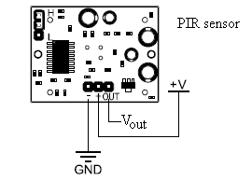
As before, V+ goes to the 3.5V supply of our board, GND goes to ground, and this time, Vout will go to a digital i/o pin, R2 (also labeled A2). The programming will be even simpler for this one, just one function to set up R2 as a digital input, and the other to output on the LCD whether there is movement or not—R2 = 1 or 0.

Power Relay
An Omron G6C-1 power relay was chosen because it is basically a single pull single throw switch. We only need it to control one device, so this perfectly meets our needs, taking up less space than choosing a larger one which can control multiple devices. It takes 2.9V to turn on the relay, which is lower than our supply voltage, but it does take 30mA to turn it on at 3.5V. This could be a problem, but only our modules which will be plugged into the wall will feature power relays, so consuming too much power from the battery will not be an issue. What could have been an issue is that 30mA is a large portion of the voltage that the regulators on our board can put out; however, the relay works with an input voltage up to 24V, so it can be connected directly to the power brick, as shown in the circuit below.
Also, 30mA is way too high to be drawn directly from the microcontroller itself, so a mosfet will be connected between the relay and the microcontroller to provide the required current. The current choice of mosfet is MTP3055VL; it is designed to work up to 12A, which is a little overkill for our project, but it is designed to work directly from logic drivers, which is what we are using it for. The other good thing it has is an internal source-drain diode, which removes our need for adding in an extra diode to block the back EMF of the relay.
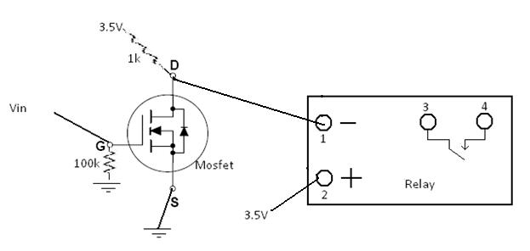
So if Vin is a digital 0, Vin=0V, the mosfet D terminal is being held at 3.5V by the 1k resistor. This keeps pin 2 at 3.5V, which means the relay does not have >3V across pins 1 and 2, which means the switch between pins 3 and 4 is open. If Vin is a digital 1, 3.5V, D is now electrically connected to S, which makes pin 2 0V. There are now 3.5V across pins 1 and 2 on the relay, closing the switch, turning on whatever device is to be controlled. The 100k resistor is there to pull the voltage at G down to zero whenever the device is first turned on, and the pin controlling Vin has not been yet set to a digital output. Pin RA3 (A3) is going to be controlling the voltage at Vin.

Power
Power can be provided by either a 9V battery or from AC power. Each node has an AC power socket with a detachable power cord so that if a battery is used the AC cord won’t be in the way. From the socket, AC power is split and sent to an AC/DC converter (9V) and to a relay to power a light socket. A switch (on the outside of the case) switches the board’s power source from the AC/DC converter to a 9V battery. Power can also be provided by USB, but this is for troubleshooting only and will not be readily accessible.
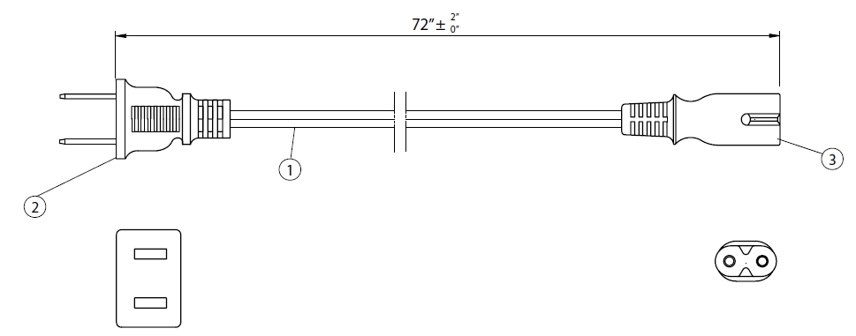
Power in socket
9v battery
AC/DC
board
relay
Power out socket
Power switch

Power schematic.

On the board itself is a 3.3v voltage regulator and a 5v DC/DC converter. The 3.3v regulator steps the 9 volts (from the AC/DC converter or battery) down to 3.3 volts for the board components to use. The 5v converter steps the 3.3 volts up for use by the SitePlayer.

System Integration Testing

The testing procedure for the circuit board evolved over time. The first board was tested before and after the microcontroller was soldered for shorts. None were found, so the rest of the components were soldered in place. A short was discovered in this board and the cause was unknown (at the time). So a new testing strategy was devised. The board was tested for shorts after the microcontroller was soldered. The power supply circuitry was then soldered in place and the board was tested to make sure it powered up. From then on, after each new set of parts was soldered, the board would be tested to see if it powered up. If the power light did not come on then there was a short. During this preliminary testing it was discovered a ground connection to a pin was missing. We fixed it by scratching the protective coating off the ground plain near the pin and connecting it with a blob of solder.
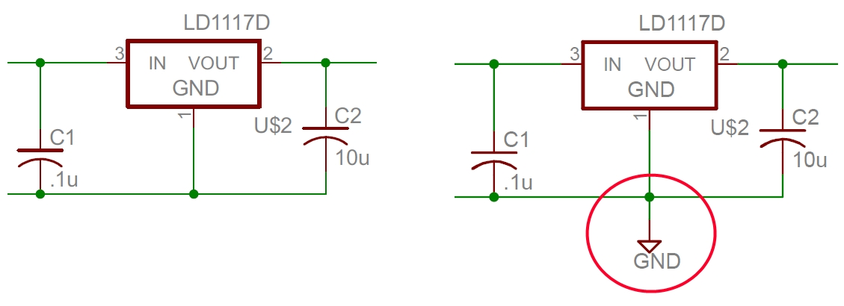
Corrected ground error on schematic.
This testing procedure led to the discovery of a small solder short by a via. This turned out to be the problem of the original board as well. After soldering everything in place, two of the boards mysteriously shorted and the cause could not be found. When power was supplied to these boards, it was noticed that the temperature became quite hot. After further examination, it was determined that the temperature sensors on these two boards were faulty and were causing said short. It is still unknown whether the temperature sensors were defective or damaged in the soldering process.
Once the boards were fully soldered, an attempt was made to program them, but the microcontrollers were not recognized by the programmer. After examination of the schematic and board, it was discovered that the MCLR pin had been omitted due to a mislabeling on the schematic. A wire was soldered in place to remedy this problem. After the microcontroller could be programmed the LCD was used to test each system. The microcontroller would display the test program’s progress along with sensor readings.
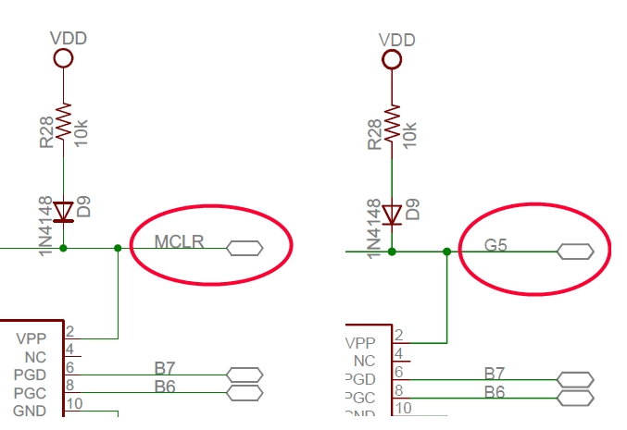
Corrected MCLR pin labeling schematic.
The relay which controlled a light was found to not function properly. After more examination of schematic and data sheets, it was discovered that our original design had a flaw. Switching two connections on the relay would solve the problem. The original connections were dremelled out and wires were soldered in place. This solved the problem.
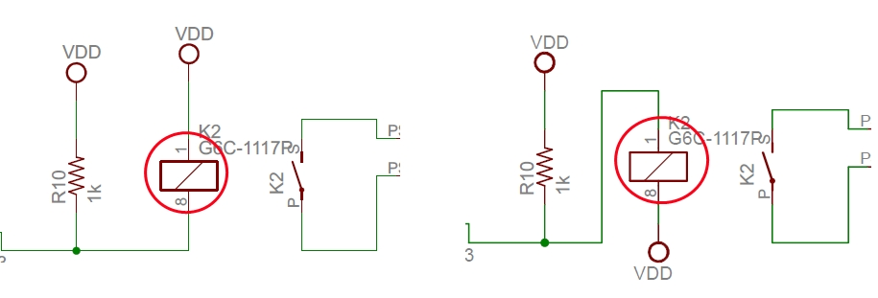
Corrected relay schematic.
Further testing with the LCD revealed that two boards had slower timing than they should have. Things printed to the LCD every tenth of a second only printed about once every 5 seconds. It was surmised that the oscillators were either malfunctioning or missoldered. Due to the small size and surface mount nature, the oscillators could not be repaired. These boards were set aside.

Installation and Setup Instructions

Thank you for purchasing the Eroding Sines wireless home sensor network. The system is designed to gather data on how much power is being wasted in a room by detecting what the temperature in the room is, if lights are turned on, and whether or not anyone is currently in the room. It displays this data to a webpage which can be viewed from any location, even via cellular phone. If the user determines that no one is currently in a room, with just one mouse click the light in a room can be turned off, or any other devices plugged into one of the nodes. It can even be programmed to automatically turn off the light if no motion has been detected in the last few minutes, and turn on the light when motion is seen.
Choose one of the devices to be the main unit. The main unit needs to be centrally located in your house, and must be plugged into 120Vac and also an Ethernet port. This device will be uploading data it receives wirelessly from the other devices to a web page.
After choosing which device is the main unit, the user must open the container and set the dip switches to 00000000. Each additional unit to be used in the system must be opened and given a different number. For example, 00000001, 00000010, 00000011...through 00001111. Each additional device may be run through wall power, or by battery power, depending on what capabilities are desired at that node. The user must take care that all jumper wires from the sensors are plugged into their respective locations, as they will be unplugged so the user can change the dip switches.
Once all devices are configured and internal wires reconnected, the user should take each device to the room that it is to be used in. The devices are guaranteed to work at least 50 feet away, in a normal household, but they may work further. The user should go to the first room with the 00000001 device, plug in the battery or plug it into the wall, and plug a light into the outlet on the device, if desired. The relays on the boards are rated at 10A, so most small electronics that the user wants to plug into the node should work, but the maximum amperage should be followed. Finally the user should place each additional device in desired locations.

How to Tell It is Working

When installing each node, check to make sure that when you plug in the power cord or place in batteries that an LED glows on the board. After that, go to the website mentioned above and check to see if any of the values for sensor data are being uploaded. If there is a light plugged into any of the devices, try toggling the relay value of that device from the webpage to see if it turns on and off. If it is unclear whether or not the data is being uploaded, cover up the motion sensor on the top of the device (the big round thing poking out the top) and check to see if PIR data goes to 0. If it already was at 0, wave your hand over the device repeatedly until it changes to a 1. One can also try turning on and off a nearby light to see if the light sensor data changes.

Troubleshooting Guide

First, get the main unit powered up and uploading data. Check to see if the main unit is plugged into the wall, and that the SitePlayer is also plugged in. Make sure that the switch on the board is set to wall power instead of battery power on the main board. Once the LEDs turn on, next make sure that the Ethernet cable is plugged into both the board and your cable box or other sort of hub. It will not work to plug it into a laptop with wireless Internet. If it is still not uploading data at this time, try refreshing the webpage. If it is still not uploading, check to make sure that all of the jumper wires are plugged in properly; if there are any wires that are not connected to anything, check the schematic to figure out where it goes.
Next check each auxiliary node's board to see if an LED is on. If the LED is not on, check to make sure the switch on the board is set to the on position, and the switch on the box is set to proper power source (i.e. batteries or wall power). If it still won't power on at this point, check to make sure all jumper wires are properly plugged in. Once it powers on, check to see if it will upload data to the webpage. If not, then try moving the node to a closer location (like right next to the central unit) and see if it uploads. If it uploads there, then the previous location was too far away for the devices to communicate, so choose a closer location for the auxiliary unit, or move the central hub closer to the secondary location. If both spots are set in stone, or well within the 50 foot range, try changing the channel on all of the devices, as there may be some interference from 2.4GHz phones or wireless Internet routers. Change the channel by changing the first four dip switch settings. The main unit should currently be set to 00000000; change that to 00010000, and all additional nodes to 0001xxxx, x's denoting to leave that current setting alone.
If you get the first device uploading to the internet, but when you install a second device, neither of them will upload, or the data starts doing strange things, check to be sure that each node has a different dip switch setting. The first auxiliary node should be xxxx0001, the second should be xxxx0010.

If you try all of this, and still nothing will upload, email dmyers4@gmail.com

Conclusion
Our sensor network should allow a new level of observation and control of homes even when away from home. Our project as detailed above should allow a reduction in power consumption due to standby power from simply leaving devices on when away at work or on vacation. While many people are all for saving energy it can be very inconvenient to have to unplug everything when not in use. Not many people are going to reach behind their TVs and unplug whenever they are not watching. Turning off devices through a web interface would be much easier for the average person and would likely increase energy savings. People can also forget to turn off lights and various electronics when away from home. Our system will allow users to still be able to turn these off whenever it crosses their mind. This saves money and provides peace of mind. The savings from this reduction in power could add up substantially over the course of a year as a watt used to power a device costs approximately one dollar per year.

Appendices

Schematics & Circuit Board
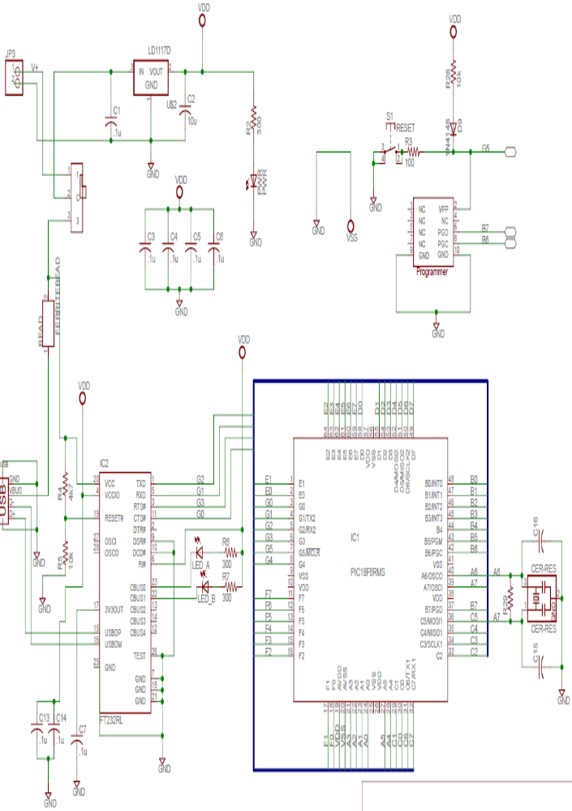
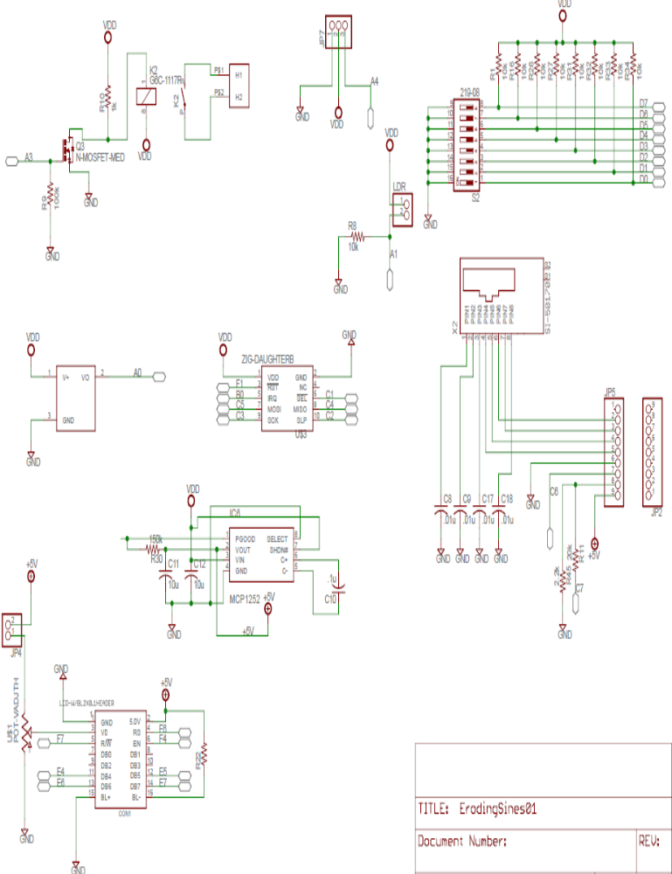

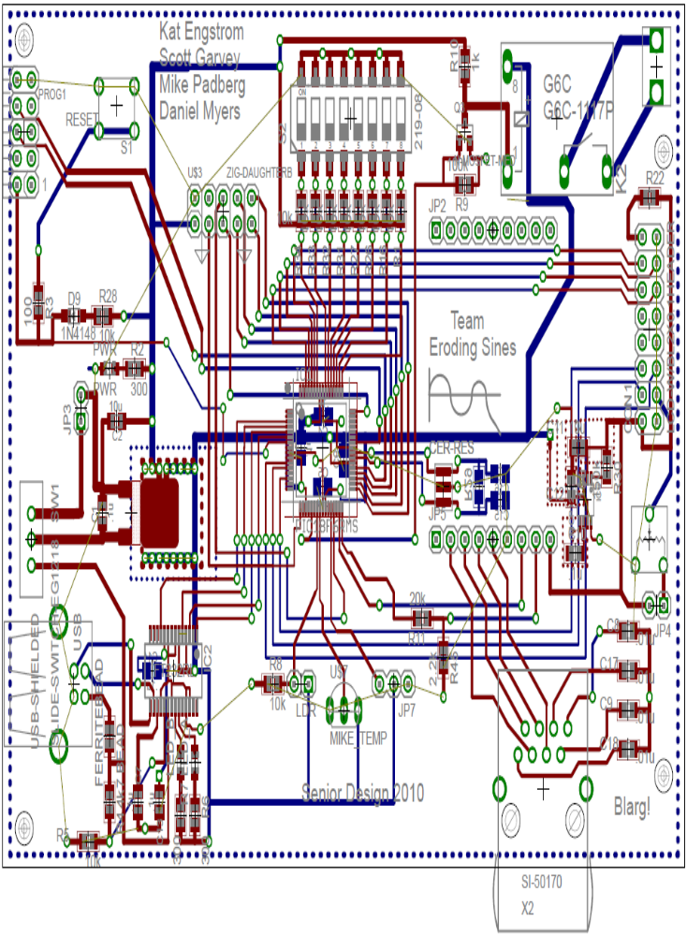

Complete Software listings

Siteplayer Software
/////////////////////////////////////
Ser_dem.inc
; siteplayer include file
; eroding sines 4/30

org 0h
object1 db 5;
object2 db 5;
object3 db 5;
object4 db 5;
object5 db 5;
object6 db 5;
object7 db 5;
object8 db 5;
object9 db 5;
object10 db 5;
object11 db 5;
object12 db 5;
object13 db 5;
object14 db 5;
object15 db 5;
object16 db 5;
object17 db 5;
object18 db 5;
object19 db 5;
object20 db 5;
object21 db 5;
object22 db 5;
object23 db 5;
object24 db 5;
object25 db 5;
object26 db 5;
object27 db 5;
object28 db 5;
object29 db 5;
object30 db 5;
object31 db 5;
object32 db 5;
object33 db 5;
object34 db 5;
object35 db 5;
object36 db 5;
object37 db 5;
object38 db 5;
object39 db 5;
object40 db 5;
object41 db 5;
object42 db 5;
object43 db 5;
object44 db 5;
object45 db 5;
object46 db 5;
object47 db 5;
object48 db 5;
object49 db 5;
object50 db 5;
object51 db 5;
object52 db 5;
object53 db 5;
object54 db 5;
object55 db 5;
object56 db 5;
object57 db 5;
object58 db 5;
object59 db 5;
object60 db 5;
object61 db 5;
object62 db 5;
object63 db 5;
object64 db 5;

org 0ff11h
io0 ds 1 ;Port 1 Bit number 0

org 0ff12h
io1 ds 1 ;Port 1 Bit number 1 connect to button 2

org 0ff13h
io2 ds 1 ;Port 1 Bit number 2 connected to button 3

org 0ff14h
io3 ds 1 ;Port 1 Bit number 3

org 0ff15h
io4 ds 1 ;Port 1 Bit number 4

org 0ff16h
io5 ds 1 ;Port 1 Bit number 5

org 0ff17h
io6 ds 1 ;Port 1 Bit number 6

org 0ff18h
io7 ds 1 ;Port 1 Bit number 7

org 0FF19h
COM ds 128 ;serial port output (only takes up really one byte)

/////////////////////////////////////

/////////////////////////////////////

serial.htm ( with only first three nodes listed)
<HTML>
<HEAD>
<TITLE>SitePlayer Test</TITLE>
</HEAD>
<BODY>

Central Node
<br>
0Temp:^object1 <br>
0Light:^object2 <br>
0PIR:^object3 <br>
0Relay:^object4 <br>

<b><font size="4"><a href="Serial.spi?object4=0"> Turn central relay on</a></font></b><br>
<b><font size="4"><a href="Serial.spi?object4=1"> Turn central relay off</a></font></b><br>
<br>

Node Number 1
<br>
1Temp:^object5 <br>
1Light:^object6 <br>
1PIR:^object7 <br>
1Relay:^object8 <br>

<b><font size="4"><a href="Serial.spi?object8=0"> Turn relay 1 on</a></font></b><br>
<b><font size="4"><a href="Serial.spi?object8=1"> Turn relay 1 off</a></font></b><br>
<br>
Node Number 2
<br>
2Temp:^object9 <br>
2Light:^object10 <br>
2PIR:^object11 <br>
2Relay:^object12 <br>

<b><font size="4"><a href="Serial.spi?object12=0"> Turn relay 2 on</a></font></b><br>
<b><font size="4"><a href="Serial.spi?object12=1"> Turn relay 2 off</a></font></b><br>
<br>

</BODY>
</HTML>
//////////////////////////////////////////

Microcontroller Software
///////////////////////////////////////////////////////////
serialLib.h
#ifndef _SERIALLIB_H_
#define _SERIALLIB_H_
#include<system.h>

// convienient data types

//#define byte char

/* ports for the standard LCD for the 0809 boards */
/*
* Ports naming -- needs to be expanded to use same
* scheme for graphics LCD
* */

/* LCD Routines
*
* */

void init_usart(unsigned short rate); // rate is placed in SPBRG
void putc(char value); //send ascii character to terminal
char getc(void); // get ascii character from terminal
void init_usart1(unsigned short rate); // rate is placed in SPBRG
void putc1(char value); //send ascii character to terminal
char getc1(void); // get ascii character from terminal
void writesite(char location, char regval); // write to siteplayer
char readsite(char location); // read siteplayer register and return value

void enable_ADC_1(void); //runs adc on an1
void enable_ADC_0(void); //runs adc on an1
void toggle_light(void);
void DCin4(void);
void getDip(void);

#endif
///////////////////////////////////////////////
serialLib.c

#include <system.h>
#include "serialLib.h"
#include "LCDlib_4.h"

volatile bit TXSTA2_TX9@TXSTA2.6;
volatile bit TXSTA2_SYNC@TXSTA2.4;
volatile bit TXSTA2_BRGH@TXSTA2.2;
volatile bit TXSTA2_TXEN@TXSTA2.5;
volatile bit BAUDCON2_BRG16@BAUDCON2.3;
volatile bit TXSTA2_TRMT@TXSTA2.1;
volatile char SER_spbrgh2@SPBRGH2;
volatile char SER_spbrg2@SPBRG2; //added
volatile char SER_txreg2@TXREG2;
volatile bit PIR3_RC2IF@PIR3.5; //added for getc()
volatile char SER_rcreg2@RCREG2; //added for getc()

volatile bit PIR3_RC2IE@PIR3.5; //added for getc()
//volatile bit INTCON_PEIE@INTCON.6; //added for getc()
//volatile bit INTCON_GIE@INTCON.7; //added for getc()
volatile bit RCSTA2_SPEN@RCSTA2.7;
volatile bit RCSTA2_RX9@RCSTA2.6;
volatile bit RCSTA2_CREN@RCSTA2.4;

volatile char SER_txreg1@TXREG1; // siteplayer transmit
volatile bit TXSTA1_TRMT@TXSTA1.1;
volatile bit PIR1_RC2IF@PIR1.5;
volatile char SER_rcreg1@RCREG1;

volatile bit SEL_ZIGBEE@LATE.1;
volatile bit ssp1if@SSP1STAT.0;
volatile bit interr@PIR1.3;
volatile bit wrcol@SSPCON1.7;

void init_usart(unsigned short rate)
{
TXSTA2_TX9 = 0;
TXSTA2_BRGH = 1; //changed to 0 and back to 1
TXSTA2_SYNC = 0;
BAUDCON2_BRG16 = 1;
RCSTA2_SPEN = 1;
SER_spbrgh2 = 0;
SER_spbrg2 = rate;

TXSTA2_TXEN = 1;
RCSTA2_RX9 = 0;
RCSTA2_CREN = 1;
PIR3_RC2IE = 1; //added for getc()
//INTCON_PEIE = 1; //added for getc()
//INTCON_GIE = 1; //added for getc()

}

void init_usart1(unsigned short rate) // setup communication with Siteplayer
{
trisc.7 = 1;
trisc.6 = 0;
rcsta1.7=1;
txsta1.6 = 0;
txsta1.5 = 1;
txsta1.4 = 0;
txsta1.2 = 1;
rcsta1.6 = 0;
rcsta1.4=1;
baudcon1.3 = 1;
spbrgh1=0b00000010;
spbrg1 =0b00001000;
int i = 0;
for(i= 0; i<20; i++){
putc1(0b00000000);
}
}

void putc(char value)
{
while(TXSTA2_TRMT ==0){}

SER_txreg2 = value;
}

void putc1(char value) // send bit to siteplayer
{
while(TXSTA1_TRMT ==0){}

SER_txreg1 = value;
}

char getc(void)
{
char dat;
while(PIR3_RC2IF == 0){}
dat = SER_rcreg2;
PIR3_RC2IF = 1;
return dat;
}

char getc1(void) // get bit from siteplayer
{
char dat;
while(PIR1_RC2IF == 0){}
dat = SER_rcreg1;
PIR1_RC2IF = 1;
return dat;
}

// write to siteplayer
void writesite(char location, char regval){ // sends write command and data to siteplayer

putc1(0b10000000);
putc1(location);
putc1(regval);
}

// read siteplayer register and return value // reads siteplayer from specified register
char readsite(char location){
putc1(0b11000000);
putc1(location);
return(getc1());
}

////////////////////////////////
void enable_ADC_1(void) //runs adc on an1 // enables light sensor a2d
{
//configure adcon1
//VCFG(1:0)=00, already what we need.
adcon1 = 0b00001100;//enables AN(0:2) as analog

//configure adcon0
adcon0 = 0b00000100;//turns converter onto channel 1
//configure adcon2
adcon2 = 0b00101010;//selects to wait for 12Tad based on 22.8Mhz run speed, this time can get
//smaller if i figure out what we are actually running at.

adcon0 |= 0b00000001;// turns on ADC module
//wait time to ensure voltage stabalizes
delay_ms(3);

//start conversion
//set GO/DONE bit
adcon0 |= 0b00000011;
delay_ms(500);//wait for GO/DONE bit to be cleared
// while(go/done bit ==1), don't know how to poll that right now
//read conversion

}

void enable_ADC_0(void) //runs adc on an1 // enables temp sensor a2d
{
//configure adcon1
//VCFG(1:0)=00, already what we need.
adcon1 = 0b00001100;//enables AN(0:2) as analog

//configure adcon0
adcon0 = 0b00000000;//turns converter onto channel 0
//configure adcon2
adcon2 = 0b00101010;//selects to wait for 12Tad based on 22.8Mhz run speed, this time can get
//smaller if i figure out what we are actually running at.

adcon0 |= 0b00000001;// turns on ADC module
//wait time to ensure voltage stabalizes
delay_ms(3);

//start conversion
//set GO/DONE bit
adcon0 |= 0b00000011;
delay_ms(250);//wait for GO/DONE bit to be cleared
delay_ms(250);
// while(go/done bit ==1), don't know how to poll that right now
//read conversion

}

void toggle_light(void) // turns relay on/off, usually set manually in main program
{
//TRISA &= 0b11110111;
trisa.3 = 0;
//LATA |= 0b00001000;
lata.3 = ~lata.3;
}

void DCin4(void) // sets up PIR to be read from
{
trisa.4 = 1;
}

void getDip(void) // reads dip switch info
{
trisd = 1;
}

///////////////////////////////////////////////
Zigbee.h
#ifndef _zigbee_H_
#define _zigbee_H_
#include<system.h>

char read_spi_reg(char address);
void write_spi_reg(char address, char data);
void init_zigbee(void);
void reset_zigbee(void);
void receive_frame(char* data, short& frame_length, char& phy_status);
void write_frame(char *frame, char length); // called from generate frame
void zig_state(char state);
void generate_frame(char payload1,char payload2, char payload3, char payload4, char payload5);

enum state_cmd
{
NOP = 0x00,
TX_START = 0x02,
FORCE_TRX_OFF = 0x03,
FORCE_PLL_ON = 0x04,
RX_ON = 0x06,
TRX_OFF = 0x08,
PLL_ON = 0x09,
RX_AACK_ON = 0x16,
TX_ARET_ON = 0x19
};

#endif
///////////////////////////////////////////////
Zigbee.c

#include <system.h>
#include "zigbee.h"
#include "serialLib.h"
#include "LCDlib_4.h"
volatile bit zgb_int @PORTB.0;
volatile bit zgb_rst @LATF .1;

volatile bit sel_zigbee @LATC.1;
volatile bit interr @PIR1.3;

char fcf1;
char fcf2;

char nodenum;
char tempdata;
char lightdata;
char PIRdata;
char relaydata;

void init_zigbee(void)
{
ssp1con1 = 0b00100010;
ssp1stat = 0b01000000;
trisc.5 = 0;
trisc.4 = 1;
trisc.3 = 0;
trisc.1 = 0;

reset_zigbee();
write_spi_reg(0x0E,0b00001000);
write_spi_reg(0x08,0b00110001); // channel 17
return;

}

void reset_zigbee(void)
{

zgb_rst=1;
delay_ms(1);
zgb_rst=0;
delay_ms(1);
zgb_rst=1;
}

char read_spi_reg(char address)
{

sel_zigbee=0;

sspbuf = address | 0b10000000;
while(!interr)
{}
interr = 0;
sspbuf = 0x00;
while(!interr)
{}
interr = 0;
sel_zigbee = 1;
return sspbuf;
}

void write_spi_reg(char address, char data)
{

sel_zigbee= 0;
sspbuf = address | 0b11000000;
while(!interr){}
interr = 0;
sspbuf = data;
while(!interr){}
interr = 0;
sel_zigbee= 1;

return;

}

void receive_frame(char* data, short& frame_length, char& phy_status)
{
unsigned short i;

sel_zigbee = 0; // enable chip select
sspbuf = 0b00100000; // begin frame transmission
while(!interr){} //wait for the receive complete flag
interr = 0;
phy_status = sspbuf; // first byte is phy_status

sspbuf = 0x00; // send data
while(!interr){}
interr = 0;
frame_length = sspbuf; // receive second byte datasheet

for(i=0; i<frame_length; ++i) // receive remaining frame bytes
{
sspbuf = 0x00;
while(!interr){}
interr = 0;
data[i] = sspbuf; }

sel_zigbee = 1; // disable chip select
return;

}

void write_frame(char *frame, char length)
{

sel_zigbee = 0; // Turn chip select on
sspbuf = 0b01100000; // start frame buffer transmission
while(!interr){} //wait for the receive complete flag
interr = 0;

// send length to be transmitted
sspbuf = length;
while(!interr){} //wait for the receive complete flag
interr = 0;

// write frame
do{
sspbuf = *frame++;
--length;
while(!interr){} //wait for the receive complete flag
interr = 0;
} while (length > 0);

sel_zigbee = 1; //Turn chip select off

return;
}

void generate_frame(char payload1, char payload2, char payload3, char payload4, char payload5)
{

//fcf1
char ftype = 0b001;
char sec = 0; //No
sec<<= 3; // move to proper location
char pend= 0;
pend <<= 4;
char ack = 0;
ack <<= 5;
char pan = 0;
pan <<= 6;
fcf1 = ftype | sec | pend | ack | pan;

//fcf2
char source = 0;
source <<= 6;
char frame = 0;
frame <<= 4;
char dest = 0b10;
dest <<= 2;
fcf2 = source | frame | dest;

nodenum = payload1;
tempdata = payload2;
lightdata = payload3;
PIRdata = payload4;
relaydata = payload5;

char trxarray[] = {fcf1, fcf2, 0, 0, 0, 0, 0, nodenum, tempdata, lightdata, PIRdata, relaydata};
char *frame;
frame = &trxarray[0];
write_frame(trxarray,14); // set newly generated frame to be written to zigbee
return;
}

void zig_state(char state)
{
write_spi_reg(0x02,state);
}
///////////////////////////////////////////////
Secondarynode.c
/***************************************
Authors: Team Eroding Sines
Kat Engstrom
Scott Garvey
Dan Myers
Mike Padberg
Date: 5/4/2010
****************************************/
#include <system.h>

#include "LCDlib_4.h"
#include "serialLib.h"
#include "zigbee.h"
#pragma DATA _CONFIG1H, _OSC_HS_1H
#pragma DATA _CONFIG2H, _WDT_OFF_2H
#pragma DATA _CONFIG4L, _LVP_OFF_4L & _XINST_OFF_4L
#pragma DATA _CONFIG3H, _MCLRE_ON_3H
#pragma CLOCK_FREQ 20000000

volatile bit zgb_int @PORTB.0; // checks for send/receive end
bool rx_timeout = false;

void interrupt(void)
{
if(intcon.2)// check if interrupt received
{

intcon.2 = 0; // clear interrupt bit
rx_timeout = 1; // do the interrupt stuff for rcif
}

}

void main(void){

t0con = 0b00010110; // setup timer, don't start
intcon |= 0b11100000; // enable interrupts

short flength = 4; //initialize frame length
char phystatus;
char payload[50]; // bits for payload
char irq_status = 0;
char nodenumber = 1; // node number set if not set by dip
//nodnumber = latd;
// initialize sensor variables
char tempsensor;
char lightsensor;
char PIRsensor;
char relaybit;
//

DCin4(); // initiate reading PIR
trisa.3 = 0; // set relay port to output
trisb.0=1; // set zigbee interrupt pin to input

init_zigbee(); // initialize Zigbee
zig_state(TRX_OFF);

while(1)
{

do //to different node
{

do //rx_timeout
{

rx_timeout = 0; // reset timeout semiphore
enable_ADC_0(); // enable temperature adc
delay_ms(5); // wait for reading
tempsensor = adresh; // save value

enable_ADC_1(); // enable light adc
delay_ms(5); // wait for reading
lightsensor = adresh; // save value

PIRsensor = porta.4; // save PIR value

///// begin send

zig_state(PLL_ON); // prepare zigbee for send

generate_frame(nodenumber, tempsensor, lightsensor,PIRsensor,0); // create frame with sensor data
zig_state(TX_START);
while(!zgb_int ) {} //wait for end transmission
irq_status = read_spi_reg(0x0F); // reset zgb_int
//////// end send

/////begin receiving reply
zig_state(RX_ON);
//start timer
tmr0l = 01101000b;
tmr0h = 01100111b;
t0con = 0b10010110;
while(!zgb_int && !rx_timeout) {} // wait for trx_end
t0con = 0b00010110; // turn timer off
irq_status = read_spi_reg(0x0F); // reset zigbee interrupt

} while(rx_timeout); // check if got out of while loop because of interrupt

receive_frame(payload, flength, phystatus); // read frame once successfully received

} while(payload[flength-7] != nodenumber); // if intended for this node set relay value

if(payload[flength-3]==1)
{
lata.3 = 0;
}
if(payload[flength-3] ==0)
{
lata.3 = 1;
}

delay_ms(500 + (nodenumber *10)); // wait before sending next , includes offset for nodenumber

}
}
///////////////////////////////////////////////
Centralnode.c
#include <system.h>

#include "LCDlib_4.h"
#include "serialLib.h"
#include "zigbee.h"
#pragma DATA _CONFIG1H, _OSC_HS_1H
#pragma DATA _CONFIG2H, _WDT_OFF_2H
#pragma DATA _CONFIG4L, _LVP_OFF_4L & _XINST_OFF_4L
#pragma DATA _CONFIG3H, _MCLRE_ON_3H
#pragma CLOCK_FREQ 20000000

volatile bit zgb_int @PORTB.0; // set up zigbee interrupt

void main(void){

// intialize variables
short flength = 4; // initialize frame length
char phystatus;
char payload[50]; // initialize payload array
char irq_status;
//initialize sensor variables
char tempsensor = 10;
char lightsensor = 10;
char PIRsensor = 10;
char relaybit = 10;
char sendrelay = 1; // realy bit to be sent to secondary node
init_usart1(86); // initiate serial conection with SitePlayer
DCin4(); // initiate reading PIR
trisa.3 = 0;//set relay pin to output
trisb.0= 1; // set zigbee interrupt to input
init_zigbee();
zig_state(TRX_OFF);
zgb_int = 0;
// sends 20 blank commands to siteplayer to
int i = 0;
for(i= 0; i<20; i++){
putc1(NOP);
}

while(1)
{
// send central node data to siteplayer
writesite(0,tempsensor);
writesite(1,lightsensor);
writesite(2,PIRsensor);

enable_ADC_0(); // set adc to read from temp sensor
delay_ms(5);
tempsensor = adresh;

enable_ADC_1(); // set adc to read from light sensor
delay_ms(5);
lightsensor = adresh;

PIRsensor = porta.4; // save PIR reading
///// receive from secondary
zig_state(RX_ON);

while(!zgb_int) {} // wait for trx_end
irq_status = read_spi_reg(0x0F); // reset zgb_int
receive_frame(payload, flength, phystatus); // read in frame when receive is complete
//////end receive from secondary

/////////// begin send reply
zig_state(PLL_ON); // prepare zigbee
sendrelay = readsite(((payload[flength-7]*4)+3)); //ready from siteplayer relay setting
generate_frame(payload[flength-7], 0, 0 ,0 ,sendrelay); // create frame to be sent

zig_state(TX_START); // begin actual send
while(!zgb_int) {} // wait for tx_end
irq_status = read_spi_reg(0x0F); // reset zigbee interrupt
///// end send reply

writesite((payload[flength-7]*4),payload[flength-6]);
writesite(((payload[flength-7]*4)+1),payload[flength-5]);
writesite(((payload[flength-7]*4)+2),payload[flength-4]);

relaybit = readsite(3); // check central node relay bit and set
if(relaybit==1)
{
lata.3 = 0;
}
if(relaybit==0)
{
lata.3 = 1;
}

}//end while
}//end main
///////////////////////////////////////////////

Bill of Materials
Part Description | Supplier | Part Number | Quantity | Cost/piece | Total Cost
AC/DC converter | Digi-key | T980-P5P-ND | 5 | $6.980 | $34.90
10 Base-T Filters RJ45 (x5) | Digi-key | 380-1047-ND | 5 | $1.980 | $9.90
AC pwer cord | Digi-key | Q348-ND | 5 | $1.726 | $8.63
Power socket | Mouser | 693-6160.0004 | 5 | $1.350 | $6.75
slide DPDT switch | Digi-key | SW116-ND | 5 | $0.810 | $4.05
300 ohm SMD resistor | Digi-key | P300DACT-ND | 10 | $0.204 | $2.04
10k SMD resistor | Digi-key | P10KDACT-ND | 10 | $0.204 | $2.04
1k smd resistor | Digi-key | P1.0KDACT-ND | 10 | $0.204 | $2.04
150k smd resistor | Digi-key | P150KDACT-ND | 10 | $0.204 | $2.04
100 ohm smd resistor | Digi-key | P100DACT-ND | 30 | $0.204 | $6.12
4.7k smd resistor | Digi-key | P4.7KDACT-ND | 10 | $0.204 | $2.04
.1uF smd capacitor | Digi-key | ECJ-2VB1E104K | 10 | $0.099 | $0.99
10uF capacitor | Digi-key | PCC2225CT-ND | 10 | $0.250 | $2.50
4.7uF capacitor | Digi-key | PCC1842CT-ND | 10 | $0.178 | $1.78
red led | Digi-key | 160-1422-1-ND | 10 | $0.105 | $1.05
green led | Digi-key | 160-1423-1-ND | 20 | $0.105 | $2.10
diode | Digi-key | 1N4148WTPMSCT-ND | 10 | $0.300 | $3.00
ferrite beed | Digi-key | 445-2201-1-ND | 10 | $0.067 | $0.67
8 pos. DIP switch | Digi-key | CT2198MST-ND | 7 | $1.020 | $7.14
5v voltage DC/DC converter | Digi-key | MCP1252-33X50I/MS-ND | 5 | $1.640 | $8.20
3.3v voltage reg. | Digi-key | 497-1235-1-ND | 7 | $0.770 | $5.39
20MHz ceramic resonator | Digi-key | 490-4717-1-ND | 7 | $0.610 | $4.27
USB connector | Digi-key | 609-3656-ND | 7 | $1.260 | $8.82
USB serial chip | Digi-key | 768-1007-1-ND | 7 | $4.500 | $31.50
microcontroller | Digi-key | PIC18LF6722-I/PT-ND | 3 | $13.180 | $39.54
.01uF capacitor | Digi-key | PCC1858CT-ND | 20 | $0.132 | $2.64
1000pF capacitor | Digi-key | PCC102BNCT-ND | 10 | $0.072 | $0.72
180pF | Digi-key | PCC181CGCT-ND | 10 | $0.240 | $2.40
power socket for lamp | Digi-key | Q281-ND | 5 | $0.620 | $3.10
Ambient Light Sensor | Digi-key | 751-1059-ND | 10 | $0.578 | $5.78
Temperature Sensor | Digi-key | LM19CIZ-ND | 5 | $0.744 | $3.72
SENSOR MOTION PIR | Digi-key | 555-28027-ND | 5 | $9.490 | $47.45
5V DC 250V AC Relay | Digi-key | Z715-ND | 5 | $5.620 | $28.10
100k ohm smd resistor | Digi-key | P100KDACT-ND | 10 | $0.204 | $2.040
zigbee connector |  |  | 10 |  | $0.00
zigbee transeivers with SMD antenna |  |  | 4 |  | $0.00
connector | Digi-key | WM2000 | 10 | $0.420 | $4.20
connector | Digi-key | WM2001 | 5 | $0.600 | $3.00
connector | Digi-key | WM4300 | 10 | $0.500 | $5.00
connector | Digi-key | WM4301 | 5 | $1.170 | $5.85
case | Polycase | AG-85 | 4 | $7.820 | $31.28
9v batteries |  |  | 5 |  | $0.00
switch | Digi-key | EG1903-ND | 5 | $0.730 | $3.65
reset button | Digi-key | 450-1655-ND | 5 | $0.270 | $1.35
battery holder | spare parts |  | 5 |  | $0.00
 |  |  |  | Total | $347.78

References

Ambient Light Sensor TEPT5700 - http://www.vishay.com/docs/81321/81321.pdf
Temperature Sensor LM19 - http://www.national.com/ds/LM/LM19.pdf
PIR Sensor - http://www.parallax.com/Portals/0/Downloads/docs/prod/audiovis/PIRSensor-V1.2.pdf
Power Relay G6C - http://www.components.omron.com/components/web/PDFLIB.nsf/0/411BA0270587C37385257201007DD6B7/$file/G6C_0609.pdf
Transistor MTP3055VL - http://www.fairchildsemi.com/ds/MT/MTP3055VL.pdf
Ethernet Filter - http://www.belfuse.com/Data/Datasheets/CT710001.pdf
AT86RF231 spec sheet - http://www.atmel.com/dyn/resources/prod_documents/doc8111.pdf
SitePlayer SP1 spec sheet - http://www.netmedia.com/siteplayer/docs/001212/SitePlayer_SP1.pdf
SitePlayer Software manual - http://www.netmedia.com/siteplayer/docs/001212/SitePlayer_Software_Manual.pdf

Lawrence Berkeley National Laboratory: Standby Power. <http://standby.lbl.gov/> Nov. 30, 2009.

