Home Monitoring Sensor Network
Low Level Design

3/3/2010

Eroding Sines:

Kat Engstrom
Scott Garvey
Dan Myers
Mike Padberg

Table of Contents

Introduction 3
Problem Statement and Proposed Solution 3
System Description and Block Diagram 4
System Requirements 6
Overall System Requirements: 6
Subsystem Requirements: 6
Future Requirements: 7
Low Level Design 7
SitePlayer 7
Wireless Communication 10
Sensors 12
Light Sensor 13
Passive Infrared Sensor 14
Power Relay 14
Bill of Materials 15
Conclusion 16
References 16

Introduction
Technology is a key example of human evolution. As we progress, our technology improves to offer more support in daily life. The home is the focal point of human life. It is intuitive to apply technology to the home as it incorporates itself more thoroughly into our lives. A “Smart Home” is created through a sensor network that connects to a base. Sensor networks are able to collect data and organize it into an efficient manner for the home owner to process. Internet monitoring allows for easy accessibility.
Our idea is to provide some basic information through sensors to the internet and allow control of power relays from any computer even in a remote location.

Problem Statement and Proposed Solution
Every year, consumers become more and more dependent upon new electrical gadgets. Most of these gadgets have one thing in common: standby power. People find it much easier to keep their chargers constantly plugged in, regardless of whether they are actually charging. Electronic appliances that are plugged in, but turned off or in a standby mode, consume electric power known as standby power. Standby power is also known as vampire power or phantom load.
Our goal is to monitor power consumption and reduce this standby power. The more that we are aware of a problem, the more opportunity we have to alleviate it. With real-time monitoring, a user can better understand where their power goes. The PlayStation 3 has been reported to use as much as 35W when on idle. Further, they can use it more efficiently. Standby power wastes energy, generates unnecessary heat, and increases fire risks. A single appliance does not draw that much power, but an American home has an average of forty products constantly drawing standby power. Less vampire power means less weight on power plants. Less weight on power plants is better for the environment. Efficient energy saves money, saves lives, and saves the environment.
Another use for our system is to turn off items in a home that have been left on and are consuming full power, not only the relatively smaller amount used by standby power consumption. For example a light sensor may set near a lamp which would enable the user to determine if a light has been left on and cut the power to it in order to save energy.

System Description and Block Diagram
Central Node

Power Relay
PIR sensor

Light Sensor
MicroController
Temp Sensor

SitePlayer
ZigBee

Node

Node

ZigBee
PIR sensor

ZigBee
PIR sensor

MicroController
MicroController

Light Sensor
Power Relay
Temp Sensor
Power Relay

Temp Sensor
Light Sensor

Central Node vs. Secondary Nodes– There are several significant differences in the role of the central node. The first of these is that the central node is the only one which is actually connected to the internet through the SitePlayer. By sending the information to the SitePlayer we will display the sensor data on the internet for the user to view and possibly act on. The SitePlayer will also allow input from the internet so that the user is able to send a signal to the nodes. This will be used to turn on or off the power relays attached to the nodes. The other difference in the design of the central node is how the ZigBee communication will operate. The secondary nodes will only need to talk to the central node. The central node will have to use its ZigBee transceiver to talk to all of the secondary nodes relaying information between those nodes and the SitePlayer.
SitePlayer – The central node differs from the other nodes primarily by the addition of a SitePlayer. The SitePlayer will allow us to post all of our nodes’ sensor data on the internet for access from anywhere with a web browser. The SitePlayer will also allow a user to send a signal from their web browser to the microcontroller telling it to enable or disable the power relay.
Temperature Sensor - Each of our nodes will be equipped with a temperature sensor. This will enable each node to determine the temperature of their environment and send that information to the central node to be displayed.
Light Sensor - Each of our nodes will also be equipped with a light sensor. This will enable each node to determine the intensity of light where the sensor is placed and display it.
PIR Sensor – Sensor will be used to check rooms for occupancy and give this information to central node.
ZigBee – Each node will be equipped with a ZigBee Transceiver in order to send or receive the readings of sensors and instructions to operate its power relay.
Power Relay– A power relay will be controlled by each microcontroller and will enable the user to turn on and off appliances from a remote location. This could be useful in many situations to save power when appliances are left on or to turn them off fully to eliminate standby power.

System Requirements

Overall System Requirements:
- Sensor Data is transferred to central node from secondary nodes using ZigBee wireless communication.
- Central node transmits orders to secondary nodes to control the power relays attached to them.
- Central node displays sensor data from all nodes on a web page.
- SitePlayer can receive a command from the internet and transmit this command to the Central node’s microcontroller.
- Low power usage. Using a large amount of power would defeat the purpose of the project.

Subsystem Requirements:
- Wireless transceivers
  - Central node is able to communicate with multiple secondary nodes.
  - Central node must know which secondary node is sending sensor data in order to control the proper relay.
  - Transceivers should be able to transmit data 50 feet so that secondary nodes can be a reasonable distance from the central node.
- Microcontroller
- Pins for connecting programmer to microcontroller
- Pins for receiving data from sensors
- USART for USB connection
- SPI interface for communicating with ZigBee transceivers
- Serial interface for communication with the SitePlayer attached to central node.

Future Requirements:
- Allow secondary nodes to forward messages to and from the central node in order to extend the range of the sensor network.
- Allow automatic programming through website to turn appliances on and off at certain times of the day or month.
- Additional sensors in order to increase the capabilities of the monitoring aspect of our sensor network.

Low Level Design

SitePlayer

The SitePlayer communicates with the PIC18LF6722 microcontroller through a serial interface. This communication is accomplished by connecting ground, send and receive lines as shown in Figure 1. One thing that must be kept in mind for the physical connection is that the microcontroller runs at 3.3V while the SitePlayer operates at 5V. The SitePlayer threshold voltage is low enough that it sees a logic 1 at 3.3V. This means that no modification is needed on the line from the microcontroller to the SitePlayer. The 5v output from the SitePlayer is too high to be allowed to directly connect to the microcontroller. This could cause the pin on the microcontroller to fail. The microcontroller pins have protective diodes to Vdd and Ground which allow a 5v connection as long as the current is kept sufficiently low. To protect from this a 20K resister is placed between the two pins which will limit the current to 250 micro amps at most.

PIC to SP
SP to PIC
PIC18LF6722
SitePlayer
Web
Ethernet
10-Base T Filter
Ground
Pin 6
GND
Pin 8
Pin 7
C6
C7

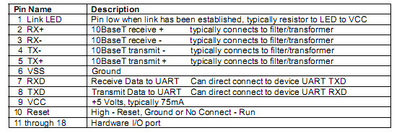

In our implementation all communication between the microcontroller and the SitePlayer will be initiated from the central microcontroller, the SitePlayer is purely responsive. Packets sent to the SitePlayer are between 2 and 19 bytes. The first byte of the transmission is the command byte which informs the SitePlayer what action is to be taken. The form of the packet and the available commands are shown in Figure 3.

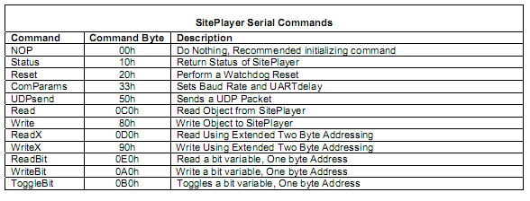
Figure 3

Upon startup 20 bytes of nulls or NOP commands are sent to the microcontroller. At this point it can be known that the SitePlayer is not in the middle of any function and is ready to accept new commands. The SitePlayer is then sent a command which will properly set the IP address in use. This is necessary since a static IP is being used. This command is not actually listed in the software manual but pc program serial tester has this function which was able to be adapted for use on the microcontroller.
All sensor data accumulated on the central node is sent to the SitePlayer using the Write command at a regular interval. WriteX is not needed since 8 bit addressing is sufficient for our purpose. This data will then be read from our website in order to be put on display for the user. When any data needs to be sent from the internet to the microcontroller a byte is first changed on the SitePlayer through the web interface. There is no interrupt from the SitePlayer since this is not a time sensitive application. Using the Read command, the microcontroller will poll a byte on the SitePlayer at regular intervals that contains information on what lights should be on or off. This information is then sent to the relevant node so that it can be put to use.
The subsystem has been tested on the SPK1 development board included in the SitePlayer development kit. The SitePlayer is viewable over the network and it is possible to write to and read from the SitePlayer/website. The first thing that will need to be tested when 10-base t Ethernet filter is ordered is that the circuit diagram we have designed will allow the SP1 to properly connect to the internet. Communication between the SitePlayer and microcontroller should not be affected by removing the development board.
The SitePlayer does involve some programming outside of the microcontroller. The HTML for the website to be hosted is very similar to normal HMTL. There are some keywords that can be used which will display the value of an object in the SitePlayer memory as shown below. The website will consist of the readings from the various sensors on the network as well as a method of changing whether the light at a certain node should be lit. An object can be changed on the SitePlayer with a button form displayed on the website. For example “<b><font size="4"><a href="Serial.spi?object7=118"> Set object 7 to v(decimal 118) </a></font> </b><br>” will display a button that will change object 7 to decimal value 118 when clicked.

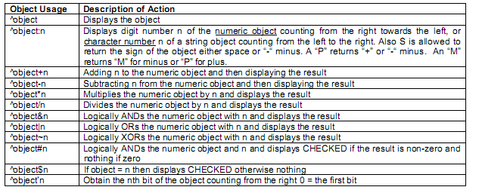

Wireless Communication
Our wireless communication will be accomplished using the ZigBee specification based on the IEEE 802.15.4-2003 standard for wireless personal are networks. The low cost, low power and accessibility made this the specification best suited to meet our needs. We will use the AT86RF231 Atmel Zigbee daughter card in order to provide wireless capability. This chip can be powered at the same 3.3 V that our board operates at and operates at 2.4 GHz. The transfer rate is limited to 250 Kbits/s which is well above what is required for our scenario.
In order to conserve battery life as much as possible for secondary nodes they will refrain from transmitting and receiving as much as possible. The central node will always be connected to AC power which will allow it to always remain on and ready to receive transmissions from the secondary nodes. The secondary nodes will periodically, ever minute or so, come online and send their data to the central node. These secondary nodes will then stay in a receive state for a few seconds in order to allow the central node to reply with whether their relay should be supplying power to any device connected. There is no time sensitive data being transmitted in the system which allows ZigBee power consumption to remain at a minimum. This all means that a beacon (periodic transmission) network will be utilized in order to conserve power as much as possible.
The basic functions for operation of the ZigBee transceiver have been completed. These are listed below.
Function Name | Description
Init_zigbee | Initializes Microcontroller to properly communicate with the ZigBee transceiver
Reset_zigbee | Flips the reset pin connected to the transceiver
Read_spi_reg | Reads a register on the transceiver through the SPI interface
Write_spi_reg | Writes to a register on the transceiver through the SPI interface
receive_frame | When an transmit end interrupt is found, this reads the frame that has been received
Generate_frame | Creates a frame to be sent carrying sensor data
Write_frame | Writes the generated frame to the transceiver to be sent when placed in transmit state
Zig_state | Function used to change the state of the ZigBee Transceiver(Finite State Machine shown below)

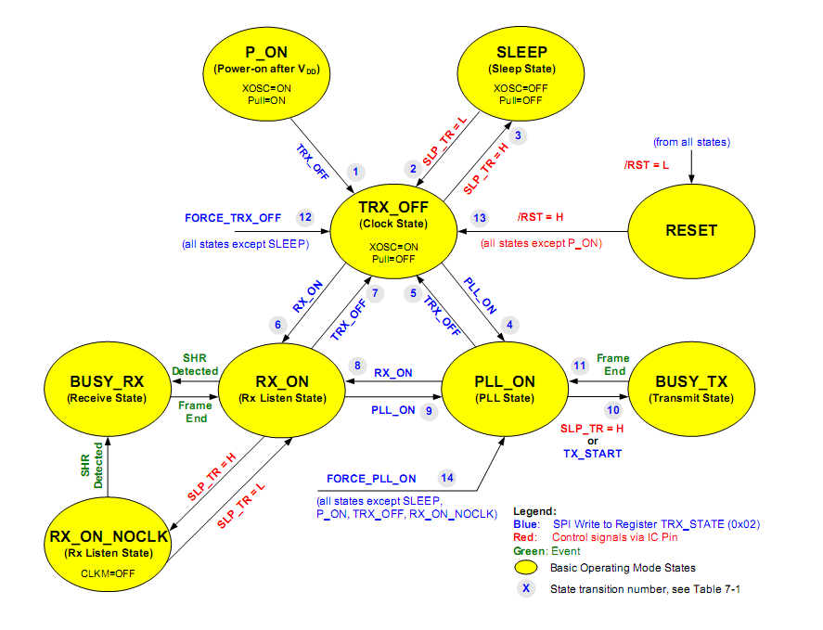

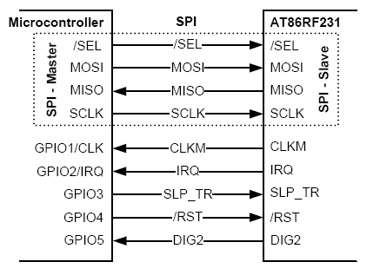

Sensors
Temperature Sensor:
Our chosen temperature sensor will be an LM19, manufactured by National Semiconductor. At 3.5V supply voltage, the range of accurate measurements is -55°C to 130°C, which is greater than our application will need, but it seems to be the range of most temperature sensors out there. It is most accurate in the middle of this range, ~30°C, where it will be ±2.5°C. It follows our objective of being very lower power, as the current drawn by the device is only 10 μA, and being such low power, it heats up less than 0.02°C.
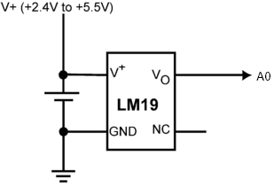
V+ will be connected to the supply voltage on the board, GND will be grounded, and Vo will be connected to an analog to digital pin, A0. Currently for testing purposes, the ADC outputs its data to the LCD in the form of 2V = 200 displayed, or 1.5V = 150 displayed.

Function Name | Description
enable_ADC(A0) | Sets A0 as an analog, sets time to wait until pin stabilizes; turns on the ADC module and starts the conversion; waits again until conversion has completed.
display_ADC_temp | Formats the output from enable_ADC into voltage and displays it on the LCD screen into X number of hundredths of a volt. Eventually this will be converted to display the temperature that voltage corresponds to.

Light Sensor
A TEPT5700, an NPN phototransistor, was chosen to be our ambient light sensor. It is designed to detect light in the same range that the human eye is sensitive to. It is T-1¾ style packaging, and has a very large angle that it can detect light from. This will also be a very low power device, with the current being drawn by it determined by the resistor connected between collector and ground. A 10k ohm resistor was chosen, making the maximum current drawn by the device to be .35mA.
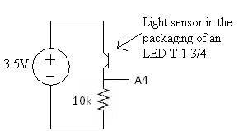
The emitter of the device will be connected to our supply voltage, the base is the detector itself, and the collector is connected to the 10k resistor. The output of the circuit is the voltage on the 10k resistor, being set by the current through it. The output will be connected to an analog to digital pin, A4. The programming for this device will be exactly as the same as the temperature sensor, except with A0 changing to A4, and ADC_temp changing to ADC_light, with the correct conversions displaying how many lumen it is receiving, or displaying whether the light in the room is on or off.

Passive Infrared Sensor
A passive infrared sensor was also chosen to be used to detect motion. A Parallax PIR 555-28027 was chosen because it can detect motion up to 20 feet away, it is fairly small and cheap, and it has a 3-pin header which will easily allow us to mount the sensor on the case and wire it to the board. Another very nice feature is that it is single pin output—puts a digital 1 out if there is motion, and puts a digital 0 if there is none detected.
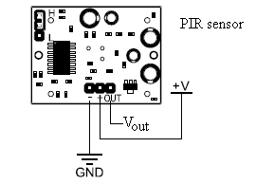
As before, V+ goes to the 3.5V supply of our board, GND goes to ground, and this time, Vout will go to a digital i/o pin, R2 (also labeled A2). The programming will be even simpler for this one, just one function to set up R2 as a digital input, and the other to output on the LCD whether there is movement or not—R2 = 1 or 0.

Power Relay
An Omicron G6C-1 power relay was chosen because it is basically a single pull single throw switch. We only need it to control one device, so this perfectly meets our needs, taking up less space than choosing a larger one which can control multiple devices. It takes 2.9V to turn on the relay, which is lower than our supply voltage, but it does take 30mA to turn it on at 3.5V. This could be a problem, but only our modules which will be plugged into the wall will feature power relays, so consuming too much power from the battery will not be an issue. What could have been an issue is that 30mA is a large portion of the voltage that the regulators on our board can put out; however, the relay works with an input voltage up to 24V, so it can be connected directly to the power brick, as shown in the circuit below.
Also, 30mA is way too high to be drawn directly from the microcontroller itself, so a mosfet will be connected between the relay and the microcontroller to provide the required current. The current choice of mosfet is MTP3055VL; it is designed to work up to 12A, which is a little overkill for our project, but it is designed to work directly from logic drivers, which is what we are using it for. The other good thing it has is an internal source-drain diode, which removes our need for adding in an extra diode to block the back EMF of the relay.
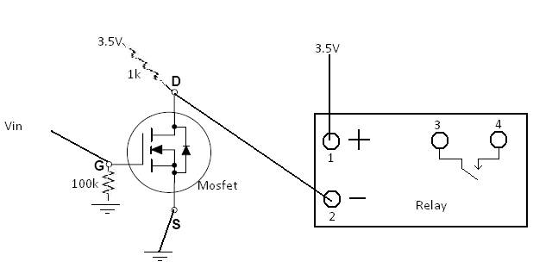
So if Vin is a digital 0, Vin=0V, the mosfet D terminal is being held at 3.5V by the 1k resistor. This keeps pin 2 at 3.5V, which means the relay does not have >3V across pins 1 and 2, which means the switch between pins 3 and 4 is open. If Vin is a digital 1, 3.5V, D is now electrically connected to S, which makes pin 2 0V. There are now 3.5V across pins 1 and 2 on the relay, closing the switch, turning on whatever device is to be controlled. The 100k resistor is there to pull the voltage at G down to zero whenever the device is first turned on, and the pin controlling Vin has not been yet set to a digital output. Pin RA3 (A3) is going to be controlling the voltage at Vin.

Power
Power can be provided by either 9v battery or from AC power. Each node has an AC power socket with a detachable power cord so that if a battery is used the AC cord won’t be in the way. From the socket, AC power is split and sent to an AC/DC converter (9v) and to a relay to power a light socket. A switch (on the outside of the case) switches the board’s power source from the AC/DC converter to a 9v battery. Power can also be provided by USB, but this is for troubleshooting only and will not readily accessible.
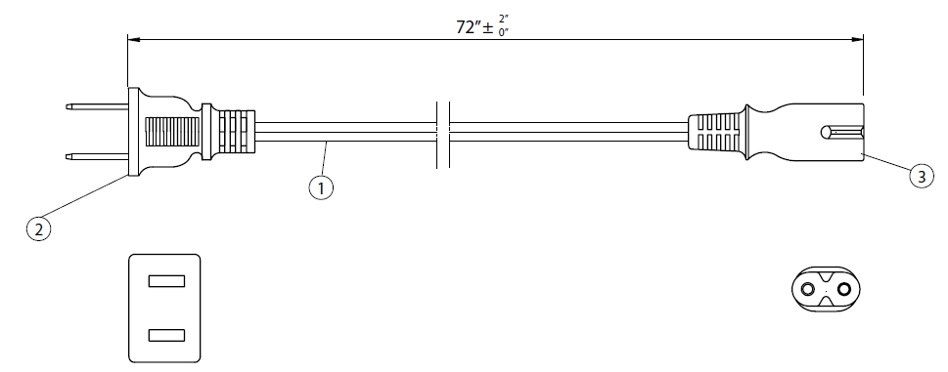
Power in socket
9v battery
AC/DC
board
relay
Power out socket
Power switch

Power schematic.

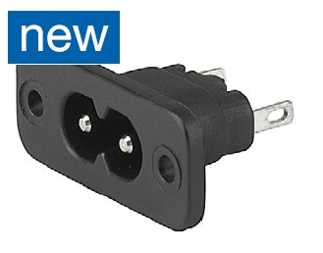
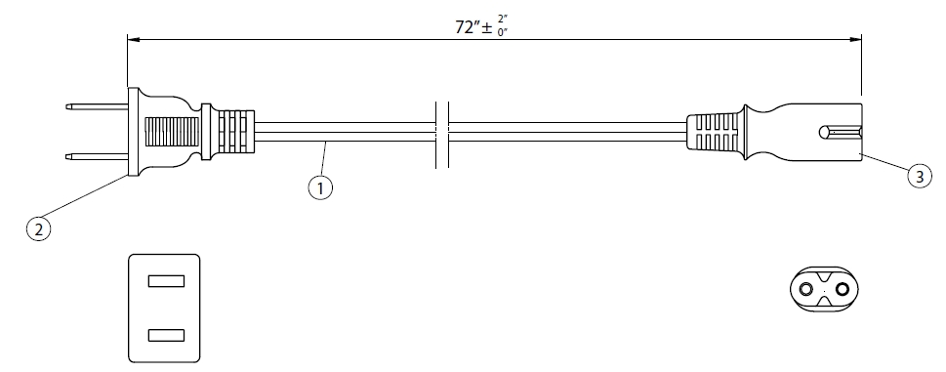

AC power socket and cord.

On the board itself is a 3.3v voltage regulator and a 5v regulator. The 3.3v regulator steps the 9 volts (from the AC/DC converter or battery) down to 3.3 volts for the board components to use. The 5v regulator steps the 3.3 volts up for use by the SitePlayer.

Schematics
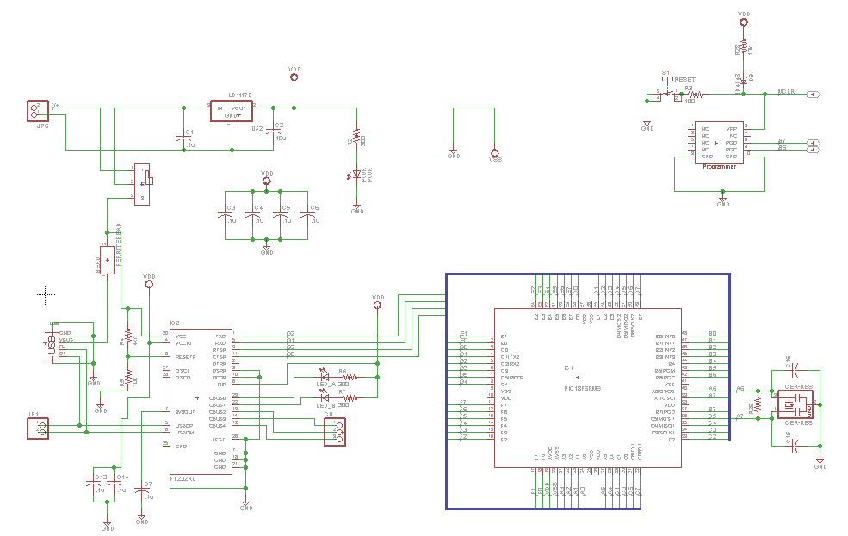
Main microcontroller circuit.

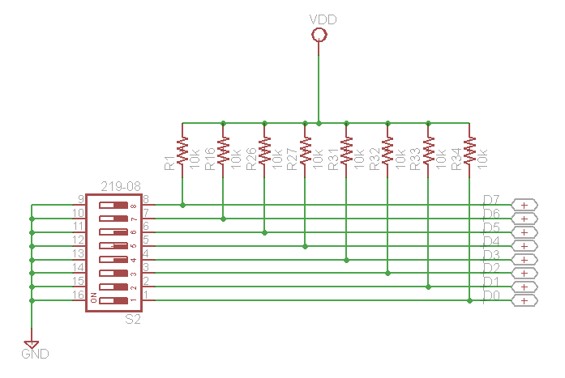
DIP switch circuit.

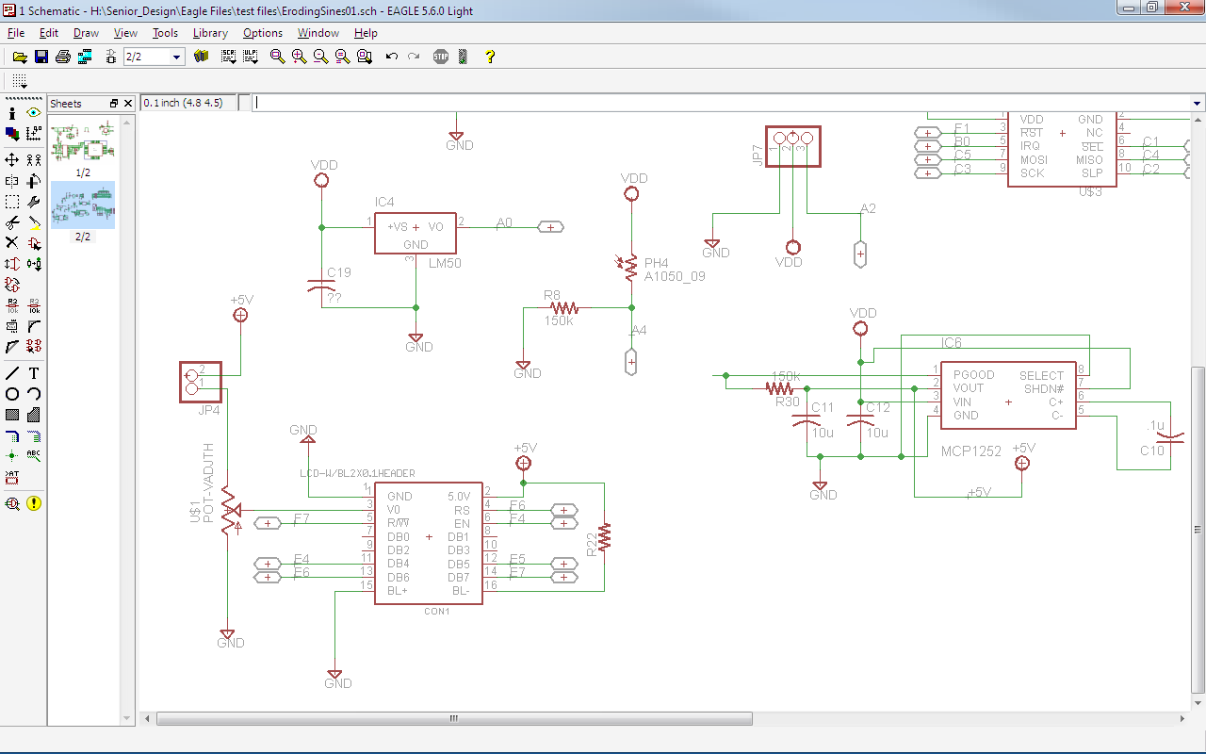
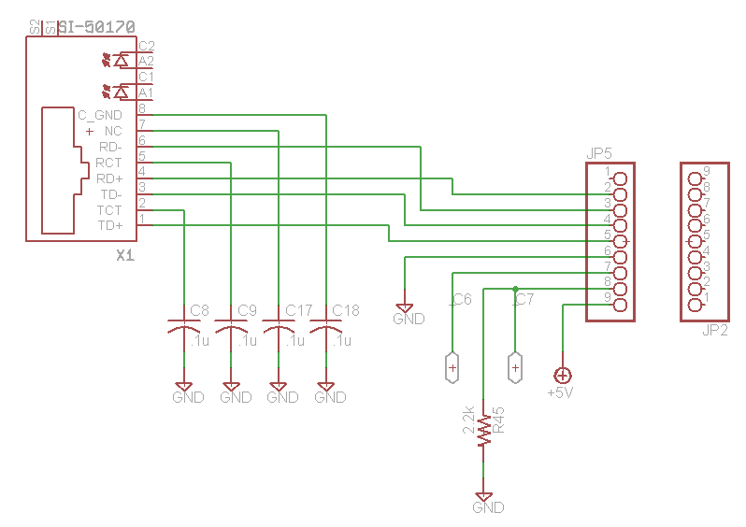
LCD circuit.

SitePlayer circuit.

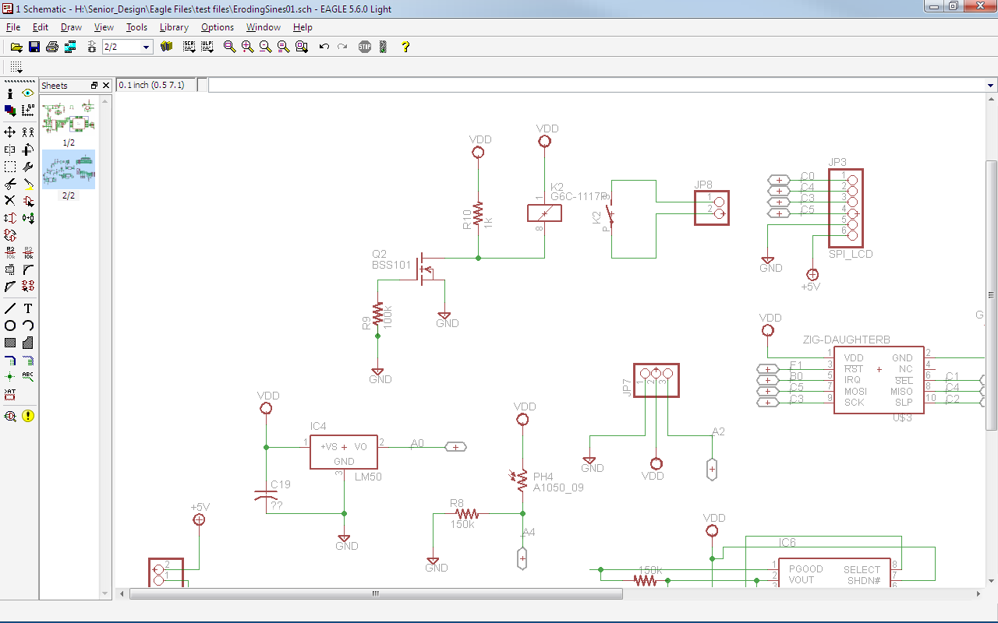
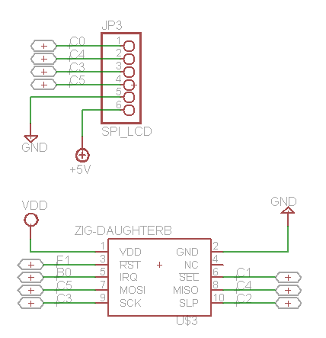
Sensor circuits.

LCD Pins & Zigbee circuit.

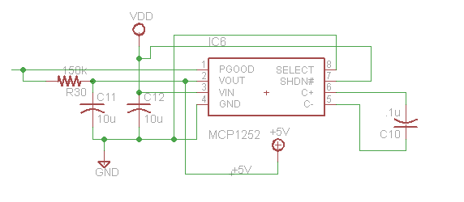
5 volt regulator circuit.

Bill of Materials

Part Description | Source | Part Number | Quantity | Cost/piece | Total Cost
AC/DC converter | Digi-key | T980-P5P-ND | 5 | $6.980 | $34.90
10 Base-T Filters RJ45 (5 pack) | Digi-key | 380-1047-ND | 5 | $1.980 | $9.90
AC pwer cord | Digi-key | Q348-ND | 5 | $1.726 | $8.63
Power socket | Mouser | 693-6160.0004 | 5 | $1.350 | $6.75
slide DPDT switch | Digi-key | SW116-ND | 5 | $0.810 | $4.05
300 ohm SMD resistor | Digi-key | P300DACT-ND | 10 | $0.204 | $2.04
10k SMD resistor | Digi-key | P10KDACT-ND | 10 | $0.000 | $0.00
1k smd resistor | Digi-key | P1.0KDACT-ND | 10 | $0.000 | $0.00
150k smd resistor | Digi-key | P150KDACT-ND | 10 | $0.000 | $0.00
100 ohm smd resistor | Digi-key | P100DACT-ND | 30 | $0.000 | $0.00
4.7k smd resistor | Digi-key | P4.7KDACT-ND | 10 | $0.000 | $0.00
.1uF smd capacitor | Digi-key | ECJ-2VB1E104K | 10 | $0.000 | $0.00
10uF capacitor | Digi-key | PCC2225CT-ND | 10 | $0.000 | $0.00
4.7uF capacitor | Digi-key | PCC1842CT-ND | 10 | $0.000 | $0.00
red led | Digi-key | 160-1422-1-ND | 10 | $0.000 | $0.00
green led | Digi-key | 160-1423-1-ND | 20 | $0.000 | $0.00
diode | Digi-key | 1N4148WTPMSCT-ND | 10 | $0.000 | $0.00
ferrite beed | Digi-key | 445-2201-1-ND | 10 | $0.000 | $0.00
8 pos. DIP switch | Digi-key | CT2198MST-ND | 7 | $1.020 | $7.14
5v voltage reg. | Digi-key | 497-1237-1-ND | 7 | $0.000 | $0.00
3.3v voltage reg. | Digi-key | 497-1235-1-ND | 7 | $0.000 | $0.00
20MHz ceramic resonator | Digi-key | 490-4717-1-ND | 7 | $0.000 | $0.00
USB connector | Digi-key | 609-3656-ND | 7 | $0.000 | $0.00
USB serial chip | Digi-key | 768-1007-1-ND | 7 | $0.000 | $0.00
microcontroller | Digi-key | PIC18LF6722-I/PT-ND | 3 | $0.000 | $0.00
.01uF capacitor | Digi-key | PCC1858CT-ND | 20 | $0.132 | $2.64
1000pF capacitor | Digi-key | PCC102BNCT-ND | 10 | $0.072 | $0.72
180pF | Digi-key | PCC181CGCT-ND | 10 | $0.240 | $2.40
power socket for lamp | Digi-key | Q281-ND | 5 | $0.620 | $3.10
Ambient Light Sensor | Digi-key | 751-1059-ND | 10 | $0.578 | $5.78
Temperature Sensor | Digi-key | LM19CIZ-ND | 5 | $0.744 | $3.72
SENSOR MOTION PIR | Digi-key | 555-28027-ND | 5 | $9.490 | $47.45
5V DC 250V AC Relay | Digi-key | Z715-ND | 5 | $5.620 | $28.10
100k ohm smd resistor | Digi-key | P100KDACT-ND | 10 | $0.000 | $0.00
zigbee connector
 |  |  |  | Total | $167.32

Conclusion
Our sensor network should allow a new level of observation and control of homes even when away from home. Our project as detailed above should allow a reduction in power consumption due to standby power from simply leaving devices on when away at work or on vacation. While many people are all for saving energy it can be very inconvenient to have to unplug everything when not in use. Not many people are going to reach behind their TV and unplug whenever they are not watching. Turning off devices through a web interface would be much easier for the average person and would likely increase energy savings. People can also forget to turn off lights and various electronics when away from home. Our system will allow users to still be able to turn these off whenever it crosses their mind and save energy. The savings from this reduction in power could add up substantially over the course of a year as a watt used to power a device costs approximately one dollar per year.

References

Lawrence Berkeley National Laboratory: Standby Power. <http://standby.lbl.gov/> Nov. 30, 2009.

