N. Bosler, T. Florencki, O. Omusi, M. Wholwend

Team IC-U
High Level Design

EE Senior Design
11/9/2010

Table of Contents
1. Introduction 2
2. Problem Statement and Proposed Solution 2
3. System Description and Block Diagram 3
4. System Requirements 4
1) Overall System 4
2) Subsystem and Interface Requirements 5
3) Future Enhancement Requirements 6
5. High Level Design Decisions 6
6. Open Questions 7
7. Major Component Costs 8
8. Conclusions 8

- Introduction
Team IC-U will be attempting to solve a security problem through the use of engineering principles and concepts. Over the next six months, the team will be finalizing the project goals, designing the necessary system components, and then implementing the design into a finished project. The hope is to develop a system that is compact and can be used by a wide range of consumers.
- Problem Statement and Proposed Solution
Security systems use many different inputs to alert the owners, but can do very little as far as actively deterring intruders and determining their identities. Also, many systems use low quality video cameras to capture movement but cannot capture descriptive features of the intruder. This project seeks to create a system that can both act as a physical deterrent and capture hi-resolution images of the intruder.
The proposed solution to this problem involves integration of a ‘seeker’ camera and a combination gun/high-resolution camera attached to two servo motors for control. The incoming video feed from the seeker camera (which remains stationary) will be analyzed for motion within the frame. The location of motion from the seeker cam will then translate to movement of the gun and high-resolution camera through the use of two servo motors. The system can then either fire the gun and/or capture images with the high-resolution camera. An embedded ARM computer will be used to handle communication between the various system elements.

- System Description and Block Diagram
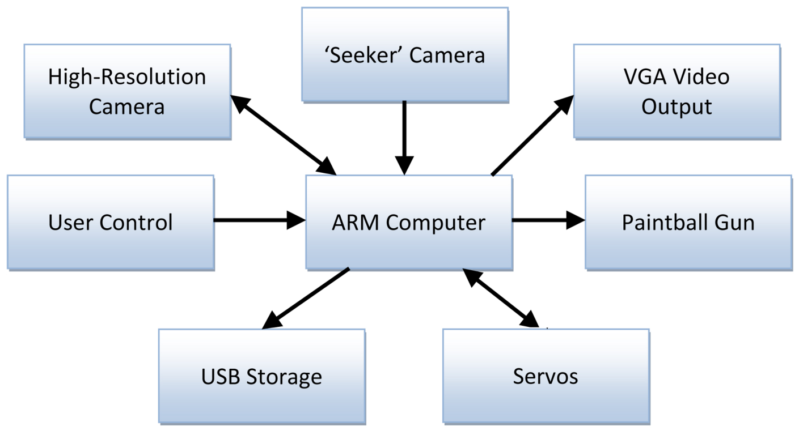

User Control
The user control portion of this system will allow the user to control the mode of operation of the deterrence aspect. The user will be able to turn the high-resolution camera and paintball gun on or off, based on the desired application of the system. To do this, easily-accessible switches will be connected to input terminals on the ARM.

VGA Video Output
The VGA port of the ARM will be connected to a monitor, displaying the video feed from the seeker camera. This feed will display a mark where movement is detected.

ARM Computer
The ARM Computer is the main processing and control unit of the whole project. The ARM will take the video from the ‘seeker’ camera, and depending on the state of the User Control switches, process this video to determine if movement occurred. If movement occurs it sends a location signal to the servo controller and a fire signal to the paintball gun and high-res camera. It then saves the image from the high-res camera to the USB storage. Also the output of the ‘seeker’ cam is sent to the VGA video output.

Paintball Gun
The paintball gun is the deterrence portion of the system. It will fire when the signal is sent from the ARM Computer.

High-Resolution Camera
The high-resolution camera will be mounted along with the paintball gun and will be used to capture images when motion is detected. This allows for the identification portion of the system.

‘Seeker’ Camera
The ‘seeker’ camera will be a low-resolution web camera that will be used for the purpose of analyzing movement.

USB Storage
The USB ports of the ARM will allow for storage of images captured by the high-resolution camera. The user will be able to use a USB flash drive to view the images on a personal computer.

Servo Motors
The two servo motors move quickly and accurately to aim the paintball gun and the high resolution camera at the target detected by the seeker camera.
- System Requirements
- Overall System
This system is required to do two major things in order for successful operation. It must accurately detect and identify intruders to provide evidence to law enforcement. Also, it must deter the intruder from approaching the system through the use of a paintball gun. These settings must be controllable by the user so unintentional harm is minimized.
The system needs to be contained in one simple box as small as possible. The small footprint will allow for the system to be mounted in a way that makes it less noticeable for possible intruders. Components will be as small as is feasible to facilitate this. Also, the turret mount for the gun needs to be strong enough to support the weight of the gun but not too heavy so that it can be aimed quickly.
The power requirements for this system are very complex. While it might be useful to have this system run on a battery, the power draw is too high to allow for long periods of operation, so our system will draw its power from a standard AC 120V outlet and convert that to 5V DC for our ARM computer. The ARM requires a 5V regulated supply current limited to 1-3 amps. This will come directly from the supply. Other requirements include the paintball gun, which operates at 9V and the servos which require 6V. These levels will be created using MOSFETs as switches to these regulated voltages.

- Subsystem and Interface Requirements
User Control
The switches need to allow for a connection between the input voltage and the input pins that control the on and off operation of the paintball gun and the high-resolution camera. Flipping the switch on or off will turn the camera or paintball gun on and off.

VGA Video Output
The VGA video output port needs to be constantly streaming the feed from the seeker camera so that a user can connect to it at any time to view the feed.

ARM Computer
The ARM computer needs to be able to process the video input from the ‘seeker’ cam. It must be fast enough to process this and send ‘fire’ signals out before the target has moved. It must also display the ‘seeker’ camera feed to the VGA output through its built-in VGA card. The ARM must also handle all the communication between devices. Most of the communication will be handled with USB interfaces, specifically for the high res camera, ‘seeker’ camera, and USB storage. The other devices will be controlled by the digital input/output (DIO) pins on the ARM’s board. Also, the ARM Computer will need to be configured to properly output the servo control signals.

Paintball Gun
The paintball gun needs to have an electrical firing mechanism so that it can be easily triggered by setting a digital output pin.

High-Resolution Camera
The high-resolution camera should have a minimum resolution of 10 Megapixels and a minimum optical zoom of 3x in order to provide a detailed image of the moving object.

‘Seeker’ Camera
The seeker camera needs to be a low resolution (preferably VGA) so that it will not require as much processing power to implement the motion-sensing algorithm. In addition, it should be small so that it will not be in the way of other components.

USB Storage
The USB storage needs to have at least 2GB of storage in order to hold enough pictures so that the media will not need to be emptied often.

Servos
The servos require 4.8-6V to operate and will have their own power source independent of the rest of the system. This voltage determines the amount of torque that the motors generate which must be enough to move the paintball gun, the high-res camera and their mount. The servos are digital precision servos that are controlled by pulse width control which the ARM orchestrates. These servos will move in horizontal and vertical 90 degree angles simultaneously. Because both servos run simultaneously and have larger current draws than can be supported by the I/O pins on the ARM, a buffer will be placed in between the two components.

- Future Enhancement Requirements
Audio Deterrence
In the interest of improved deterrence of intruders, vocal deterrence may be included. This will be in the form of audio recordings that will play whenever an intruder is detected, warning the individual that they are entering a restricted area and warn the intruder that he/she may be fired upon. If the system is in attack mode, then this system will also taunt the intruder while he is being physically deterred.
Implementing this concept will require audio speakers. However, the embedded ARM chosen for this task does not have an audio output port so USB speakers will need to be used.

Infrared Camera
An infrared camera will allow for better detection of intruders under all conditions. Adding a camera like this to the system would not be challenging, but it would greatly increase the overall system cost.
- High Level Design Decisions
User Control
It was determined that user control was necessary for political reasons. Based on the application, the user might not need the paintball gun aspect of the system. The user control gives the operator this capability.

VGA Video Output
VGA video output was added to the system because it allows the user the convenience of viewing the feed from the seeker camera as well as knowing when motion is detected based on the mark that will appear on the screen. VGA output was chosen because the embedded ARM has a VGA port. This allows for an easy connection from ARM to monitor.

ARM Computer
Initially, a microcontroller was considered as the system processor, but due to the heavy processing requirements of the motion detection algorithms, a faster and more feature rich system was needed. ARM systems were recommended because they combine the ability to use a standard 32-bit operating system and still have discreet DIO pins. They operate at a much higher frequency than a microcontroller. The specific board choice was made due to hardware support for VGA outputs, USB, and DIO. Having these features integrated on the board saves money and time integrating the system.

Paintball Gun
An electric trigger paintball gun was necessary to provide as ease of firing control. A 9V signal is needed to trigger the gun to fire. This signal will be sent by the ARM.

High-Resolution Camera
Point-and-shoot cameras typically come in resolutions upwards of 10 Megapixels and optical zooms of 3x. Since this meets the design requirements, a member’s pre-owned camera will be used for this application.

‘Seeker’ Camera
Common web cameras provide an inexpensive and relatively low resolution solution to this component. In addition, its USB interface allows for an easy connection to the embedded ARM computer.

USB Storage
The two options that were considered were an SD card and a USB flash drive. It was decided to use a flash drive for two reasons. The first is cost - flash drives have a lower cost per storage amount than do SD cards. The second reason is location flexibility. With a flash drive, a USB extension can be used to place the flash drive connection in an easily-accessible location to the user whereas an SD card must connect directly into the board.

Servos
There are two broad groups of servos: analog and digital. It was decided that the design team should go with digital servos because these have shorter response time, and can give much more precise movement. The downside to using these is that they are more expensive and pull more current from the ARM. The decision whether to use a servo controller to control the movement of the servos or whether to do this directly with the ARM also needed to be made. After much research, it was found that there was no need for a controller for less than three servos and that we could easily implement pulse width control in software in the ARM.
- Open Questions
The exact method of how to trigger the paintball gun is still undecided. The preliminary idea would be to use a MOSFET as a switch, with the gate triggered by an output from the ARM.
The method of capturing an image from the high-resolution camera and outputting video to the monitor is as of yet undetermined. For the camera, it will need to be seen what kind of output is seen through the USB. This will determine the method implemented for saving an image from the camera onto the USB flash drive. As for the monitor, software will need to be implemented to display the output from the seeker cam with a superimposed ‘target’ as opposed to the Linux environment that runs the ARM computer. It is possible that this can be implemented as an input from the user controls (a flip of a switch determines whether the VGA outputs the Linux environment or the seeker cam).

- Major Component Costs

Component | Price | Quanity | Total
ARM Computer | ~$250 | 1 | $250
Servo Motor | ~$55 | 2 | $110
High-res Camera | Already Owned | 1 | $0
Seeker Camera | ~$10 | 1 | $10
Paintball Gun | Already Owned | 1 | $0
USB Flash Drive | ~$10 | 1 | $10
Printed Circuit Board | $50 | 1 | $50
Total |  |  | $430

- Conclusions
Through the use of existing technologies Team IC-U hopes to integrate two useful security features into one system. Integrating the paintball gun allows a security system to fight back against intruders and actively deter crimes from occurring. Using the high resolution camera to identify intruders, the system also helps in the prosecution of the intruder. The system increases safety for its users and their household or business.
The key challenges of developing this system are the motion sensing algorithm, high-res image storage and capture, and communication between each system. This all relies on successful implementation of the ARM computer from a software and hardware standpoint. The software needs to be able to generate all the necessary signals for communication and process the video and picture storage.

References:
http://www.embeddedarm.com/products/board-detail.php?product=TS-7300
http://www.servocity.com/html/hs-5645mg_digital_torque.html
http://www.pyroelectro.com/tutorials/servo_motor/theory.html
http://www.paintballsentry.com/Products.htm

