Ninja TurtlEEs: High Level Design
2014

Casey Morris, John O’Brien, Joshua Vahala, Justin Yoder

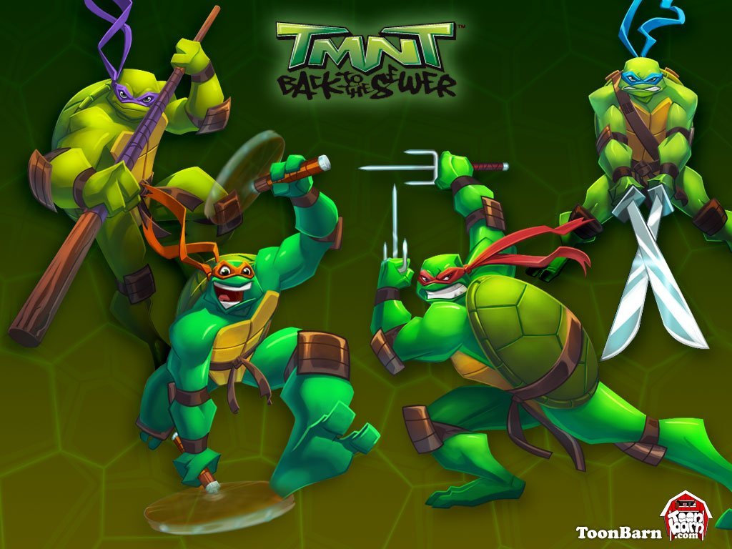
Table of Contents
1 Introduction………………………………………………………………………………………………2
2 Problem Statement and Proposed Solution……………………………………………………………2
3 System Requirements……………………………………………………………………………………3
4 System Block Diagram……………………………………………………………………...…………….4
4.1 Overall System……………………………………………………………………………...…..4
4.2 Subsystem and Interface Requirements……………………………………………………….5
4.3 Future Enhancement Requirements……………………………………………………...……5
5 High Level Design Decisions……………………………………………………………………...………..6
6 Open Questions……………………………………………………………………………………….…..7
7 Major Component Costs…………………………………………………………………………………..8
8 Conclusions………………………………………………………………………………………….…….8

Introduction
The city of South Bend, Indiana derives its name from the southern bend of the Saint Joseph’s River. A tributary that flows into the St. Joe’s river at this southern bend is known as Bowman Creek. Most of the tributaries along the St. Joe’s river are able to support a flourishing ecosystem; however, Bowman Creek has long been unable to support any aquatic life. City officials believe that the cause of this unfortunate circumstance is that the water is somehow draining from the creek, resulting in water levels that are too low to support fish. One theory is that the water is leaking into large sewer pipes that cross and parallel the creek at many points. The city of South Bend is vigorously searching for new technological solutions to revitalize the Bowman Creek watershed area.

Problem Statement and Proposed Solution
One of the current areas in which the city of South Bend is trying to apply technology solutions is in the inspection of the sewer pipes while looking for leaks. These pipes are very old, so over time, the joints connecting the sections of pipe may be worn and disjointed. This is a problem because it means that either sewage or waste that should in the pipes is leaking into the ground, or because other things from the outside are leaking into pipe, like rain water, and are being treated at the waste treatment plant. If the waste treatment plant is treating things that are not supposed to be treated, it is obviously wasting money spending the time to do so.

The Bowman Creek area is of great interest to the city of South Bend because the creek, which may be full at its mouth, very often runs dry before it gets to the St. Joe’s river. A consequence of this is the inability for aquatic life in the river to thrive in the areas that are often dry. South Bend’s engineer, Gary Gilot, suspects that this dry problem is a result of the creek leaking into the sewer pipes that cross and run parallel to it. Thus, Gary is very interested in inspecting these pipes for disjoints and other potential problems that may cause the creek to leak into the sewer. We also spoke to Patrick Henthorn, an engineer working on the sewer projects, and we discussion his own vision for the robot. He expressed his desire for the video processing to be something that is interactive after the robot has explored the tunnel.

The city of South Bend currently has two robots with cameras that are able to inspect pipes, but they are quite small. These robots are made to inspect pipes that are 18”-20” in diameter. Generally, these are sufficient because that is the size of 80% of the city’s sewage pipes. However, when the pipe size is 66”-70” diameter, these robots are not applicable. The main reason that these robots are inadequate is that the camera is stationary. It has little means of moving around and being able to inspect the entire large pipe, or to focus in on potential leak areas. This makes it very difficult to be able to determine the quality of the joints. In addition to this limitation, another problem for the large pipes is the mobility of the camera apparatus. It is small and moves via tracks, which make it difficult turn and balance in large pipes. Additionally, because it is so small, it would be difficult to mount and stabilize a controllable arm/camera apparatus as an improvement to the current robot. Thus, the city of South Bend is looking for a new solution that answers some of these problems while serving the same purpose of inspecting the pipes. Having clearly laid out the problem, the team set out on a project to overcome the hurdles of the Bowman Creek watershed project. First, we decided to tackle the problem of the limited mobility inside of the sewer pipes. The team has decided that the best method of getting around the sewer pipes would be to have a chassis with either four wheels attached to it or a track based movement. We have not been able to determine the size need for the chassis because we have yet to see the operating environment. However, once we determine the correct size of the chassis we will be able to then decide an appropriate size for the wheels of the chassis. We need the wheels to be large enough that the robot can maneuver over debris on the ground, but small enough that it can have good control and use a small amount of power. The other main hurdle for this project is having the robot locate leakage areas. In order to most efficiently look for the leakage areas, the team has decided that it is necessary to have a camera that can rotate 360 degrees. This camera would allow for viewing of the entire sewer area. We want the robot to be able to locate any areas of leakage and to not be limited in his exploration of the pipes. A camera that is mounted on a track that allows for 360 degree viewing will be able to focus in on any part of the pipe.

Next, we needed to overcome the hurdles of control and detecting leakage. We have decided that the robot will have two functioning modes. The main mode will be a human controlled mode in which the robot is simply driven around the pipes by a human with a remote control. This human will also have a controller for the camera and will be able to look around the pipes very easily and look for leaks as the robot goes along. The video will also be sent to a video processor that will be able to identify where leaks are in the pipe based on the phosphorescent dye. The secondary mode will be an autonomous mode in which the robot will drive itself down the pipes and scan all of the walls as it goes along. This mode will most likely be slower and require more power from the robot because it would need to do a very thorough search in order to make sure the video processing is accurate in locating leakage spots. The robot would also include a functioning sonar sensor and gyroscope. The sonar sensor would be pointed in front of the robot so that the robot would be able to detect possible objects in its path. The gyroscope would be used to make sure the robot would not tip over. It will be especially useful if the robot tries to drive up the circular wall. The gyroscope would detect the change in level and force the wheels to correct the robot.

System Requirements
Our proposed solution is a robot that can scan the tunnels. The robot will be approximately the size of a cube with side length of one and a half feet. It should be light enough that a user could easily lift and maneuver it. Besides these obvious design points, we are designing this robot so that it will reliably operate in a sewer environment and it will be user-friendly such that different operators can run it. Considering all of these general design criteria, we began thinking more specifically about the requirements of our system. Firstly, we decided to tackle some of the problems associated with the environment. The robot needs to move without slipping on the mud or water that may be present in the pipes. This implies that either a system of four wheels or tracks will be used with the robot. We have not decided which will be the best fit and we will discuss it further in the sixth section. Along with that, the entire casing for the robot must be waterproof so as to protect the electronic systems that are at work in the robot. Lastly, the robot must be equipped with a system of LED lights that will work to light up the tunnel in the direction that the camera is pointing. We will use LED lights because they are the most efficient and they have the ability of being pointed in a specific direction.
After the challenges of the operating environment, we considered some of the systems that we would need to actually run the robot. We have decided that the robot will have two electric motors that will control the left- and right-hand sides of the robot. These motors will be controlled by an on board microcontroller via a user interface. This user interface will also be able to control two motors that will be used to move the camera vertically ninety degrees as well as horizontally three hundred and sixty degrees. Lastly, it is not clear whether we will use a wire to run a video signal from the robot back to the user interface, or if we can do this wirelessly within the sewer pipe. We have researched different wireless video transmission methods and we have doubts that an operating environment such as a sewer would be conducive to wireless transmission. This paper will cover this more in the sixth section. However, this decision is inter-related to another decision that we will make. If we do need to run a wire down to the robot for video transmission, we will also run a wire for power down to the robot. However, if wireless video transmission is possible, then we will use on board lithium polymer batteries to power our robot through the pipes. We chose lithium polymer because they have the greatest energy density. We have decided that we will want enough battery power that the robot can run reasonably for two hours.

System Block Diagram

Overall System:
User Interface

Camera Controls
Environment Sensing

Camera
Motor Controls

Driving
Image Processing

4.2 Subsystem and Interface Requirements

4.2.1 User Interface
The user interface must be simple and intuitive for the user. It must allow the user to control the movement of the robot, movement of the camera, and it must display the images from the camera in real-time. It must also allow the user to put the robot into autonomous mode, so that the robot can traverse the pipes by itself. It must be able to relay all user inputs to the microcontroller on the robot.

4.2.2 Environment Sensing
The robot must be able to measure its tilt rotation in order to stay upright as its traveling through round pipes. It must also be able to detect nearby walls and other obstacles so that it can avoid them.

4.2.3 Motor Controls
The motor control system must be able to receive input from the user interface. The robot must be able to move forwards, backwards, and turn easily. The motor control system must be able to control the robot in response to user input or autonomously. It must also be able to take environment sensing data into account, and override the user input if necessary.

4.2.4 Driving
The robot needs to be able to move easily in small amounts of water and over small obstacles. It also needs to move smoothly so as to minimize disturbances with the camera. The wheels or tracks will be connected to a series of gears, and the two motors will control each side of the robot independently.

4.2.5 Camera Controls
The camera controls must be able to receive input from the user interface. The camera must be able to move continuously from side to side, and have a 90 degree range up-and-down. The camera must be capable of moving in response to user input or autonomously.

4.2.6 Camera
The camera must record high-enough quality video that the pipes can clearly be seen. It must be able to send this data to the user interface for viewing. It must also be capable of sending pictures to a storage device so that they can be processed and viewed later.

4.2.7 Image Processing
The image processing system must be capable of compiling the images from the camera into a complete view of the pipe.

4.3 Future Enhancement Requirements
An iPad would be ideal for the user interface, because the screen could display the feed from the camera, and also be used to control the robot. This iPad may be a part of the initial release, but it is not clear at the moment if that is the direction we are headed. We will discuss this more in the sixth section. Furthermore, the wireless feature may not be feasible for the initial release, but it is something that we would look to add in the future. This will also be discussed in the sixth section.
Lastly, the image processing could be upgraded to look for cracks in the pipe and highlight them for the user.

5 High Level Design
5.1 User Interface
The best option for the user interface is an open question (section six) that is still under consideration. We are deciding between an iPad application, computer inputs, or a memory card used for on board directions.

5.2 Environment Sensing
The on-board gyroscope will connect to the microcontroller via an I²C serial interface. When the angle that is measured by the gyroscope gets too high, the microcontroller (as the motor control system) will automatically redirect the direction of the robot. The ultrasonic sensor necessary to detect proximity to walls will connect to the microcontroller via an RS232 connection. The microcontroller will once again use the data from the sensor to redirect the path of the robot in order to keep it out of harm’s way. Both the gyroscope and the ultrasonic sensor are available through Trossen Robotics.

5.3 Motor Controls
The central microcontroller will serve as the motor controller. We will use Pulse Width Modulation (PWM) to control the speed of the motors that are connected to the wheels. This will be particularly important when turning, because each side of the robot will need to move a different speed. The microcontroller will have steering information sent to it from the user interface, which the microcontroller will translate into speeds for the motors. It will also receive data from the environment sensing subsystem that it will take into account when controlling the path of the robot. In order to control forward and reverse, we need a tri-state switch that implements two pins on the microcontroller.

5.4 Driving
Two DC motors will be used to drive the robots. One motor will control the left side, and one will control the right side. Each motor will require a separate output. The selection of specific DC motors will depend on the total weight of the robot and the maximum desired speed. We will need to continue testing to decide whether we want four wheels driving the robot or two tracks.

5.5 Camera Controls
The microcontroller will serve as the camera control system. It will power a pair of servo motors that will move the camera with 5V output pins and the output compare pins on the microcontroller will handle pulse width modulation. The servo motor controlling the side-to-side rotation is a continuous rotation servo. The servo motor controlling the up-and-down movement is a regular servo. The microcontroller will limit the range of motion on the regular servo to 90 degrees. Pulse width modulation is the mechanism that determines the angular velocity of the continuous rotation servo and the target angle of the regular servo.

5.6 Camera
The camera we are using is a C429-TTL Serial Camera Module from Sicube. It connects to the camera control subsystem through an on-board TTL serial interface. The camera control subsystem will be responsible for saving the images or for transmitting the video to the user interface. It provides full-color video and images with resolution up to 640x480. It provides simple image manipulation features like control of brightness, contrast, hue and saturation, as well as backlight compensation.

5.7 Image Processing
The user interface will need to handle image processing. This is discussed more in section sixth.

6 Open Questions

How do we connect robot to user?
First, we could use a wired interface where the robot is physically connected to the computer above ground. This would be implemented as video, transmit, receive, and power cables. This would allow for simple transmission of signals from user to robot, but carrying a cable presents other problems with the robot retreating to its initial position and loose cables following the robot. If a taught cable is carried around by the robot, it would add an extra force to be pulled but would also allow for a more simple retrieval method for the user.
Second, we could use a wireless interface that includes a user interface. This system would be similar to the wired interface in that it would include a complete user interface and connection. We would implement this hopefully with a simple RF transmitter of some sort, but problems exist with the underground nature of the sewer system. So, we would probably need an auxiliary transmitter/receiver located at the base of the man hole. The robot would send a signal to this node, which would transmit the signal wirelessly to the user interface. This is ideal because it allows us to avoid all wires and create a fully autonomous robot as a final product. It does raise the issue of battery life and delivering enough power to the system.
Third, we could store all pictures in a Google Street View style so that the user could take the memory from the robot and personally walk through the pipe in any direction they wish. We do not necessarily need a wireless signal for this option. This could be difficult to prototype without first connecting the camera to a computer using a wire.
What will be our power source?
First, we could use a wired power source. This is especially effective if we choose to use a wired user interface. The problem arises in finding the power source. We could use the operator’s car, generator, or a power supply connected to the grid. It is unknown whether this third option exists.
Second, we could use batteries. This would be most effective with the wireless interfaces. The problem is that these could add a lot of weight to the system, so we would need more power than with the wired possibility.
What kind of user interface?
First, we could use an iPad. One member of our group is well versed in app development, so actual development is not a large issue. The problem is that we would need to have a wireless signal sent from robot to user, which could be a great obstacle in the underground environment. This is the ideal approach because it gives the greatest user interface and most controllability by the user.
Second, we could use a laptop that would allow us to use a wired approach to the robot or a wireless approach. The user would need a laptop with them, which adds bulk over an iPad but would be easier to interface than an iPad.
Third, we could only have a user interface when the memory card is plugged in. As in, the memory card would either launch an app on an iPad or computer or load the information to the cloud when in range of Wi-Fi.
How will the turtle move around?
First, we could use wheels and use two or four motors to control the movement.
Second, we could use tracks with two motors to control the movement. It is somewhat unclear how we would connect the wheels inside the tracks together. We could possibly use a gear system on the wheels or look more into how other sources use tracks.

7 Major Component Costs
Component | Cost
Camera | $45
Camera control motors | $30
Camera base—3d printed
Robot body—3d printed
Camera system weatherproofing | $15
Wheels/Tracks | $50
Sensors | $20
Motors for movement | $100
Board revisions (3 revs) | $150
Total | $410

8 Conclusion
This project has aspects of many different types of engineering including social, mechanical, and (most importantly) electrical. In order to turn out a complete project we will need to integrate all of these different aspects to make them work as one. However, the most challenging part of this project is and will remain the interaction with the client. This project, just like in the real world, will revolve around the specifications of our client. In the end, we hope that our design will be able to meet those specifications and alleviate some of the issues presented by the Bowman Creek watershed.

