Ninja TurtlEEs

I. Introduction

The city of South Bend, Indiana derives its name from the layout of the Saint Joseph’s River, as the city is located along its southern bend. A waterway that flows into the St. Joe’s river at this point is known as Bowman Creek. Along this creek, large combined sewer pipes cross and parallel the creek at many points. Unfortunately, this has led to many problems in the Bowman Creek area, especially has time has passed and the infrastructure has aged. The city of South Bend is vigorously searching for new technological solutions to improve its infrastructure to be able to revitalize the Bowman Creek watershed area.

II. Problem Description

One of the current areas in which the city of South Bend is trying to apply technology solutions is in the inspection of the sewer pipes while looking for leaks. These pipes are very old, so over time, the joints connecting the sections of pipe may be worn and disjointed. This is a problem because it means that either sewage or waste that should in the pipes is leaking into the ground, or because other things from the outside are leaking into pipe, like rain water, and are being treated at the waste treatment plant. If the waste treatment plant is treating things that are not supposed to be treated, it is obviously wasting money spending the time to do so.

The Bowman Creek area is of great interest to the city of South Bend because the creek, which may be full at its mouth, very often runs dry before it gets to the entrance of the river. A consequence of this is the inability for aquatic life in the river to thrive in the areas that are often dry. South Bend’s engineer, Gary Gilot, suspects that this dry problem is a result of the creek leaking into the sewer pipes that cross and run parallel to it. Thus, Gary is very interested in inspecting these pipes for disjoints and other potential problems that may cause the creek to leak into the sewer.

The city of South Bend currently has two robots with cameras that are able to inspect pipes, but they are quite small. These robots are made to inspect pipes that are 18”-20” in diameter. Generally, these are sufficient because that is the size of 80% of the city’s sewage pipes. However, when the pipe size is 66”-70” diameter, these robots are not applicable. The main reason that these robots are inadequate is that the camera is stationary. It has no means of moving around and being able to inspect the entire large pipe, or to focus in on potential leak areas. This makes it very difficult to be able to determine the quality of the joints. In addition to this limitation, another problem for the large pipes is the mobility of the camera apparatus. It is small and moves via tracks, which make it difficult turn and balance in large pipes. Additionally, because it is so small, it would be difficult to mount and stabilize a controllable arm/camera apparatus as an improvement to the current robot. Thus, the city of South Bend is looking for a new solution that answers some of these problems while serving the same purpose of inspecting the pipes.

III. Proposed solution

Having clearly laid out the problem, the team set out on a project to overcome the hurdles of the Bowman Creek watershed project. First, we decided to tackle the problem of the limited mobility inside of the sewer pipes. The team has decided that the best method of getting around the sewer pipes is to have a chassis with four wheels attached to it. We have not been able to determine the size need for the chassis because we have yet to see the operating environment. However, once we determine the correct size of the chassis we will be able to then decide an appropriate size for the wheels of the chassis. We need the wheels to be large enough that the robot can maneuver over debris on the ground, but small enough that it can have good control and use a small amount of power. The other main hurdle for this project is having the robot locate leakage areas. In order to most efficiently look for the leakage areas, the team has decided that it is necessary to have a camera that can rotate 360 degrees. This camera would allow for viewing of the entire sewer area. We want the robot to be able to locate any areas of leakage and to not be limited in his exploration of the pipes. A camera that is mounted on a track that allows for 360 degree viewing will be able to focus in on any part of the pipe.

Now that we have a chassis with wheels and a mounted camera we needed to overcome the hurdles of control and detecting leakage. We have decided that the robot will have two functioning modes. The main mode will be a human controlled mode in which the robot is simply driven around the pipes by a human with a remote control. This human will also have a controller for the camera and will be able to look around the pipes very easily and look for leaks as the robot goes along. The video will also be sent to a video processor that will be able to identify where leaks are in the pipe based on the phosphorescent dye. The secondary mode will be an autonomous mode in which the robot will drive itself down the pipes and scan all of the walls as it goes along. This mode will most likely be slower and require more power from the robot because it would need to do a very thorough search in order to make sure the video processing is accurate in locating leakage spots. The robot would also include a functioning sonar sensor and gyroscope. The sonar sensor would be pointed in front of the robot so that the robot would be able to detect possible objects in its path. The gyroscope would be used to make sure the robot would not tip over. It will be especially useful if the robot tries to drive up the circular wall. The gyroscope would detect the change in level and force the wheels to right the robot.

IV. Demonstration Features

For our demonstration we will attempt to display all of the features of the robot. First, we will show a video tape of the robot operating in both modes in its actual setting. This will show off the control of the motors for the wheels and camera as well as its operating capability in the environment for which it was designed. Also, operating it in both modes would allow us to show off the variety of sensors and controls that we will built into the robot. Hopefully, we would be able to find a leakage area both by operating it manually and automatically. Lastly, we could demonstrate some of the finer systems in the classroom by driving the robot around and showing how the wheels and camera are controlled.

V. Available Technology

Technology | Details
Robot | The robot will be built on a platform mounted to four wheels. It will need to be large enough to drive above any water that would still be in the drain pipe. It will need a water resistant casing to hold the electronics, like the sonar and camera, and the motors that control the wheels and the camera.
Camera | The camera will need to be capable of taking pictures and video. A simple webcam will work and would be $25 - $50, depending on the quality. It will need to be compatible with the wavelength of the phosphorescent dye used to detect the leaks.
Sonar Module | The sonar does not need to have a high degree of accuracy. It only needs to be able to identify objects in its path. A simple sonar module is about $30.
User Interface | The user will need a display in order to see the transmission from the video camera. The simplest method would be to use an existing tablet computer, like an iPad, however any small LCD display would be sufficient. We will also need a controller to steer the robot. Ideally, we would create an app that would allow you to control the robot from the tablet computer that you are using to view the video feed. Another option would to use an RC car-style controller.
Motors | We will need 4 standard motors and pulse width modulators to drive the wheels. We will use a servo to control the camera.
Gyroscope | 3-axis gyroscopes are commonly used in helicopters to assist in flight-stabilization, and will cost about $30.
Cables and Video Transmission | We have two options for transmitting the video from the robot to the user. High powered wireless video transmitters are available, but they are fairly expensive, and it may have trouble sending the signal through thick, underground drain pipe walls. The other option is to use a very long video cable, like the kind that is commonly used for home security systems. If we decide to use a video cable, we would likely also power the robot with a parallel cord.
Battery | Lithium polymer rechargeable batteries deliver the most power for their weight. The exact specifications on the battery will depend on the power requirements of the robot.

VI. Engineering Content

Robotics
The team needs to build a physical machine to navigate the sewer while collecting the necessary data to resolve the problems previously mentioned. In order to achieve this task, a robot will be needed to move, and the camera system will need to be mounted on an arm to view the problem spots of the pipe itself. The robustness of the robot’s mobility will be based on its need to avoid obstacles in the pipe to continue forward progression and on its ability to return to its starting location for retrieval. The arm will need to rotate in the y-z plane and potentially in the x-y plane if the team decides that the x-y plane direction should not be based entirely on the rotation of the robot itself. The robot will also need housing for the various sensors on board that give the robot its environmental awareness and also the camera gear and transmitting devices.

Control
The team needs the ability to remotely control the robot’s direction and camera. This capability will be based on delivering the correct signals to the motors and servos positioning the wheels and robotic arm. If the signal is overly powerful, for example, the camera could be thrust too far to move to the desired location or it could damage the arm itself. A feedback system will be needed to remove this potential danger. Further, a physical remote should be built to send signals to the robot in a manual fashion. The remote will need to send signals to the robot and receive information from the sensors on the robot itself.

Wireless interface
The team’s ideal robot would be wireless and would be controlled by an iOS and/or Android application for use on a tablet device such as the iPad. This application will have multiple modes that the operator can run the robot through with easy access to the video feed and settings that can affect the sensors and motors driving the robot. This interface will involve integrating the application with the physical devices through the use of either a wireless transmitter.

Environment Sensing
The robot should be smart enough to avoid walls and debris with a sonar sensor in the front and a gyroscope to keep the robot from climbing a sewer wall and falling over. Along with integrating these sensors, the team will need to use the camera to detect and focus in on spots deemed problematic to the pipe (i.e. leak spots designated by the phosphorescent dye). Therefore, the team will need video processing methods so that the robot operators can inspect these specific trouble spots.

Automation
In order to make the most efficient use of the operator’s time, the robot should be capable of many autonomous processes. The team will need to program an automated process that tells the robot to move in the pipe while avoiding debris and obstacles along with taking data and looking for these previously mentioned problem spots. If a problem spot is found, the team will need to tell the robot to focus in and take pictures and record the location of the spot using its location progress system that tracks the distance that the robot has moved in the pipe. After the pipe is searched, the robot should be able to retrace its steps back to the mouth of the pipe so it can be collected by the operator.

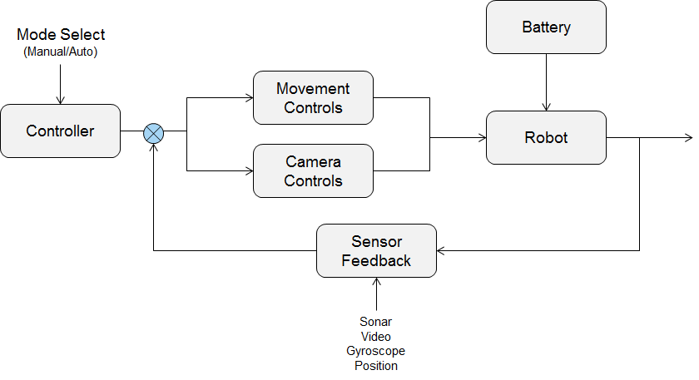
Figure 1. Expected TurtleBot Block Diagram

VII. Conclusion

This project will prove to be both a social engineering problem and a challenging experience. Sensing the environment and automating the robot will be very difficult, but it will vastly simplify the data collection process from the user’s perspective. Having the opportunity to design a product to meet a client’s requirement is an added element that emphasizes the real-world experience. In the end, we hope that our design will be able to alleviate some of the issues presented by the aging infrastructure in Bowman Creek, and revitalize the aquatic life throughout the entirety of the stream.

