Smart Garden
High Level Design Document

Team grEEn
Kara Vitale, David Wieczorek, & Bridget Harrington

Table of Contents

- Introduction..…………………………………………………… 2

- Problem Statement and Proposed Solution …………………….. 3

- System Requirements…..……………………..………………… 4

- System Block Diagram…………………………………………5-7

  - Overall System………………………..…………………5
  - Subsystem and Interface Requirements…………….... 6-7
  - Future Enhancement Requirements……………………. 7

- Wi-Fi Considerations…………………………………………. 8-9

  - Connection Considerations……………………………. 8
  - Data Flow…………………...…………………………. 8
  - ESP8266……………………………………………….. 9
  - Protocol for Data Exchange…………..……………….. 9

- High Level Design Decisions…….……………………………. 10

- Open Questions…….………………..……………………… 11-12

- Major Component Costs.…….……………………...…………. 13

- Conclusions…….……………………...………………………. 14

- References …….……………………...…………………….. 15

- Introduction

According to several recent psychological studies, potted plants do make you feel better and in particular help to lower blood pressure and raise job satisfaction. However, many may not have the time to constantly monitor their plants. With the Smart Garden, you can be as stress-free as possible. While potted plants have been proven to improve your health and productivity, the Smart Garden will help you take care of these plants so they don’t wilt away to nothing. This high level design outlines the basic design plans for the Smart Garden, a revolutionary device that will detect moisture, temperature, and sunlight levels and send updates to an app on your phone to let you know when your plants are in need of watering, more sun, or if it is too hot or cold for your plant.

- Problem Statement and Proposed Solution

Many plant owners face the problem of how to care for their plants when they are too busy to constantly monitor these plants. To monitor these plants, moisture, temperature, and light exposure are key factors that need to be detected. The plant needs to be watered consistently to ensure the plant isn’t being over or under watered. The plant also cannot be overheated or in too cold of temperatures. Plants need sunlight for photosynthesis to occur so they can grow and flourish. However, it can prove difficult to monitor each of these aspects of the plant life constantly. Different plants require different thresholds of these three key plant health factors.
Our proposed solution, the Smart Garden System, provides an all-in-one device that will have three different sensors to monitor the moisture level, temperature level, and light exposure of the different types of plants that are growing. The device will be in a clear container with the exception of the moisture sensor so that all of the electronic parts will not be damaged when the plant is watered. This device will stick right into the potted plant. The device will also send these plant owners updates on their plants using Wi-Fi through a Mobile Application on their phones. Through the Mobile Application, the plant owners will have an easier way to track how their plants are doing. The notification system in the Mobile Application will help to ensure you never forget about a plant.

- System Requirements

The overall system requirements for the Smart Garden System are as followed. The sensors must take accurate sensor readings of their current environment and be able to communicate that data to the Main Board. This Main Board must have the ability to send these values to an online database where they can be used for the Mobile Application. The system must be Wi-Fi enabled. The system must be able to communicate back and forth with the Mobile Application. This application can be Android and/or iOS based. The Mobile Application must be capable of notifying the user of critical levels of moisture. The Mobile Application must also have the ability to have different critical parameters and levels for different types of plants, based on the input of plant type by the user. The Power Supply for this system must supply the necessary voltage for the Main Board. The Power Supply will be alkaline batteries and must be able to provided power for at least 6 months without the need to be replaced. If this requirement can not be met a solar panel, rechargeable battery combination must replace the original Power Supply. The entire Smart Garden System must be water resistant.

- System Block Diagram

4.1 Overall System

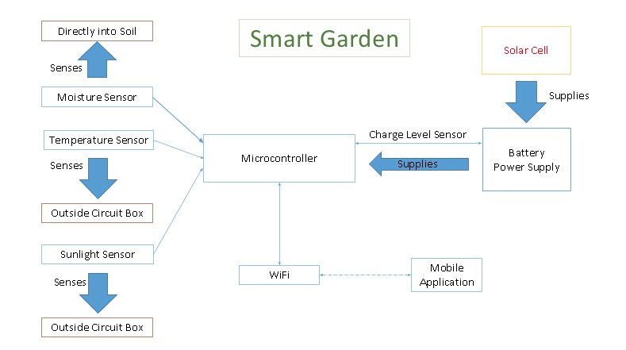

The Smart Garden System is made up of the Sensor System, Main Board, Power System, and Mobile App. The Sensor System is responsible for collecting the data that will be used by the Mobile App. The Sensor System will consist of a thermistor, a photoresistor, and a moisture detector. The main board will include a microprocessor and an ESP8266. Its main purpose is to facilitate the communication between the sensors and the Mobile Application. The sensor information will be stored on the Main Board and then sent over Wi-Fi to the Mobile Application. The Mobile Application will provide the user interaction to the rest of the systems. It will track the sensor readings and send necessary alerts to the user. The Power System consists of a battery and possibly a solar cell. A design question that still remains is whether or not we will use a solar cell for charging an on board battery. If we can supply the Smart Garden System using AAA batteries for 6 months or longer, we will not include a solar cell. If we choose to use the solar cell we will use a rechargeable battery.

4.2 Subsystem and Interaction Requirements

Sensor System
The Sensor System is a critical subsystem in our Smart Garden System. This subsystem provides the data that is used by the Mobile Application. We plan to use a thermistor to measure the temperature and a photoresistor to measure the light exposure. For moisture detection we plan to use a voltage divider and measuring the voltage across the soil of two. The resistance of the soil will change with moisture, allowing us to detect moisture. The thermistor needs to be capable of a range of 0-100 degrees Celsius. The photoresistor must be placed such that it mimics the sun exposure to the plant (i.e. can’t be shaded by any hardware components). The moisture detection has to be sensitive enough to give reliable moisture data. It is required that all sensors give reliable and accurate values.

Main Board
The Main Board subsystem is another crucial subsystem of the Smart Garden System. It will contain a PCB with the Sensor System Integrated in it as well as the ESP8266. Its main responsibility will be reading sensor values and then using the ESP8266 to send this data to a database to be read by our mobile app. This subsystem requires a protective water resistant case. This case has to insure that it will not harm the effectiveness of the Sensor System. This subsystem needs to be run at 3.3 V and it will be powered but the Power Supply subsystem. We will design the PCB.

Power
The Power subsystem will consist of a battery to power the Main Board, thus powering the sensors. It has to supply the required 3.3 V. We plan on first trying to power the device with alkaline batteries. If we are not able to get the operation time we desire, ~6 months, we will replace the alkaline with a rechargeable battery and solar panel for recharging. The power system also must be weatherproofed or encased in a water resistant case.

Mobile Application
The Mobile Application will connect the user to the hardware, therefor it must be capable of communicating in some way with the hardware. The Mobile Application must be capable of sending the user alerts when their moisture level is critically low. It must have the ability to track plants uniquely based on the plant type. The plant type will be set by the user. It must also be able to display sensor values in real time. We require that it is available on either Android, iOS or both. Many potential features could be added to the app but it is only required to do the functions mentioned above.

4.3 Future Enhancements Requirements
There are many different enhancements that can be added to this project, many of which can be added to the mobile app without any change to the hardware. For example, we could implement a “What Can I Plant Here” function. This feature would basically be the ability to initiate a 24-hour test of the environment the Smart Garden System is in and using that information make an informed decision about what to plant there. We could also add the ability to track multiple plants at once. Enhancements could also be made to the hardware. We could have nutrition analysis of the soil allowing you to know exactly what your plant needs. We could also implement a self watering system or integration with automatic sprinklers.

- Wi-Fi Considerations

  - Connection Considerations
Based on the needs of our Smart Garden System, the Wi-Fi module will be connected to a single Wi-Fi network within the home. The connection will be to a secure network. The ESP8266 makes this step easy. There are built in functions to connect to already present Wi-Fi networks. An example: (AT+ CWJAP =<ssid>,< pwd >).

  - Data Flow
Our Wi-Fi module will need to send the data from our Sensor System. All three measurements, temperature, light exposure, and moisture, will be integer values. Data will be sent around every 6 hours, but can be altered if needed. The data can also be accessed at the request of the user through the Mobile Application. We plan on using a Parse database or Thingspeak for this project, this way we don’t have to worry about setting up a server ourselves. The database will allow the Mobile Application to receive the temperature, light exposure, and moisture sensor data from their plant. In order to connect to an online server, the ESP8266 must be compatible to do so. In order to choose the optimal server, more research is required. Thingspeak seems to have integration with the ESP8266, and may be easily connected. After researching there are concerns with using Thingspeak. They seem to use http protocol, which will increase our power consumption.
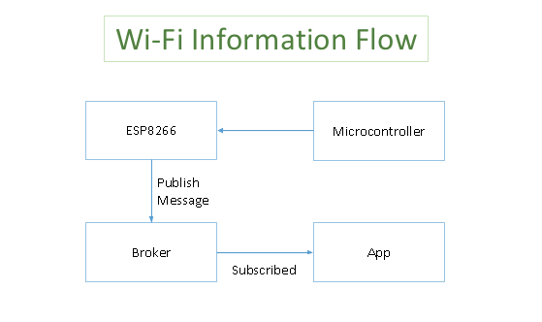

  - ESP8266
Integrating the ESP8266 module to the Smart Garden will require a separate microcontroller. The microcontroller will communicate when and where the data will be sent to and from the ESP. The ESP8266 Wi-Fi Wireless Module will be a sufficient device for the Smart Garden because the device only needs to communicate between the microcontroller, the user, and the online server. The Arduino programming environment will work best with the ESP8266.

  - Protocol for Data Exchange
The protocol needed for the Smart Garden is MQTT. MQTT is beneficial for mobile devices because it features faster response and throughput of data, and consumes lower bandwidth and battery. Because low power high battery life is such a key feature in the design of the Smart Garden, MQTT is ideal. MQTT uses the principle of publishing messages and subscribing to topics. Publishing involves a client connecting to a broker and then publishing messages to a specific topic. Clients may also subscribe to certain topics. When subscribing the client will receive a new message when published. We believe this is all we require for our data exchange however this may change during development.

- High Level Design Decisions

The reasoning behind our design decisions are as followed, based on subsystem. The requirements of the sensor system are based on the fact that to have an accurate Mobile Application alert system you need to have accurate and relevant sensor data. We decided on temperature, light exposure, and moisture level because they are all critical to the health of a user’s plant. For the Main Board we decided to have a separate microcontroller in addition to the Wi-Fi module so that we could do the A/D conversion on the board. We need the Wi-Fi to be able to communicate back and forth with the Mobile Application so that we can get the data in real time if desired. We also need it to provide the information that will set off alerts in the Mobile Application.
We decided to make the addition of the solar cell contingent upon an alkaline battery not providing enough duration between battery replacements. We felt that a solar cell and rechargeable battery would add too much unnecessary bulk and take away from the plant itself. We have decided to make this primarily a device for a potted plant or window box as opposed to an open field or backyard garden. We thought there was a better chance that a potted plant or window box would be within Wi-Fi range of the home of the user. We haven’t ruled the possibility of making a solution adapted for the open field or backyard garden but it will not be the main objective of this design.

- Open Questions

Moving forward with our design, we have a great deal of pertinent questions that will be answered through further research, testing, and analysis of our design during Spring semester. All of our subsystem, Sensor System, Main Board, Power Supply, and the Mobile Application have design questions associated to them.
First, is the concern of how much battery life the Power Supply of our Smart Garden will require. Our question is if whether using alkaline batteries will last for 6 months or longer, in which case the solar charging is not needed. But if the battery life is shorter than 6 months, we would try to use a solar cell and a rechargeable battery. We hopefully would like to work with the alkaline batteries. We feel as though the solar cell would add a lot of bulk to our system. This bulk could take away from the plant itself. The purpose of our design is to make sure the user's plant is at its best and most beautiful therefor distracting from it would go against our goal.
We are sure of what will be included in the Main Board substance, however we are unsure of the specifics. We are still choosing the ideal microcontroller to use but we didn’t want to make a choice until we knew more about how the ESP8266 will interact with it. There are still a number of questions regarding the Wi-Fi necessities of our device. Depending on the limitations of our App, we need to decide what protocol should be used. The MQTT protocol is great for sending and receiving messages from one device to the other. There is a problem when the user requests that information. We need to research if there a way for this to be done in MQTT or will HTTP be more useful? Also, because of the significant battery benefits when using MQTT, is there a situation in which a mixture between the two can be used? With the battery being so important in the Smart Garden, we will also have to see which ways we can change the length and how often the ESP8266 is powered up. This is an important question to answer because it will be essential when trying to cut down power consumption and preserve as much of the battery as possible.
There is also the concern of how well the Wi-Fi will work inside and outside, specifically the range of the Wi-Fi. It is impossible to predict the range of every user’s Wi-Fi as we are designing but it is safe to assume that if they have a large backyard vegetable garden or open farmland that is out of Wi-Fi range. We plan on first adapting the system to be used inside the home and in potted plants or window boxes close to the home. If the personal Wi-Fi range of the user is large enough, then our device has the ability to also be used in a larger garden or field, but we don’t want to rely on this.
A lot of testing and experimentation has to go into how sensitive the moisture detection is to different types of soil. We are measuring the change in moisture by measuring the change is resistance of the soil and different properties of this soil has the potential to affect the resistance. We also have to test the range of this moisture detector to see how much area can be monitored by one Smart Garden System.
Our last open question is whether we want to develop the Mobile Application in Android, iOS, or both. We need to look at the two platforms to ensure that they can both fulfill the design requirement of communicating with the hardware. If it turns out that they are both able to communicate effectively with the hardware we will make a decision on whether or not to make two Mobile Apps. If we decide against making two separate Mobile Apps we then have to choose a platform.
These open questions should hopefully be easily answered through more research, testing, and analyzing during the Spring semester. Also through further research, we may decide to expand on our Smart Garden by including a “What Can I Plant Here” function through which the sensors will monitor the moisture, temperature, and sunlight of the planter you place your Smart Garden device into. After monitoring these factors for about 24-36 hours, the Smart Garden mobile application will notify the user what type of plants would flourish in those conditions and which plants to avoid. Another expansion opportunity would be including a self-watering system in which the plants would be watered when the moisture sensor detects low amounts of moisture. One final expansion opportunity would be to have multi-tag communication. This would entail having the Mobile Application track more than one Smart Garden System. This would be especially effective if Wi-Fi range was strong enough and you place the Smart Garden System into a larger backyard garden.

- Major Component Costs

Qty | Part Number | Part Name | Manufacturer/ Distributer | Price ($) | Total Price ($)
1 | PDV-P9203-ND | PDV-P9203 | Digi-Key | 1.78 | 1.78
1 | 568-3251-ND | KTY81/220 | Digi-Key | 1.08 | 1.08
1 |  | 100 Ohm resistor |  | Provided | Provided
1 |  | 100 K Ohm resistor |  | Provided | Provided
1 |  | Alkaline Batteries | Target | 13.99 | 13.99
1 |  | ESP8266 | Amazon Prime | 7.68 | 7.68
1 |  | Board |  | ~50.00 | ~50.00
 |  | Water Resistant  Enclosure Materials |  | ~20.00 | ~20.00
 |  |  |  |  | Total: 94.53

As seen, our project would be way under budget. Potentially, we would spend more of our budget on a solar cell if we decide against Alkaline batteries.

- Conclusions

This high level design describes our Smart Garden System, which serves as our Senior Design Final Project. Currently, we are in a good position in reaching our final goal for our project. We have tested how we will implement our moisture sensor. With the materials we have in mind, we will most definitely be able to stay under budget. We do have some open ended questions and concerns at this point, but after further research combined with testing, we should be able to find answers.
In the Spring semester, we will continue researching, testing, and analyzing our design as well as construct the device. We will need to test our design using the ESP8266 and decide how powerful of a microcontroller we need for our board. We will need to prototype our sensor circuits, confirm they work, and design a PCB. We will also need to implement our Mobile Application. We anticipate that this will be our most time consuming aspect of this project because of the learning curve involved in making a Mobile Application. The Mobile Application also requires an extensive database of plant types and their ideal growing conditions which will take some time to construct. Overall we are excited about our project and look forward to seeing our design become a usable product.

References

http://www.instructables.com/id/ESP8266-Weather-Station-with-Arduino-2-Software/step2/The-Arduino-Software/

http://wiki.iteadstudio.com/ESP8266_Serial_WIFI_Module

http://fab.cba.mit.edu/classes/863.14/tutorials/Programming/serialwifi.html

https://en.wikipedia.org/wiki/ThingSpeak

https://thingspeak.com/

http://bb-smartsensing.com/basics-of-mqtt/

http://mqtt.org/

https://www.psychologytoday.com/blog/urban-mindfulness/200903/plants-make-you-feel-better

