SmartSurge
High-Level Design
Adam Rainey, Joseph Kosteck, Patrick McCullough

Table of Contents
1. Introduction 3
2. Problem Statement and Proposed Solution 3
3. System Requirements 4
4. System Block Diagram
4.1 Overall System 4
4.2 Subsystem and Interface Requirements 4
4.3 Future Enhancement Requirements 5
5. WiFi Considerations
5.1 Connection Considerations 5
5.2 Data Flow 5
5.3 ESP8266 6
6. High Level Design Decisions 6
7. Open Questions 7
8. Major Component Costs 7
9. Conclusions 8
10. References ……………………………………………………………………………………8

1. Introduction
Every year, roughly $19 billion worth of electricity is wasted due to so-called ‘vampire energy’– the energy that appliances, electronics, and other household equipment use when left plugged into an outlet. The International Energy Agency estimates that 10% of an average household’s utility bill is used on vampire energy. A lot of this energy is wasted because consumers either forget to or find it too inconvenient to unplug devices and/or switch off power strips every time they leave the house. According to a study conducted by the Natural Resources Defense Council, the five worst energy “vampires” are set-top boxes, audio gear and game consoles, televisions, desktop computers, and modems. These devices are also often almost always plugged into surge protectors due to the fact that they have many supporting components or are placed next to each other. Thus a few surge protectors that are turned off when not in used could save a considerable percentage of this wasted energy. Our goal is to reduce this energy by implementing a wirelessly controlled surge protector that can be turned on and off through a phone, tablet, or computer.

2. Problem Statement and Proposed Solution
The problem that we intend to solves is reducing the considerable amount of energy wasted by electronic devices that are plugged in yet are not in use. These devices are usually left in due to the inconvenience that it takes to connect and then disconnect them to power every time that one wants to use the device. In order to reduce the energy wasted we intend to drastically reduce the amount of effort needed to connect and disconnect electronic devices from power sources. Our proposed solution is a surge protector that can be controlled wirelessly through WiFi so that a consumer can control the surge protector from their phone, computer, or tablet. The user will also be able to use a web application to set a schedule for the power usage of the surge protector. This makes it more convenient for the user as he/she can set a series of times for when he/she is at school or work for the surge protector can be powered off. Likewise, we will enable the user to selectively deny power to select outlets on the surge protector so that some devices can always be powered, such as alarm clocks, while other devices can be selectively power, such as game consoles and televisions. Our surge protector will also be able to monitor power levels so that the consumer can adjust their power usage accordingly and further find ways to save power. The ability to monitor power consumption as well as the ability to turn power on or off wirelessly makes SmartSurge a viable solution to significantly decrease the amount of energy needlessly consumed by unused devices.

3. System Requirements
- The embedded intelligence must be able to control solid state relays to switch power on and off based on user input. It must be able to monitor power consumption and relay this information to the web application
- The device will be powered through the wall outlet. The solid state relays (5 V), the board (3.3 V), and the WiFi module (3.3 V) will run off of a power supply which provides 3.3 and 5 volts
- SmartSurge will have one wireless device: the WiFi module. The Wi-Fi module will
- We will create an iOS app that will track and store the power consumption of the device. The app will also enable the user to instantly switch the surge protector on and off while also enabling the user to create a schedule for the surge protector to be on or off
- We will use a fuse to limit the current/voltage of the various requirements so that none of the components are destroyed
- To improve safety of the use of the 120 volt connections, we will be using 12 gauge wire for our connections. 4

4.1 Overall System Block Diagram
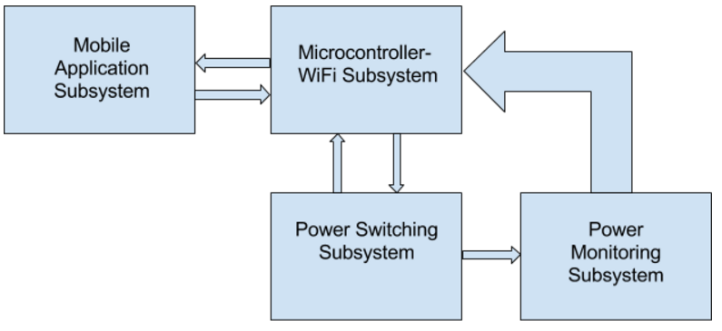

4.2 Subsystem and Interface Requirements
1. Power Monitoring Subsystem
a. Accurately measure power drawn without drawing too much itself
b. Communicate power level to microcontroller
2. Power Switching
a. Must switch 120 Vac to ports on/off
b. Must draw minimal amount of power
3. Mobile application subsystem
a. Must be able to implement calendar/store schedule
b. Must be able to store and display power consumption data
4. Microcontroller-WiFi Subsystem
a. Steps power down to acceptable level for microcontroller
b. Store password for WiFi connection
c. Change state of power switch system
d. Monitor state of power switch system
e. Determine power drawn from power monitoring system
4.3 Future Enhancement Requirements
1. The control of individual power outlets rather than two groups of outlets
a. A relay must be present for each outlet
b. Additional ports would be used on the microcontroller
2. Ability to monitor power of each outlet
a. Power monitor would be present at each outlet
b. Additional ports of microcontroller would be used
3. Ability to manually control the power to each outlet
a. Would require a sliding switch for each outlet

5.1 Connection Considerations
Our device will only need to connect to a single WiFi network: ND guest.

5.2 Data Flow
We plan on using MQTT to communicate with the server and the WiFi module and establishing a connection every five minutes.
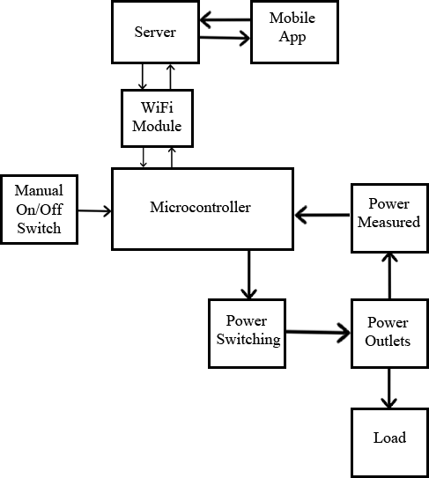
5.3 ESP8266
We plan on using the ESP8266, more specifically the ESP-09 so that we can use the 1 MB of flash memory. We also plan on using a microcontroller as well to help coordinate the monitoring of the power level, the power switching, and

6. High Level Design Decision
1. Microcontroller
a. Sends signal to power switching subsystem toggling power switching
b. Receives information from push button toggling power switching
c. Receives data from the mobile application through the server and WiFi module
d. Controlled by a sliding switch, toggling the power on or off
e. Can compute power based on signal from power measurement subsystem
f. Communicates data to the mobile application about current power consumption and which outlets are toggled on or off
2. iOS Application
a. Receive input from the user:
i. Switching power outlets on or off
ii. Schedule for when to turn outlets on or off
b. Output to the user:
i. Immediate power draw
ii. Current state of outlets (on or off)
c. Storage and display of power usage history
3. Physical Interface
a. A slide switch controlling the entire device
b. A push-button which sends a signal to the microcontroller, toggling power on/off
4. Server
a. Software to send or receive information to the mobile application
b. Software to establish a connection and exchange information with the WiFi module
5. WiFi Module
a. Software to send information from the microcontroller to the server
b. Software to pass information from the server to the microcontroller
6. Power Switching
a. Ability to switch 120 Vac power in the outlets based on signal from the microcontroller
b. Ability to isolate microcontroller from high power levels
7. Power Outlets
a. Must send data about power consumption to the power measurement subsystem
b. Provides reliable power to the load
8. Power Measurement
a. Sends signal to the microcontroller about power consumption
b. Receives information about the power being used

7. Open Questions
1. How to monitor the power to the device in a way that will not use too much power itself

8. Major Component Costs
 | Unit Price | Quantity | Total Cost | Subsystem
5 Vdc Power Supply | 13.86 | 1 | $13.86 | System Power
Solid State Relay | 26.33 | 2 | $52.66 | Power Switching
5V-3.3V DC-DC Converter | 8.64 | 1 | $8.64 | System Power
15 Amp Duplex Receptacle | 3.9 | 3 | $10.80 | Power Outlets
WiFi Module | 6.95 | 1 | $6.59 | Microcontroller-WiFi Subsystem

9. Conclusions

In conclusion, our project serves to solve the problem of wasted energy in both residential neighborhoods and commercial businesses. SmartSurge serves as an easy way for the user to both monitor energy consumption and save power while at the same time changing very little in their daily routines. Through the utilization of a mobile application, the user will be able to control the device over a specific WiFi network and keep track of its power status as well as energy consumption levels. An MQTT server will also be implemented to allow the device to communicate with the application and vice versa. SmartSurge has the potential to save users hundreds of dollars over the course of a year, and it is a very useful way of applying this Internet of Things theme to an existing piece of technology.

10. References

http://mqtt.org/

http://www.esp8266.com/wiki/doku.php?id=esp8266-module-family

